Supplementary material
Supplementary Table 1. Description of the dietary indexes excluded, and the criteria applied for the exclusion.
Authors (year) | Dietary index | Country | Scoring range | Reason for exclusion
Sotos-Prieto et al.²⁴ | MEDLIFEª | Spain | 0-28 | Structure questionnaire/not applicable to 24HDR data
Gerber et al.²⁵ | Med-DQI-2000^{b} | South of France | 0-14 | MedDietScore variation
Gerber et al.²⁵ | Med-DQI-f-2000 | South of France | 0-16 | MedDietScore variation
Gerber²⁶ | Med-DQI-2006 | France | 0-14 | MedDietScore variation
Agnoli et al.²⁷ | IMI-2011^{c} | Italy | 0-11 | MDS variation
Knoops et al.²⁸ | MAI-2006^{d} | Mediterranean and non-Mediterranean European countries | Not normalized | Not normalized
Schröder et al.²⁹ | MEDAS-2011e | Spain | 0-14 | Structure questionnaire/not applicable to 24HDR data
Domınguez et al.³⁰ | MEDAS-2013 | Spain | 0-13 | Structure questionnaire/not applicable to 24HDR data
Haveman-Nies et al.¹⁰ | MDS-2001^{f} | Western countries (USA, Europe) | 0-8 | MDS variation
Haveman-Nies et al.³¹ | MDS-2002 | Western countries (Europe) | 0-7 | MDS variation
Knoops et al.³² | MDS-2004 | Western countries (Europe) | 0-8 | MDS variation
Cade et al.³³ | MDS-2011 | United Kingdom | 0-10 | MDS variation
Trichopoulou et al.³⁴ | mMDS^{g} | Mediterranean and non-Mediterranean European countries | 0-9 | MDS variation
Yang et al.¹¹ | mMDS-2014 | USA | 0-42 | Structure questionnaire/not applicable to 24HDR data
Fung et al.¹² | aMED-2005^{h} | USA | 0-9 | MDS variation
Sanchez-Taınta et al.³⁵ | MeDiet-2008^{i} | Spain | 0-14 | Structure questionnaire/not applicable to 24HDR data
Goulet et al.³⁶ | MS-2003^{j} | Canada | 0-44 | MedDietScore variation
Buckland et al.³⁷ | rMED-2009^{k} | Spain | 0-18 | MDS variation
Buckland et al.³⁸ | arMED-2013^{l} | Mediterranean and non-Mediterranean European countries | 0-16 | MDS variation
ªMediterranean Lifestyle index. ^{b}Mediterranean Diet Quality Index. ^{c}Italian Mediterranean Index. ^{d}Mediterranean Adequacy Index. ^{e}Mediterranean Adherence Diet Screener. ^{f}Mediterranean Diet Score. ^{g}Modified Mediterranean Diet Score. ^{h}Alternate Mediterranean Diet Score. ^{i}Mediterranean Food Pattern. ^{j}Mediterranean Score. ^{k}Relative Mediterranean Diet. ^{l}Adapted Relative Mediterranean Diet

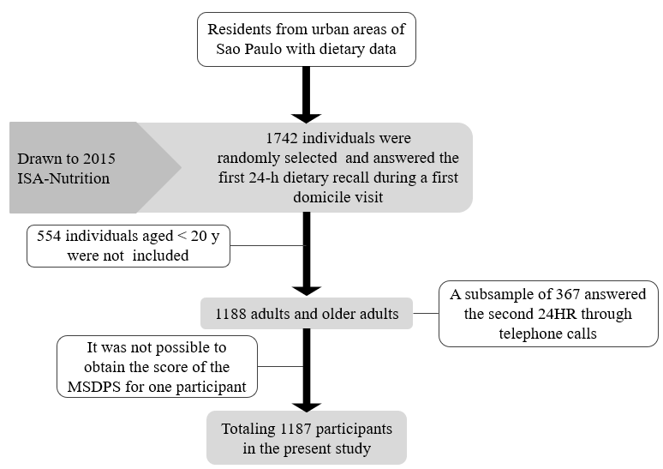

Supplementary Figure 1. Description of the sample in the 2015 Health Survey of São Paulo with Focus on Nutrition Study (2015 ISA-Nutrition) included in the present study.

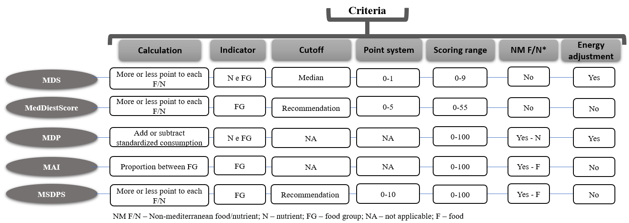
Supplementary Figure 2. Criteria adopted in constructing the five selected dietary indexes.

