SUPPLEMENTAL MATERIALS

Figure S1: Proportion of the UK population not meeting the EAR for calcium
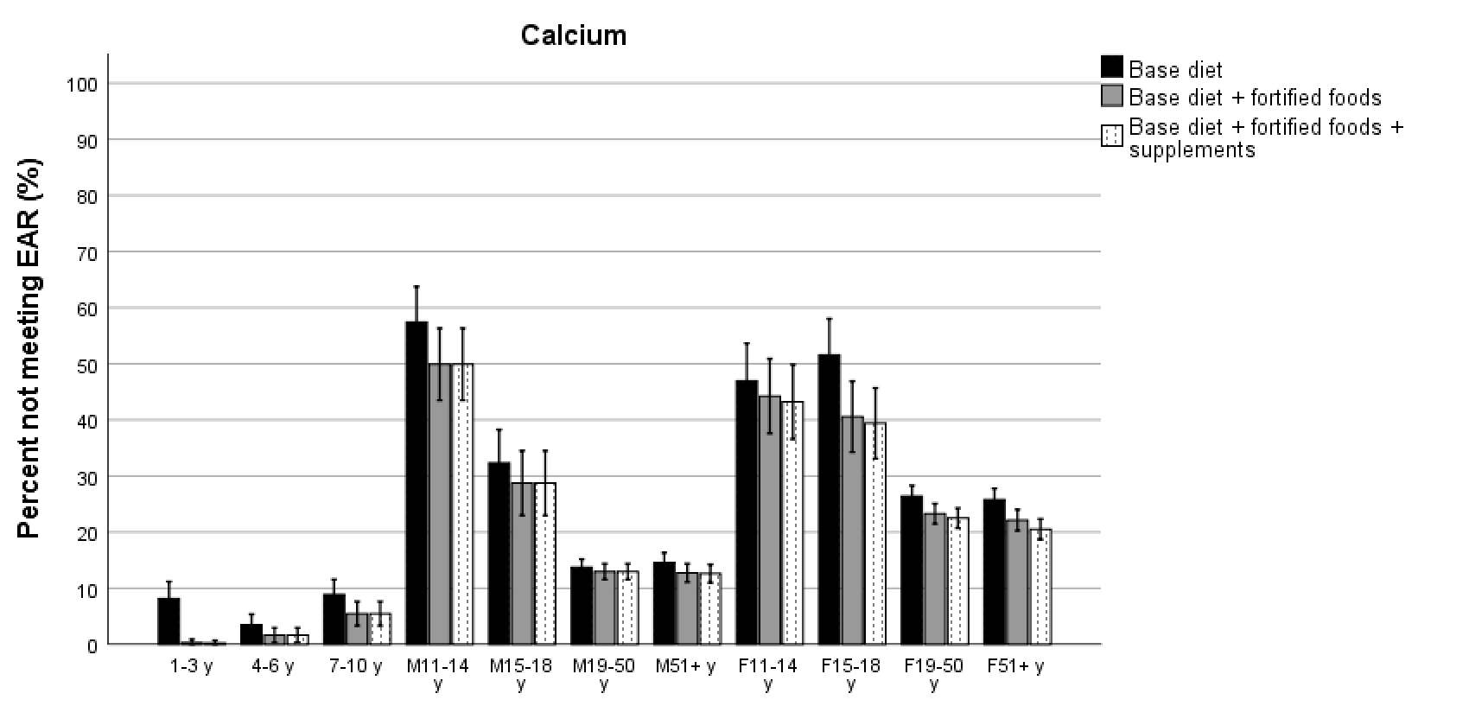

Figure S2: Proportion of the UK population not meeting the LRNI for iodine
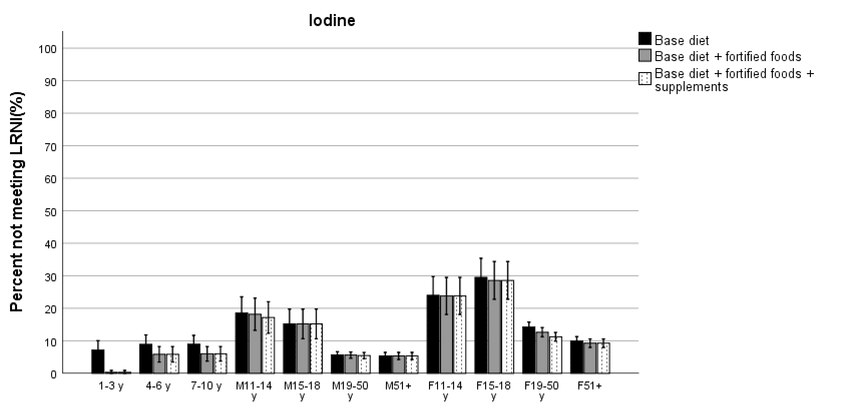

Figure S3: Proportion of the UK population not meeting the EAR for magnesium
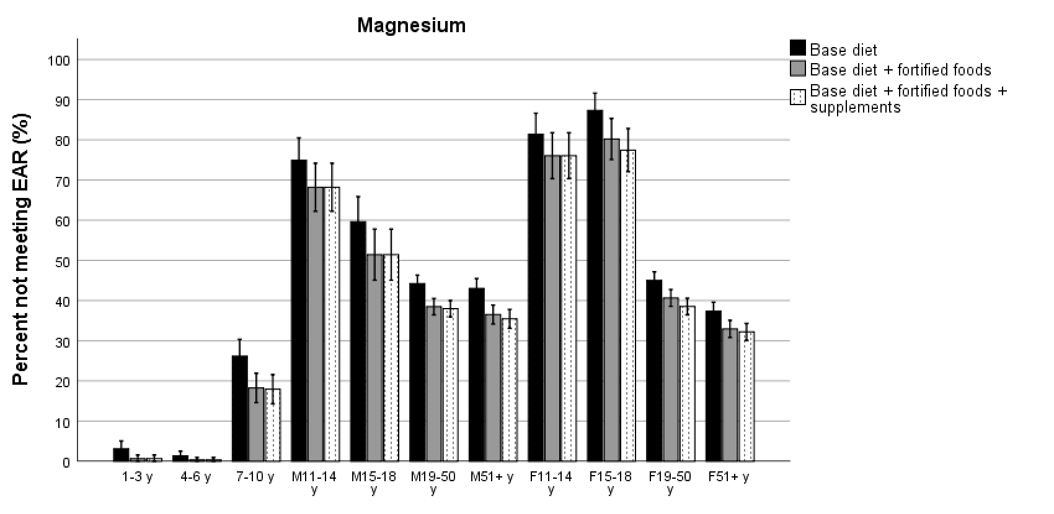

Figure S4: Proportion of the UK population not meeting the LRNI for potassium
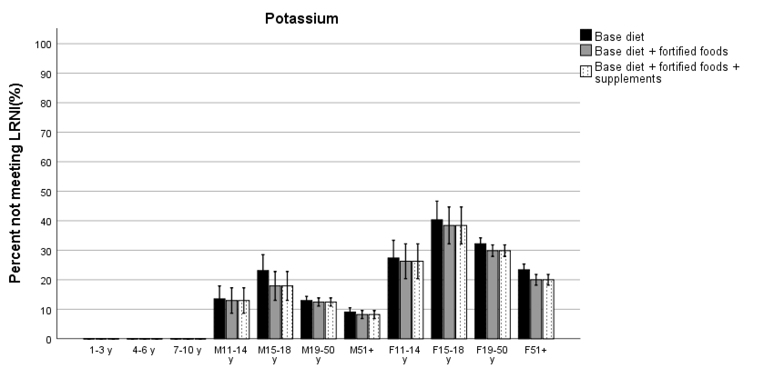

Figure S5: Proportion of the UK population not meeting the EAR for iron
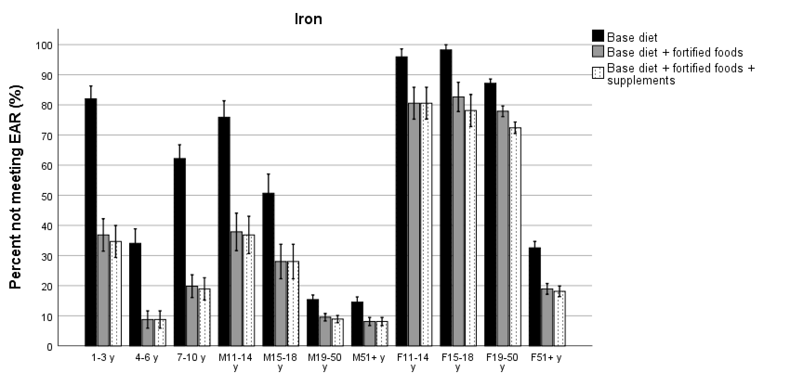

Figure S6: Proportion of the UK population not meeting the LRNI for selenium
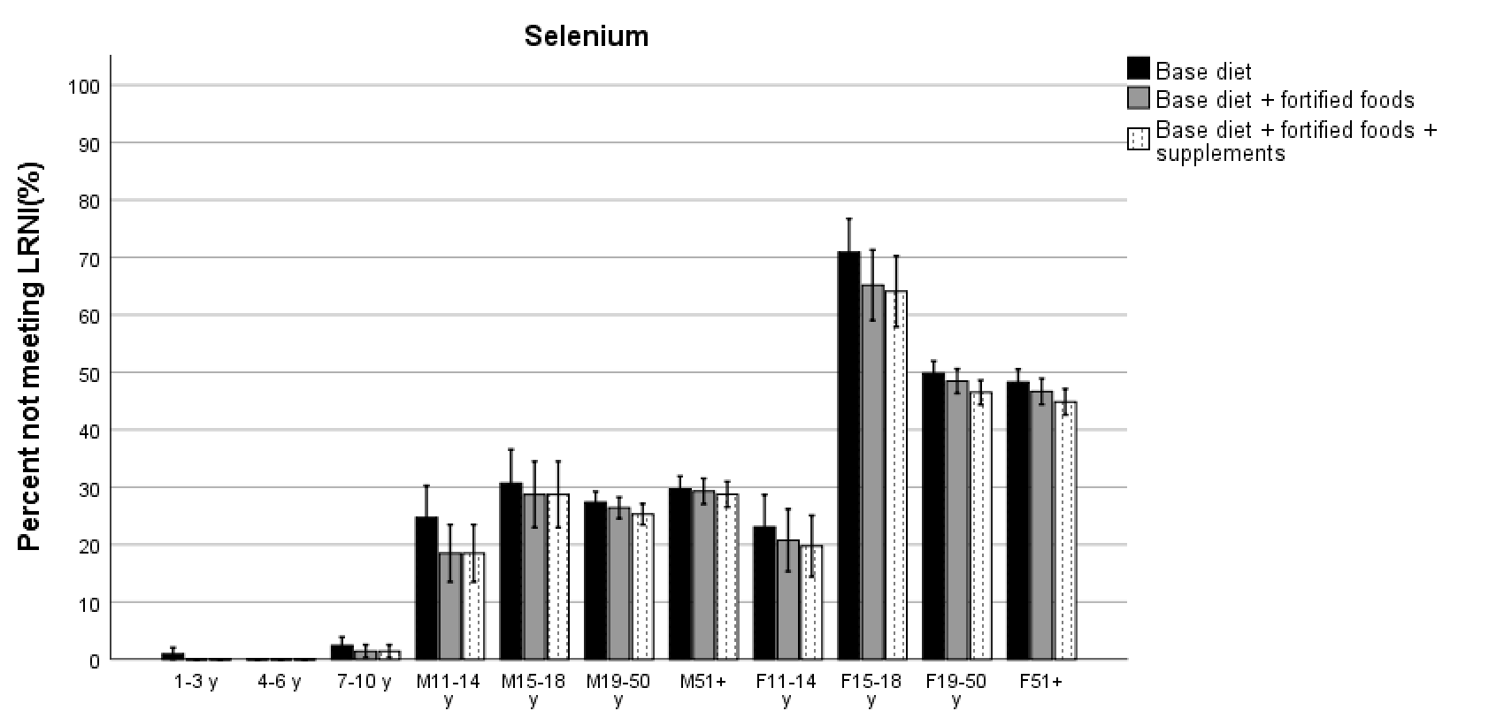

Figure S7: Proportion of the UK population not meeting the EAR for zinc
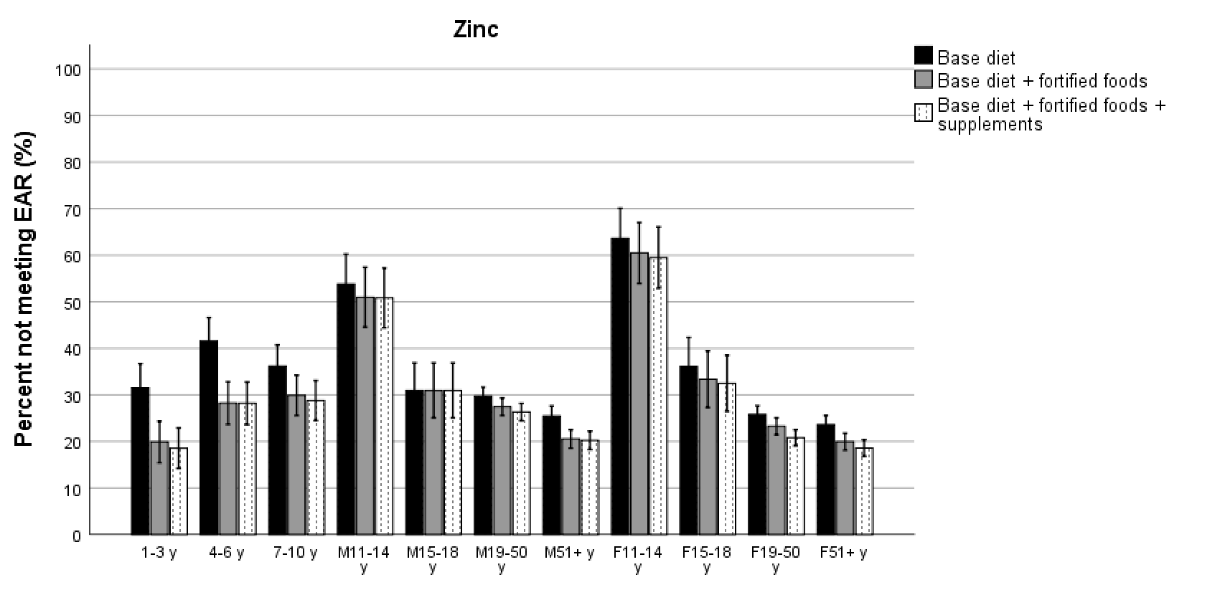

Figure S8: Proportion of the UK population not meeting the EAR for vitamin A
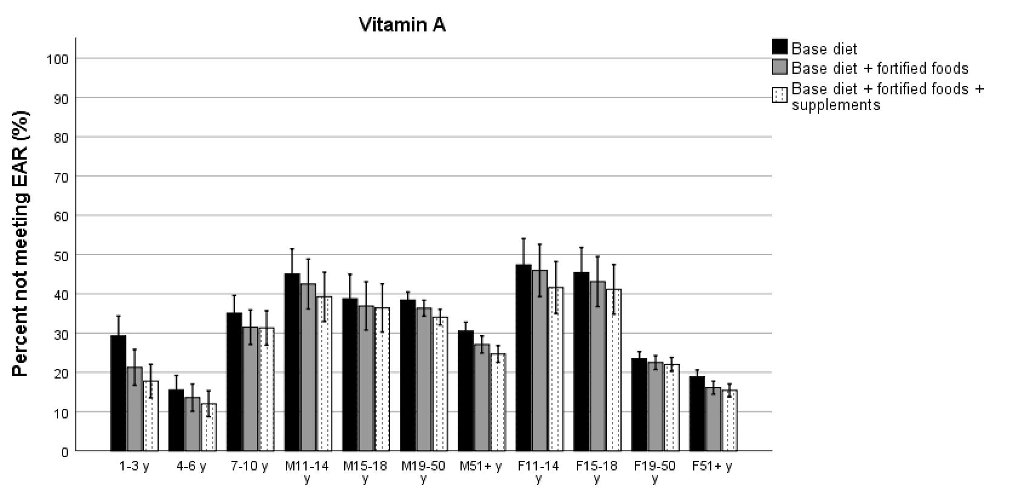

Figure S9: Proportion of the UK population not meeting the EAR for riboflavin

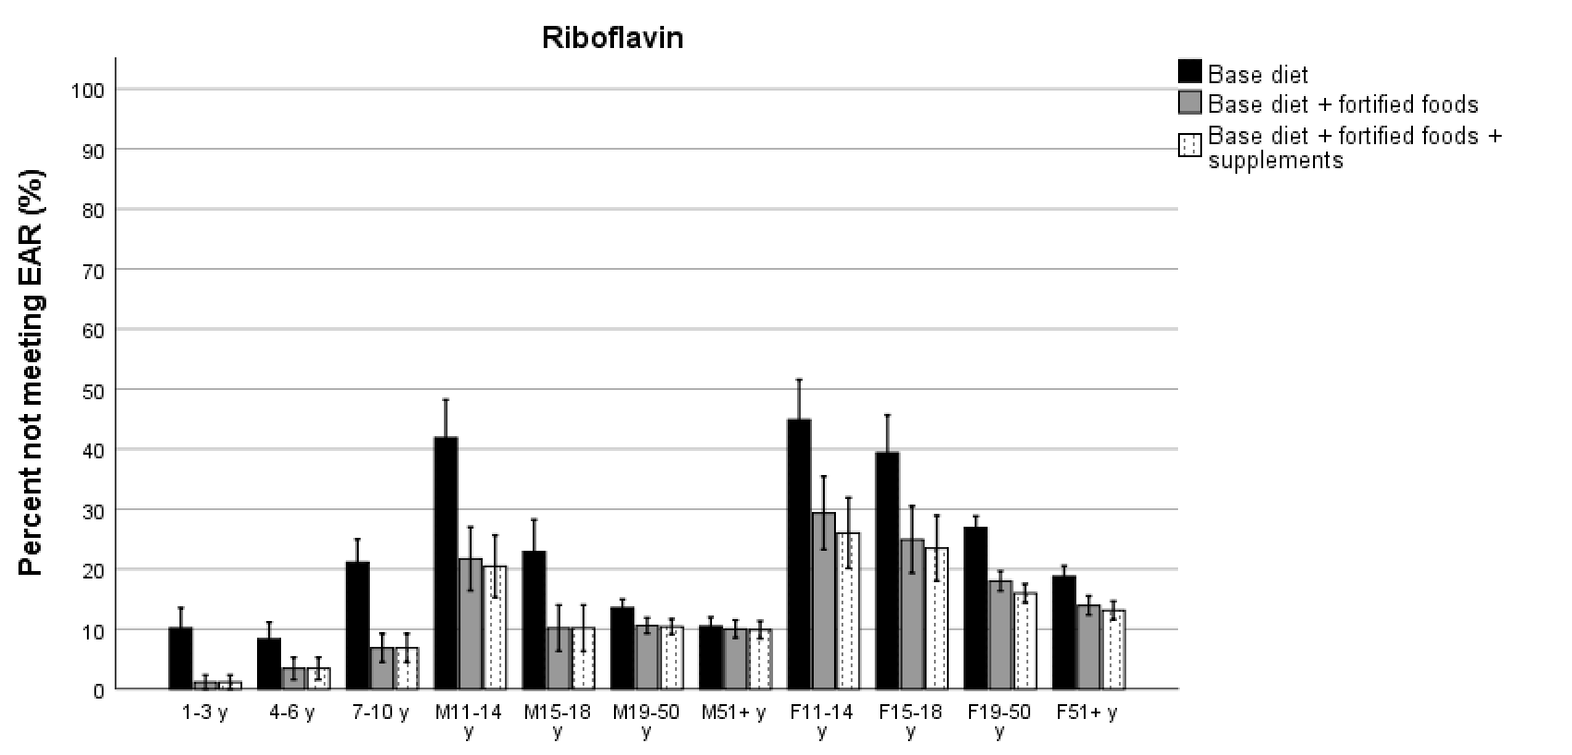

Figure S10: Proportion of the UK population not meeting the EAR for vitamin B6

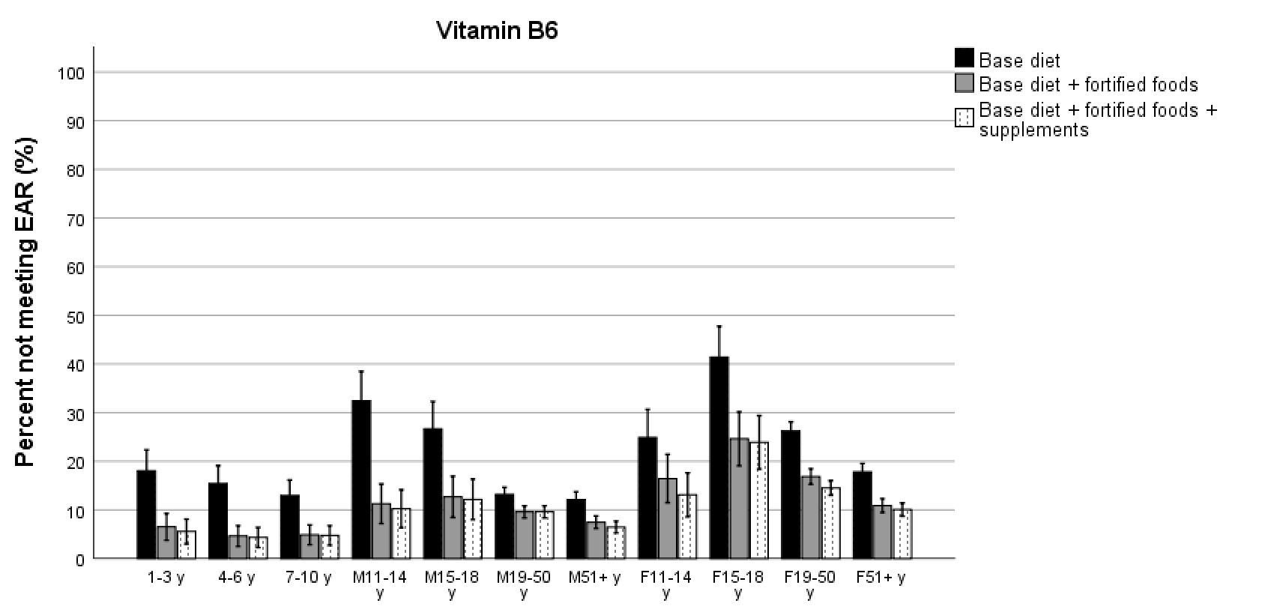

Figure S11: Proportion of the UK population not meeting the EAR for folate
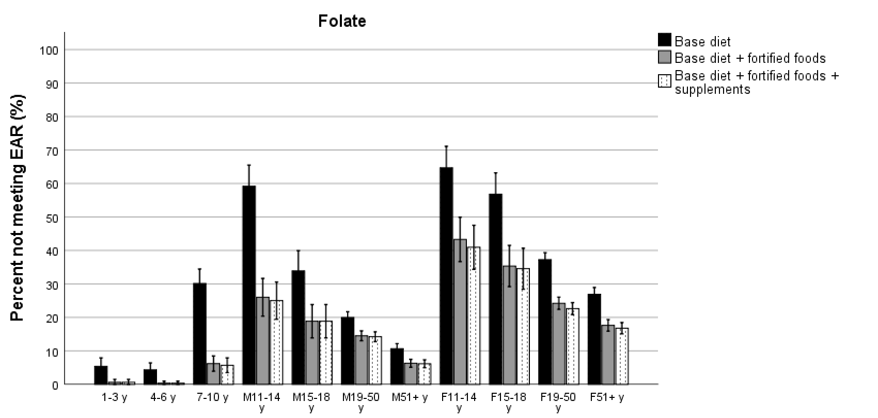

Figure S12: Proportion of the UK population not meeting the EAR for vitamin C
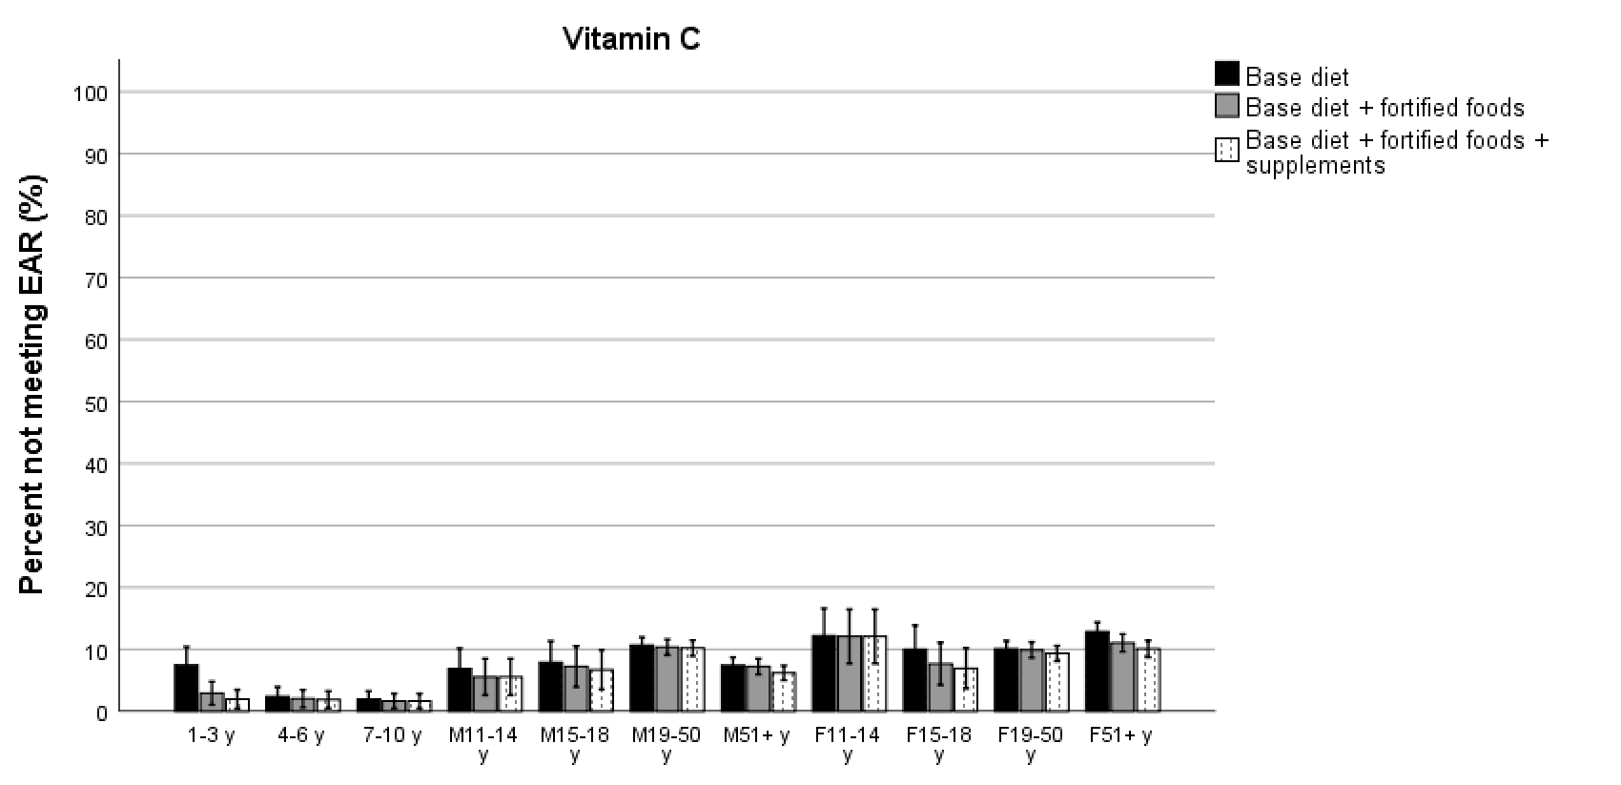

Figure S13: Proportion of the UK population not meeting the RNI for vitamin D
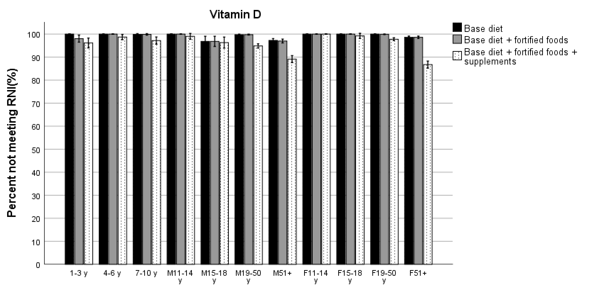

Table S1: Number and proportion of fortified food consumers and the type of fortified foods consumer per fortified micronutrient
 | Undefined | Vit A | Vit C | Vit D | Vit B1 | Vit B2 | Niacin | Vit B5 | Vit B6 | Vit B12 | Vit E | Folic acid | Calcium
Number (proportion) of fortified food consumers | 142  (4.2%) | 531 (21.5%) | 332 (9.7%) | 1,651 (57.7%) | 1,571 (54.7%) | 1,645 (57.3%) | 1,709 (59.6%) | 554 (18.8%) | 1,538 (54.5%) | 1,506 (55.9%) | 75  (3.4%) | 1,713 (61.0%) | 377 (11.9%)
Biscuits | X |  |  | X | X | X | X |  | X | X |  | X | X
Brown, granary and wheat-germ bread |  |  |  |  |  |  |  |  |  |  |  | X
Buns, cakes pastries & fruit pies |  |  |  | X |  |  |  |  |  |  |  | X
Cheese |  |  |  | X |  |  |  |  |  |  |  |  | X
Chocolate confectionery |  |  |  |  | X |  |  | X | X | X |  |  | X
Commercial toddlers foods and drinks | X | X | X | X | X | X | X | X | X |  | X |  | X
Fruit juice | X |  |  |  |  |  |  |  |  |  |  |  | X
High fibre breakfast cereals | X |  | X | X | X | X | X | X | X | X |  | X | X
Low fat spread |  | X |  | X |  |  |  |  | X | X |  | X
Miscellaneous |  | X |  | X | X |  | X | X | X | X | X | X | X
Other breakfast cereals |  |  |  | X | X | X | X | X | X | X |  | X | X
Other milk and cream |  |  |  | X |  | X |  |  |  | X | X |  | X
Pasta, rice and other cereals | X
Reduced fat spread | X | X |  | X |  | X | X |  | X | X |  | X

