SUPPLEMENTAL MATERIALS
Table S1. Anthropometric indices of students
Anthropometric indices | Kindergarten  (age 4–6 years) |  | Elementary school  (age 7–12 years)
 | N | % | N | %
Gender
Boys | 257 | 48.4 | 127 | 53.1
Girls | 274 | 51.6 | 112 | 46.9
Weight for age
<-2 S.D. | 15 | 2.8 | 117 | 48.9
-1.5 S.D. to -2 S.D. | 24 | 4.5 | 14 | 5.9
-1.5 S.D. to +1.5 S.D. (Median) | 454 | 85.5 | 88 | 36.8
+1.5 S.D. to +2 S.D. | 12 | 2.3 | 3 | 1.3
>+2 S.D. | 26 | 4.9 | 17 | 7.1
Height for age
<-2 S.D. | 10 | 1.9 | 142 | 59.4
-1.5 S.D. to -2 S.D. | 17 | 3.2 | 7 | 2.9
-1.5 S.D. to +1.5 S.D. (Median) | 462 | 87.0 | 80 | 33.5
+1.5 S.D. to +2 S.D. | 24 | 4.5 | 6 | 2.5
>+2 S.D. | 18 | 3.4 | 4 | 1.7
Weight for height
<-2 S.D. (Extreme underweight) | 13 | 2.4 | 5 | 2.1
-1.5 S.D. to -2 S.D. (Underweight) | 26 | 4.9 | 16 | 6.7
-1.5 S.D. to +1.5 S.D. (Normal) | 435 | 81.9 | 166 | 69.4
+1.5 S.D. to +2 S.D. (Overweight) | 7 | 1.3 | 15 | 6.3
+2 S.D. to +3 S.D. (Obesity) | 21 | 4.0 | 17 | 7.1
>+3 S.D. (Extreme obesity) | 29 | 5.5 | 20 | 8.4

Table S2. Menus and nutritional composition of main ingredients served in school lunch program
Name of Menu | Food item/ ingredient |  |  | Amount† (g/portion) | Nutritional composition‡
 |  |  |  |  | Carbo  hydrate (g) |  | Protein  (g) |  | Fat  (g) | Energy (kcal)
Kindergarten
Rice with side dish: Steamed white rice, chicken and wax gourd soup, papaya
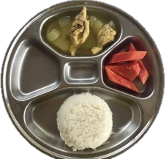 | White rice, cooked |  |  | 144.6 | 45.0 |  | 3.3 |  | 0.3 | 195.9
 | Chicken thigh, cooked |  |  | 59.6 | 0.0 |  | 14.0 |  | 7.4 | 122.6
 | Wax gourd |  |  | 42.5 | 1.1 |  | 0.2 |  | 0.0 | 5.2
 | Papaya, ripe |  |  | 65.0 | 4.8 |  | 0.4 |  | 0.1 | 21.7
 | Total |  |  | 311.7 | 50.9 |  | 17.9 |  | 7.8 | 345.4
Rice with side dish: Steamed white rice, Chinese cabbage soup with minced pork and omelet, sweet corn gruel with coconut milk
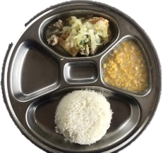 | White rice, cooked |  |  | 128.1 | 39.8 |  | 2.9 |  | 0.3 | 173.5
 | Minced pork, cooked |  |  | 24.3 | 0.0 |  | 5.9 |  | 3.6 | 56.0
 | Omelet |  |  | 39.3 | 0.9 |  | 5.5 |  | 12.9 | 141.7
 | Chinese cabbage |  |  | 36.8 | 0.3 |  | 0.3 |  | 0.0 | 2.4
 | Sweet corn |  |  | 80.5 | 8.4 |  | 2.3 |  | 4.3 | 81.5
 | Total |  |  | 309.0 | 49.4 |  | 16.9 |  | 21.1 | 455.1
Rice with side dish: Steamed white rice, omelet, grass jelly in syrup
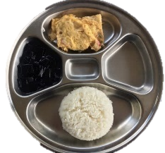 | White rice, cooked |  |  | 130.0 | 40.4 |  | 3.0 |  | 0.3 | 176.3
 | Omelet |  |  | 61.4 | 1.5 |  | 8.6 |  | 20.2 | 222.2
 | Grass jelly |  |  | 70.9 | 2.8 |  | 0.1 |  | 0.0 | 11.6
 | Total |  |  | 262.3 | 44.7 |  | 11.7 |  | 20.5 | 410.1
One-dish meal: Shrimp paste-seasoned rice (seasoned rice, caramelized pork, omelet), apple
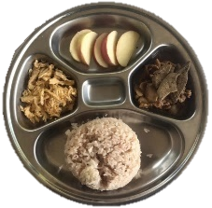 | Shrimp paste-seasoned rice |  |  | 176.0 | 54.7 |  | 4.0 |  | 0.4 | 238.4
 | Caramelized pork |  |  | 53.8 | 23.6 |  | 18.3 |  | 4.1 | 204.5
 | Omelet |  |  | 33.4 | 0.8 |  | 4.7 |  | 11.0 | 121.0
 | Apple |  |  | 36.2 | 4.5 |  | 0.1 |  | 0.0 | 18.4
 | Total |  |  | 299.4 | 83.6 |  | 27.1 |  | 15.5 | 582.3
One-dish meal: Chicken biryani, guava
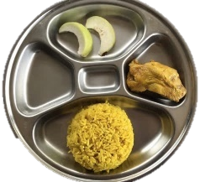 | Biryani rice |  |  | 176.8 | 59.3 |  | 5.9 |  | 5.5 | 310.3
 | Chicken thigh, cooked |  |  | 73.5 | 0.0 |  | 17.3 |  | 9.1 | 151.1
 | Guava |  |  | 31.4 | 2.2 |  | 0.2 |  | 0.0 | 9.6
 | Total |  |  | 281.7 | 61.5 |  | 23.4 |  | 14.6 | 471.0
Elementary school
Rice with side dish: Steamed white rice, green papaya and morning glory sour soup with pork, omelet, tangerine
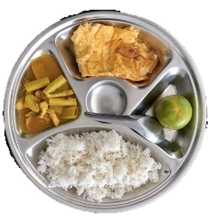 |  | White rice, cooked | 196.2 |  |  | 61.0 | 4.5 | 0.5 |  |  | 266.5
 |  | Pork, cooked | 24.0 |  |  | 0.0 | 8.0 | 0.5 |  |  | 36.5
 |  | Omelet | 85.0 |  |  | 2.0 | 11.9 | 28.0 |  |  | 307.6
 |  | Papaya, green | 20.7 |  |  | 0.6 | 0.1 | 0.0 |  |  | 2.8
 |  | Morning glory | 17.6 |  |  | 0.1 | 0.3 | 0.1 |  |  | 2.5
 |  | Tangerine | 43.7 |  |  | 3.6 | 0.4 | 0.1 |  |  | 16.9
 |  | Total | 387.2 |  |  | 67.3 | 25.2 | 29.2 |  |  | 632.8
Rice with side dish: Steamed white rice, cabbage soup with egg tofu and minced pork, spicy stir-fried chicken with holy basil and string bean, apple
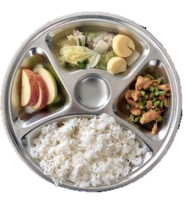 | White rice, cooked |  |  | 210.2 | 65.4 |  | 4.8 |  | 0.5 | 285.3
 | Pork, cooked |  |  | 22.8 | 0.0 |  | 5.6 |  | 3.4 | 53.0
 | Chicken thigh, cooked |  |  | 36.6 | 0.0 |  | 7.2 |  | 3.0 | 55.8
 | Egg tofu |  |  | 28.5 | 0.5 |  | 1.3 |  | 0.9 | 15.3
 | Chinese cabbage |  |  | 37.6 | 0.3 |  | 0.3 |  | 0.0 | 2.4
 | String bean |  |  | 15.7 | 0.4 |  | 0.4 |  | 0.0 | 3.2
 | Apple |  |  | 38.7 | 4.8 |  | 0.1 |  | 0.0 | 19.6
 | Total |  |  | 390.1 | 71.4 |  | 19.7 |  | 7.8 | 434.6
Rice with side dish: Steamed white rice, chicken curry with wax gourd, stir-fried mung bean glass noodle with cabbage and chicken, tangerine
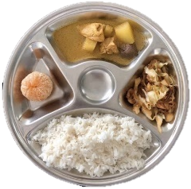 | White rice, cooked |  |  | 179.5 | 55.8 |  | 4.1 |  | 0.4 | 243.2
 | Mung bean glass noodle |  |  | 31.8 | 6.4 |  | 0.0 |  | 0.0 | 25.6
 | Chicken thigh, cooked |  |  | 32.5 | 0.0 |  | 6.4 |  | 2.7 | 49.9
 | Wax gourd |  |  | 26.1 | 0.7 |  | 0.1 |  | 0.0 | 3.2
 | Cabbage |  |  | 24.8 | 0.8 |  | 0.4 |  | 0.0 | 4.8
 | Tangerine |  |  | 48.2 | 3.9 |  | 0.4 |  | 0.1 | 18.1
 | Total |  |  | 342.9 | 67.6 |  | 11.4 |  | 3.2 | 344.8
One-dish meal: Chicken biryani and wax gourd soup, apple
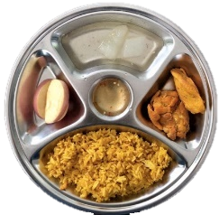 | Biryani rice |  |  | 171.8 | 53.4 |  | 3.9 |  | 0.4 | 232.8
 | Chicken thigh, cooked |  |  | 58.2 | 0.0 |  | 14.8 |  | 6.5 | 117.7
 | Wax gourd |  |  | 24.2 | 0.6 |  | 0.1 |  | 0.0 | 2.8
 | Apple |  |  | 36.0 | 4.4 |  | 0.1 |  | 0.0 | 18.0
 | Total |  |  | 297.7 | 58.4 |  | 18.9 |  | 6.9 | 371.3
One-dish meal: Chicken rice and wax gourd soup, longan
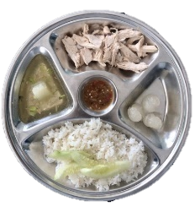 | Chicken-fat rice |  |  | 160.3 | 53.8 |  | 4.9 |  | 5.6 | 285.2
 | Chicken thigh, cooked |  |  | 46.2 | 0.0 |  | 13.2 |  | 4.0 | 88.8
 | Wax gourd |  |  | 13.5 | 0.4 |  | 0.1 |  | 0.0 | 2.0
 | Cucumber |  |  | 21.9 | 0.7 |  | 0.2 |  | 0.0 | 3.6
 | Longan |  |  | 22.6 | 3.6 |  | 0.3 |  | 0.0 | 15.6
 | Total |  |  | 264.5 | 58.5 |  | 18.7 |  | 9.6 | 395.2
†Mean of 10 portions served; ‡Calculated using data from Online Thai Food Composition Database 2015

