Supplementary Materials
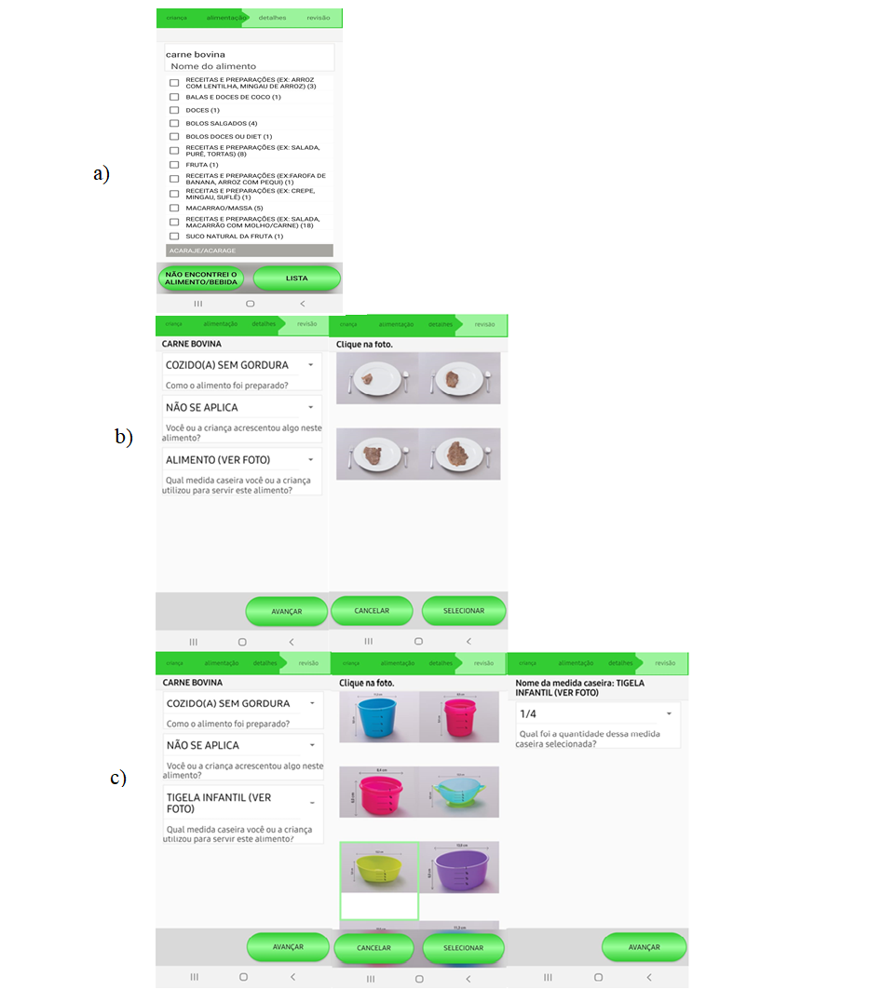 Supplementary Figure S1. Quantification of a steak in the CADE application. (a) selection of beef through the CADE app food list (b) Quantification using digital images of food portions; (c) quantification using digital images of household measurements. Digital photos from ⁽⁵¹⁾

