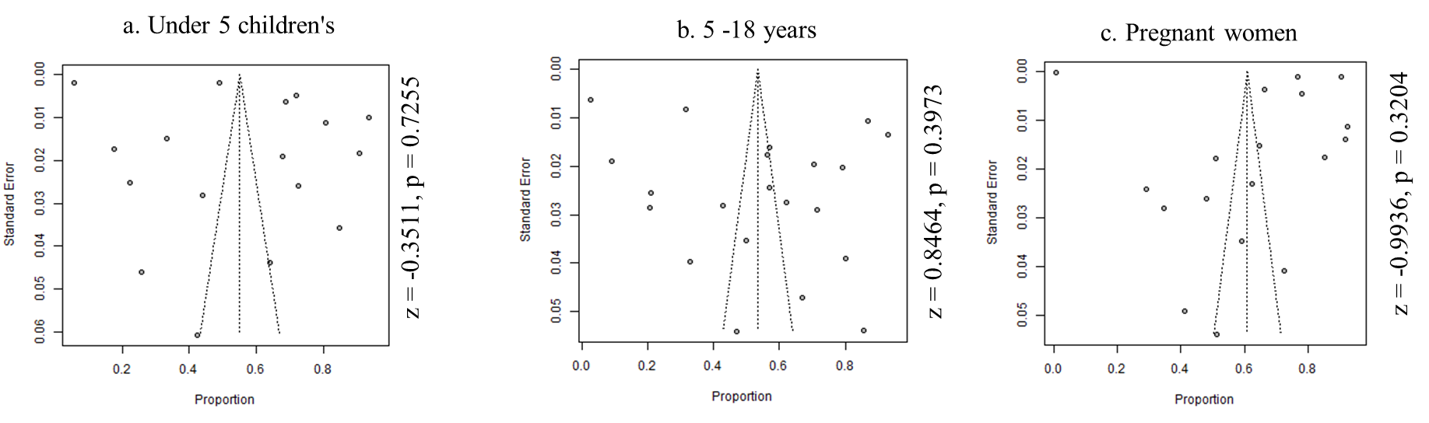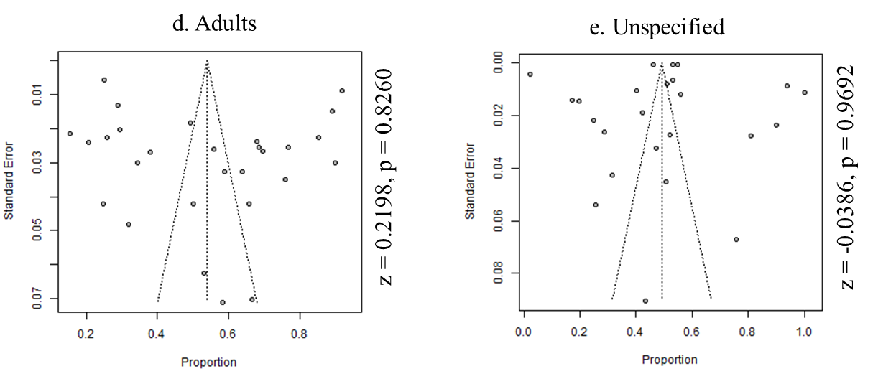
Supplementary Figure S1: Funnel plot of studies included in the Iron micronutrient deficiencies among different age groups (a) Under 5 children’s (b) 5-18 years (c) Pregnant women (d) Adults (e) Unspecified

