Supplemental table 1. Association between sociodemographic and behavioural characteristics and ultra-processed foods usual consumption (grams), stratified by age group (weighted for the distribution of the Portuguese population), using linear regression models.
 | Children  (3-9 years) |  | Adolescents  (10-17 years) |  | Younger adults  (18-44 years) |  | Older adults  (45-64 years) |  | Elderly  (65-84 years)
 | Crude model | Model 2 | Crude model | Model 2 | Crude model | Model 2 | Crude model | Model 2 | Crude model | Model 2
 | $\hat{β}$ (95% CI) | $\hat{β}$ (95% CI) | $\hat{β}$ (95% CI) | $\hat{β}$ (95% CI) | $\hat{β}$ (95% CI) | $\hat{β}$ (95% CI) | $\hat{β}$ (95% CI) | $\hat{β}$ (95% CI) | $\hat{β}$ (95% CI) | $\hat{β}$ (95% CI)
SEX
Female | Ref. | Ref. | Ref. | Ref. | Ref. | Ref. | Ref. | Ref. | Ref. | Ref.
Male | 25 (-32;81) | 36 (-17;88) | 118 (54;182) | 163 (101;225) | 120 (78;162) | 138 (92;183) | -22 (-54;10) | -13 (-45;19) | -3 (-43;37) | 4 (-35;43)
EDUCATION
≤ 6 years | 120 (5;236) | 111 (13;209) | 70 (-35;175) | 24 (-83;131) | -101 (-185;-17) | -117 (-197;-37) | -73 (-113;-33) | -75 (-115;-34) | -72 (-168;24) | -77 (-172;17)
7 to 12 years | 72 (15;130) | 59 (0;118) | 52 (-19;123) | 26 (-45;98) | 35 (-9;80) | 14 (-27;54) | -4 (-41;32) | -4 (-42;33) | -28 (-126;71) | -33 (-131;66)
> 12 years | Ref. | Ref. | Ref. | Ref. | Ref. | Ref. | Ref. | Ref. | Ref. | Ref.
REGION
North | Ref. | Ref. | Ref. | Ref. | Ref. | Ref. | Ref. | Ref. | Ref. | Ref.
Centre | 5 (-49;58) | 28 (-33;88) | -26 (-96;44) | -32 (-96;32) | -11 (-73;51) | -9 (-73;55) | 3 (-48;54) | 2 (-48;52) | 38 (0;75) | 38 (1;76)
Lisbon Metropolitan Area | 94 (16;171) | 128 (56;200) | 113 (10;217) | 107 (12;20358) | 41 (-27;109) | 41 (-26;108) | 64 (20;108) | 50 (6;94) | 56 (2;111) | 52 (1;103)
Alentejo | 50 (-69;169) | 38 (-84;160) | 88 (-13;190) | 58 (-47;163) | 40 (-24;105) | 57 (-8;122) | 25 (-17;67) | 30 (-13;72) | 44 (-10;99) | 46 (-11;104)
Algarve | 84 (-14;181) | 113 (19;207) | 6 (-111;124) | 12 (-82;105) | 7 (-56;70) | 21 (-47;88) | 58 (22;93) | 52 (19;85) | 13 (-18;44) | 17 (-16;50)
Autonomous Region of Madeira | -6 (-88;76) | -15 (-106;75) | -63 (-121;5) | -115 (-177;-53) | -27 (-74;20) | -38 (-87;11) | 26 (-3;55) | 27 (-3;57) | 18 (-20;56) | 18 (-22;58)
Autonomous Region of Azores | 92 (-31;214) | 60 (-39;91) | 16 (-69;101) | -30 (-121;61) | 77 (19;135) | 66 (-1;132) | 67 (9;124) | 68 (-11;125) | 82 (-5;169) | 72 (-11;156)
URBANIZATION LEVEL
Predominantly urban area | Ref. | Ref. | Ref. | Ref. | Ref. | Ref. | Ref. | Ref. | Ref. | Ref.
Medially urban area | -56 (-116;5) | -70 (-130;-9) | -50 (-115;16) | -53 (-124;18) | 21 (-31;73) | 14 (-39;67) | -32 (-88;23) | -16 (-69;38) | -1 (-54;51) | 7 (-43;58)
Predominantly rural area | -77 (-142;-11) | -74 (-162;14) | -39 (-129;50) | -54 (-126;18) | 4 (-90;97) | 7 (-94;109) | -27 (-114;59) | -14 (-97;70) | -15 (-58;28) | 3 (-39;46)
CIVIL STATUS
Single, divorced or widowed |  |  |  |  | Ref. | Ref. | Ref. | Ref. | Ref. | Ref.
Married, couples |  |  |  |  | -63 (-111;-16) | -40 (-86;6) | -19 (-64;26) | -19 (-64;26) | 1 (-37;38) | 7 (-28;42)
HOUSEHOLD MEMBERS
1 to 2 | Ref. | Ref. | Ref. | Ref. | Ref. | Ref. | Ref. | Ref. | Ref. | Ref.
3 to 4 | -67 (-261;127) | -89 (-269;90) | -42 (-199;116) | -21 (-148;106) | 31 (-18;79) | 27 (-22;76) | 2 (-33;38) | -8 (-43;26) | 0 (-60;60) | -9 (-61;44)
≥ 5 | 26 (-181;233) | -12 (-210;187) | 26 (-150;202) | -1 (-147;145) | -17 (-88;53) | -7 (-79;65) | -38 (-85;10) | -36 (-86;15) | -29 (-108;50) | -28 (-103;47)
FOOD INSECURITY
No |  |  |  |  | Ref. | Ref. | Ref. | Ref. | Ref. | Ref.
Yes |  |  |  |  | -27 (-93;38) | -9 (-71;52) | -45 (-87;-3) | -34 (-78;11) | -24 (-68;20) | -18 (-61;25)
PHYSICAL ACTIVITY LEVEL
Inactive |  |  |  |  | Ref. | Ref. | Ref. | Ref. | Ref. | Ref.
Minimally active |  |  |  |  | -44 (-92;4) | -35 (-77;7) | -6 (-51;38) | -4 (-49;40) | 5 (-33;43) | 5 (-36;46)
Active |  |  |  |  | 20 (-39;79) | 11 (-46;68) | -18 (-57;22) | -4 (-45;37) | 6 (-47;59) | 19 (-35;74)
SMOKING STATUS
Never smoked |  |  |  |  | Ref. | Ref. | Ref. | Ref. | Ref. | Ref.
Former smoker |  |  |  |  | 21 (-37;79) | 4 (-51;60) | 44 (14;73) | 53 (22;85) | 35 (-12;82) | 47 (6;87)
Current smoker |  |  |  |  | 48 (-3;99) | 28 (-26;81) | 37 (-10;84) | 40 (-6;86) | 27 (-34;88) | 28 (-31;86)
UPF: ultra-processed foods. Model 2. Adjusted for age group, education and non-UPF consumption.
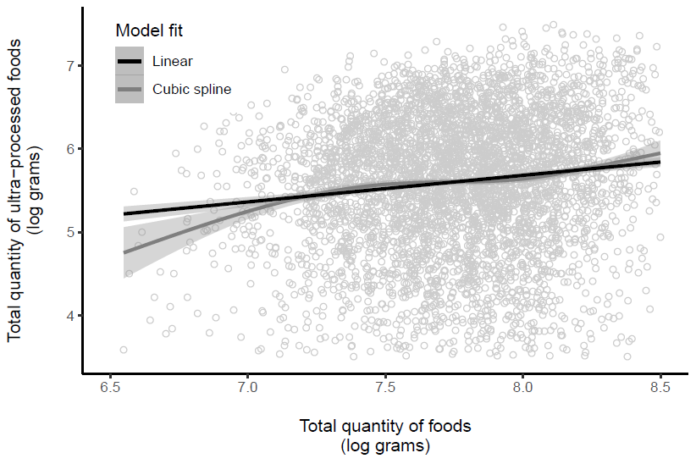
Supplemental figure 1. Association between total quantity of foods and total quantity of ultra-processed foods after logarithmic transformation, applying a linear and cubic spline fit.
This figure supports the decision to study absolute grams instead of their proportion of the total quantity consumed. When modeling the relationship between ultra-processed foods consumption and the total quantity consumed with a cubic spline, we capture the actual trend of the data which shows to be different from the linear relationship, in particular for the lowest and highest values.

