TITLE
Imbalanced Amino Acid Metabolism of Rainbow Trout Long-Term Fed a Plant-Based Diet as Revealed by ¹H-NMR Metabolomics

AUTHORS
Deborde C.^{1,2}, MadjiHounoum B.^{1,3}, Moing A.^{1,2}, Maucourt M.^{1,2}, Jacob D.^{1,2}, Corraze G.³, Médale F.³, Fauconneau B.³

ADDRESS
1 PMB-Metabolome, INRAE, 2018. Bordeaux Metabolome Facility, MetaboHUB, Centre INRAE de Nouvelle Aquitaine Bordeaux ; F-33140 Villenave d’Ornon, France doi: 10.15454/1.5572412770331912E12
2 INRAE, Univ. Bordeaux, UMR Fruit Biology and Pathology, Centre INRAE Nouvelle Aquitaine Bordeaux, F-33140 Villenave d'Ornon, France
3 INRAE, Univ. Pau Pays Adour, UMR Nutrition Metabolism Aquaculture, Centre INRAE Nouvelle Aquitaine Bordeaux, F-64310 Saint Pée-sur-Nivelle, France

CORRESPONDING AUTHOR
Benoit Fauconneau
Address: INRAE, Univ. Pau Pays Adour, UMR Nutrition Metabolism Aquaculture, Centre INRAE Nouvelle Aquitaine Bordeaux, F-64310 Saint Pée-sur-Nivelle, France

Supplemental material

Table S1: Detailed composition of vitamin and mineral premix (Vit-Min premix, INRAE UPAE, Jouy en Josas, France) used in the experimental diets. IU: vitamin activity in international unit.
Vitamins | (IU or mg.kg⁻¹ diet)
DL-α tocopherol acetate (Vitamin E) | 60 IU
Retinil acetate (Vitamin A) | 15,000 IU
DL-colecalcipherol (Vitamin B3) | 3,000 IU
Sodium menadione bisulphate | 5 mg
Thiamin (Vitamin B1) | 15 mg
Riboflavin (Vitamin B2) | 30 mg
Pyridoxine (Vitamin B6) | 15 mg
Vitamin B12 | 0.05 mg
Nicotinic acid (Vitamin B3) | 175 mg
Folic acid (Vitamin B9) | 500 mg
Inositol | 1,000 mg
Biotin (Vitamin B7) | 2.5 mg
Calcium pantothenate (vitamin B5) | 50 mg
Choline chloride | 2,000 mg
Minerals | (g or mg.kg⁻¹ diet)
Dibasic calcium phosphate (20% Ca, 18% P) | 5.00 g
Calcium carbonate (40% Ca) | 2.15 g
NaCl | 0.40 g
KCl | 0.90 g
Magnesium oxide (60% Mg) | 1.24 g
Ferric citrate | 0.20 g
Zinc sulphate (36% Zn) | 0.40 g
Manganese sulphate (33% Mn) | 0.30 g
Copper sulphate (25% Cu) | 0.30 g
Cobalt sulphate | 2.00 mg
Potassium iodide (75% I) | 0.40 mg
Sodium selenite (30% Se) | 3.00 mg

Table S2: Cumulative list of unknown resonances in the ¹H-NMR spectra of hydro-alcoholic extracts of the three diet pellets (s=singlet, d=doublet, dd=doublet of doublets. MSI status from Sumner et al. (2007)⁴⁰: 4: unknown compound) and their estimative contents (µg.g⁻¹ DM; 0=not detectable, mean (SD); n=12, ANOVA analysis significance of diet effect: *** P < 0.001 ** P < 0.01 * P < 0.05.

Unknowns | Resonances used for quantification  (Chemical shift in ppm) and multiplicity | MSI status | Diet  (Content in µg.g⁻¹ DM) |  |  | ANOVA
 |  |  | Marine  (M) | Commercial (C) | Plant-based (P) | Diet Effect
UnkS8.638 | 8.64 (s) | 4 | 0 | 0 | 7 (1) ª | ***
UnkD8.59 | 8.59 (d) | 4 | 116 (10) ª | 78 (8) ^{b} | 0 | ***
UnkS8.489 | 8.49 (s) | 4 | 0 | 0 | 12 (2) ª | ***
UnkS8.43 | 8.43 (s) | 4 | 0 | 0 | 8 (1) ª | ***
UnkS8.38 | 8.38 (s) | 4 | 6 (1) ª | 4 (1) ^{b} | 3 (1) ^{c} | ***
UnkS8.35 | 8.35 (s) | 4 | 20 (1) ª | 19 (1) ª | 11 (1) ^{b} | ***
UnkS8.27 | 8.27 (s) | 4 | 50 (3) ª | 46 (3) ^{b} | 0 | ***
UnkS8.26 | 8.26 (s) | 4 | 38 (2) ª | 40 (3) ª | 25 (2) ^{b} | ***
UnkS7.876 | 7.88 (s) | 4 | 51 (3) ª | 53 (4) ª | 0 | ***
UnkS7.86 | 7.86 (s) | 4 | 16 (2)^{c} | 25 (3) ª | 21 (2) ^{b} | ***
UnkM7.959 | 7.96 (m) | 4 | 0 | 0 | 28 (4)ª | ***
UnkS7.76 | 7.76 (s) | 4 | 59 (3) ª | 51 (3) ^{b} | 0 | ***
UnkD7.68 | 7.68 (d) | 4 | 0 | 105 (12) | 193 (9)^{c} | ***
UnkD7.15 | 7.15 (d) | 4 | 0 | 49 (5) ª | 42 (5) ^{b} | ***
UnkS6.91 | 6.91 (s) | 4 | 16 (1) ª | 9 (1) ^{b} | 10 (1)^{b} | ***
UnkD6.48 | 6.48 (d) | 4 | 0 | 199 (20)^{b} | 381 (22)ª | ***
UnkDD6.15 | 6.15 (dd) | 4 | 137 (4) ª | 98 (7) ^{b} | 0 | ***
UnkS5.94 | 5.94 (s) | 4 | 16 (2) ª | 11 (1) ^{b} | 9 (3)^{b} | ***
UnkS5.93 | 5.93 (s) | 4 | 12 (2) ª | 7 (2) ^{b} | 5 (2)^{c} | ***
UnkS5.928 | 5.93 (s) | 4 | 15 (2)^{b} | 19 (2) ª | 14 (3) ^{b} | ***
UnkS5.92 | 5.92 (s) | 4 | 27 (3)^{b} | 31 (2) ª | 21 (2) ^{c} | ***
UnkS5.913 | 5.91 (s) | 4 | 15 (2)^{b} | 20 (1) ª | 14 (2) ^{b} | ***
UnkS5.906 | 5.905 (s) | 4 | 18 (3) ª | 15 (2) ^{b} | 9 (2)^{c} | ***
UnkS5.89 | 5.89 (s) | 4 | 14 (3)^{b} | 19 (2) ª | 14 (2) ^{b} | ***
UnkD5.2 | 5.2 (d) | 4 | 0 | 0 | 286 (43) ª | ***
UnkD5.17 | 5.17 (d) | 4 | 0 | 0 | 256 (14) ª | ***
UnkS3.23 | 3.23 (s) | 4 | 2901 (98) ª | 1910 (63) ^{b} | 669 (35) ^{c} | ***
UnkS3.04 | 3.04 (s) | 4 | 8319 (181) ª | 4887 (107) ^{b} | 0 | ***
UnkS2.825 | 2.82 (s) | 4 | 162 (7) ª | 87 (5) ^{b} | 0 | ***
UnkS2.857 | 2.86 (s) | 4 | 371 (18) ^{b} | 271 (11) ^{c} | 1166 (81) ª | ***
UnkS2.742 | 2.74 (s) | 4 | 80 (3) ª | 47 (2) ^{b} | 0 | ***

Table S3: List of compounds detected in the ¹H-NMR spectra of the plasma of rainbow trout. MSI status from Sumner et al. (2007): 1: identified compound; 2: putatively annotated compound; 3: putatively characterized compound classes; 4: unknown compound
Compound | Chemical shift (ppm) | MSI status
Amino acids
alanine | 1.48; 1.49; 3.78; 3.79; 3.80 | 1
glutamine | 2.11; 2.16; 2.43; 2.44; 2.45; 2.46; 2.47; 2.48; 3.76; 3.77 | 1
glycine | 3.56 | 1
histidine | 7.05; 7.76 | 2
isoleucine | 0.94; 0.96; 1.00; 1.02 | 1
leucine | 0.95; 0.97; 0.98; 1.67; 1.68; 1.73; 1.75 | 1
lysine | 1.71; 1.73; 1.75; 1.77; 1.90; 1.92; 3.01; 3.03 | 1
methionine | 2.11; 2.14; 2.17; 2.63; 2.65; 2.66 | 1
phenylalanine | 3.17; 4.01; 7.33; 7.34; 7.38; 7.39; 7.42; 7.43; 7.45 | 1
tyrosine | 6.89; 6.9; 7.19; 7.20 | 1
valine | 0.99 ; 1.00 ; 1.04; 1.05; 2.25; 2.27; 2.28; 2.29; 2.30; 3.60 ; 3.62 | 1
creatine | 3.04 | 2
phospho-creatine | 3.05 | 2
taurine | 3.17; 3.19 | 2
Carbohydrates/cyclitol
α-glucose / β-glucose  inositol | 3.25; 2.37; 3.39; 3.40; 3.42; 3.43; 3.44; 3.45; 3.46; 3.47; 3.48; 3.49; 3.50; 3.51; 3.53; 3.55; 3.70; 3.71; 3.72; 3.73; 3.74; 3.76; 3.78; 3.79; 3.82; 3.84; 3.86; 3.89; 3.90; 3.91; 3.92; 4.64; 4.66; 5.23; 5.24  3.28; 3.30; 3.53; 3.53; 3.55; 3.55; 3.61; 3.63; 3.65; 4.06; 4.07; 4.07; | 1  1
Lipids
unsaturated lipids + glyceryl  -CH=CH-CH₂-CH=CH-  CO-CH₂-CH(CO)-CH₂-CO  unsaturated lipids  -CH=CH-CH₂-CH=CH-  glyceryl  CO-CH₂-CH(CO)-CH₂-CO  lipids  CH₂-CH₂-CO-  lipoproteins  VLDL/LDL (CH₂)n  VLDL/LDL -CH₃  HDL -CH₃  cholesterol | 5.30; 5.31; 5.32; 5.33; 5.34  2.74; 2.78; 2.83  4.32  1.52; 1.58  1.24; 1.28  0.92  0.85  0.66 | 3  3  3  3  3  3  3  3
Nucleotides/Nucleosides  adenosine-XP like  inosine | 6.10; 6.11; 8.23; 8.34  5.91; 5.92 | 3  3
Organic acid  lactic acid | 1.33; 1.34; 4.10; 4.11; 4.13; 4.14 | 1
Vitamins
pterin | 8.55; 8.72 | 2
betaine | 3. 27; 3.90 | 2
choline | 3.21; 4.05; 4.08 | 2
Others  acetyl glycoprotein  ethanol | 2.02  1.17; 1.19; 1.20; 3.66; 3.67 | 3  1
DMA dimethylamine | 2.73 | 3
TMAO | 3.21 | 3
TMA trimethylamine | 3.26 | 3

Sumner LW., Amberg A., Barrett D., et al. (2007) Proposed minimum reporting standards for chemical analysis Chemical Analysis Working Group (CAWG) Metabolomics Standards Initiative (MSI). Metabolomics. 3:211-221.

Table S4: Effect of diet (marine M, commercial C and plant-based P) and time after feeding (6h vs 48h) on semi-quantitative assessment of representative spectral regions or bucket of the ¹H-NMR spectra of plasma in rainbow trout. Mean +/-std MANOVA analysis *** P < 0.001 ** P < 0.01 * P < 0.05 (6h or 48h diet effect only significant at 6 or 48h ; ↑ ↓ data significantly higher or lower at 48h than at 6h ; Int significant interaction between diet and time effect). B1_68 means bucket centred at 1.68 ppm. unk : resonance(s) from unknown metabolite(s). See Table S2 for MSI status of resonance annotation.

 |  | 6h post-feeding |  |  |  |  |  | 48h post-feeding |  |  |  |  |  | Effect
 |  | Marine |  | Commercial |  | Plant-Based |  | Marine |  | Commercial |  | Plant-Based |  | Diet | Time
Bucket | Metabolite resonance annotation | mean | std | mean | std | mean | std | mean | Std | mean | std | mean | std
Marine Diet > Plant Diet
B1_753 | unk + leucine +lysine¹ | 33.9 | 5.5 | 30.1 | 3.3 | 15.5 | 3.3 | 29.6 | 5.2 | 29.1 | 4.3 | 13.9 | 3.1 | *** | *** ↓
B2_392 | unk | 1.78 | 0.45 | 1.69 | 0.57 | 0.79 | 0.26 | 0.25 | 0.08 | 0.22 | 0.07 | 0.20 | 0.06 | *** 6h | *** ↓
B2_444 | glutamine | 0.97 | 0.31 | 1.52 | 0.29 | 1.55 | 0.43 | 1.80 | 0.19 | 2.32 | 0.49 | 1.39 | 0.33 | ***48h | *** ↑
B2_452 | glutamine | 1.11 | 0.33 | 1.65 | 0.28 | 1.65 | 0.44 | 1.72 | 0.20 | 2.27 | 0.46 | 1.40 | 0.34 | ***48h | *** ↑
B2_732 | dimethylamine | 1.78 | 0.57 | 0.78 | 0.34 | 0.00 | 0.02 | 0.12 | 0.06 | 0.17 | 0.07 | 0.06 | 0.03 | *** 6h | *** ↓
B2_757 | unk | 4.19 | 1.35 | 2.43 | 0.97 | 2.06 | 0.68 | 0.25 | 0.11 | 0.31 | 0.26 | 0.31 | 0.20 | *** 6h | *** ↓
B2_903 | unk | 2.75 | 1.56 | 1.18 | 0.32 | 0.40 | 0.19 | 0.38 | 0.17 | 0.33 | 0.06 | 0.21 | 0.09 | *** | *** ↓
B3_044 | creatine + phosphocreatine | 29.65 | 6.50 | 15.72 | 2.80 | 10.71 | 1.81 | 10.97 | 2.50 | 11.13 | 1.94 | 12.42 | 2.41 | *** 6h | *** ↓
B3_119 | unk | 2.53 | 0.48 | 1.83 | 0.29 | 1.61 | 0.21 | 3.65 | 0.68 | 3.54 | 0.44 | 3.57 | 0.59 | *** 6h | *** ↑
B3_130 | unk | 2.15 | 0.65 | 1.58 | 0.35 | 1.39 | 0.33 | 1.10 | 0.24 | 1.17 | 0.12 | 1.12 | 0.17 | *** 6h | *** ↓
B3_199 | unk | 6.10 | 1.64 | 5.24 | 0.89 | 3.82 | 0.95 | 18.43 | 3.23 | 19.77 | 2.16 | 17.04 | 2.30 | *** | *** ↑
B3_270 | unk +TMAO + betaine + inositol + glucose | 270.2 | 51.7 | 138.1 | 24.8 | 95.6 | 24.2 | 168.4 | 30.6 | 113.7 | 16.8 | 81.8 | 15.0 | *** | *** ↓
B3_483 | unk | 6.91 | 1.92 | 7.67 | 1.11 | 7.54 | 1.08 | 8.27 | 0.93 | 7.38 | 0.74 | 6.99 | 0.52 | ***48h
B3_488 | unk | 6.17 | 1.78 | 6.86 | 1.01 | 6.86 | 0.90 | 7.59 | 0.78 | 6.77 | 0.69 | 6.50 | 0.42 | ***48h
B3_562 | unk | 29.2 | 3.6 | 27.0 | 4.7 | 21.7 | 4.2 | 32.3 | 8.6 | 31.3 | 7.2 | 29.2 | 7.0 | *** | *** ↑
B3_936 | unk | 11.95 | 3.11 | 7.27 | 1.68 | 5.45 | 1.09 | 8.80 | 1.49 | 9.47 | 1.23 | 9.77 | 1.72 | *** 6h | Int.
B4_066 | unk | 6.86 | 2.16 | 4.32 | 0.86 | 3.95 | 0.75 | 2.47 | 0.34 | 3.72 | 0.76 | 4.16 | 0.72 | *** 6h | Int.
B5_186 | unk | 20.7 | 4.9 | 22.1 | 3.1 | 20.4 | 2.4 | 32.7 | 3.8 | 31.1 | 3.7 | 25.4 | 2.2 | ***48h | *** ↑
B5_248 | unk | 19.9 | 6.3 | 19.9 | 2.7 | 17.6 | 2.4 | 32.7 | 3.4 | 31.1 | 3.5 | 24.7 | 2.2 | *** | *** ↑
Plant diet > Marine diet
B0_9765 | leucine + isoleucine + unk | 19.10 | 10.7 | 19.54 | 10.7 | 28.64 | 11.1 | 1.60 | 1.02 | 1.86 | 0.62 | 3.95 | 1.50 | ***48h | ***↓
B0_978 | leucine | 5.04 | 2.77 | 6.94 | 4.14 | 9.77 | 3.93 | 3.19 | 2.08 | 5.11 | 1.35 | 7.81 | 1.73 | *** | ***↓
B0_987 | valine | 7.62 | 2.49 | 7.09 | 1.64 | 8.29 | 2.37 | 1.21 | 0.79 | 1.85 | 0.62 | 2.91 | 0.73 | ***48h | ***↓
B0_998 | valine | 7.14 | 2.62 | 7.02 | 1.75 | 8.57 | 2.39 | 10.00 | 2.03 | 12.64 | 2.32 | 14.83 | 2.55 | ***48h | *** ↑
B1_008 | isoleucine | 3.03 | 1.45 | 3.53 | 0.93 | 4.58 | 1.24 | 8.00 | 1.95 | 10.06 | 1.95 | 12.07 | 2.28 | *** | *** ↑
B1_021 | isoleucine | 2.93 | 1.19 | 3.06 | 0.86 | 4.04 | 1.21 | 3.81 | 0.97 | 4.81 | 0.85 | 5.82 | 1.21 | *** | *** ↑
B1_036 | valine | 9.39 | 3.68 | 8.27 | 1.82 | 8.68 | 2.41 | 4.29 | 1.06 | 5.26 | 0.83 | 6.17 | 1.24 | ***48h | *** ↑
B1_051 | valine | 9.16 | 3.58 | 8.01 | 1.68 | 8.58 | 2.48 | 8.74 | 1.81 | 11.00 | 1.94 | 12.22 | 2.21 | ***48h | *** ↑
B1_061 | unk | 0.62 | 0.45 | 0.60 | 0.26 | 0.41 | 0.11 | 8.29 | 1.79 | 10.42 | 1.86 | 11.83 | 2.12 | ***48h | *** ↑
B1_447 | lysine + unk | 1.03 | 0.17 | 1.22 | 0.19 | 1.43 | 0.27 | 1.23 | 0.38 | 1.11 | 0.25 | 1.62 | 0.23 | ***6h | NS
B1_459 | lysine + ¹³C lactic acid + unk | 0.21 | 0.10 | 0.25 | 0.11 | 0.59 | 0.15 | 0.55 | 0.17 | 0.51 | 0.15 | 0.66 | 0.14 | ***6h | *** ↑
B1_465 | unk | 0.84 | 0.26 | 1.08 | 0.24 | 1.55 | 0.22 | 1.45 | 0.25 | 1.38 | 0.19 | 1.52 | 0.20 | ***6h | Int.
B1_681 | lysine + leucine | 1.17 | 0.25 | 1.88 | 0.40 | 2.98 | 0.70 | 1.28 | 0.45 | 1.48 | 0.49 | 2.26 | 0.46 | *** | *** ↑
B1_694 | lysine + leucine | 0.27 | 0.27 | 0.79 | 0.24 | 1.57 | 0.35 | 0.66 | 0.31 | 0.75 | 0.25 | 1.25 | 0.29 | *** | *** ↑
B1_702 | lysine + leucine | 0.95 | 0.66 | 1.97 | 0.38 | 3.35 | 0.79 | 1.22 | 0.50 | 1.47 | 0.43 | 2.25 | 0.49 | *** | *** ↑
B1_694 | lysine + leucine | 2.47 | 1.18 | 3.78 | 0.60 | 5.78 | 1.35 | 2.76 | 1.04 | 3.24 | 0.86 | 4.65 | 1.19 | *** | *** ↑
B1_914 | lysine | 0.72 | 0.23 | 0.53 | 0.16 | 0.78 | 0.23 | 0.42 | 0.21 | 0.44 | 0.14 | 0.73 | 0.20 | ***48h | NS
B2_358 | unk | 1.48 | 0.34 | 1.48 | 0.38 | 1.53 | 0.26 | 2.43 | 0.66 | 2.75 | 0.69 | 3.46 | 0.73 | ***48h | *** ↑
B2_375 | unk | 2.15 | 0.41 | 2.61 | 0.41 | 3.02 | 0.49 | 1.93 | 0.87 | 1.98 | 0.51 | 2.87 | 0.52 | *** | Int.
B2_436 | glutamine | 0.97 | 0.31 | 1.52 | 0.29 | 1.55 | 0.43 | 1.80 | 0.19 | 2.32 | 0.49 | 1.39 | 0.33 | ***6h | Int.
B2_444 | glutamine | 1.11 | 0.33 | 1.65 | 0.28 | 1.65 | 0.44 | 1.72 | 0.20 | 2.27 | 0.46 | 1.40 | 0.34 | ***6h | Int.
B2_421 | glutamine | 1.84 | 0.57 | 2.88 | 0.51 | 2.80 | 0.75 | 2.41 | 0.34 | 3.33 | 0.68 | 1.99 | 0.53 | ***6h | Int.
B2_460 | glutamine | 2.06 | 0.61 | 3.09 | 0.53 | 2.97 | 0.78 | 2.54 | 0.35 | 3.48 | 0.75 | 2.13 | 0.57 | ***6h | Int.
B2_468 | glutamine | 0.73 | 0.22 | 1.23 | 0.23 | 1.20 | 0.27 | 1.11 | 0.19 | 1.54 | 0.31 | 0.97 | 0.26 | ***6h | Int.
B2_479 | glutamine | 1.00 | 0.25 | 1.61 | 0.29 | 1.79 | 0.38 | 1.47 | 0.26 | 1.98 | 0.37 | 1.39 | 0.36 | ***6h | Int.
B2_549 | unk | 0.79 | 0.18 | 0.96 | 0.21 | 1.11 | 0.37 | 1.02 | 0.15 | 1.36 | 0.29 | 1.49 | 0.25 | *** | *** ↑
B3_011 | unk | 4.51 | 1.03 | 4.21 | 0.53 | 4.52 | 0.71 | 3.49 | 0.84 | 3.94 | 0.49 | 4.81 | 0.71 | ***48h | Int.
B3_028 | unk | 5.62 | 1.35 | 4.54 | 0.49 | 5.11 | 0.83 | 3.70 | 1.10 | 4.10 | 0.63 | 5.46 | 1.09 | ***48h | Int.
B3_060 | unk | 2.91 | 0.61 | 2.79 | 0.40 | 2.74 | 0.46 | 2.17 | 0.48 | 2.40 | 0.34 | 2.90 | 0.46 | ***48h | Int.
B3_286 | inositol | 7.85 | 2.45 | 10.00 | 1.81 | 10.44 | 1.60 | 6.47 | 0.96 | 8.38 | 1.67 | 7.52 | 1.13 | *** | ***↓
B3_307 | inositol | 6.63 | 2.36 | 8.21 | 1.42 | 8.53 | 1.21 | 5.23 | 0.87 | 6.46 | 1.46 | 5.87 | 0.80 | ** | ***↓
B3_534 | glucose | 12.42 | 2.95 | 14.92 | 1.82 | 16.40 | 1.41 | 13.84 | 1.16 | 13.92 | 1.24 | 14.23 | 1.06 | ***6h | Int
B3_598 | unk | 2.83 | 0.55 | 4.79 | 0.59 | 4.02 | 0.63 | 2.66 | 0.49 | 5.08 | 0.95 | 3.86 | 0.55 | *** | NS
B3_607 | valine + inositol | 8.51 | 1.69 | 10.80 | 1.62 | 13.38 | 2.27 | 6.06 | 0.93 | 9.40 | 1.63 | 10.60 | 1.76 | *** | ***↓
B3_618 | unk | 5.93 | 0.55 | 6.66 | 0.70 | 6.80 | 1.12 | 4.88 | 0.64 | 6.47 | 0.96 | 6.52 | 0.99 | *** | ***↓
B3_628 | inositol | 6.96 | 1.09 | 10.90 | 2.15 | 14.51 | 2.64 | 5.30 | 0.85 | 9.09 | 1.93 | 10.48 | 2.21 | *** | ***↓
B3_652 | ethanol + inositol | 39.8 | 10.3 | 51.6 | 7.1 | 48.1 | 8.4 | 36.8 | 8.3 | 43.2 | 8.4 | 42.6 | 9.5 | ***6h | ***↓
B3_676 | ethanol | 8.62 | 0.91 | 9.69 | 0.96 | 8.95 | 1.23 | 7.15 | 0.56 | 8.94 | 1.04 | 8.17 | 0.76 | *6h | *↓
B3_763 | glucose + alanine + glutamine | 9.94 | 1.68 | 12.21 | 1.57 | 12.20 | 1.26 | 16.77 | 1.09 | 18.28 | 1.32 | 17.35 | 1.13 | ***6h | ***↑
B3_796 | alanine | 3.41 | 0.43 | 3.35 | 0.39 | 3.42 | 0.33 | 6.19 | 0.37 | 6.76 | 0.58 | 6.92 | 0.34 | ***48h | ***↑
B3_808 | alanine | 0.30 | 0.14 | 0.32 | 0.06 | 0.26 | 0.07 | 1.46 | 0.10 | 1.89 | 0.20 | 1.81 | 0.14 | ***48h | ***↑
B4_034 | unk | 0.24 | 0.10 | 0.80 | 0.24 | 0.58 | 0.14 | 1.48 | 0.25 | 3.06 | 0.56 | 2.27 | 0.50 | *** | *** ↑
B4_028 | unk | 0.14 | 0.11 | 0.65 | 0.22 | 0.50 | 0.13 | 0.90 | 0.18 | 1.82 | 0.39 | 1.56 | 0.37 | *** | *** ↑
B4_060 | inositol | 6.86 | 2.16 | 4.32 | 0.86 | 3.95 | 0.75 | 2.47 | 0.34 | 3.72 | 0.76 | 4.16 | 0.72 | ***48h | Int.
B4_068 | inositol | 2.92 | 0.96 | 4.24 | 1.08 | 5.97 | 1.25 | 2.42 | 0.40 | 4.24 | 1.03 | 5.01 | 1.02 | *** | NS
B4_076 | inositol | 1.72 | 0.67 | 2.51 | 0.61 | 3.29 | 0.65 | 1.84 | 0.29 | 3.03 | 0.69 | 3.34 | 0.61 | *** | NS
B4_147 | lactic acid | 5.37 | 1.77 | 6.22 | 1.00 | 6.94 | 0.73 | 4.50 | 0.85 | 5.41 | 1.02 | 5.16 | 1.27 | ***6h | ***↓
B6_906 | tyrosine | 2.45 | 0.60 | 3.68 | 0.70 | 4.11 | 0.82 | 0.96 | 0.34 | 1.33 | 0.27 | 1.43 | 0.37 | *** | ***↓
B6_888 | tyrosine | 2.12 | 0.62 | 2.78 | 0.66 | 3.33 | 0.78 | 0.97 | 0.32 | 1.22 | 0.38 | 1.27 | 0.31 | *** | ***↓
B7_207 | tyrosine | 2.00 | 0.63 | 2.58 | 0.58 | 3.11 | 0.74 | 1.41 | 0.43 | 1.63 | 0.52 | 1.86 | 0.41 | *** | ***↓
B7_766 | unk | 1.93 | 0.51 | 2.34 | 0.38 | 2.71 | 0.34 | 1.81 | 0.65 | 1.99 | 0.56 | 2.37 | 0.70 | ***6h | NS
B8_549 | pterin | 0.16 | 0.13 | 0.07 | 0.12 | 0.53 | 0.15 | 0.00 | 0.00 | 0.00 | 0.00 | 0.16 | 0.13 | *** | ***↓
B8_721 | pterin | 0.08 | 0.15 | 0.11 | 0.19 | 0.60 | 0.14 | 0.02 | 0.07 | 0.01 | 0.04 | 0.22 | 0.15 | *** | ***↓

¹ Unk + leucine + lysine in C and M diets; leucine + lysine in P diet

Table S5: List of compounds detected in the ¹H-NMR spectra of the liver or/and muscle of rainbow trout. MSI status from Sumner et al. (2007): 1: identified compound; 2: putatively annotated compound; 3: putatively characterized compound classes; 4: unknown compound

Compound | Chemical shift (ppm) | MSI status
Amino acids
alanine | 1.48; 1.50; 3.79; 3.80; 3.82 | 1
asparagine | 2.86; 2.88; 2.89; 2.91; 2.95; 2.98; 2.99; 4.05 | 1
aspartic acid | 2.79; 2.80; 2.83; 2.84 | 2
beta-alanine | 2.56; 2.57; 2.58; 3.18; 3.19; 3.20 | 1
glutamic acid | 2.04; 2.05; 2.07; 2.08; 2.10; 2.11; 2.12; 2.13; 2.32; 2.34; 2.34; 2.35; 2.36; 2.37; 2.37; 2.39 | 1
glutamine | 2.13; 2.16; 2.17; 2.18; 2.44; 2.46; 2.47; 2.47; 2.48; 2.49 | 1
glycine | 3.57 | 2
histidine | 3.14; 3.15; 3.17; 3.18; 3.99; 4.00; 4.01; 4.02; 7.11; 7.9 | 1
isoleucine | 0.93; 0.94; 0.96; 1.00; 1.02 | 1
leucine | 0.96; 0.97; 0.98; 1.67; 1.69; 1.77; 2.25; 2.27; 2.27; 2.28; 2.29; 2.29; 2.30 | 1
lysine | 1.71; 1.72; 1.74; 1.75; 1.77; 1.89; 1.90; 1.91; 1.94; 1.95; 3.01; 3.02 | 1
methionine | 2.15; 2.64; 2.66; 2.67 | 1
phenylalanine | 7.33; 7.34; 7.37; 7.38; 7.39; 7.40; 7.42; 7.43; 7.44; 7.45; 7.46 | 1
threonine | 1.33; 1.35; | 2
tryptophan | 7.28; 7.29; 7.33; 7.73; 7.75 | 2
tyrosine | 6.90; 6.92; 7.20; 7.21 | 1
valine | 0.99; 1.00 ; 1.04; 1.06; 2.25; 2.30 | 1
anserine | 2.65; 2.66; 2.68; 2.68; 2.70; 2.70; 2.71; 2.72; 2.73; 2.75; 2.76; 3.03; 3.07; 3.08; 3.22; 3.23; 3.24; 3.25; 3.26; 3.79; 4.48; 4.49; 4.50; 4.50; 7.10; 8.25 | 1
taurine | 3.26; 3.29; 3.43; 3.44; 3.45 | 1
creatine | 3.05; 3.94 | 2
Carbohydrates
α-glucose / β-glucose | 3.25; 3.26; 3.26; 3.28; 3.40; 3.41; 3.42; 3.43; 3.44; 3.47; 3.48; 3.49; 3.49; 3.50; 3.51; 3.51; 3.52; 3.53; 3.54; 3.55; 3.56; 3.57; 3.70; 3.71; 3.73; 3.74; 3.75; 3.76; 3.78; 3.79; 3.83; 3.83; 3.84; 3.85; 3.85; 3.86; 3.87; 3.89; 3.90; 3.91; 3.92; 4.65; 4.67; 5.25; 5.26 | 1
mannose | 3.66; 3.67; 3.69; 3.88; 3.95; 3.95; 3.96; 4.93; 4.93; 5.20; 5.20 | 1
Nucleotides/Nucleosides  inosine  uracile  uridine | 4.28; 4.28; 4.29; 4.29; 4.29; 4.30; 4.40; 4.45; 4.45; 4.46; 4.77; 4.78; 4.79; 6.10; 6.11; 8.25; 8.36  5.81; 5.83; 7.55; 7.57  4.17; 4.24; 4.25; 4.26; 4.37; 4.38; 4.39; 5.92; 5.93; 5.93; 5.94; 7.87; 7.88 | 2  2  2
Organic acids  acetic acid  formic acid | 1.92  8.46 | 3  2
lactic acid | 1.33; 1.34; 4.10; 4.12; 4.13; 4.14 | 1
Vitamin precursors
betaine | 3. 28; 3.91 | 1
choline | 3.22; 4.06; 4.07; 4.07; 4.08; 4.09;4.09 | 1
niacinamide | 7.60; 7.60; 7.61; 7.62; 7.62; 7.63; 7.63; 8.72; 8.72; 8.73; 8.73; 8.95; 8.95 | 1
Others  ethanol  putrescine | 1.17; 1.19; 1.20;  1.76; 1.77; 1.78; 1.79; 1.80; 3.06; 3.07; 3.08 | 2  2

Table S6: Effect of diet (marine M, commercial C and plant-based P) on semi-quantitative assessment of representative spectral regions or bucket of the ¹H-NMR spectra of hydro-alcoholic extract of liver in rainbow trout. Mean +/-std ANOVA analysis *** P< 0.001 ** P < 0.01 * P<0.05. B8_27 means bucket centred at 8.27 ppm. unk : resonance(s) from unknown metabolite(s). See Table S4 for MSI status of resonance annotation. unkS: singlet resonance of unknown metabolite; unkD: doublet of resonances of unknown metabolite; unkT: triplet of resonances of unknown metabolite; b: broad signal.

Bucket | Metabolite resonance annotation | Plant-Based diet |  | Commercial diet |  | Marine diet |  | Diet Effect .
 |  | mean | std | mean | std | mean | std
Marine Diet > Plant Diet
B8_267 | niacinamide | 0.050 | 0.029 | 0.068 | 0.010 | 0.092 | 0.022 | **
B8_223 | unkD8.22 | 0.013 | 0.013 | 0.043 | 0.012 | 0.032 | 0.008 | ***
B8_212 | unkS8.21 | 0.006 | 0.006 | 0.011 | 0.003 | 0.017 | 0.007 | ***
B8_202 | unkD8.22 | 0.011 | 0.012 | 0.040 | 0.011 | 0.031 | 0.009 | ***
B6_158 | unkD6.16 | 0.000 | 0.000 | 0.002 | 0.006 | 0.014 | 0.011 | ***
B6_093 | unk | 0.028 | 0.003 | 0.024 | 0.009 | 0.038 | 0.008 | ***
B6_080 | unkD6.088 | 0.020 | 0.005 | 0.017 | 0.009 | 0.034 | 0.009 | ***
B4_312 | Unk + Uridine | 0.031 | 0.009 | 0.040 | 0.009 | 0.058 | 0.018 | ***
B3_911 | unk | 1.100 | 0.111 | 1.365 | 0.081 | 1.300 | 0.122 | *
B3_844 | unk | 0.293 | 0.030 | 0.435 | 0.039 | 0.375 | 0.061 | ***
B3_787 | unk | 1.495 | 0.143 | 1.823 | 0.105 | 1.779 | 0.256 | **
B3_774 | glucose + mannose | 0.642 | 0.060 | 0.910 | 0.088 | 0.965 | 0.094 | ***
B3_587 | unk + mannose + threonine | 0.075 | 0.070 | 0.289 | 0.123 | 0.312 | 0.081 | ***
B3_432 | unk | 1.355 | 0.097 | 1.763 | 0.082 | 1.528 | 0.125 | **
B2_952 | unkS2.95 | 0.001 | 0.002 | 0.003 | 0.002 | 0.007 | 0.002 | ***
B2_912 | unkS2.91 | 0.013 | 0.006 | 0.057 | 0.020 | 0.135 | 0.079 | ***
B2_750 | unkS2.75 | 0.016 | 0.003 | 0.022 | 0.011 | 0.057 | 0.024 | ***
B2_737 | unkS2.73 | 0.023 | 0.012 | 0.092 | 0.035 | 0.202 | 0.114 | ***
B2_487 | glutamine | 0.055 | 0.018 | 0.099 | 0.021 | 0.088 | 0.027 | ***
B2_478 | glutamine | 0.036 | 0.012 | 0.068 | 0.014 | 0.058 | 0.017 | ***
B2_461 | unk | 0.090 | 0.031 | 0.174 | 0.038 | 0.151 | 0.045 | ***
B2_453 | unk | 0.052 | 0.017 | 0.100 | 0.020 | 0.083 | 0.025 | ***
B2_445 | glutamine | 0.055 | 0.018 | 0.111 | 0.022 | 0.097 | 0.027 | ***
B1_322 | unk | 1.248 | 0.292 | 1.142 | 0.289 | 1.700 | 0.378 | **
Plant diet > Marine diet
B8_940 | niacinamide | 0.07 | 0.01 | 0.07 | 0.01 | 0.06 | 0.01 | **
B8_46 | formic acid | 0.10 | 0.01 | 0.05 | 0.01 | 0.04 | 0.01 | ***
B8_392 | unkS8.39 | 0.01 | 0.00 | 0.01 | 0.00 | 0.01 | 0.00 | ***
B8_361 | inosine | 0.71 | 0.10 | 0.64 | 0.08 | 0.52 | 0.11 | ***
B7_791 | unkD7.79 | 0.03 | 0.01 | 0.02 | 0.00 | 0.01 | 0.00 | **
B7_772 | unkD7.79 | 0.03 | 0.01 | 0.02 | 0.00 | 0.01 | 0.00 | ***
B7_563 | uracile | 0.03 | 0.01 | 0.03 | 0.01 | 0.02 | 0.01 | ***
B7_548 | uracile | 0.03 | 0.01 | 0.03 | 0.01 | 0.02 | 0.01 | ***
B7_310 | unk + tryptophan | 0.03 | 0.00 | 0.02 | 0.00 | 0.02 | 0.00 | ***
B6_124 | inosine | 0.33 | 0.05 | 0.31 | 0.04 | 0.23 | 0.05 | ***
B6_105 | inosine | 0.35 | 0.05 | 0.32 | 0.04 | 0.23 | 0.05 | ***
B5_824 | uracile | 0.03 | 0.01 | 0.03 | 0.01 | 0.02 | 0.01 | ***
B5_804 | uracile | 0.03 | 0.01 | 0.03 | 0.01 | 0.02 | 0.01 | ***
B5_579 | unkbS5.58 | 0.02 | 0.01 | 0.02 | 0.01 | 0.01 | 0.01 | ***
B4_924 | mannose | 0.14 | 0.02 | 0.18 | 0.02 | 0.12 | 0.02 | ***
B4_798 | inosine | 0.18 | 0.04 | 0.16 | 0.04 | 0.11 | 0.06 | **
B4_787 | inosine | 0.38 | 0.05 | 0.31 | 0.09 | 0.20 | 0.11 | ***
B4_776 | inosine | 0.19 | 0.04 | 0.12 | 0.03 | 0.09 | 0.06 | ***
B4_462 | inosine | 0.16 | 0.02 | 0.15 | 0.02 | 0.11 | 0.03 | ***
B4_453 | inosine | 0.17 | 0.02 | 0.15 | 0.02 | 0.12 | 0.02 | ***
B4_448 | inosine | 0.19 | 0.03 | 0.17 | 0.02 | 0.14 | 0.03 | ***
B4_438 | inosine | 0.21 | 0.03 | 0.18 | 0.02 | 0.15 | 0.03 | ***
B4_303 | inosine | 0.09 | 0.01 | 0.07 | 0.01 | 0.07 | 0.02 | ***
B4_294 | inosine | 0.29 | 0.04 | 0.27 | 0.03 | 0.21 | 0.05 | ***
B4_285 | inosine | 0.27 | 0.04 | 0.25 | 0.03 | 0.17 | 0.04 | ***
B4_073 | unk + choline | 0.83 | 0.17 | 0.61 | 0.16 | 0.53 | 0.11 | ***
B3_920 | glucose | 0.89 | 0.12 | 0.92 | 0.11 | 0.70 | 0.13 | ***
B3_566 | glucose | 0.80 | 0.09 | 0.89 | 0.07 | 0.67 | 0.10 | ***
B3_557 | glucose | 0.72 | 0.10 | 0.76 | 0.10 | 0.56 | 0.11 | ***
B3_547 | unk | 0.75 | 0.08 | 0.78 | 0.09 | 0.63 | 0.08 | ***
B3_537 | unk | 0.87 | 0.13 | 0.89 | 0.09 | 0.70 | 0.09 | ***
B3_486 | unk | 0.66 | 0.09 | 0.72 | 0.09 | 0.56 | 0.06 | ***
B3_424 | unk | 4.44 | 0.20 | 4.20 | 0.25 | 3.88 | 0.36 | *
B3_390 | glucose | 0.72 | 0.08 | 0.82 | 0.07 | 0.61 | 0.09 | ***
B3_267 | unk | 2.70 | 0.73 | 1.86 | 0.21 | 1.84 | 0.28 | ***
B3_255 | glucose | 1.00 | 0.09 | 1.17 | 0.16 | 0.76 | 0.22 | ***
B3_080 | unkT3.09 | 0.06 | 0.02 | 0.06 | 0.03 | 0.03 | 0.02 | ***
B2_775 | unkS2.78 | 0.02 | 0.01 | 0.01 | 0.00 | 0.01 | 0.00 | ***
B2_391 | unkS2.39 + glutamic acid | 0.08 | 0.01 | 0.04 | 0.01 | 0.04 | 0.01 | ***
B1_802 | putrescine | 0.04 | 0.02 | 0.04 | 0.01 | 0.03 | 0.01 | *
B1_350 | threonine + lactic acid | 0.36 | 0.06 | 0.25 | 0.07 | 0.19 | 0.05 | ***
B1_216 | ethanol | 0.02 | 0.01 | 0.02 | 0.00 | 0.01 | 0.01 | **
B1_072 | unkS1.07 | 0.02 | 0.00 | 0.01 | 0.00 | 0.02 | 0.00 | ***
B0_928 | isoleucine | 0.04 | 0.01 | 0.04 | 0.01 | 0.03 | 0.01 | *

Table S6: Effect of diet (marine M, commercial C and plant-based P) on semi-quantitative assessment of representative spectral regions or bucket of the ¹H-NMR spectra of hydro-alcoholic extract of muscle in rainbow trout. Mean +/-std ANOVA analysis *** P < 0.001 ** P < 0.01 * P < 0 .05. B8_27 means bucket centred at 8.27 ppm. unk : resonance(s) from unknown metabolite(s). See Table S4 for MSI status of resonance annotation. unkS: singlet resonance of unknown metabolite; unkD: doublet of resonances of unknown metabolite; unkT: triplet of resonances of unknown metabolite; b: broad.

Bucket | Metabolite resonance annotation | Plant Based diet |  | Commercial diet |  | Marine diet |  | Diet effect
 |  | mean | std | mean | std | mean | std
Marine > Plant Based-diet
B9_332 | unk | nd | 0.001 | 0.001 | 0.001 | 0.004 | 0.002 | ***
B9_139 | unk | nd |  | nd |  | 0.005 | 0.002 | ***
B8_953 | niacinamide | 0.012 | 0.001 | 0.022 | 0.003 | 0.023 | 0.004 | ***
B8_942 | niacinamide | 0.010 | 0.001 | 0.020 | 0.002 | 0.020 | 0.003 | ***
B8_861 | unk | nd |  | nd |  | 0.002 | 0.001 | ***
B8_843 | unk | 0.000 | 0.001 | 0.000 | 0.001 | 0.002 | 0.001 | ***
B8_732 | niacinamide | 0.006 | 0.001 | 0.011 | 0.001 | 0.012 | 0.002 | ***
B8_725 | niacinamide | 0.005 | 0.001 | 0.010 | 0.001 | 0.010 | 0.002 | ***
B8_720 | niacinamide | 0.006 | 0.001 | 0.011 | 0.001 | 0.011 | 0.002 | ***
B8_714 | niacinamide | 0.005 | 0.001 | 0.009 | 0.001 | 0.009 | 0.001 | ***
B7_624 | niacinamide | 0.007 | 0.001 | 0.013 | 0.002 | 0.013 | 0.002 | ***
B7_612 | niacinamide | 0.006 | 0.001 | 0.012 | 0.001 | 0.012 | 0.002 | ***
B7_604 | niacinamide | 0.006 | 0.001 | 0.011 | 0.001 | 0.011 | 0.002 | ***
B7_590 | niacinamide | 0.007 | 0.001 | 0.012 | 0.002 | 0.012 | 0.002 | ***
B6_034 | unk | 0.001 | 0.000 | 0.001 | 0.000 | 0.002 | 0.001 | ***
B5_917 | uridine | 0.000 | 0.001 | nd |  | 0.002 | 0.001 | ***
B5_619 | unk | 0.003 | 0.001 | 0.005 | 0.001 | 0.006 | 0.001 | ***
B5_602 | unk | 0.001 | 0.001 | 0.004 | 0.002 | 0.004 | 0.002 | **
B5_451 | unk | nd |  | 0.001 | 0.001 | 0.001 | 0.001 | *
B5_377 | unk | 0.024 | 0.017 | 0.053 | 0.034 | 0.050 | 0.017 | **
B5_239 | unk | 0.000 | 0.000 | 0.024 | 0.023 | 0.045 | 0.005 | ***
B5_030 | unk | 0.006 | 0.003 | 0.019 | 0.012 | 0.013 | 0.006 | ***
B4_836 | unk | 0.003 | 0.002 | 0.219 | 0.193 | 0.076 | 0.055 | ***
B4_348 | unk | 0.032 | 0.017 | 0.052 | 0.014 | 0.062 | 0.025 | **
B4_074 | choline + ¹³C creatine | 0.053 | 0.007 | 0.046 | 0.004 | 0.063 | 0.012 | ***
B4_063 | choline | 0.020 | 0.006 | 0.019 | 0.003 | 0.026 | 0.006 | ***
B3_547 | choline | 0.089 | 0.014 | 0.091 | 0.006 | 0.121 | 0.026 | ***
B3_536 | choline | 0.051 | 0.008 | 0.048 | 0.005 | 0.068 | 0.012 | ***
B3_413 | unk | 0.087 | 0.013 | 0.090 | 0.017 | 0.117 | 0.012 | ***
B3_225 | choline + anserine + taurine + betaine + histidine + unk | 10.693 | 1.076 | 15.847 | 1.654 | 18.542 | 1.900 | ***
B2_592 | unk | 0.003 | 0.001 | 0.011 | 0.007 | 0.008 | 0.003 | ***
B2_425 | unk | 0.002 | 0.002 | 0.011 | 0.003 | 0.007 | 0.003 | ***
B2_420 | unk | 0.001 | 0.001 | 0.003 | 0.001 | 0.003 | 0.001 | ***
B2_294 | unk + leucine | 0.005 | 0.001 | 0.007 | 0.002 | 0.008 | 0.002 | **
B2_287 | unk + leucine | 0.010 | 0.005 | 0.013 | 0.009 | 0.019 | 0.005 | **
B2_263 | unk + leucine | 0.006 | 0.002 | 0.007 | 0.005 | 0.011 | 0.003 | **
B2_242 | unk | 0.000 | 0.000 | 0.001 | 0.000 | 0.001 | 0.000 | ***
B2_162 | unk | 0.039 | 0.007 | 0.059 | 0.006 | 0.052 | 0.008 | ***
B1_946 | unkS1.94 | 0.009 | 0.004 | 0.010 | 0.002 | 0.016 | 0.002 | ***
B1_126 | unk | 0.001 | 0.000 | 0.002 | 0.001 | 0.004 | 0.001 | ***
B0_936 | unkS0.94 | 0.009 | 0.002 | 0.015 | 0.002 | 0.014 | 0.003 | ***
B0_910 | unkbS0.91 | 0.016 | 0.003 | 0.021 | 0.003 | 0.021 | 0.004 | ***
Plant-Based diet > Marine diet
B8_123 | anserine + histidine | 2.840 | 0.221 | 2.301 | 0.122 | 2.150 | 0.214 | ***
B7_146 | anserine + histidine | 2.414 | 0.117 | 1.927 | 0.126 | 1.738 | 0.191 | ***
B6_903 | tyrosine | 0.012 | 0.002 | 0.010 | 0.003 | 0.008 | 0.003 | *
B6_915 | tyrosine | 0.003 | 0.001 | 0.002 | 0.001 | 0.002 | 0.001 | **
B4_460 | inosine | 0.030 | 0.010 | 0.027 | 0.007 | 0.017 | 0.009 | **
B4_449 | inosine | 0.070 | 0.022 | 0.061 | 0.013 | 0.037 | 0.021 | **
B4_437 | inosine | 0.043 | 0.014 | 0.035 | 0.007 | 0.022 | 0.012 | **
B4_285 | inosine + unk | 0.072 | 0.023 | 0.090 | 0.028 | 0.041 | 0.016 | ***
B4_277 | inosine + unk | 0.022 | 0.007 | 0.017 | 0.008 | 0.012 | 0.005 | **
B4_269 | unk | 0.030 | 0.006 | 0.035 | 0.006 | 0.024 | 0.007 | **
B4_263 | unk | 0.024 | 0.006 | 0.044 | 0.011 | 0.016 | 0.003 | ***
B4_167 | unk | 0.031 | 0.012 | 0.012 | 0.004 | 0.011 | 0.005 | ***
B4_146 | lactic acid | 1.022 | 0.112 | 0.914 | 0.059 | 0.899 | 0.061 | *
B4_127 | lactic acid | 2.901 | 0.273 | 2.669 | 0.202 | 2.643 | 0.201 | *
B4_112 | lactic acid | 2.870 | 0.271 | 2.665 | 0.208 | 2.623 | 0.208 | *
B4_098 | lactic acid | 0.936 | 0.093 | 0.878 | 0.073 | 0.850 | 0.075 | *
B4_021 | unk | 0.177 | 0.043 | 0.096 | 0.013 | 0.126 | 0.023 | ***
B4_012 | histidine | 0.136 | 0.027 | 0.050 | 0.013 | 0.083 | 0.019 | ***
B4_005 | histidine | 0.101 | 0.035 | 0.038 | 0.007 | 0.060 | 0.025 | ***
B3_997 | histidine | 0.147 | 0.031 | 0.046 | 0.012 | 0.075 | 0.022 | ***
B3_997 | histidine + unk | 0.043 | 0.016 | 0.020 | 0.012 | 0.027 | 0.013 | **
B3_876 | unk | 0.140 | 0.037 | 0.077 | 0.014 | 0.102 | 0.027 | ***
B3_854 | unk + glucose | 0.116 | 0.030 | 0.074 | 0.013 | 0.075 | 0.019 | ***
B3_785 | unkS3.79 + unk | 6.338 | 0.621 | 5.667 | 0.442 | 5.114 | 0.396 | ***
B3_613 | unk +valine | 0.064 | 0.015 | 0.061 | 0.018 | 0.044 | 0.011 | *
B3_563 | glucose | 0.040 | 0.007 | 0.032 | 0.007 | 0.030 | 0.005 | **
B3_454 | taurine | 0.294 | 0.049 | 0.223 | 0.080 | 0.211 | 0.048 | **
B3_440 | taurine | 0.759 | 0.118 | 0.566 | 0.191 | 0.552 | 0.121 | **
B3_431 | glucose | 0.059 | 0.008 | 0.039 | 0.014 | 0.048 | 0.006 | ***
B3_424 | taurine | 0.488 | 0.064 | 0.348 | 0.113 | 0.347 | 0.067 | ***
B3_057 | creatine | 17.307 | 1.959 | 13.927 | 0.915 | 15.494 | 1.020 | *
B2_580 | unkT2.56 | 0.026 | 0.012 | 0.016 | 0.004 | 0.014 | 0.003 | **
B2_566 | unkT2.56 | 0.047 | 0.024 | 0.029 | 0.009 | 0.022 | 0.006 | **
B2_553 | unkT2.56 | 0.021 | 0.011 | 0.015 | 0.005 | 0.010 | 0.003 | **
B2_407 | unkS2.39 + glutamic acid | 0.003 | 0.003 | 0.001 | 0.001 | 0.000 | 0.000 | **
B2_391 | unk | 0.011 | 0.004 | 0.006 | 0.001 | 0.007 | 0.002 | ***
B2_371 | glutamic acid + unk | 0.039 | 0.018 | 0.025 | 0.006 | 0.020 | 0.005 | **
B2_356 | glutamic acid + unk | 0.077 | 0.025 | 0.050 | 0.012 | 0.042 | 0.013 | ***
B2_339 | glutamic acid + unk | 0.047 | 0.016 | 0.019 | 0.016 | 0.002 | 0.007 | ***
B2_326 | glutamic acid + unk | 0.006 | 0.004 | 0.003 | 0.001 | 0.001 | 0.001 | ***
B2_309 | valine | 0.001 | 0.000 | 0.001 | 0.000 | 0.001 | 0.000 | *
B2_232 | unk | 0.002 | 0.000 | 0.001 | 0.000 | 0.001 | 0.000 | ***
B2_110 | glutamic acid + unk | 0.006 | 0.003 | 0.003 | 0.001 | 0.004 | 0.001 | ***
B2_099 | glutamic acid + unk | 0.022 | 0.011 | 0.010 | 0.003 | 0.007 | 0.002 | ***
B2_085 | glutamic acid + unk | 0.035 | 0.016 | 0.017 | 0.005 | 0.012 | 0.003 | ***
B2_071 | glutamic acid + unk | 0.039 | 0.016 | 0.019 | 0.005 | 0.016 | 0.004 | ***
B2_062 | glutamic acid + unk | 0.007 | 0.006 | 0.002 | 0.001 | 0.002 | 0.000 | **
B2_056 | glutamic acid + unk | 0.024 | 0.007 | 0.011 | 0.003 | 0.009 | 0.002 | ***
B2_049 | glutamic acid + unk | 0.012 | 0.009 | 0.004 | 0.002 | 0.004 | 0.001 | **
B2_039 | unk | 0.037 | 0.017 | 0.013 | 0.005 | 0.010 | 0.002 | ***
B2_024 | unk | 0.054 | 0.032 | 0.018 | 0.007 | 0.013 | 0.003 | ***
B2_009 | unk | 0.049 | 0.034 | 0.015 | 0.008 | 0.009 | 0.003 | ***
B1_991 | unk | 0.074 | 0.026 | 0.039 | 0.014 | 0.038 | 0.014 | ***
B1_979 | unk | 0.004 | 0.002 | 0.001 | 0.000 | 0.001 | 0.000 | ***
B1_966 | unk | 0.005 | 0.002 | 0.002 | 0.000 | 0.002 | 0.001 | ***
B1_924 | acetic acid | 0.152 | 0.036 | 0.114 | 0.020 | 0.091 | 0.042 | ***
B1_889 | lysine + unk | 0.010 | 0.003 | 0.004 | 0.001 | 0.007 | 0.002 | ***
B1_873 | lysine + unk | 0.011 | 0.002 | 0.004 | 0.001 | 0.005 | 0.001 | ***
B1_711 | leucine + lysine | 0.020 | 0.007 | 0.010 | 0.003 | 0.012 | 0.005 | ***
B1_694 | leucine + unk | 0.011 | 0.004 | 0.005 | 0.003 | 0.006 | 0.002 | ***
B1_466 | ¹³C lactic acid | 0.066 | 0.004 | 0.063 | 0.004 | 0.056 | 0.004
B1_451 | ¹³C lactic acid | 0.066 | 0.006 | 0.061 | 0.003 | 0.056 | 0.006
B1_440 | unk | 0.008 | 0.002 | 0.002 | 0.001 | 0.003 | 0.001 | ***
B1_354 | lactic acid | 12.422 | 1.213 | 11.546 | 0.721 | 11.033 | 0.903 | *
B1_312 | lactic acid | 12.180 | 1.238 | 11.470 | 0.756 | 10.861 | 0.872 | *
B1_155 | unk | 0.002 | 0.001 | 0.001 | 0.000 | 0.001 | 0.000 | **
B1_059 | unk | 0.075 | 0.020 | 0.051 | 0.011 | 0.044 | 0.020 | **
B1_041 | valine | 0.066 | 0.019 | 0.045 | 0.011 | 0.042 | 0.013 | **
B1_012 | isoleucine | 0.030 | 0.010 | 0.018 | 0.006 | 0.018 | 0.008 | **
B1_003 | isoleucine | 0.063 | 0.017 | 0.044 | 0.010 | 0.042 | 0.012 | **
B0_993 | valine | 0.061 | 0.016 | 0.042 | 0.009 | 0.040 | 0.012 | **
B0_986 | valine | 0.014 | 0.002 | 0.011 | 0.002 | 0.011 | 0.002 | ***
B0_979 | leucine | 0.041 | 0.011 | 0.022 | 0.007 | 0.022 | 0.009 | ***
B0_960 | isoleucine | 0.101 | 0.031 | 0.052 | 0.018 | 0.057 | 0.023 | ***
B0_953 | leucine | 0.028 | 0.010 | 0.015 | 0.005 | 0.016 | 0.007 | ***
B0_944 | isoleucine | 0.022 | 0.009 | 0.010 | 0.004 | 0.013 | 0.005 | ***
B0_936 | unkS0.93 | 0.028 | 0.011 | 0.017 | 0.005 | 0.017 | 0.007 | **
B0_927 | isoleucine | 0.013 | 0.005 | 0.008 | 0.003 | 0.009 | 0.004 | **

Figure S1 Representative 500 MHz ¹H-NMR spectra of rainbow trout plasma fed a commercial diet, 6 h after the last meal. Spectra was acquired with a (a) zgpr and (b) cpmg sequence. Legend: 1 (adenosine-XP like) ; 2 (PHE); 3 (TYR) ; 4 (HIS*); 5 (-CH=CH-, unsaturated lipids); 6 (α-glucose); 7 (β-glucose) ; 8 (HOD) ; 9 (-CH2-, glucose); 10 (lactate); 11 (creatine); 12 (ethanol); 13 (choline); 14 (THR); 15 (LYS); 16 (-CH3, lipoprotein, VLDL); 17 (MET); 18 (GLN); 19 (-CH2-C=O, lipids); 20 (acetyl glycoprotein*); 21 (-CH2-CH2-C=O, lipids); 22 (ALA); 23 (-(CH2) n—, lipoprotein, HDL); 24 (VAL); 25 (ILE); 26 (LEU); 27 (betaine).
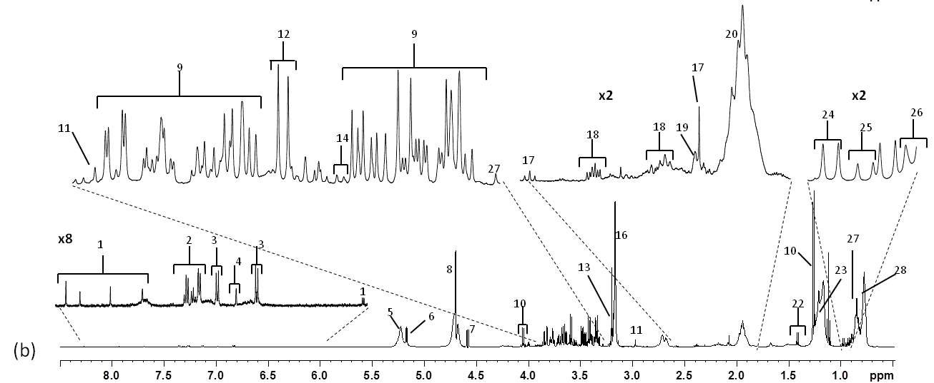

Figure S2: Multidimensional PCA analysis of ¹H-NMR spectra (CPMG sequence) of plasma segmented into 212 variable-size spectral regions. A) representation on the first and third PC axes of the scores of plasma of individuals fish fed a marine M diet (triangle), a plant-based P diet (circle) and a commercial C diet (diamond) either 6h post feeding (straight line) or 48h post feeding (dotted line) and (B) representation of the main significant spectral regions involved in the PC3 axis differences related to time after feeding
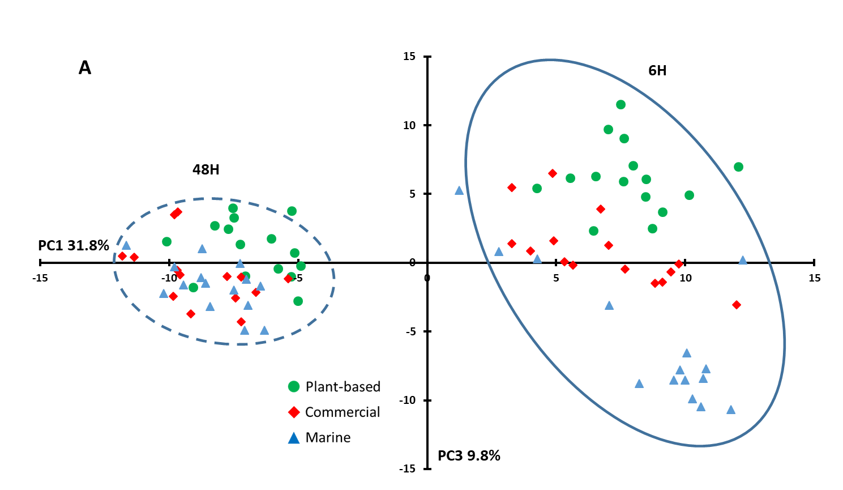  A | 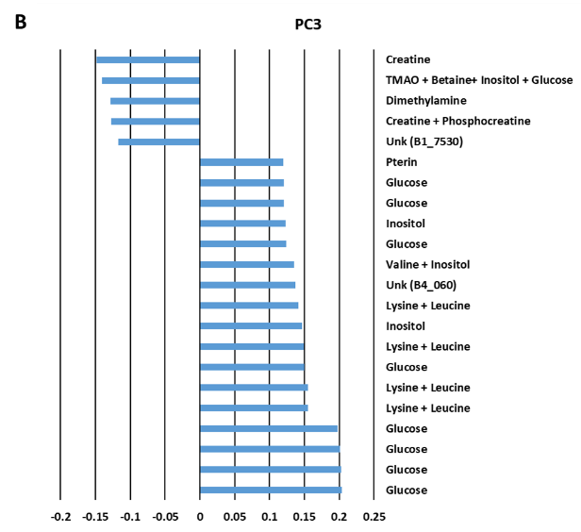

Figure S3 Representative 500 MHz 1H-NMR spectra of liver hydro-alcoolic polar extracts in rainbow trout fed a commercial diet. Legend: 1: niacinamide; 2: phenylalanine; 3: tyrosine; 4: inosine; 5: glucose; 6: mannose; 7: choline; 8: taurine; 9: methionine; 10: beta-alanine; 11: glutamine; 12: glutamate; 13: acetate; 14: alanine; 15: valine; 17: leucine; 16: isoleucine; 18: lactate
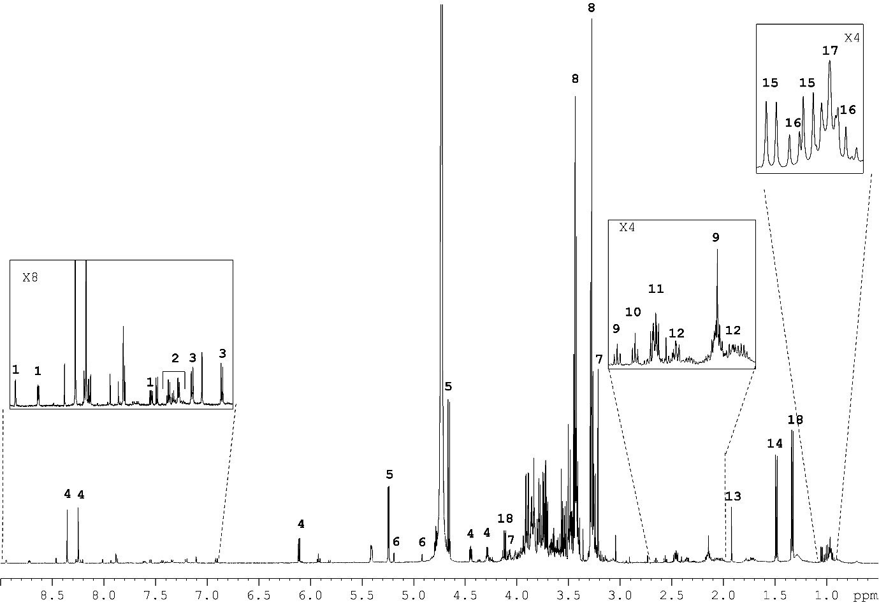

Figure S4 Representative 500 MHz ¹H-NMR spectrum of muscle tissue hydro-alcoolic extracts in rainbow trout fed a commercial C diet. Legend: GLU (Glutamate), GLN (Glutamine), TYR (Tyrosine), PHE (Phenylalanine), TRP (Tryptophan), HIS (Histidine), ALA (Alanine), LYS (Lysine), ILE (Isoleucine), VAL (Valine), ADP/ATP (Adenosine Di and/or Triphosphate).
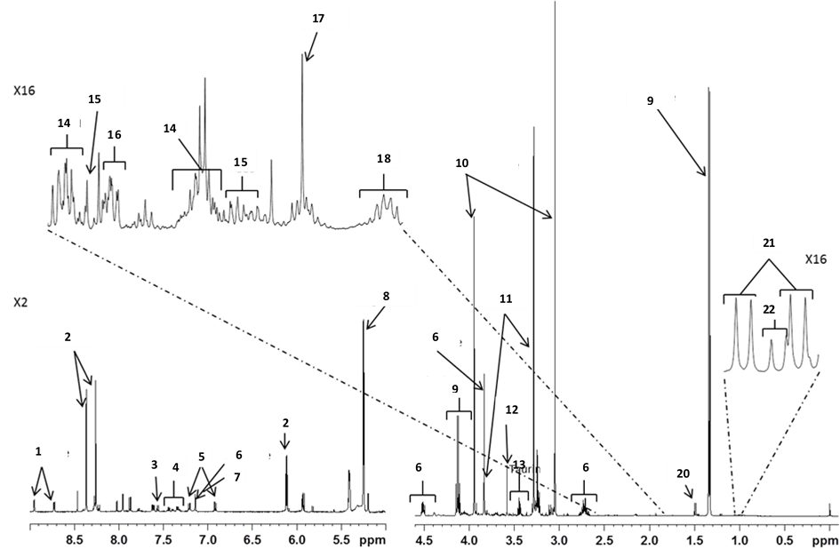

Methodological consideration for successful development of ¹H-NMR methodologies on diet, plasma and tissues
Diet
The alcoholic extracts of diet contained a rich mixture of soluble compounds representative of the free soluble compounds already present originally in the marine products (fish meal) or in the plant products but contained also probably the end-products of the degradation process occurring during process and storage. The profiles of these compounds were found to be stable during storage of the diet. The quantification of these compounds was possible as the ¹H-NMR spectra of diet comprised at least one or several resonances for each compound with few overlapping between resonance patterns.
Plasma
A direct analysis of plasma without extraction was implemented. The raw ¹H-NMR profile was however complex due to the presence of macromolecules namely lipoproteins - sometimes at high concentration as it is for chylomicrons after feeding - and other circulating plasmatic protein such as glyco-protein. A serum preparation with blood clotting is currently practiced in mammals to eliminate a large part of the circulating protein ⁽⁾. Clotting is however not easy to manage in fish as blood contained erythrocytes nucleated cells to ensure oxygen transport rather than enucleated one in mammals. Furthermore, fish such as salmonids live at lower temperature than mammals and the kinetic of clotting is slowed. For these reason, plasma is usually preferred in these species ^{(, )}.
The ¹H-NMR spectra of plasma after CPGM revealed a relatively comprehensive set of 40 compounds amongst the main expected circulating metabolites: amino acids, sugars, organic acids, nucleic acids and even cholesterol and lipid-soluble compounds. The relative changes with time after feeding (6 h and 48 h) was in concordance with the known changes after feeding of circulating metabolites i.e. peak of amino acids at 6 h after feeding ⁽⁾ and accumulation of glucose and other related compounds at 48 h after feeding ^{(,)}.
The plasmatic content of some compounds such as glucose and lactate detected by ¹H-NMR was compared to that measured by classical biochemical method. Only semi-quantitative assessment of compounds in plasma was possible with the CPMG sequence of acquisition which does not saturated the signal of proton in molecules analysed. The comparison was clear enough for glucose which was measured by the two methods at relatively stable concentration at 6 h and 48 h after feeding except a higher concentration in marine diet at 48h compared to the two other diets. For lactate the comparison of the two measurements showed discrepancies as lactate measured by ¹H-NMR was found to be higher in plant-based diet compared to marine diet, a difference that was not observed by classical method. Specific signals of lactate were identified at 1.33 and 4.13 ppm, thus ¹H-NMR analysis could be considered as feasible for this compounds although not quantitative. The interesting differences observed with ¹H-NMR has however to be investigated further as it could not only accounts for changes in fish metabolism but also in microbiota metabolism.
For the preparation of tissues, different methods have been tested in mammals and even in fish ⁽⁾ for metabolomic studies. The solvent extraction in two steps seems to extract the maximum number of metabolites and it is current practice in fish ^{(ii, iii, , , )}. Other methods based on protein precipitation with either acetonitrile, PCA or TCA are still used even in fish ⁽⁾ but are less applicable for NMR analysis as it requires adjustment of pH and ionic strength.
The ¹H-NMR spectra of liver and muscle revealed the main expected compounds i.e. amino acids, carbohydrates, organic acids, nucleotides and derivatives. The few number of compounds identified - 18 in liver and 16 in muscle - were however quite similar to that found by previous works in fish for liver: 9 to 19 compounds ⁽⁾ and for muscle : from 10-13 compounds ^{(X, XIII, XIV,)} to 28-39 compounds ^{(IX, XII)}. The other compounds not identified were glycogen in liver extract and TMA/TMAO and hypoxanthine in muscle. Glycogen is not soluble in a hydroalcoholic extract thus it could not be detected in our study. TMA and TMAO are mainly the results of alteration of fish flesh by micro-organisms thus they are not present at high concentration in live fresh fish. Furthermore, these last compounds were not also detected in the marine and commercial diets demonstrating the high quality of fish meals used in our experimental diets.
Different segmentation of the ¹H-NMR profile were implemented to increase the specificity and the number of signals. The final semi-automatic segmentation process with NMRProcFlow raised almost but 300 spectral regions in liver and muscle compared to 80 to 100 spectral regions with the initial manual segmentation. Further annotation of these signals will thus largely improved the number of metabolites that could be detected and analysed in fish.

Zhang A., Sun H, Wang X. (2012) Serum metabolomics as a novel diagnostic approach for disease: a systematic review. Anal Bioanal Chem., 404, 1239-1245
Kullgren A., Samuelsson LM., Larsson DGJ., Björnsson BT., Bergman EJ. (2010) A metabolomics approach to elucidate effects of food deprivation in juvenile rainbow trout (Oncorhynchus mykiss) Am J Physiol Regul Integr Comp Physiol 299, R1440–R1448.
Kullgren A., Jutfelt F., Fontanillas R., Sundell K., Samuelsson L., Wiklander K., Kling P., Koppe W., Larsson DG J., Björnsson BT., Jönsson E. (2013) The impact of temperature on the metabolome and endocrine metabolic signals in Atlantic salmon (Salmo salar). Comp. Biochem. Physiol., 164(A), 44-53.
Larsen B.K., Dalsgaard J., Pedersen PB. (2012) Effects of plant proteins on postprandial, free plasma amino acid concentrations in rainbow trout (Oncorhynchus mykiss). Aquaculture 326–329, 90–98.
Panserat S., Plagnes-Juan E., Kaushik S. (2001) Nutritional regulation and tissue specificity of gene expression for proteins involved in hepatic glucose metabolism in rainbow trout (Oncorhynchus mykiss). J. Exp. Biol. 204, 2351-2360.
Stone DAJ (2003) Dietary Carbohydrate Utilization by Fish. Rev. Fish. Sci., 11, 337-369.
Lin C.Y., Wu H., Tjeerdema R.S., Viant M.R. (2007) Evaluation of metabolite extraction strategies from tissue samples using NMR metabolomics. Metabolomics, 3, 55-67.
Wu H., Southam A.D., Hines A., Viant M.R. 2008 High-throughput tissue extraction protocol for NMR- and MS-based metabolomics. Anal. Biochem. 372, 204–212.
Mannina L., Sobolev A.P., Capitani D., Iaffaldano N., Rosato MP., Ragni P., Reale A., Sorrentino E., D’Amico I., Coppola R. (2008) NMR metabolic profiling of organic and aqueous sea bass extracts: implications in the discrimination of wild and cultured sea bass, Talanta 77, 433–444.
Lardon I., Nilsson GE., Stecyk JAW., Vu TN., Laukens K., Dommisse R., De Boeck, G. (2013) H-1-NMR study of the metabolome of an exceptionally anoxia tolerant vertebrate, the crucian carp (Carassius carassius), Metabolomics, 9 , 311-323.
Schock TB., Newton S., Brenkert K., Leffler J., Bearden DW. 2012 An NMR-based metabolomic assessment of cultured cobia health in response to dietary manipulation Food Chemistry 133 (2012) 90–101.
Gribbestad IS., Aursand M., Martinez I., 2005 High-resolution 1H magnetic resonance spectroscopy of whole fish, fillets and extracts of farmed Atlantic salmon (Salmo salar) for quality assessment and compositional analyses, Aquaculture 250 (2005) 445–457.
Picone G., Balling ES., Savorani F., Testi S., Badiani A., Capozzi F. 2011 Metabolomics as a Powerful Tool for Molecular Quality Assessment of the Fish Sparus aurata Nutrients, 3, 212-227
Wagner L., Trattner S., Pickova J., Gómez-Requeni P., Moazzami c AA. 2014 1H NMR-based metabolomics studies on the effect of sesamin in Atlantic salmon (Salmo salar), Food Chemistry 147, 98–105.
Abro, R., Moazzami, A.A., Lindberg, J.E. & Lundh, T. (2014) Metabolic insights in Arctic charr (Salvelinus alpinus) fed with zygomycetes and fish meal diets as assessed in liver using nuclear magnetic resonance (NMR) spectroscopy. Int. Aquat. Res., 6, 1-11.

