Supplementary Calculation S1

Total energy expenditure
Rate constants and pool sizes are calculated from the slopes and intercepts of the log transformed data, with the rate of CO₂ production, $R_{{CO}_{2}}$ given by(36):

$$R_{CO_{2}}=\frac{k_{O}N_{O}-k_{H}N_{H}-27.3\left(f_{2}-f_{1}\right)}{2f_{3}+2.1\left(f_{2}-f_{1}\right)}$$

Where k and N refer to the rate constant and pool size respectively, with subscripts to indicate the isotope. The fractionation factors f₁, f₂, and f₃, are given as 0.941, 0.991 and 1.037 respectively.
$R_{{CO}_{2}}$ was converted to TEE using the energy equivalent of CO₂ from Elia and Livesey(37, 38)with the Respiratory Quotient (RQ) fixed at 0.85 to reflect a typical Western diet:

$$TEE (kJ.{day}^{-1})=22.4×\left(\frac{15.48}{RQ}+5.55\right)R_{{CO}_{2}}(mol.{day}^{-1})$$

694 invitations sent
247 responses received
88 participants non-DLW
105 participants invited to do DLW*
100 participants completed DLW
- Did not pass pre-screening (n=13)
- Withdrew prior to booking (n=2)
- Unable to contact or attend appointment (n=36)

196 participants attended first clinic visit

- Did not pass screening (n=3)
193 participants

*Participants were allocated to DLW based on balancing sample across age, sex, BMI strata

Excluded:
- Postponed appointment (n=3)
- Declined to do DLW (n=2)
93 participants enrolled into non-DLW arm of study (not reported in this paper)

Excluded from analysis (n=2):
Did not complete at least one Intake24 dietary recall during measurement period

Included in DLW Validation study

- Analysed datasets (n=98)
- Completed ≥ 2 24hr recalls (n=74)
- Completed ≥ 3 24hr recalls (n=53)

Supplementary Fig. S1. Participant flow chart of the validation study

Study 3
Study 2
Study 1
Previous participants of the Scottish Health Survey recruited by phone

Made contact
n=747
Not eligible
n=71

Agreed
n=384 (57%)

Refused
n=239 (35%)

Completed 4 or more recalls
n=133 (20%)

Eligible
n=676 (100%)
Unable
(due to illness/holiday)
n=53 (8%)

Recruited via posters and leaflets displayed on campus, in shops and leisure centres.
Agreed
n=90

Completed 4 or more recalls
n=46 (%)

Completed 4 or more recalls
n=129 (44%)

Agreed
n=291

Recruited via letters home to secondary school children and on street recruitment.

Included in Repeatability study
Figure 1. Participant contact and response

Supplementary Fig. S2. Participant flow chart for the reliability study

Supplementary Fig. S3. Scatterplots of EI (kJ) against TEE (kJ) on original (left) and log (right) scale*
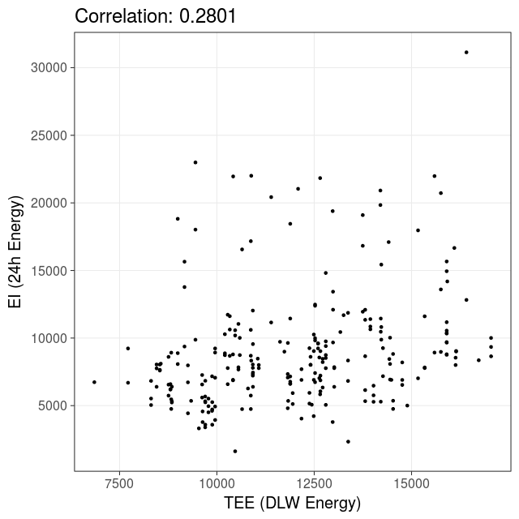
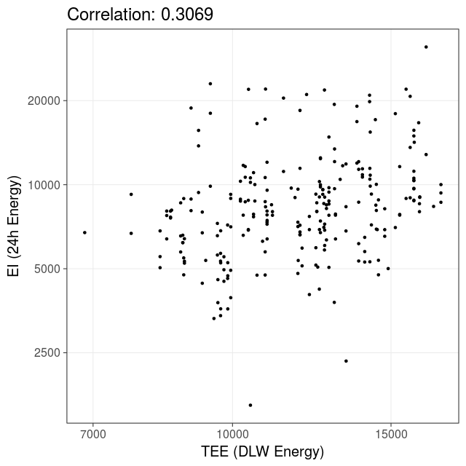
*The correlations presented do not truly reﬂect the relationship between EI and TEE because of intra-individual variation.
Supplementary Table S1. Estimates and credible intervals for applying the linear mixed effects models to different subsets of the data

 | Data | 1 day | 2 days (or fewer) | 3 days (or fewer) | All
 | Measurements | 98 | 172 | 225 | 247
All covariates | (Intercept) | -0.1661  (-1.2377, 0.9139) | -0.3661  (-1.1522, 0.4367) | -0.1455  (-0.8073, 0.513) | -0.184  (-0.8091, 0.426)
 | Age | 0.0046  (-0.0007, 0.0099) | 0.0054  (0.0015, 0.0094) | 0.0063  (0.0031, 0.0096) | 0.0063  (0.0031, 0.0094)
 | Height (cm) | -0.0008  (-0.0067, 0.0052) | 0.0004  (-0.004, 0.0047) | -0.0009  (-0.0046, 0.0027) | -0.0009  (-0.0042, 0.0025)
 | BMI | -0.0035  (-0.015, 0.0078) | -0.0053  (-0.0139, 0.0036) | -0.0073  (-0.0147, 0.0001) | -0.006  (-0.013, 0.0011)
 | Gender (M) | -0.0354  (-0.1468, 0.0782) | -0.0302  (-0.114, 0.054) | -0.0013  (-0.0723, 0.0694) | -0.0026  (-0.0703, 0.0653)
Age only | (Intercept) | -0.4193  (-0.7137, -0.1266) | -0.4474  (-0.6593, -0.2387) | -0.4961  (-0.6762, -0.3168) | -0.4847  (-0.6552, -0.313)
 | Age | 0.0046  (-0.0007, 0.01) | 0.0055  (0.0016, 0.0093) | 0.0063  (0.0031, 0.0096) | 0.0061  (0.003, 0.0091)

For each covariate, the standalone number represents the average effect on the validity measure. For example, for the ﬁrst day log-ratios, an increase in the age by 1 year corresponds to, on average, an increase of 0.0046 in the log-ratio. Whether such an effect is signiﬁcant is determined by whether 0 is in the 95% credible interval (CI), which is reported in the bracketed pair underneath.

Supplementary Table S2. Reliability analysis - Mean of 4 recalls, lower and upper quartiles of intake of energy and nutrients for all participants and split by age group

 | All ages |  |  | 11-16 year olds |  |  | 17-24 year olds |  |  | 25-64 year olds |  |  | 65 years +
 | Mean | Lower Upper |  | Mean | Lower Upper |  | Mean | Lower Upper |  | Mean | Lower Upper |  | Mean | Lower Upper
Energy (kJ) | 7600 | 5835 | 8849 | 7020 | 5497 | 8002 | 7985 | 6058 | 9416 | 7385 | 6087 | 8773 | 8329 | 6562 | 9146
Fat (g) | 67.7 | 48.0 | 82.0 | 58.7 | 42.6 | 65.0 | 72.9 | 51.7 | 85.1 | 65.9 | 48.4 | 79.2 | 78.0 | 60.6 | 93.5
Protein (g) | 66.9 | 50.3 | 78.5 | 56.6 | 44.1 | 67.2 | 70.1 | 52.9 | 80.3 | 71.3 | 56.7 | 79.8 | 75.5 | 62.9 | 94.2
Carbohydrate (g) | 237.1 | 180.0 | 283.0 | 242.7 | 185.2 | 278.6 | 245.5 | 186.2 | 295.5 | 218.1 | 167.0 | 256.1 | 226.9 | 184.7 | 250.8
Total Sugar (g) | 111.3 | 75.1 | 131.7 | 121.4 | 83.6 | 141.7 | 115.6 | 83.1 | 143.1 | 95.1 | 69.0 | 112.5 | 99.1 | 61.1 | 113.3
NMES* (g) | 74.1 | 41.7 | 92.4 | 91.7 | 55.2 | 106.0 | 76.6 | 43.5 | 95.6 | 54.3 | 28.3 | 73.3 | 53.5 | 34.3 | 65.7
Calcium (mg) | 829.8 | 590.9 | 997.4 | 792.7 | 551.6 | 953.7 | 818.7 | 593.8 | 992.6 | 871.8 | 649.5 | 1038.8 | 902.7 | 708.0 | 1099.3
Vitamin C (mg) | 105.1 | 48.7 | 143.7 | 125.7 | 58.0 | 150.5 | 101.4 | 48.1 | 144.0 | 88.4 | 43.3 | 129.8 | 96.3 | 48.8 | 136.0
Iron (mg) | 9.9 | 7.1 | 11.8 | 8.6 | 6.1 | 10.6 | 10.1 | 7.3 | 11.9 | 10.7 | 8.7 | 12.5 | 11.6 | 8.8 | 12.3
*NMES = non milk extrinsic sugar

Supplementary Table S3. Reliability analysis Bland-Altman analysis – Split by age group
Age group | Nutrient | Recalls 1&2  Geometric mean | Recalls 3&4 Geometric mean | Mean  Ratio | Limits of Agreement  Lower Upper
11-16 years | Energy (kJ) | 6686 | 6450 | 1.04 | 0.53 | 2.03
 | Fat (g) | 54.6 | 51.4 | 1.06 | 0.42 | 2.65
 | Protein (g) | 53.0 | 52.1 | 1.02 | 0.46 | 2.25
 | Carbohydrate (g) | 228.9 | 221.5 | 1.03 | 0.50 | 2.13
 | Total Sugar (g) | 109.3 | 102.3 | 1.07 | 0.43 | 2.66
 | NMES* (g) | 76.8 | 70.5 | 1.09 | 0.28 | 4.28
 | Alcohol (g) | 0.0 | 0.0 | 0.92 | 0.19 | 4.43
 | Calcium (mg) | 745.8 | 664.2 | 1.12 | 0.43 | 2.95
 | Vitamin C (mg) | 97.6 | 76.1 | 1.28 | 0.26 | 6.26
 | Iron (mg) | 7.9 | 8.0 | 0.98 | 0.41 | 2.33
17-24 years | Energy (kJ) | 7741 | 7281 | 1.06 | 0.51 | 2.20
 | Fat (g) | 66.9 | 60.9 | 1.10 | 0.39 | 3.07
 | Protein (g) | 64.3 | 63.9 | 1.01 | 0.41 | 2.45
 | Carbohydrate (g) | 233.0 | 228.7 | 1.02 | 0.50 | 2.07
 | Total Sugar (g) | 106.3 | 100.6 | 1.06 | 0.42 | 2.67
 | NMES* (g) | 65.4 | 57.7 | 1.25 | 0.09 | 17.45
 | Alcohol (g) | 0.2 | 0.1 | 1.76 | 0.00 | >1000
 | Calcium (mg) | 746.5 | 729.1 | 1.02 | 0.33 | 3.16
 | Vitamin C (mg) | 69.4 | 65.8 | 1.05 | 0.15 | 7.34
 | Iron (mg) | 9.3 | 9.2 | 1.00 | 0.39 | 2.60
25-64 years | Energy (kJ) | 6816 | 7034 | 0.97 | 0.54 | 1.75
 | Fat (g) | 57.4 | 59.6 | 0.96 | 0.38 | 2.40
 | Protein (g) | 63.4 | 68.3 | 0.93 | 0.41 | 2.12
 | Carbohydrate (g) | 200.2 | 206.7 | 0.97 | 0.54 | 1.74
 | Total Sugar (g) | 82.1 | 84.6 | 0.97 | 0.36 | 2.59
 | NMES* (g) | 37.5 | 39.4 | 0.95 | 0.20 | 4.46
 | Alcohol (g) | 3.1 | 3.4 | 1.42 | 0.00 | >1000
 | Calcium (mg) | 742.4 | 800.4 | 0.93 | 0.44 | 1.96
 | Vitamin C (mg) | 62.2 | 65.8 | 0.95 | 0.15 | 5.92
 | Iron (mg) | 9.5 | 9.7 | 0.99 | 0.42 | 2.32
65 years + | Energy (kJ) | 8071 | 7714 | 1.05 | 0.59 | 1.85
 | Fat (g) | 75.0 | 71.1 | 1.05 | 0.40 | 2.78
 | Protein (g) | 72.7 | 70.2 | 1.04 | 0.45 | 2.41
 | Carbohydrate (g) | 219.0 | 212.4 | 1.03 | 0.66 | 1.62
 | Total Sugar (g) | 89.5 | 87.2 | 1.03 | 0.47 | 2.23
 | NMES* (g) | 43.9 | 42.4 | 1.03 | 0.49 | 2.17
 | Alcohol (g) | 24.1 | 18.4 | 0.74 | 0.00 | 712.6
 | Calcium (mg) | 866.4 | 825.0 | 1.05 | 0.54 | 2.06
 | Vitamin C (mg) | 83.0 | 62.7 | 1.32 | 0.25 | 6.99
 | Iron (mg) | 10.8 | 10.3 | 1.05 | 0.62 | 1.79

Supplementary Table S4. Reliability analysis (ICC) of a single 24hr recall with sex as a covariate – by age group

 | 11-16 year olds |  |  | 17-24 year olds |  |  | 25-64 year olds |  |  | 65 years +
 | ICC | 95% CI |  | ICC | 95% CI |  | ICC | 95% CI |  | ICC | 95% CI
Energy (kJ) | 0.403 | 0.289 | 0.517 | 0.272 | 0.179 | 0.371 | 0.347 | 0.217 | 0.478 | 0.463 | 0.000 | 0.685
Fat (g) | 0.334 | 0.220 | 0.452 | 0.337 | 0.242 | 0.436 | 0.312 | 0.183 | 0.446 | 0.001 | 0.000 | 0.003
Protein (g) | 0.260 | 0.145 | 0.380 | 0.329 | 0.235 | 0.428 | 0.398 | 0.270 | 0.527 | 0.002 | 0.000 | 0.013
Carbohydrate (g) | 0.417 | 0.306 | 0.532 | 0.301 | 0.207 | 0.400 | 0.338 | 0.207 | 0.473 | 0.449 | 0.231 | 0.659
Total Sugar (g) | 0.498 | 0.388 | 0.605 | 0.370 | 0.276 | 0.466 | 0.187 | 0.013 | 0.329 | 0.525 | 0.319 | 0.717
NMES* (g) | 0.490 | 0.381 | 0.597 | 0.435 | 0.343 | 0.528 | 0.113 | 0.001 | 0.270 | 0.526 | 0.318 | 0.716
Calcium (mg) | 0.350 | 0.236 | 0.466 | 0.192 | 0.099 | 0.289 | 0.455 | 0.328 | 0.580 | 0.294 | 0.000 | 0.584
Vitamin C (mg) | 0.504 | 0.398 | 0.609 | 0.349 | 0.254 | 0.448 | 0.323 | 0.194 | 0.457 | 0.286 | 0.001 | 0.550
Iron (mg) | 0.338 | 0.224 | 0.455 | 0.182 | 0.088 | 0.279 | 0.350 | 0.221 | 0.483 | 0.530 | 0.321 | 0.722
*NMES = non milk extrinsic sugar

Supplementary Table S5. Reliability analysis (ICC) of paired recalls (recalls 1&2 and recalls 3&4) by age group

 | 11-16 year olds |  |  | 17-24 year olds |  |  | 25-64 year olds |  |  | 65 years +
 | ICC | 95% CI |  | ICC | 95% CI |  | ICC | 95% CI |  | ICC | 95% CI
Energy (kJ) | 0.591 | 0.436 | 0.712 | 0.370 | 0.200 | 0.518 | 0.631 | 0.480 | 0.746 | 0.697 | 0.420 | 0.856
Fat (g) | 0.511 | 0.339 | 0.650 | 0.301 | 0.126 | 0.459 | 0.512 | 0.331 | 0.656 | 0.069 | -0.336 | 0.452
Protein (g) | 0.427 | 0.239 | 0.584 | 0.465 | 0.306 | 0.599 | 0.691 | 0.559 | 0.790 | 0.169 | -0.258 | 0.534
Carbohydrate (g) | 0.616 | 0.467 | 0.731 | 0.499 | 0.345 | 0.626 | 0.580 | 0.415 | 0.708 | 0.790 | 0.573 | 0.903
Total Sugar (g) | 0.669 | 0.535 | 0.771 | 0.610 | 0.478 | 0.715 | 0.395 | 0.193 | 0.564 | 0.733 | 0.471 | 0.875
NMES* (g) | 0.664 | 0.528 | 0.767 | 0.662 | 0.543 | 0.755 | 0.342 | 0.134 | 0.522 | 0.863 | 0.709 | 0.939
Calcium (mg) | 0.462 | 0.281 | 0.611 | 0.231 | 0.047 | 0.400 | 0.717 | 0.592 | 0.808 | 0.682 | 0.391 | 0.849
Vitamin C (mg) | 0.643 | 0.501 | 0.751 | 0.524 | 0.375 | 0.647 | 0.530 | 0.352 | 0.670 | 0.713 | 0.449 | 0.864
Iron (mg) | 0.489 | 0.311 | 0.634 | 0.278 | 0.097 | 0.442 | 0.532 | 0.356 | 0.672 | 0.857 | 0.681 | 0.930
*NMES = non milk extrinsic sugar

