Supplementary Figure 1. Daily new cases and timing of baseline and follow-up assessments.
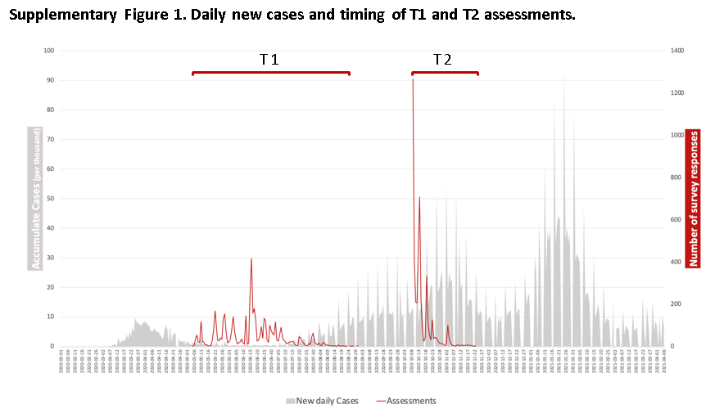

Supplementary Figure 2. Diagram of recruitment process.
