APPENDIX

Title : Psychiatric advance directives facilitated by peer workers among people with mental illness: economic evaluation of a randomized controlled trial (DAiP study)

Pages: 11
Tables: 3
Table S1: Unit costs considered in the DAiP trial
Table S2: Total hospital admissions and length of stay in both compulsory and voluntary settings
Table S3: Results on complete data

Figures: 3
Figure S1: Outcomes regarding psychiatric advance directives (PADs) for all participants (N=394)
Figure S2: CONSORT Flow Diagram in the DAIP trial
Figure S3: Cost-effectiveness acceptability curve (CEAC) indicating the probability of cost-effectiveness for different thresholds of willingness-for-pay (€) per unit of effect (QALY) gained

PW-PAD – English version
Table S1: Unit costs considered in the DAiP trial

Category | Type | Unit costs (in Euros) | Sources
Inpatient costs
Hospitalizations - psychiatric hospital (public) | Day care | 231.67/day | ATIH – Scan santé  https://www.scansante.fr 2019
 | Partial time | 229.00/day
 | Complete | 369.68/day
 | Consultation | 104.03
Hospitalizations – medical (public) | Complete | 497.28/day | ATIH – Scan santé  https://www.scansante.fr 2019
 | Consultation | 92.76
Supplemental fees | Intensive care unit | 1 888.81 | ATIH – Scan santé  https://www.scansante.fr 2019
 | Palliative care | 1 117.94
 | Surveillance | 862.13
Emergency Department visit | General medicine | 161.50 | Rapport Cours des Comptes 2019
 | Psychiatry | 185.84
Transport | Emergency ambulance | 933.80 | Rapport Sécurité Sociale 2017
Ambulatory costs
Consultations | General practitioner | 25.00/visit | NGAP - www.ameli.fr
 | Psychiatrist | 46.70/visit | NGAP - www.ameli.fr
 | Other specialist | 25.00/visit | NGAP - www.ameli.fr
Intervention costs
Training | 2 half-day sessions per week for 6 weeks | 1215.00/pw
PW’s salary | Monthly amount (including charges) | 3 738.00/pw | Peer worker (pw) interwiew
Transport indemnity | Monthly amount | 75.00/pw

PW: peer-worker. ATIH: Agence technique de l'information sur l'hospitalisation (Agency for Information on Hospital Care - AIHC). NGAP: Nomenclature générale des actes professionnels (Relative value scale of medical procedures)

Table S2: Total psychiatric hospital admissions and length of stay in both compulsory and voluntary settings

 | PW-PAD group | Control group
Psychiatric hospital resource use | N (%) or  mean (sd) | N (%) or  mean (sd) | P-value
No. (%) of patients with at least one psychiatric admission | 70 (35.70) | 79 (39.90) | 0.392
No. (%) of patients with at least one compulsory admission | 53 (27.00) | 79 (39.90) | 0.007
Mean (sd) admissions per patient | 1.07 (2.04) | 1.44 (1.97) | 0.070
Mean (sd) days at hospital | 45.4 (89) | 57.1 (88) | 0.026
Mean (sd) days in compulsory admission | 20.4 (62) | 28.0 (72) | 0.002
Mean (sd) days in voluntary admission | 25.0 (66) | 29.1 (62) | 0.147

PW-PAD: peer-worker facilitated psychiatric advance directive; sd: standard deviation.

Table S3: Mean and incremental costs and QALYs for patients receiving PW-PAD versus usual care based on complete data

 | PW-PAD group | Control group
 | Mean (95%CI) | Mean (95%CI) | Mean change from baseline (95%CI) | P Value
Utilities | 0.808 (0.778 – 0.839) | 0.763 (0.733 – 0.793) | 0.045 (0.002 – 0.088) | 0.039
 | Mean (95%CI) | Mean (95%CI) | Difference in mean (95%CI) | P Value
Costs | 20 467 (16 307 – 24 626) | 25 346 (20 427 – 30 265) | -4 879 (-11 321 – 1 562) | 0.138

PW-PAD: peer-worker facilitated psychiatric advance directive; QALY: quality-adjusted life year; CI indicates confidence interval.

Figure S1. Outcomes regarding psychiatric advance directives (PADs) for all participants (N=394)

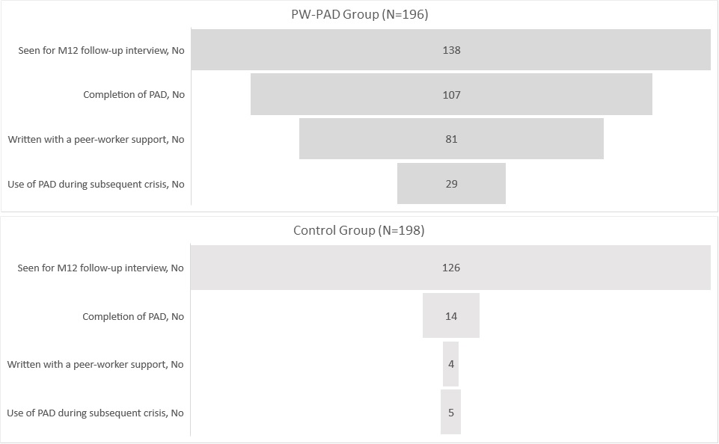

Legend Figure S1:
PAD: psychiatric advance directive; PW-PAD: peer-worker facilitated psychiatric advance directive.

Figure S2: CONSORT Flow Diagram for the DAIP trial
473 Assessed for eligibility
from January 2019 to June 2020

- Excluded by Research assistants
48 Declined to participate (not interested, worried that drafting PADs may lead to a crisis)
14 Had no contact after reflection
10 Did not meet inclusion criteria

401 Randomized individuals

200 Intervention group
201 Control group
Allocation

- Excluded by Data board
- 1 with Eligibility criteria not verified
- 2 withdrawals
- Excluded by Data board
- 1 with Eligibility criteria not verified
- 3 withdrawals

198 Control group
196 Intervention group

Follow-up
at M6
198 patients with Primary outcome data

127 completed the interview
71 discontinued
- 1 Patient who died
- 69 Patients did not attend six-month follow-up
- 1 Withdrawal
196 patients with Primary outcome data

118 completed the interview
78 discontinued
- 0 Patient who died
- 78 Patients did not attend six-month follow-up
- 0 withdrawal

Follow-up
at M12
198 patients with Primary outcome data

139 completed the interview
60 discontinued
- 1 Patient who died
- 56 Patients did not attend 12-month follow-up
- 2 Withdrawals
196 patients with Primary outcome data

127 completed the interview
69 discontinued
- 0 Patient who died
- 68 Patients did not attend 12-month follow-up
- 1 withdrawal

198 analysed
in intention-to-treat analysis
196 analysed
in intention-to-treat analysis
Intention-to-treat Analysis

Figure S3: Cost-effectiveness acceptability curve (CEAC) indicating the probability of cost-effectiveness for different thresholds of willingness-for-pay (€) per unit of effect (QALY) gained

Legend Figure S3:
PW-PAD: peer-worker facilitated psychiatric advance directive; QALY: quality-adjusted life year; CE: Cost-effectiveness; CEAC: Cost-effectiveness acceptability curve.
The cost-effectiveness acceptability curve provides visual results of the probabilistic sensitivity analysis. CEAC presents the relative cost-effectiveness as a function of the ICER threshold (WTP). For each WTP value, the graph uses net benefits to determine the percentage of simulation iterations that favor each strategy. The percentages will increase for more effective strategies as the WTP increases.

PW-PAD form – version in English

Psychiatric Advance directives

Person concerned and health care agent

I, undersigned, ………………………………………………………………………………………….............……., born on….…/………/………. in ……………………………………......., designates as health care agent in accordance with the article L. 1111-6 of the Public Health Code:

Contact Type of relationship Function
- M.-Mrs.
- M.-Mrs.
- Others

To ensure the carrying out the of my following Psychiatric Advance Directives, with my consent at the time of writing.

It is understood that the Psychiatric Advance Directives are not binding on relatives and caregivers.

Done in …………… the ……/……./……./………, alone or with ……………………………………………

Name(s) : Signature(s) :

- When I am competent to decide: | - When I am not competent to decide:

Warning signs

1 – 3 –

2 – 4 –

New signs (« update ») : _________________________________________________________________________________________________________________________________________________________________________________________________________________________________

What help me in case of crisis :

1 – 3 –

2 – 4 –

What doesn’t help me in case of crisis :

1 – 3 –

2 – 4 –

Signals of end of crisis, when it gets better:

1 – 3 –

2 – 4 –
In case of danger (auto or hetero agressivity)

To do : Not to do :
- -
- -
- -
Medication | Dosage | Effect | Note

I want to take a medication: YES □ NO □

Medications that help me, that can be used
– Article 1111.4 of the Public Health Code about the choice of treatment

Medication | Dosage | Effect | Note

Medications that do not help me, that should not be used

I want to be accompanied to a care setting: YES □ NO □

Care settings I want to use (hospitals, services, teams)
- Article 1110.8 of the Public Health Code on the choice of practitioner and health facility
- -
- -
- -
Remarks : …………………………………………………………………………………………………………………………………………………………………………………………………………………………………………………………………………………………………………………………………………………………………………………
Care settings I don’t want to use :
- -
- -
- -

Remarks: …………………………………………………………………………………………………………………………………………………………………………………………………………………………………………………………………………………………………………………………………………………………………………………………

Health care professionals

- I want to be supported by : - I don’t want to be supported by :

* *
* *
* *

Other personal remarks, useful tips, notes…

…………………………………………………………………………………………………………………………………………………………………………………………………………………………………………………………………………………………………………………………………………………………………………………………………………………………………………………………………………………………………………………………………………………………………………………………………………………………………………………………………………………………………………………………………………………………………………………………………………………………………………………………………………………………………………………………………………………………………………………………………………………………………………………………………………………………………………………………………………………………………………………………………………………………………………………………………………………………………………………………………………………………………………………………………………………………………………………………………………………………………………………………………………………………………………………………………………………………………………………………………………………………………………………………………………………………………………………………………………………………………………………………………………………………………………………………………………………………………………………………………………………………………………………………………………………………………………………………………………………………………………………………………………………………………………………………………………………………………………………………………………………………………………………………………………………………………………………………………………………………………………………………………………………………………………………………………………………………………………………………………………………………………………………………………………………………………………………………………………………………………………………………………………………………………………………………………………………………………………………………………………………………………………………………………………………………………………………………………………

