Supplementary material
Supplementary table 1. STROBE statement checklist for observational studies

 |  | Item No | Recommendation | Page
Title and abstract |  | 1 | (a) Indicate the study’s design with a commonly used term in the title or the abstract | Title sheet
 |  |  | (b) Provide in the abstract an informative and balanced summary of what was done and what was found | Title sheet
Introduction
Background/rationale |  | 2 | Explain the scientific background and rationale for the investigation being reported | 1-4
Objectives |  | 3 | State specific objectives, including any prespecified hypotheses | 4
Methods
Study design |  | 4 | Present key elements of study design early in the paper | 4,5
Setting |  | 5 | Describe the setting, locations, and relevant dates, including periods of recruitment, exposure, follow-up, and data collection | 5, figure 1
Participants |  | 6 | (a) Cohort study—Give the eligibility criteria, and the sources and methods of selection of participants. Describe methods of follow-up | 4,5
 |  |  | (b) Cohort study—For matched studies, give matching criteria and number of exposed and unexposed | N/A
Variables |  | 7 | Clearly define all outcomes, exposures, predictors, potential confounders, and effect modifiers. Give diagnostic criteria, if applicable | 6-9
Data sources/ measurement |  | 8* | For each variable of interest, give sources of data and details of methods of assessment (measurement). | 6-9
Bias |  | 9 | Describe any efforts to address potential sources of bias | 9-11
Study size |  | 10 | Explain how the study size was arrived at | 5, 9
Quantitative variables |  | 11 | Explain how quantitative variables were handled in the analyses. If applicable, describe which groupings were chosen and why | 6-9
Statistical methods |  | 12 | (a) Describe all statistical methods, including those used to control for confounding | 9-11
 |  |  | (b) Describe any methods used to examine subgroups and interactions | 10-11
 |  |  | (c) Explain how missing data were addressed | 10, supplementary table 3, supplementary figures 1 and 2
 |  |  | (d) Cohort study—If applicable, explain how loss to follow-up was addressed | 9
 |  |  | (e) Describe any sensitivity analyses | N/A
Results |  |  |  | Page
Participants | 13* | (a) Report numbers of individuals at each stage of study—eg numbers potentially eligible, examined for eligibility, confirmed eligible, included in the study, completing follow-up, and analysed |  | N/A
 |  | (b) Give reasons for non-participation at each stage |  | N/A
 |  | (c) Consider use of a flow diagram |  | N/A
Descriptive data | 14* | (a) Give characteristics of study participants (eg demographic, clinical, social) and information on exposures and potential confounders |  | 11 and table 1
 |  | (b) Indicate number of participants with missing data for each variable of interest |  | Supplementary table 3
 |  | (c) Cohort study—Summarise follow-up time (eg, average and total amount) |  | Figures 1 and 2
Outcome data | 15* | Cohort study—Report numbers of outcome events or summary measures over time |  | 11-13, figure 2
Main results | 16 | (a) Give unadjusted estimates and, if applicable, confounder-adjusted estimates and their precision (eg, 95% confidence interval). Make clear which confounders were adjusted for and why they were included |  | Supplementary table 4, supplementary figure 3, page 11
 |  | (b) Report category boundaries when continuous variables were categorized |  | Table 2, supplementary table 4
 |  | (c) If relevant, consider translating estimates of relative risk into absolute risk for a meaningful time period |  | N/A
Other analyses | 17 | Report other analyses done—eg analyses of subgroups and interactions, and sensitivity analyses |  | Supplementary materials
Discussion
Key results | 18 | Summarise key results with reference to study objectives |  | 15
Limitations | 19 | Discuss limitations of the study, taking into account sources of potential bias or imprecision. Discuss both direction and magnitude of any potential bias |  | 21, 22
Interpretation | 20 | Give a cautious overall interpretation of results considering objectives, limitations, multiplicity of analyses, results from similar studies, and other relevant evidence |  | 15-22
Generalisability | 21 | Discuss the generalisability (external validity) of the study results |  | 21, 22
Other information
Funding | 22 | Give the source of funding and the role of the funders for the present study and, if applicable, for the original study on which the present article is based |  | 23

Supplementary table 2. Results from the mixed effects models
Psychological distress (PHQ-4)
 | AIC | BIC | logLik | deviance | Chisq | Df | Pr(>Chisq)
Random intercept only | 125663 | 125696 | -62827 | 125655
Random slope only | 138801 | 138835 | -69397 | 138793 | 0 | 0
Random slope only | 138801 | 138835 | -69397 | 138793
Random intercept and slope | 125069 | 125119 | -69528 | 125057 | 13736 | 2 | <0.0001
Random intercept only | 125663 | 125696 | -62827 | 125655
Random intercept and slope | 125069 | 125119 | -62528 | 125057 | 598.21 | 2 | <0.0001
Personal growth
 | AIC | BIC | logLik | deviance | Chisq | Df | Pr(>Chisq)
Random intercept only | 88501 | 88531 | -44246 | 88493
Random slope only | 95322 | 95353 | -47657 | 95314 | 0 | 0
Random slope only | 95322 | 95353 | -47657 | 95314
Random intercept and slope | 88403 | 88449 | -44195 | 88391 | 6923.1 | 2 | <0.0001
Random intercept only | 88501 | 88531 | -44246 | 88493
Random intercept and slope | 88403 | 88449 | -44195 | 88391 | 101.75 | 2 | <0.0001
Loneliness (UCLA)
 | AIC | BIC | logLik | deviance | Chisq | Df | Pr(>Chisq)
Random intercept only | 74672 | 74705 | -377332 | 74664
Random slope only | 81076 | 81109 | -40534 | 81068 | 0 | 0
Random slope only | 81076 | 81109 | -40534 | 81068
Random intercept and slope | 74443 | 74492 | -37215 | 74431 | 6637.2 | 2 | <0.0001
Random intercept only | 74672 | 74705 | -37332 | 74664
Random intercept and slope | 74443 | 74492 | -37215 | 74431 | 233.23 | 2 | <0.0001

Supplementary table 3. Percentage of missingness in the exposures
Variables | % of missingness
Sex | 0.00%
Age | 0.00%
Marital status | 0.02%
Living alone | 0.02%
Educational level | 0.02%
Occupation | 0.02%
Household income | 0.00%
Living in a city | 0.02%
Global health | 0.11%
Cognitive function | 0.11%
Sleeping problems | 0.07%
Smoking | 0.07%
Personality traits | 38.62%
Engaged living scale | 12.19%
Autonomy | 13.82%
Environmental mastery | 13.82%
Positive relationships | 13.82%
Brief resilience and coping scale | 39.17%
Perceived stress | 48.15%

Supplementary figure 1. Density plots for continuous variables conducted to check the imputation quality
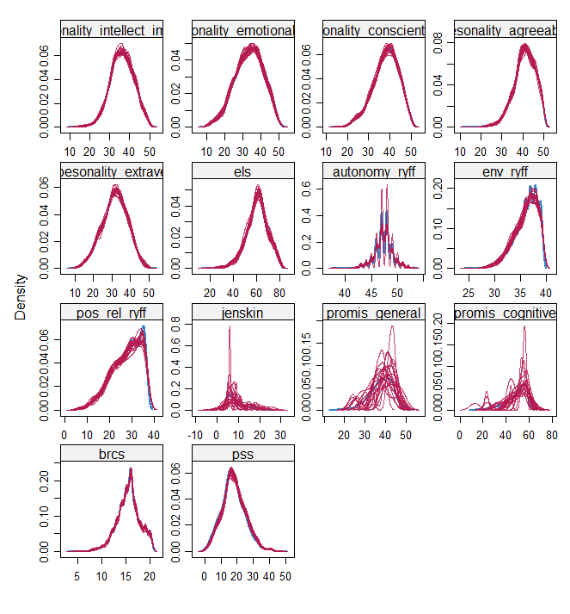

Supplementary figure 2. Stripplots for categorical variables conducted to check the imputation quality
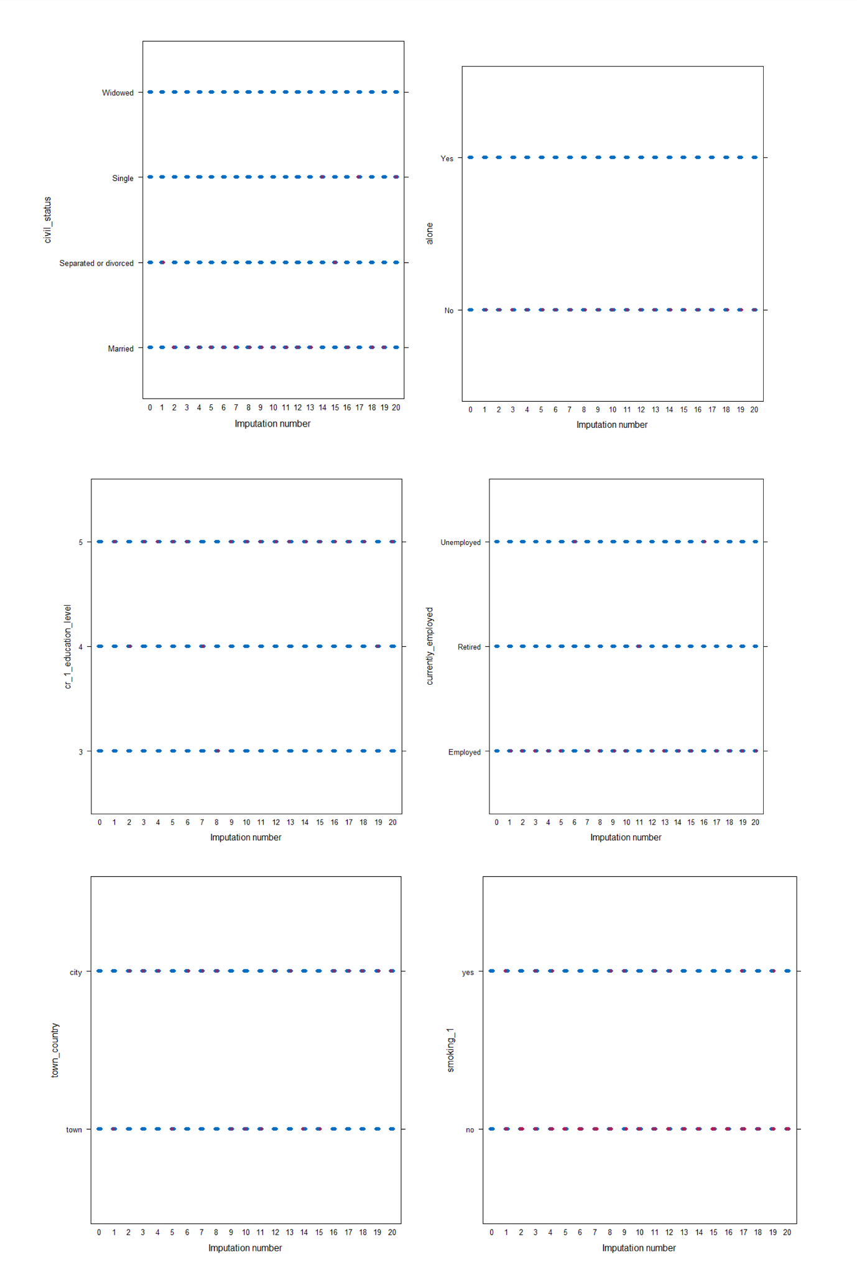
Supplementary figure 3. Correlation matrix to assess multicollinearity among the predictors

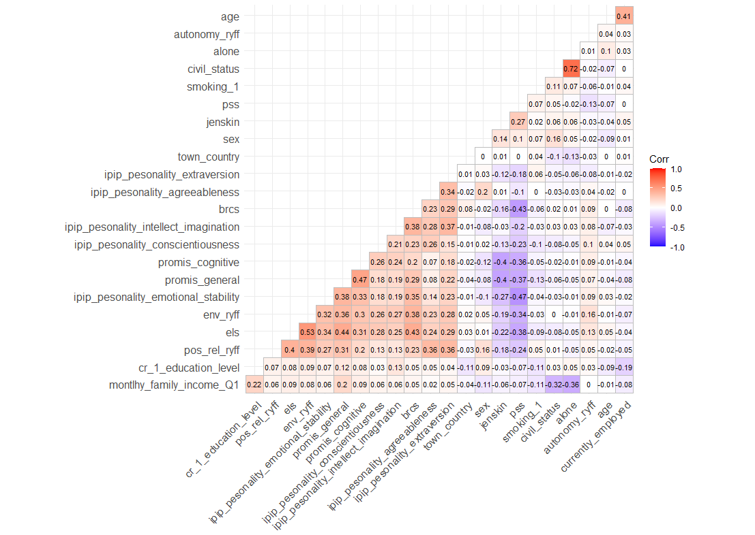
Supplementary table 4. Results from the univariable models to explore the association between latent trajectory membership and exposures in the mental health constructs
 | Psychological distress |  | Personal growth |  | Loneliness
Variables | “Chronic” | “Moderately resilient” | “Worsening” | “Improving” | “Chronic – high loneliness” | “Chronic – medium loneliness”
Sex
Male (ref.) | - | - | - | - | - | -
Female | 2.66 (2.11-3.34) | 1.86 (1.65-2.09) | 1.13 (0.89-1.43) | 0.81 (0.71-0.91) | 1.26 (1.01-1.57) | 1.26 (1.07-1.49)
Age | 0.95 (0.94-0.97) | 0.97 (0.96-0.98) | 1.02 (1.00-1.03) | 1.02 (1.01-1.03) | 0.99 (0.98-1.00) | 0.99 (0.98-1.00)
Living alone
No (ref.) | - | - | - | - | - | -
Yes | 1.45 (1.12-1.87) | 1.02 (0.86-1.20) | 1.08 (0.80-1.44) | 0.93 (0.79-1.09) | 2.98 (2.40-3.71) | 1.99 (1.63-2.42)
Occupation
Employed (ref.) | - | - | - | - | - | -
Unemployed | 1.73 (1.28-2.35) | 1.07 (0.87-1.32) | 1.40 (0.98-2.00) | 1.25 (1.02-1.54) | 1.57 (1.16-2.12) | 1.29 (0.99-1.68)
Retired | 0.61 (0.42-0.87) | 0.73 (0.61-0.88) | 1.29 (0.90-1.86) | 1.48 (1.21-1.80) | 0.91 (0.64-1.29) | 1.12 (0.88-1.43)
Household income
<1000€ (ref.) | - | - | - | - | - | -
1000-2000€ | 0.57 (0.38-0.88) | 1.26 (0.91-1.75) | 1.30 (0.73-2.32) | 1.24 (0.92-1.67) | 0.73 (0.49-1.08) | 0.91 (0.62-1.35)
2000-5000€ | 0.32 (0.21-0.48) | 0.93 (0.68-1.27) | 1.18 (0.68-2.06) | 1.10 (0.82-1.46) | 0.31 (0.21-0.45) | 0.61 (0.41-0.89)
>5000€ | 0.21 (0.13-0.33) | 0.65 (0.46-0.91) | 0.84 (0.46-1.54) | 0.78 (0.57-1.07) | 0.25 (0.16-0.39) | 0.43 (0.28-0.65)
Living in a city
No (ref.) | - | - | - | - | - | -
Yes | 1.05 (0.84-1.31) | 1.03 (0.90-1.17) | 0.92 (0.73-1.17) | 1.05 (0.92-1.19) | 1.08 (0.87-1.34) | 1.02 (0.86-1.21)
Educational level
Primary education or less | - | - | - | - | - | -
Secondary education | 0.53 (0.35-0.82) | 0.89 (0.65-1.21) | 2.74 (1.07-7.05) | 0.61 (0.43-0.84) | 0.67 (0.43-1.03) | 0.88 (0.57-1.37)
Higher education | 0.41 (0.28-0.62) | 0.88 (0.65-1.17) | 2.10 (0.83-5.32) | 0.35 (0.26-0.49) | 0.60 (0.40-0.91) | 0.82 (0.54-1.23)
Global health | 0.73 (0.71-0.74) | 0.86 (0.85-0.87) | 0.96 (0.94-0.98) | 0.90 (0.89-0.91) | 0.84 (0.82-0.85) | 0.90 (0.89-0.91)
Cognitive function | 0.83 (0.82-0.84) | 0.90 (0.89-0.91) | 0.98 (0.97-1.00) | 0.94 (0.94-0.95) | 0.92 (0.91-0.93) | 0.95 (0.95-0.96)
Smoking
No (ref.) | - | - | - | - | - | -
Yes | 2.24 (1.74-2.89) | 1.37 (1.15-1.63) | 1.12 (0.82-1.52) | 1.18 (1.00-1.40) | 1.49 (1.17-1.90) | 1.12 (0.91-1.39)
Sleeping problems | 1.39 (1.35-1.42) | 1.18 (1.15-1.20) | 0.99 (0.97-1.02) | 1.05 (1.03-1.06) | 1.15 (1.13-1.18) | 1.08 (1.06-1.10)
Personality traits
Extraversion | 0.92 (0.90-0.93) | 0.96 (0.95-0.97) | 0.97 (0.95-0.98) | 0.93 (0.92-0.94) | 0.92 (0.90-0.93) | 0.96 (0.95-0.97)
Emotional stability | 0.81 (0.79-0.82) | 0.90 (0.89-0.91) | 0.96 (0.95-0.98) | 0.94 (0.93-0.95) | 0.88 (0.86-0.89) | 0.93 (0.92-0.94)
Agreeableness | 0.96 (0.94-0.99) | 0.99 (0.97-1.00) | 0.97 (0.95-0.99) | 0.92 (0.91-0.94) | 0.93 (0.91-0.95) | 0.97 (0.96-0.98)
Conscientiousness | 0.90 (0.89-0.92) | 0.95 (0.94-0.96) | 0.97 (0.95-0.99) | 0.94 (0.93-0.95) | 0.93 (0.92-0.95) | 0.96 (0.95-0.97)
Openness to experience | 0.93 (0.91-0.95) | 0.96 (0.95-0.97) | 0.93 (0.91-0.95) | 0.90 (0.89-0.91) | 0.96 (0.95-0.98) | 0.99 (0.97-1.00)
Engaged living scale | 0.87 (0.85-0.88) | 0.93 (0.92-0.94) | 0.96 (0.95-0.98) | 0.91 (0.91-0.92) | 0.90 (0.89-0.91) | 0.94 (0.93-0.95)
Autonomy | 0.85 (0.80-0.90) | 0.92 (0.89-0.95) | 1.00 (0.94-1.06) | 0.93 (0.90-0.96) | 0.95 (0.90-1.00) | 0.94 (0.91-0.98)
Environmental mastery | 0.64 (0.61-0.67) | 0.81 (0.78-0.83) | 0.86 (0.82-0.91) | 0.71 (0.69-0.74) | 0.73 (0.70-0.76) | 0.85 (0.82-0.88)
Positive relationships with others | 0.87 (0.85-0.88) | 0.94 (0.93-0.95) | 0.97 (0.95-0.99) | 0.92 (0.91-0.93) | 0.83 (0.82-0.84) | 0.91 (0.90-0.92)
Brief resilience and coping scale | 0.64 (0.61-0.67) | 0.82 (0.79-0.84) | 0.82 (0.77-0.86) | 0.74 (0.72-0.77) | 0.74 (0.70-0.77) | 0.87 (0.84-0.90)
Perceived stress | 1.27 (1.24-1.30) | 1.12 (1.11-1.13) | 1.04 (1.02-1.06) | 1.06 (1.05-1.07) | 1.15 (1.13-1.17) | 1.07 (1.06-1.09)
Note. Relative risk ratios (95% CI) from multinomial logistic regression models. Models were run in 20 imputed datasets and results combined using Rubin’s rules. Boldface indicates statistically significant results.

Supplementary table 5. Model fit indices for different number of classes solutions for psychological distress (PHQ-4)
No. of classes | Loglik | npm | AIC | BIC | Entropy | class 1 (%) | class 2 (%) | class 3 (%) | class 4 (%) | class 5 (%) | Average posterior probabilities
1 | -62528.364 | 6 | 125068.728 | 125108.435 | 1 | 100 | NA | NA | NA | NA | 1.000
2 | -61695.263 | 10 | 123410.526 | 123476.705 | 0.60 | 11.482 | 88.517 | NA | NA | NA | 0.872  0.903
3 | -61374.635 | 14 | 122777.270 | 122869.92 | 0.54 | 9.367 | 35.081 | 55.551 | NA | NA | 0.860  0.742  0.805
4 | -61295.112 | 18 | 122626.224 | 122745.347 | 0.48 | 27.142 | 6.636 | 34.122 | 32.097 | NA | 0.590  0.866  0.737  0.687
5 | -61278.940 | 22 | 122601.881 | 122747.476 | 0.47 | 4.249 | 31.320 | 34.394 | 23.743 | 6.292 | 0.812  0.585  0.734  0.565  0.605

Supplementary table 6. Model fit indices for different number of classes solutions for personal growth
No. of classes | Loglik | npm | AIC | BIC | Entropy | class 1 (%) | class 2 (%) | class 3 (%) | class 4 (%) | class 5 (%) | Average posterior probabilities
1 | -44195.484 | 6 | 88402.969 | 88442.682 | 1 | 100 | NA | NA | NA | NA | 1.000
2 | -44029.113 | 10 | 88078.227 | 88144.415 | 0.55 | 70.551 | 29.448 | NA | NA | NA | 0.911  0.714
3 | -44009.436 | 14 | 88046.872 | 88139.536 | 0.48 | 7.642 | 56.296 | 36.061 | NA | NA | 0.618  0.812  0.719
4 | -43987.555 | 18 | 88011.110 | 88130.249 | 0.56 | 1.607 | 59.548 | 36.224 | 2.619 | NA | 0.665  0.788  0.746  0.655
5 | -43984.202 | 22 | 88012.404 | 88158.019 | 0.61 | 55.447 | 0.090 | 3.541 | 1.282 | 39.638 | 0.793  0.688  0.644  0.659  0.744

Supplementary table 7. Model fit indices for different number of classes solutions for loneliness (UCLA)
No. of classes | Loglik | npm | AIC | BIC | Entropy | class 1 (%) | class 2 (%) | class 3 (%) | class 4 (%) | class 5 (%) | Average posterior probabilities
1 | -37215.358 | 6 | 74442.716 | 74480.578 | 1 | 100 | NA | NA | NA | NA | 1.000
2 | -35390.855 | 10 | 70801.711 | 70864.815 | 0.68 | 70.388 | 29.611 | NA | NA | NA | 0.915  0.933
3 | -35239.470 | 14 | 70506.940 | 70595.286 | 0.68 | 68.125 | 11.510 | 20.363 | NA | NA | 0.899  0.849  0.768
4 | -35239.470 | 18 | 70514.940 | 70628.527 | 0.43 | 65.592 | 0.00 | 11.510 | 22.897 | NA | 0.519  NA  0.849  0.728
5 | -35239.470 | 22 | 70522.940 | 70661.769 | 0.35 | 0.000 | 0.000 | 11.510 | 61.288 | 27.201 | NA  NA  0.849  0.346  0.661

