Table S1. Sociodemographic characteristics of the study cohort (N=1351).
Sociodemographic characteristics | N | Percentage
Sex
Male | 498 | 36.9%
Female | 853 | 63.1%
Age
18-30 years | 135 | 10.0%
30-45 years | 364 | 26.9%
45-60 years | 470 | 34.8%
60 years and above | 382 | 28.3%
Marital status
Single | 590 | 43.7%
Married/Common-law | 502 | 37.2%
Separated/Divorced/Widowed | 259 | 19.2%
Ethnicity
White | 1176 | 87.0%
Non-white | 175 | 13.0%
Immigration status
Yes | 250 | 19.1%
No | 1060 | 80.9%
Educational attainment
Less than secondary education | 92 | 6.8%
Secondary education | 145 | 10.8%
Some post-secondary | 232 | 17.2%
Post-secondary degree | 882 | 65.3%
Income
Less than $10,000 | 178 | 13.2%
$10,000 to $30,000 | 257 | 19.0%
$30,000 to $60,000 | 754 | 55.8%
$60,000 or more | 162 | 12.0%

Table S2. Estimates on the propensity score matching for emotional abuse.
Predictor variables | Sample | Mean |  | Std Diff | t-test
 |  | Maltreated | Non-maltreated |  | t | p-value
Age | Unmatched | 50.076 | 50.711 | -4.6 | -0.76 | 0.449
 | Matched | 50.076 | 49.267 | 5.9 | 0.81 | 0.420
Female | Unmatched | 0.739 | 0.586 | 32.8 | 5.28 | 0.001
 | Matched | 0.739 | 0.734 | 1.1 | 0.16 | 0.869
Ethnicity | Unmatched | 0.124 | 0.129 | -1.7 | -0.29 | 0.775
 | Matched | 0.124 | 0.130 | -1.8 | -0.25 | 0.800
Immigration status | Unmatched | 0.845 | 0.804 | 10.7 | 1.72 | 0.085
 | Matched | 0.845 | 0.839 | 1.4 | 0.20 | 0.843
Polygenetic risk score | Unmatched | -0.003 | -0.003 | 12.7 | 2.12 | 0.034
 | Matched | -0.003 | -0.002 | -7.7 | -1.04 | 0.298

Table S3. Estimates on the propensity score matching for physical abuse.
Predictor variables | Sample | Mean |  | Std Diff | t-test
 |  | Maltreated | Non-maltreated |  | t | p-value
Age | Unmatched | 51.733 | 50.140 | 11.9 | 1.72 | 0.085
 | Matched | 51.733 | 52.674 | -7.0 | -0.85 | 0.394
Female | Unmatched | 0.630 | 0.629 | 0.2 | 0.003 | 0.974
 | Matched | 0.630 | 0.649 | -3.9 | -0.47 | 0.640
Ethnicity | Unmatched | 0.157 | 0.121 | 10.2 | 1.57 | 0.116
 | Matched | 0.157 | 0.148 | 2.4 | 0.27 | 0.785
Immigration status | Unmatched | 0.972 | 0.988 | -11.4 | -1.92 | 0.055
 | Matched | 0.972 | 00974 | -1.7 | -0.17 | 0.863
Polygenetic risk score | Unmatched | -0.002 | -0.003 | 24.2 | 3.64 | 0.000
 | Matched | -0.002 | -0.002 | 3.2 | 0.38 | 0.703

Table S4. Estimates on the propensity score matching for sexual abuse.
Predictor variables | Sample | Mean |  | Std Diff | t-test
 |  | Maltreated | Non-maltreated |  | t | p-  value
Age | Unmatched | 52.338 | 49.720 | 19.5 | 3.17 | 0.002
 | Matched | 52.338 | 52.190 | 1.1 | 0.16 | 0.877
Female | Unmatched | 0.713 | 0.594 | 25.2 | 4.13 | 0.001
 | Matched | 0.713 | 0.714 | -0.4 | -0.05 | 0.958
Ethnicity | Unmatched | 0.127 | 0.130 | -1.2 | -0.2 | 0.840
 | Matched | 0.127 | 0.142 | -4.8 | -0.66 | 0.510
Immigration status | Unmatched | 0.977 | 0.986 | -6.7 | -1.18 | 0.240
 | Matched | 0.977 | 0.970 | 5.0 | 0.59 | 0.553
Polygenetic risk score | Unmatched | -0.002 | -0.003 | 20.4 | 3.43 | 0.001
 | Matched | -0.002 | -0.003 | 2.6 | 0.37 | 0.709

Table S5. Estimates on the propensity score matching for physical neglect.
Predictor variables | Sample | Mean |  | Std  Diff | t-test
 |  | Maltreated | Non-maltreated |  | t | p-value
Age | Unmatched | 51.389 | 49.757 | 11.9 | 2.16 | 0.031
 | Matched | 51.389 | 52.078 | -5.0 | -0.89 | 0.376
Female | Unmatched | 0.654 | 0.610 | 9.3 | 1.68 | 0.092
 | Matched | 0.654 | 0.649 | 1.1 | 0.20 | 0.843
Ethnicity | Unmatched | 0.116 | 0.1427 | -7.9 | -1.43 | 0.152
 | Matched | 0.116 | 0.133 | -5.0 | -0.89 | 0.374
Immigration status | Unmatched | 0.974 | 0.992 | -13.4 | -2.47 | 0.014
 | Matched | 0.974 | 0.970 | 2.9 | 0.40 | 0.687
Polygenetic risk score | Unmatched | -0.003 | -0.003 | 11.2 | 2.03 | 0.042
 | Matched | -0.003 | -0.003 | -0.5 | -0.08 | 0.935

Table S6. Estimates on the propensity score matching for emotional neglect.
Predictor variables | Sample | Mean |  | Std Diff | t-test
 |  | Maltreated | Non-maltreated |  | t | p-value
Age | Unmatched | 52.066 | 50.048 | 15.0 | 2.25 | 0.025
 | Matched | 52.066 | 51.916 | 1.1 | 0.14 | 0.889
Female | Unmatched | 0.671 | 0.6139 | 11.9 | 1.81 | 0.07
 | Matched | 0.671 | 0.697 | -5.5 | -0.70 | 0.486
Ethnicity | Unmatched | 0.138 | 0.125 | 3.9 | 0.60 | 0.551
 | Matched | 0.138 | 0.136 | 0.6 | 0.08 | 0.937
Immigration status | Unmatched | 0.974 | 0.986 | -9.0 | -1.51 | 0.130
 | Matched | 0.974 | 0.980 | -4.7 | -0.54 | 0.589
Polygenetic risk score | Unmatched | -0.002 | -0.003 | 17.4 | 2.67 | 0.008
 | Matched | -0.002 | -0.002 | 1.3 | 0.16 | 0.876

Table S7. Total, direct and indirect effect of the association between childhood maltreatment and incident major depression.
Maltreatment | Mediators | TCE | NDE | NIE
 |  | RR (95% CI) | RR (95% CI) | RR (95% CI)
Emotional abuse | Social support | 2.04(1.34, 3.12) | 1.41(0.91, 2.18) | 1.45(1.23, 1.72)
 | + Mastery | 2.04(1.34, 3.12) | 1.16(0.74, 1.82) | 1.76(1.47, 2.10)
Physical abuse | Social support | 1.77(1.17, 2.69) | 1.04(0.64, 1.68) | 1.70(1.37, 2.13)
 | + Mastery | 1.77(1.17, 2.69) | 1.01(0.61, 1.64) | 1.76(1.43, 2.17)
Sexual abuse | Social support | 1.23(0.83, 1.83) | 0.94(0.63, 1.43) | 1.31(1.16, 1.47)
 | + Mastery | 1.23(0.83, 1.83) | 0.84(0.52, 1.35) | 1.47(1.24, 1.75)
Emotional neglect | Social support | 1.64(1.10, 2.42) | 1.19(0.77, 1.85) | 1.38(1.17, 1.61)
 | + Mastery | 1.64(1.10, 2.42) | 1.03(0.69, 1.55) | 1.58(1.36, 1.83)
Physical neglect | Social support | 1.92(1.32, 2.81) | 1.24(0.71, 2.16) | 1.55(1.23, 1.96)
 | + Mastery | 1.92(1.32, 2.81) | 1.06(0.70, 1.61) | 1.81(1.44, 2.29)
Note: NDE: natural direct effect; NIE: natural indirect effect; TCE: total causal effect; RR: risk ratio; CI: confidence interval.

Figure S1. Schematic flow diagram of the procedure for propensity score matching.

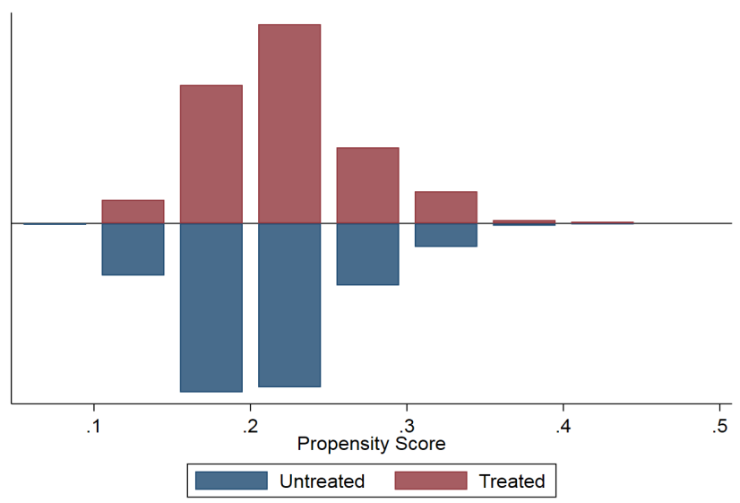
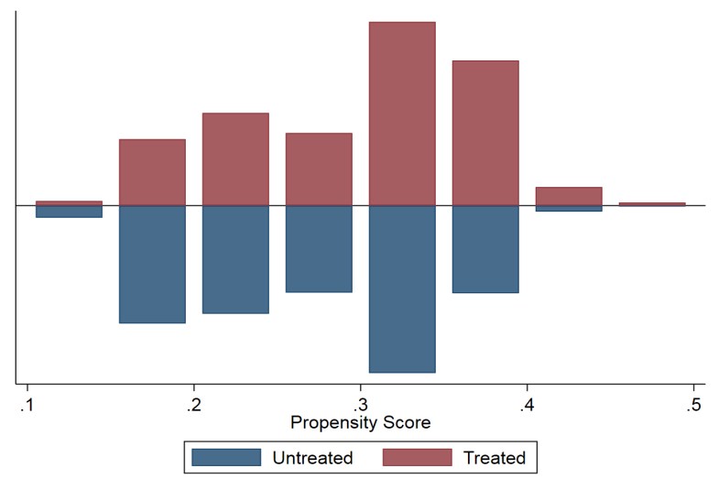
A
C
B
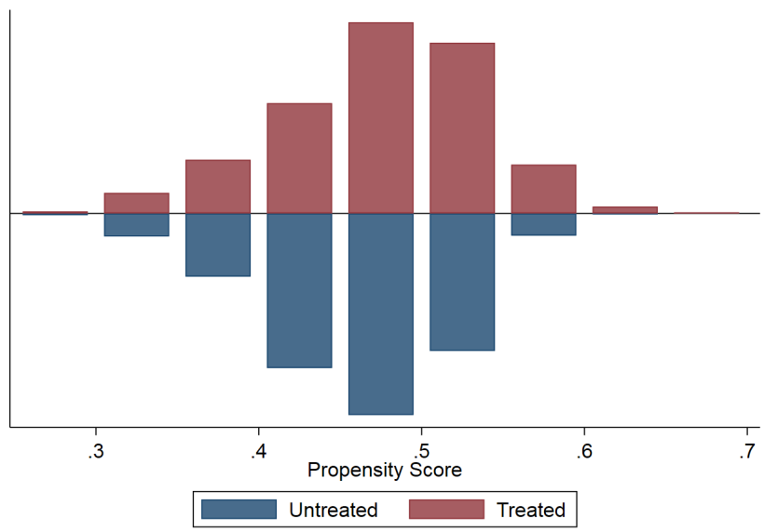
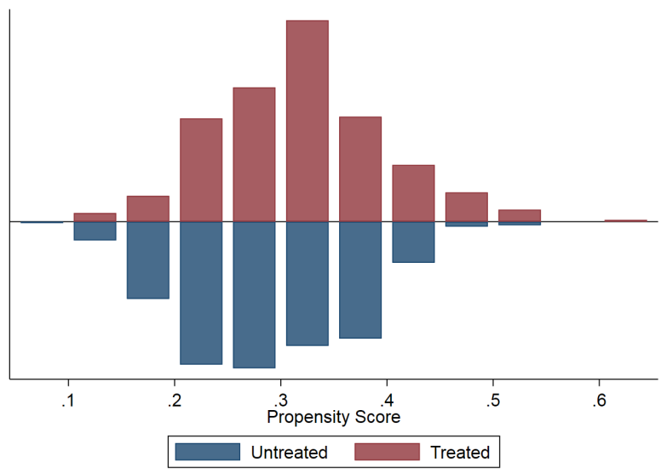
D
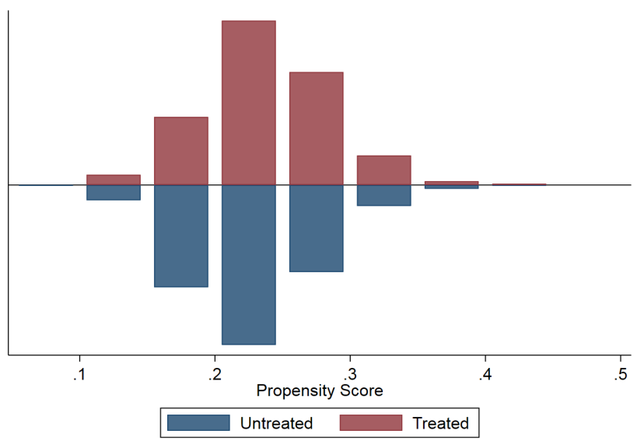
E

Figure S2. Propensity score distributions. A. Emotional abuse; B. Physical abuse; C. Sexual abuse; D. Emotional neglect; E. Physical neglect.

