Supplementary appendix

Supplementary Figure 1 | Interrupted time-series analysis for changes in mental health care use during the lockdown by sex
Supplementary Table 1 | Comparison of statistical models of the effect of the COVID-19 lockdown on mental health care utilisation
Supplementary Table 2 | Interrupted time-series analysis for changes in mental health care utilisation in the same period in 2019 (weeks 14-22) as the lockdown was introduced in 2020
Supplementary Figure 2 | Hospital admission rates for selected mental health conditions
Supplementary Figure 3 | Outpatient consultation rates for selected mental health conditions
Supplementary Figure 4 | Health care utilisation rates for selected mental health conditions

Supplementary Figure 1: Interrupted time-series analysis for changes in mental health care use during the lockdown by sex
Solid grey lines represent percentages of the study population admitted to a hospital, consulting outpatient care, or admitted to a hospital or consulting outpatient care for any mental disorder in each week between January 1, 2020, and June 1, 2020. Red lines depict the estimated average percentage admitted to a hospital, consulting outpatient care, or admitted to a hospital or consulting outpatient care for any mental disorder in a week with 95% CIs (grey shaded areas). Area between the dashed grey and dashed red line: data not used to account for anticipatory behaviour. Dashed red line: first Monday during lockdown (March 30, 2020). Dashed black line: beginning of lockdown level 4 (April 30, 2020). Lockdown: odds ratios (OR) for the immediate effect of the lockdown on mental health care utilisation rates. Weekly change: OR for the weekly change in the odds utilizing mental health care during the lockdown (week 14-22 in 2020). 95% confidence intervals for ORs in parentheses.

Supplementary Table 1. Comparison of statistical models of the effect of the COVID-19 lockdown on mental health care utilisation
 | Hospital admissions |  |  | Outpatient consultation |  |  | Any mental health care
 | Primary analysis | Sensitivity analysis |  | Primary analysis | Sensitivity analysis |  | Primary analysis | Sensitivity analysis
 | OR (95% CI) | OR (95% CI) |  | OR (95% CI) | OR (95% CI) |  | OR (95% CI) | OR (95% CI)
Any mental disorder
Lockdown | 0.38 (0.33-0.44) | 0.38 (0.32-0.47) |  | 0.74 (0.63-0.87) | 0.75 (0.73-0.77) |  | 0.74 (0.63-0.86) | 0.74 (0.72-0.76)
Weekly change | 1.07 (1.05-1.09) | 1.07 (1.03-1.10) |  | 1.03 (1.00-1.05) | 1.03 (1.02-1.03) |  | 1.03 (1.01-1.05) | 1.03 (1.02-1.03)
Organic mental disorders
Lockdown | 0.56 (0.42-0.75) | 0.55 (0.36-0.84) |  | 0.71 (0.49-1.05) | 0.71 (0.57-0.89) |  | 0.68 (0.49-0.94) | 0.68 (0.56-0.83)
Weekly change | 1.04 (0.98-1.10) | 1.04 (0.97-1.11) |  | 1.03 (0.97-1.08) | 1.03 (0.99-1.07) |  | 1.03 (0.98-1.08) | 1.03 (0.99-1.06)
Substance use disorders
Lockdown | 0.44 (0.32-0.60) | 0.43 (0.25-0.74) |  | 0.32 (0.25-0.42) | 0.32 (0.20-0.52) |  | 0.36 (0.30-0.43) | 0.36 (0.25-0.51)
Weekly change | 0.99 (0.94-1.05) | 0.99 (0.91-1.09) |  | 1.11 (1.07-1.16) | 1.11 (1.03-1.20) |  | 1.07 (1.04-1.10) | 1.07 (1.01-1.14)
Serious mental disorders
Lockdown | 0.42 (0.29-0.60) | 0.42 (0.26-0.67) |  | 0.84 (0.71-0.99) | 0.84 (0.79-0.90) |  | 0.83 (0.70-0.98) | 0.83 (0.78-0.88)
Weekly change | 1.04 (0.97-1.11) | 1.04 (0.96-1.12) |  | 1.01 (0.99-1.04) | 1.01 (1.00-1.02) |  | 1.01 (0.99-1.04) | 1.01 (1.00-1.02)
Depression
Lockdown | 0.32 (0.26-0.38) | 0.32 (0.24-0.42) |  | 0.74 (0.63-0.88) | 0.75 (0.72-0.77) |  | 0.73 (0.62-0.86) | 0.74 (0.71-0.76)
Weekly change | 1.10 (1.07-1.12) | 1.10 (1.05-1.14) |  | 1.02 (1.00-1.05) | 1.02 (1.02-1.03) |  | 1.02 (1.00-1.05) | 1.02 (1.02-1.03)
Anxiety disorders
Lockdown | 0.36 (0.25-0.52) | 0.38 (0.32-0.47) |  | 0.65 (0.55-0.77) | 0.65 (0.55-0.77) |  | 0.65 (0.55-0.77) | 0.65 (0.55-0.77)
Weekly change | 1.08 (1.02-1.14) | 1.07 (1.03-1.10) |  | 1.04 (1.02-1.06) | 1.04 (1.02-1.06) |  | 1.04 (1.02-1.06) | 1.04 (1.02-1.06)
Other mental disorders
Lockdown | 0.36 (0.12-1.10) | 0.36 (0.09-1.47) |  | 0.75 (0.61-0.91) | 0.75 (0.69-0.81) |  | 0.74 (0.61-0.91) | 0.75 (0.69-0.81)
Weekly change | 1.07 (0.91-1.25) | 1.07 (0.85-1.35) |  | 1.04 (1.01-1.07) | 1.04 (1.02-1.05) |  | 1.04 (1.01-1.07) | 1.04 (1.02-1.05)
Self-harm
Lockdown | 0.35 (0.19-0.64) | 0.34 (0.19-0.63) |  | 0.68 (0.30-1.53) | 0.67 (0.29-1.59) |  | 0.44 (0.24-0.79) | 0.42 (0.25-0.71)
Weekly change | 1.07 (0.97-1.18) | 1.07 (0.97-1.19) |  | 1.04 (0.90-1.19) | 1.04 (0.89-1.21) |  | 1.05 (0.96-1.15) | 1.06 (0.97-1.15)
Alcohol withdrawal syndrome
Lockdown | 1.36 (0.46-4.02) | 1.49 (0.12-18.31) |  | 2.11 (0.53-8.43) | 2.31 (0.16-34.02) |  | 2.24 (0.69-7.24) | 2.22 (0.28-17.62)
Weekly change | 0.62 (0.40-0.97) | 0.61 (0.28-1.36) |  | 0.63 (0.39-1.02) | 0.62 (0.27-1.42) |  | 0.50 (0.27-0.94) | 0.50 (0.22-1.15)
Data are odds ratios (OR) and 95% confidence intervals (CI) comparing two statistical models. In the primary analysis, modelled the effect of the lockdown on mental health care utilisation using a binomial generalized linear regression model with logit link and robust standard errors in Stata. In sensitivity analysis, we implemented the model used by Mansfield and colleague in R.(Mansfield et al. 2021) ORs for the lockdown measure the effect of the COVID-19 lockdown on mental health care utilisation. ORs for the weekly change measure the weekly change in the odds of mental health care utilisation during the lockdown (week 14-22 in 2020). Three types of mental health services are examined: hospital admission rates, outpatient consultation rates, and any mental health care utilisation rates including hospital admissions and outpatient consultations.
Supplementary Table 2. Interrupted time-series analysis for changes in mental health care utilisation in the same period in 2019 (weeks 14-22) as the lockdown was introduced in 2020
 | Hospital admissions | Outpatient consultation | Any mental health care
 | OR (95% CI) | OR (95% CI) | OR (95% CI)
Any mental disorder
Step change | 1.01 (0.77-1.33) | 1.02 (0.86-1.20) | 1.02 (0.86-1.20)
Weekly change | 1.00 (0.97-1.03) | 0.99 (0.97-1.01) | 0.99 (0.97-1.01)
Organic mental disorders
Step change | 0.97 (0.70-1.34) | 1.09 (0.88-1.35) | 1.05 (0.86-1.28)
Weekly change | 1.03 (0.99-1.08) | 0.98 (0.96-1.01) | 0.99 (0.97-1.02)
Substance use disorders
Step change | 1.17 (0.75-1.82) | 0.74 (0.51-1.06) | 0.95 (0.67-1.33)
Weekly change | 0.99 (0.93-1.05) | 1.05 (1.00-1.10) | 1.02 (0.97-1.06)
Serious mental disorders
Step change | 1.21 (0.91-1.62) | 0.97 (0.83-1.13) | 0.97 (0.84-1.13)
Weekly change | 0.99 (0.94-1.04) | 1.00 (0.98-1.01) | 1.00 (0.98-1.01)
Depression
Step change | 1.00 (0.74-1.35) | 1.02 (0.88-1.18) | 1.02 (0.87-1.18)
Weekly change | 1.00 (0.96-1.03) | 0.99 (0.98-1.01) | 0.99 (0.98-1.01)
Anxiety disorders
Step change | 0.97 (0.63-1.49) | 1.07 (0.86-1.32) | 1.07 (0.86-1.32)
Weekly change | 1.00 (0.94-1.06) | 0.99 (0.96-1.01) | 0.99 (0.96-1.01)
Other mental disorders
Step change | 1.89 (0.65-5.52) | 1.06 (0.86-1.31) | 1.06 (0.86-1.31)
Weekly change | 0.91 (0.79-1.04) | 0.99 (0.96-1.01) | 0.99 (0.96-1.01)
Self-harm
Step change | 1.28 (0.93-1.76) | 1.57 (0.80-3.10) | 1.19 (0.90-1.59)
Weekly change | 0.97 (0.93-1.01) | 0.98 (0.86-1.11) | 0.98 (0.94-1.02)
Alcohol withdrawal syndrome
Step change | 0.33 (0.04-2.60) | 2.62 (0.24-28.63) | 0.67 (0.16-2.93)
Weekly change | 1.02 (0.79-1.31) | 0.93 (0.64-1.36) | 0.97 (0.78-1.21)
Data are odds ratios (OR) and 95% confidence intervals (CI) for changes in mental health care in the same period in 2019 (weeks 14-22) as the lockdown was introduced in 2020. ORs for the step-change measure the immediate change in mental health care use in week 14 in 2019. ORs for the weekly change measure the change in mental health care utilisation during weeks 14-22 in 2019. Three types of mental health services are examined: hospital admission rates, outpatient consultation rates, and any mental health care utilisation rates, including hospital admissions and outpatient consultations.

Supplementary Figure 2: Hospital admission rates for selected mental health conditions
The coloured lines represent percentages of the study population admitted to a hospital for conditions in each week between January 1, 2017, and June 28, 2020. The dashed red, black, and grey lines show the beginning of lockdown levels 5, 4, and 3, respectively.
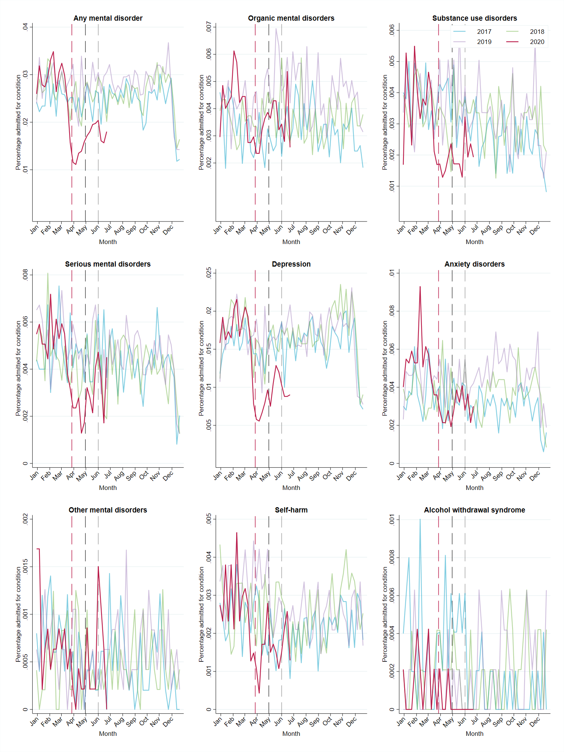

Supplementary Figure 3: Outpatient consultation rates for selected mental health conditions
The coloured lines represent percentages of the study population consulting outpatient care for conditions in each week between January 1, 2017, and June 28, 2020. The dashed red, black, and grey lines show the beginning of lockdown levels 5, 4, and 3, respectively.
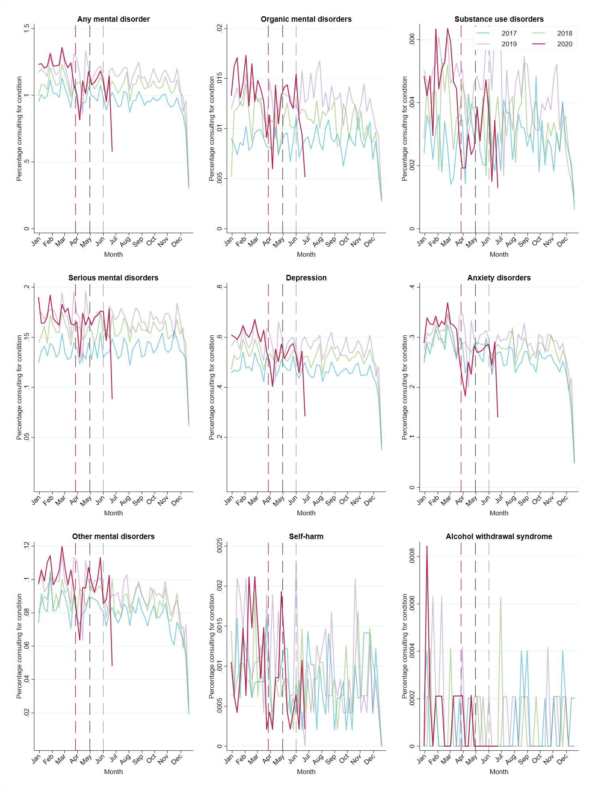
Supplementary Figure 4: Health care utilisation rates for selected mental health conditions
The coloured lines represent percentages of the study population admitted to a hospital or consulting outpatient care for conditions in each week between January 1, 2017, and June 28, 2020. The dashed red, black, and grey lines show the beginning of lockdown levels 5, 4, and 3, respectively.
