Online resource 2: Forest plots from meta-analyses
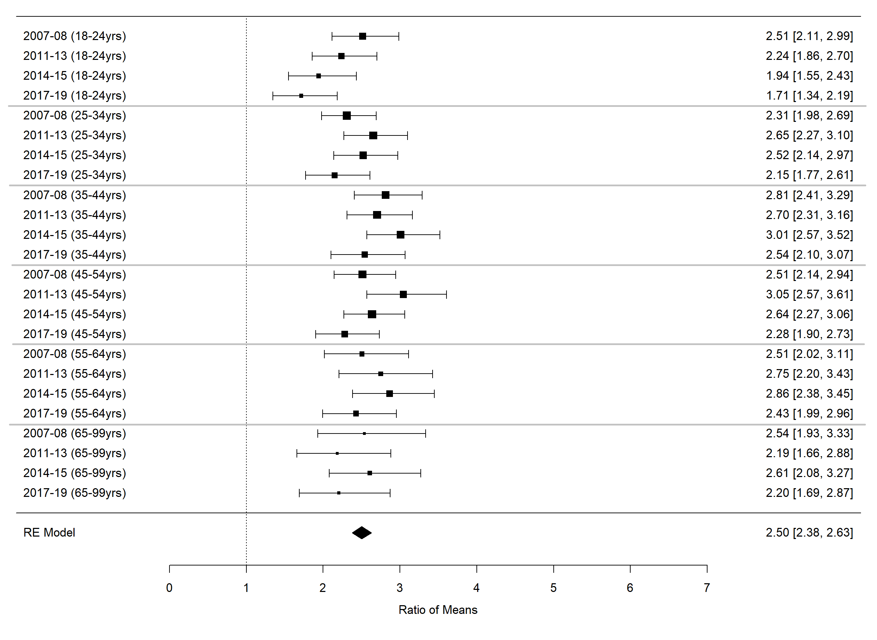
Figure 1 Forest plot of all ages meta-analysis of high/very high K5 scores combining all four survey pairs
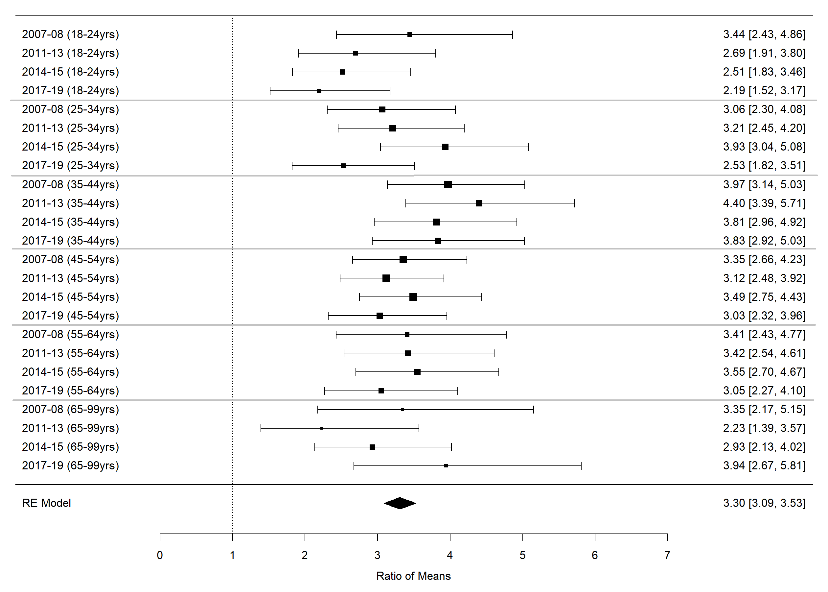
Figure 2 Forest plot of all ages meta-analysis of very high K5 scores combining all five survey pairs
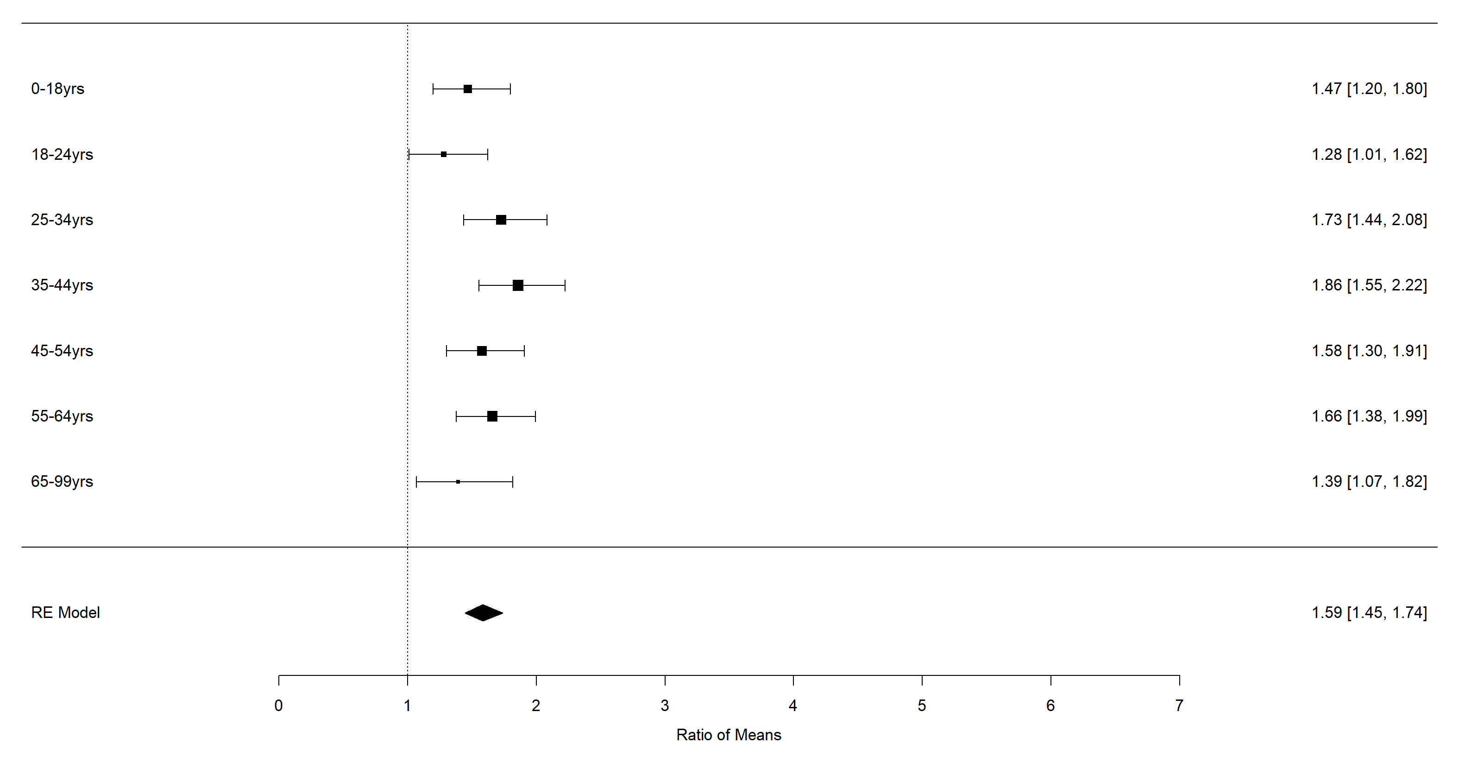
Figure 3 Forest plot of all ages meta-analysis of self-reported diagnosis in NATSIHS 2018/19 and NHS 2017/18 surveys

