Supplementary Material

Global, regional and national burden of autism spectrum disorder from 1990 to 2019: Results from the Global Burden of Disease Study 2019

Short Title: Global burden of autism spectrum disorder

Zhen Li, MPH^{1#}, Lejin Yang, PhD^{2#}, Hui Chen, MPH^{3,4}, Yuan Fang, MMed¹, Tongchao Zhang, PhD^{3,4}, Xiaolin Yin, PhD¹, Jinyu Man, PhD¹, Xiaorong Yang, PhD^{3,4*}, Ming Lu, PhD^{1,3,4*}

6 supplementary tables and 4 supplementary figures:
Table S1. Prevalence and age-standardized prevalence rate per 100,000 people for autism spectrum disorders in 1990 and 2019, and its average annual percentage change from 1990 to 2019.
Table S2. DALYs and age-standardized DALY rate per 100,000 people for autism spectrum disorders in 1990 and 2019, and its average annual percentage change from 1990 to 2019.
Table S3. The countries and territories with the ASIR/100,000 in 2019 more than 13.
Table S4. The countries and territories with the ASIR/100,000 in 2019 less than 7.5.
Table S5. The countries and territories with the EAPC in ASIR from 1990 to 2019 more than 0.1.
Table S6. The countries and territories with the EAPC in ASPR from 1990 to 2019 more than 0.1.
Figure S1. The global disease burden of autism spectrum disorder in 204 countries and territories. (A) ASPR in 2019; (B) AAPC of ASPR from 1990 to 2019; (C) Prevalent cases in 2019; (D) Relative change in prevalent cases between 1990 and 2019.
Figure S2. The annual burden and its change of autism spectrum disorder by different age groups, and SDI regions, from 1990 to 2019.
Figure S3. The factors affecting the change of age-standardized prevalence rate of autism spectrum disorder from 1990 to 2019.
Figure S4. The factors affecting the change of age-standardized DALYs rate of autism spectrum disorder from 1990 to 2019.

Table S1. Prevalence and age-standardized prevalence rate per 100,000 people for autism spectrum disorder in 1990 and 2019, and its average annual percentage change from 1990 to 2019
Characteristics | 1990 |  | 2019 |  | 1990-2019
 | Prevalent cases  No.×10⁵ (95% UI) | ASPR per 100,000  No. (95% UI) | Prevalent cases  No.×10⁵ (95% UI) | ASPR per 100,000  No. (95% UI) | AAPC in ASPR  No. (95% CI)
Overall | 203.36 (168.57 ,242.23) | 372.85 (309.07 ,444.87) | 283.25 (235.01 ,338.11) | 369.39 (305.95 ,441.19) | -0.02 (-0.03 ,-0.01)
Sex
Males | 156.48 (129.87 ,186.07) | 571.17 (473.84 ,679.63) | 216.34 (179.79 ,257.61) | 560.12 (465.19 ,667.29) | -0.05 (-0.07 ,-0.04)
Females | 46.89 (37.97 ,57.12) | 173.37 (140.93 ,211.45) | 66.91 (54.36 ,81.54) | 176.33 (142.96 ,214.46) | 0.07 (0.06 ,0.08)
SDI region
High SDI | 43.19 (36.13 ,51.02) | 539.6 (451.69 ,638.43) | 54.84 (45.87 ,65.2) | 579.32 (485.3 ,684.53) | 0.3 (0.24 ,0.36)
High-middle SDI | 46.65 (38.63 ,55.76) | 404.58 (334.91 ,483.25) | 55.2 (45.67 ,66.19) | 405.43 (335.95 ,485.02) | 0.01 (0.01 ,0.01)
Middle SDI | 56.99 (46.68 ,69.01) | 319.69 (262.68 ,387.21) | 75.67 (62.2 ,91.44) | 321.44 (264.5 ,388.03) | 0.01 (0 ,0.02)
Low-middle SDI | 37.11 (30.58 ,44.5) | 311.5 (257.2 ,373.87) | 56.13 (46.21 ,67.4) | 312.82 (258.23 ,375.69) | 0.01 (0.01 ,0.01)
Low SDI | 19.31 (15.93 ,23.29) | 340.49 (280.16 ,408.27) | 41.25 (34.02 ,49.66) | 342.19 (281.4 ,410.17) | 0.01 (0.01 ,0.02)
GBD region
High-income Asia Pacific | 10.47 (8.72 ,12.44) | 617.81 (514.98 ,734.67) | 10.78 (8.96 ,12.89) | 634.26 (528.79 ,756.68) | 0.1 (0.08 ,0.12)
High-income North America | 14.35 (12.1 ,16.86) | 526.24 (443.35 ,617.9) | 21.86 (18.34 ,25.87) | 640.03 (537.66 ,756.44) | 0.83 (0.68 ,0.97)
Western Europe | 21.13 (17.73 ,25.08) | 573.65 (482.69 ,679.91) | 23.55 (19.68 ,27.91) | 581.33 (488.23 ,686.41) | 0.05 (0.04 ,0.05)
Australasia | 0.87 (0.73 ,1.04) | 436.83 (364.31 ,521.81) | 1.2 (1 ,1.44) | 436.11 (363.84 ,521.21) | 0 (0 ,0)
Southern Latin America | 2.4 (2 ,2.88) | 480.81 (399.33 ,576.62) | 3.13 (2.6 ,3.76) | 482.49 (400.85 ,579.04) | 0.01 (0.01 ,0.01)
Andean Latin America | 1.37 (1.13 ,1.65) | 340.36 (280.93 ,408.52) | 2.19 (1.81 ,2.63) | 342.12 (282.37 ,410.5) | 0.02 (0.02 ,0.02)
Tropical Latin America | 5.63 (4.65 ,6.74) | 353.93 (291.98 ,425.42) | 7.74 (6.39 ,9.31) | 353.87 (291.96 ,425.28) | 0 (0 ,0)
Central Latin America | 6.09 (5.02 ,7.26) | 351.69 (289.59 ,420.59) | 8.75 (7.2 ,10.47) | 350.86 (288.77 ,419.47) | -0.01 (-0.01 ,0)
Caribbean | 1.25 (1.03 ,1.5) | 344.18 (283.98 ,414.13) | 1.6 (1.32 ,1.92) | 343.78 (283.7 ,413.6) | 0 (0 ,0)
Eastern Europe | 8.67 (7.17 ,10.39) | 394.77 (326.14 ,472.79) | 7.73 (6.39 ,9.28) | 397.35 (328.27 ,476.04) | 0.02 (0.02 ,0.02)
Central Europe | 4.45 (3.67 ,5.33) | 370.47 (305.76 ,443.35) | 3.94 (3.25 ,4.72) | 373.57 (308.39 ,446.94) | 0.03 (0.03 ,0.04)
Central Asia | 2.68 (2.21 ,3.21) | 371.74 (305.94 ,446.85) | 3.55 (2.91 ,4.27) | 374.83 (308 ,450.95) | 0.03 (0.03 ,0.03)
North Africa and Middle East | 11.06 (9.12 ,13.27) | 303.49 (250.39 ,365.48) | 18.8 (15.51 ,22.62) | 304.41 (251.21 ,366.07) | 0.01 (0.01 ,0.01)
South Asia | 33.7 (27.68 ,40.62) | 291.87 (240.09 ,351.92) | 53.11 (43.56 ,64.07) | 290.02 (238.4 ,349.24) | -0.03 (-0.03 ,-0.03)
Southeast Asia | 15.19 (12.53 ,18.25) | 310.47 (256.1 ,373.22) | 20.97 (17.3 ,25.15) | 312.48 (257.7 ,374.43) | 0.02 (0.02 ,0.03)
East Asia | 44.13 (36.24 ,53.09) | 353.46 (290.35 ,425.39) | 50.99 (42.06 ,61.5) | 367.78 (304.36 ,441.91) | 0.13 (0.12 ,0.14)
Oceania | 0.2 (0.16 ,0.24) | 290.01 (236.83 ,350.41) | 0.4 (0.33 ,0.49) | 289.04 (235.46 ,349.03) | -0.01 (-0.01 ,0)
Western Sub-Saharan Africa | 7.69 (6.35 ,9.18) | 375.3 (309.56 ,448.99) | 18.08 (14.9 ,21.6) | 370.63 (305.52 ,443.32) | -0.05 (-0.06 ,-0.04)
Eastern Sub-Saharan Africa | 7.76 (6.39 ,9.27) | 378.24 (311.66 ,454.2) | 16.67 (13.72 ,19.92) | 378.35 (311.75 ,454.44) | 0 (0 ,0)
Central Sub-Saharan Africa | 2.22 (1.81 ,2.67) | 370.44 (302.99 ,446.34) | 5.23 (4.26 ,6.28) | 370.83 (303.29 ,446.87) | 0 (0 ,0.01)
Southern Sub-Saharan Africa | 2.05 (1.68 ,2.45) | 369.4 (302.94 ,444.78) | 2.99 (2.45 ,3.59) | 371.59 (304.94 ,447.74) | 0.02 (0.02 ,0.03)
No., number; ASPR, age-standardized prevalence rate; UI, uncertainty interval; AAPC, average annual percentage change; CI, confidential interval.

Table S2. DALYs and age-standardized DALY rate per 100,000 people for autism spectrum disorder in 1990 and 2019, and its average annual percentage change from 1990 to 2019
Characteristics | 1990 |  | 2019 |  | 1990-2019
 | DALYs  No.×10⁵ (95% UI) | ASDR per 100,000  No. (95% UI) | DALYs  No.×10⁵ (95% UI) | ASDR per 100,000  No. (95% UI) | AAPC in ASDR  No. (95% CI)
Overall | 31.06 (20.25 ,45.14) | 56.69 (37.01 ,82.21) | 43.07 (28.22 ,62.32) | 56.26 (36.82 ,81.52) | -0.02 (-0.03 ,0)
Sex
Males | 23.94 (15.6 ,34.44) | 86.87 (56.7 ,125.14) | 32.94 (21.53 ,47.69) | 85.34 (55.77 ,123.55) | -0.05 (-0.06 ,-0.03)
Females | 7.12 (4.68 ,10.41) | 26.23 (17.22 ,38.23) | 10.12 (6.63 ,14.77) | 26.75 (17.54 ,39.16) | 0.08 (0.07 ,0.08)
SDI region
High SDI | 6.55 (4.29 ,9.32) | 82.24 (53.77 ,117.37) | 8.23 (5.42 ,11.75) | 88.19 (57.85 ,126.31) | 0.3 (0.24 ,0.35)
High-middle SDI | 7.13 (4.65 ,10.33) | 61.81 (40.34 ,89.52) | 8.38 (5.46 ,12.12) | 62.11 (40.45 ,89.8) | 0.02 (0.02 ,0.02)
Middle SDI | 8.76 (5.7 ,12.85) | 48.84 (31.84 ,71.55) | 11.55 (7.55 ,16.8) | 49.2 (32.13 ,71.58) | 0.02 (0.01 ,0.03)
Low-middle SDI | 5.67 (3.73 ,8.28) | 47.17 (31.01 ,68.47) | 8.57 (5.62 ,12.45) | 47.6 (31.17 ,69.08) | 0.03 (0.02 ,0.03)
Low SDI | 2.94 (1.92 ,4.27) | 51.31 (33.63 ,74.49) | 6.31 (4.15 ,9.18) | 51.87 (34.07 ,75.17) | 0.04 (0.04 ,0.04)
GBD region
High-income Asia Pacific | 1.6 (1.04 ,2.3) | 94.54 (61.56 ,136.39) | 1.62 (1.07 ,2.34) | 97.27 (63.55 ,141.02) | 0.11 (0.09 ,0.13)
High-income North America | 2.17 (1.42 ,3.08) | 79.9 (52.33 ,113.3) | 3.26 (2.15 ,4.63) | 96.85 (63.73 ,137.74) | 0.81 (0.67 ,0.96)
Western Europe | 3.2 (2.09 ,4.55) | 87.5 (57.14 ,124.96) | 3.54 (2.33 ,5.05) | 88.69 (58.11 ,127.11) | 0.05 (0.05 ,0.05)
Australasia | 0.13 (0.09 ,0.19) | 66.36 (43.63 ,94.27) | 0.18 (0.12 ,0.26) | 66.29 (43.48 ,96.12) | 0 (0 ,0)
Southern Latin America | 0.37 (0.24 ,0.53) | 73.5 (47.53 ,105.38) | 0.48 (0.31 ,0.69) | 73.75 (47.9 ,106.24) | 0.01 (0.01 ,0.01)
Andean Latin America | 0.21 (0.14 ,0.31) | 51.89 (33.88 ,75.6) | 0.34 (0.22 ,0.49) | 52.34 (34.4 ,75.85) | 0.03 (0.03 ,0.04)
Tropical Latin America | 0.86 (0.56 ,1.25) | 53.77 (35.15 ,78.18) | 1.18 (0.77 ,1.7) | 53.89 (35.19 ,78.04) | 0.01 (0.01 ,0.01)
Central Latin America | 0.94 (0.61 ,1.35) | 53.66 (35.1 ,77.27) | 1.34 (0.87 ,1.95) | 53.63 (35 ,78.16) | -0.01 (-0.01 ,0)
Caribbean | 0.19 (0.13 ,0.27) | 52.5 (34.48 ,75.81) | 0.24 (0.16 ,0.35) | 52.35 (34.18 ,75.93) | 0 (-0.01 ,0)
Eastern Europe | 1.31 (0.85 ,1.91) | 60.17 (39.23 ,87.33) | 1.17 (0.76 ,1.69) | 60.77 (39.61 ,87.83) | 0.03 (0.03 ,0.04)
Central Europe | 0.68 (0.44 ,0.97) | 56.49 (36.63 ,81.21) | 0.59 (0.39 ,0.85) | 57.12 (37.25 ,81.98) | 0.04 (0.04 ,0.05)
Central Asia | 0.41 (0.27 ,0.6) | 56.85 (37.3 ,82.67) | 0.54 (0.36 ,0.79) | 57.38 (37.65 ,83.16) | 0.04 (0.03 ,0.04)
North Africa and Middle East | 1.7 (1.11 ,2.48) | 46.27 (30.23 ,67.59) | 2.88 (1.88 ,4.19) | 46.44 (30.44 ,67.49) | 0.01 (0.01 ,0.02)
South Asia | 5.13 (3.38 ,7.48) | 44 (28.98 ,64.38) | 8.08 (5.3 ,11.76) | 43.99 (28.87 ,63.89) | 0 (-0.01 ,0)
Southeast Asia | 2.33 (1.52 ,3.43) | 47.33 (30.91 ,69.49) | 3.21 (2.08 ,4.7) | 47.84 (31 ,70.1) | 0.04 (0.04 ,0.05)
East Asia | 6.8 (4.44 ,9.96) | 54.3 (35.45 ,79.55) | 7.78 (5.1 ,11.3) | 56.65 (36.98 ,82.7) | 0.14 (0.13 ,0.15)
Oceania | 0.03 (0.02 ,0.04) | 44.03 (28.67 ,63.91) | 0.06 (0.04 ,0.09) | 43.88 (28.6 ,63.17) | 0 (-0.01 ,0)
Western Sub-Saharan Africa | 1.17 (0.77 ,1.69) | 56.7 (37.18 ,81.59) | 2.77 (1.81 ,4.01) | 56.25 (36.94 ,81.27) | -0.03 (-0.04 ,-0.02)
Eastern Sub-Saharan Africa | 1.18 (0.78 ,1.71) | 57.07 (37.3 ,82.62) | 2.56 (1.68 ,3.69) | 57.43 (37.74 ,83.06) | 0.03 (0.03 ,0.03)
Central Sub-Saharan Africa | 0.34 (0.22 ,0.49) | 55.68 (36.08 ,80.29) | 0.8 (0.53 ,1.16) | 56.15 (37.14 ,81.36) | 0.03 (0.03 ,0.04)
Southern Sub-Saharan Africa | 0.31 (0.21 ,0.46) | 56.17 (36.71 ,81.33) | 0.46 (0.3 ,0.66) | 56.43 (36.96 ,81.43) | 0.02 (0.01 ,0.03)
DALYs, disability-Adjusted Life Years; ASDR, age-standardized DALY rate; No., number; UI, uncertainty interval; AAPC, average annual percentage change; CI, confidential interval.

Table S3. The countries and territories with the ASIR/100,000 in 2019 more than 13
Number | Location | ASIR/100,000 in 2019  No. (95% UI) | ASPR/100,000 in 2019  No. (95% UI) | Age-standardized  DALYs rate /100,000 in 2019  No. (95% UI)
1 | Andorra | 18.56 (15.30, 22.28) | 580.42 (476.09, 699.49) | 88.64 (57.68, 127.47)
2 | United Kingdom | 17.95 (14.99, 21.20) | 739.60 (617.23, 876.26) | 112.29 (73.69, 160.47)
3 | Sweden | 17.12 (14.37, 20.23) | 706.81 (589.11, 838.48) | 107.95 (71.19, 155.26)
4 | Japan | 16.65 (13.95, 19.68) | 676.47 (562.79, 804.98) | 103.78 (67.70, 149.66)
5 | United States of America | 16.53 (13.83, 19.47) | 643.41 (535.12, 763.63) | 97.27 (63.96, 138.80)
6 | Canada | 15.18 (13.10, 17.33) | 608.11 (526.78, 696.64) | 92.85 (62.45, 131.90)
7 | Netherlands | 15.15 (12.42, 18.19) | 629.63 (515.21, 754.73) | 96.31 (62.18, 137.94)
8 | Ireland | 15.01 (12.40, 17.90) | 607.28 (500.51, 727.21) | 92.54 (60.42, 134.48)
9 | Brunei Darussalam | 14.85 (12.22, 17.84) | 569.59 (469.25, 686.18) | 87.06 (57.08, 125.40)
10 | Singapore | 14.46 (11.95, 17.31) | 588.14 (485.35, 707.63) | 90.26 (58.81, 131.74)
11 | Spain | 14.35 (11.88, 17.12) | 579.47 (479.19, 701.46) | 88.60 (58.13, 128.07)
12 | Cyprus | 13.94 (11.56, 16.56) | 562.31 (465.84, 671.98) | 85.91 (56.07, 123.95)
13 | Switzerland | 13.90 (11.51, 16.64) | 573.42 (470.69, 688.37) | 87.58 (57.12, 126.32)
14 | Greece | 13.88 (11.56, 16.67) | 562.32 (466.93, 679.66) | 85.88 (55.96, 124.97)
15 | Republic of Korea | 13.88 (11.48, 16.51) | 548.87 (452.67, 653.65) | 84.14 (53.82, 121.94)
16 | Malta | 13.87 (11.41, 16.50) | 578.42 (473.90, 692.34) | 88.25 (57.01, 127.37)
17 | Italy | 13.85 (11.55, 16.47) | 567.88 (471.19, 675.07) | 86.65 (56.72, 124.44)
18 | Austria | 13.85 (11.40, 16.40) | 567.53 (468.28, 675.26) | 86.63 (56.40, 125.49)
19 | Portugal | 13.75 (11.33, 16.34) | 547.75 (449.41, 654.95) | 83.58 (53.99, 123.19)
20 | Belgium | 13.73 (11.42, 16.42) | 563.27 (464.75, 677.08) | 85.91 (56.12, 123.52)
21 | San Marino | 13.68 (11.28, 16.27) | 560.42 (457.64, 669.86) | 85.50 (55.90, 123.96)
22 | Iceland | 13.66 (11.35, 16.14) | 566.11 (471.10, 673.23) | 86.48 (56.61, 124.12)
23 | Luxembourg | 13.63 (11.29, 16.23) | 571.42 (470.43, 687.47) | 87.15 (56.11, 125.62)
24 | Finland | 13.55 (11.24, 16.16) | 557.68 (460.85, 666.13) | 85.11 (56.24, 121.59)
25 | Germany | 13.44 (11.11, 16.14) | 572.32 (467.38, 687.17) | 87.30 (56.72, 127.14)
ASIR, age-standardized incidence rate; ASPR, age-standardized prevalence rate; DALYs, disability-adjusted life years; No., number; UI, uncertainty interval.

Table S4. The countries and territories with the ASIR/100,000 in 2019 less than 7.5
Number | Location | ASIR/100,000 in 2019  No. (95% UI) | ASPR/100,000 in 2019  No. (95% UI) | Age-standardized DALYs rate/100,000 in 2019  No. (95% UI)
1 | Turkey | 7.48 (6.11, 9.07) | 293.29 (239.39, 355.85) | 44.86 (29.48, 66.22)
2 | Palestine | 7.48 (6.05, 9.01) | 292.12 (237.83, 353.58) | 44.41 (28.86, 64.37)
3 | Egypt | 7.46 (6.02, 9.06) | 292.22 (237.95, 353.92) | 44.71 (29.06, 64.61)
4 | Vanuatu | 7.46 (6.01, 9.04) | 287.75 (233.17, 346.44) | 43.87 (28.46, 64.57)
5 | United Arab Emirates | 7.45 (6.03, 9.01) | 331.17 (271.91, 400.76) | 50.47 (32.96, 73.53)
6 | Bahrain | 7.45 (6.04, 8.99) | 316.59 (255.93, 382.93) | 48.28 (31.69, 70.79)
7 | Saudi Arabia | 7.45 (6.04, 8.99) | 310.90 (253.18, 375.59) | 47.36 (30.76, 68.71)
8 | Syrian Arab Republic | 7.43 (6.07, 8.93) | 283.93 (231.29, 345.36) | 43.17 (28.56, 63.41)
9 | Iraq | 7.42 (6.02, 8.93) | 286.79 (231.92, 345.87) | 43.77 (28.67, 64.01)
10 | Tuvalu | 7.40 (6.02, 8.95) | 290.74 (236.48, 351.21) | 44.46 (29.12, 65.07)
11 | Kuwait | 7.38 (6.02, 8.93) | 304.97 (247.99, 370.05) | 46.58 (30.59, 68.50)
12 | Libya | 7.30 (6.04, 8.82) | 286.49 (235.17, 347.91) | 43.69 (28.57, 64.41)
13 | Tonga | 7.28 (5.94, 8.83) | 287.17 (233.44, 347.73) | 43.96 (28.36, 63.67)
14 | Jordan | 7.28 (5.93, 8.78) | 299.86 (246.04, 364.22) | 45.97 (30.11, 67.85)
15 | Qatar | 7.26 (5.90, 8.74) | 344.73 (283.23, 415.71) | 52.57 (34.00, 75.94)
16 | Oman | 7.10 (5.79, 8.52) | 302.97 (248.16, 366.04) | 46.30 (30.65, 67.91)
17 | Democratic People's Republic of Korea | 6.93 (5.61, 8.38) | 261.44 (212.16, 315.85) | 40.26 (25.94, 58.92)
18 | Samoa | 6.93 (5.63, 8.36) | 294.05 (239.40, 354.77) | 44.88 (29.13, 66.51)
19 | Taiwan (Province of China) | 5.44 (4.61, 6.41) | 215.82 (183.19, 256.44) | 33.31 (22.06, 47.89)
ASIR, age-standardized incidence rate; ASPR, age-standardized prevalence rate; DALYs, disability-adjusted life years; No., number; UI, uncertainty interval.

Table S5. The countries and territories with the AAPC in ASIR from 1990 to 2019 more than 0.1
Number | Location | AAPC in ASIR  No. (95% CI) | AAPC in ASPR  No. (95% CI) | AAPC in Age-standardized DALYs rate  No. (95% CI)
1 | USA | 0.87（0.73，1.02） | 0.91（0.75，1.07） | 0.9（0.74，1.06）
2 | Andorra | 0.51（0.35，0.67） | -0.07（-0.08，-0.06） | -0.07（-0.09，-0.06）
3 | Syria | 0.2（-0.01，0.4） | -0.09（-0.13，-0.05） | -0.11（-0.15，-0.15）
4 | Japan | 0.18（0.16，0.2） | 0.17（0.14，0.19） | 0.17（0.14，0.2）
5 | Albania | 0.18（0.07，0.29） | -0.01（-0.03，0.01） | 0.01（-0.01，0.03）
6 | Afghanistan | 0.17（0.03，0.3） | 0.05（0.04，0.06） | 0.08（0.07，0.09）
7 | Brunei | 0.16（0.13，0.18） | 0（-0.03，0.03） | 0.01（-0.02，0.04）
8 | South Sudan | 0.15（0.05，0.25） | -0.11（-0.12，-0.09） | -0.1（-0.11，-0.08）
9 | Venezuela | 0.14（0.06，0.23） | 0.01（0，0.02） | 0.01（0，0.02）
10 | Azerbaijan | 0.13（0.04，0.22） | 0.08（0.08，0.09） | 0.09（0.08，0.09）
11 | Greece | 0.12（0.1，0.15） | -0.01（-0.02，0） | -0.01（-0.02，0）
12 | Argentina | 0.12（0.1，0.15） | 0.01（0.01，0.01） | 0.01（0.01，0.01）
13 | Georgia | 0.12（0.09，0.16） | 0.07（0.06，0.06） | 0.06（0.05，0.07）
14 | Croatia | 0.12（0.09，0.15） | 0.03（0.02，0.03） | 0.03（0.03，0.04）
15 | San Marino | 0.11（0.1，0.01） | -0.05（-0.06，-0.05） | -0.06（-0.07，-0.05）
16 | France | 0.10（0.08，0.08） | 0.08（0.07，0.09） | 0.08（0.07，0.1）
17 | Northern Mariana Islands | 0.10（0.01，0.18） | -0.02（-0.07，0.03） | -0.02（-0.08，0.03）
ASIR, age-standardized incidence rate; ASPR, age-standardized prevalence rate; DALYs, disability-adjusted life years; No., number; AAPC, average annual percentage change; CI, confidential interval.

Table S6. The countries and territories with the AAPC in ASPR from 1990 to 2019 more than 0.1
Number | Location | AAPC in ASIR  No. (95% CI) | AAPC in ASPR  No. (95% CI) | AAPC in age-standardized DALYs rate  No. (95% CI)
S1 | USA | 0.87 (0.73, 0.73) | 0.91 (0.75, 1.07) | 0.9 (0.74, 1.06)
2 | Maldives | 0.05 (0.02, 0.07) | 0.2 (0.14, 0.26) | 0.24 (0.18, 0.3)
3 | Qatar | -0.12 (-0.15, -0.09) | 0.2 (0.16, 0.25) | 0.2 (0.150.25,)
4 | Equatorial Guinea | -0.04 (-0.05, -0.03) | 0.19 (0.18, 0.21) | 0.25 (0.23, 0.26)
5 | Japan | 0.18 (0.16, 0.2) | 0.17 (0.14, 0.19) | 0.17 (0.14, 0.2)
6 | Tuvalu | -0.15 (-0.2, -0.11) | 0.17 (0.17, 0.18) | 0.17 (0.16, 0.18)
7 | North Korea | -0.25 (-0.31, -0.2) | 0.16 (0.15, 0.16) | 0.16 (0.15, 0.17)
8 | Cape Verde | 0.08 (0.04, 0.12) | 0.14 (0.14, 0.14) | 0.14 (0.14, 0.15)
9 | China | 0.02 (-0.06, 0.09) | 0.13 (0.13, 0.14) | 0.14 (0.13, 0.15)
10 | Palau | -0.04 (-0.08, 0.01) | 0.12 (0.07, 0.16) | 0.11 (0.07, 0.15)
11 | Tokelau | -0.19 (-0.29, -0.1) | 0.12 (0.1, 0.14) | 0.11 (0.09, 0.14)
12 | Seychelles | -0.04 (-0.04, -0.04) | 0.11 (0.09, 0.12) | 0.11 (0.09, 0.12)
13 | Sweden | 0.02 (-0.01, -0.05) | 0.1 (0.1, 0.11) | 0.11 (0.1, 0.11)
ASIR, age-standardized incidence rate; ASPR, age-standardized prevalence rate; DALYs, disability-adjusted life years; No., number; AAPC, average annual percentage change; CI, confidential interval.

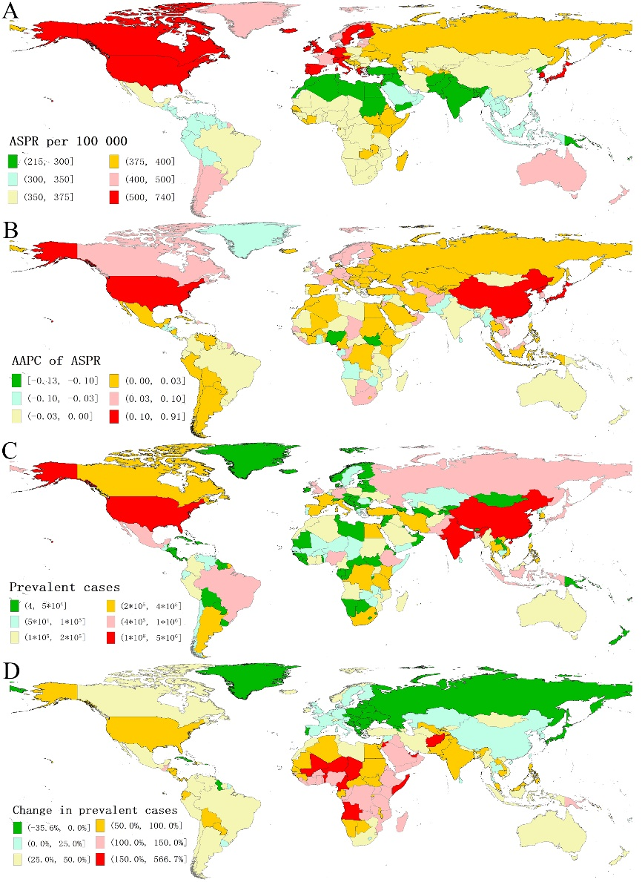
Figure S1. The global disease burden of autism spectrum disorder in 204 countries and territories. (A) ASPR in 2019; (B) AAPC of ASPR from 1990 to 2019; (C) Prevalent cases in 2019; (D) Relative change in prevalent cases between 1990 and 2019. ASPR, age-standardized prevalence rate; AAPC, average annual percentage change. 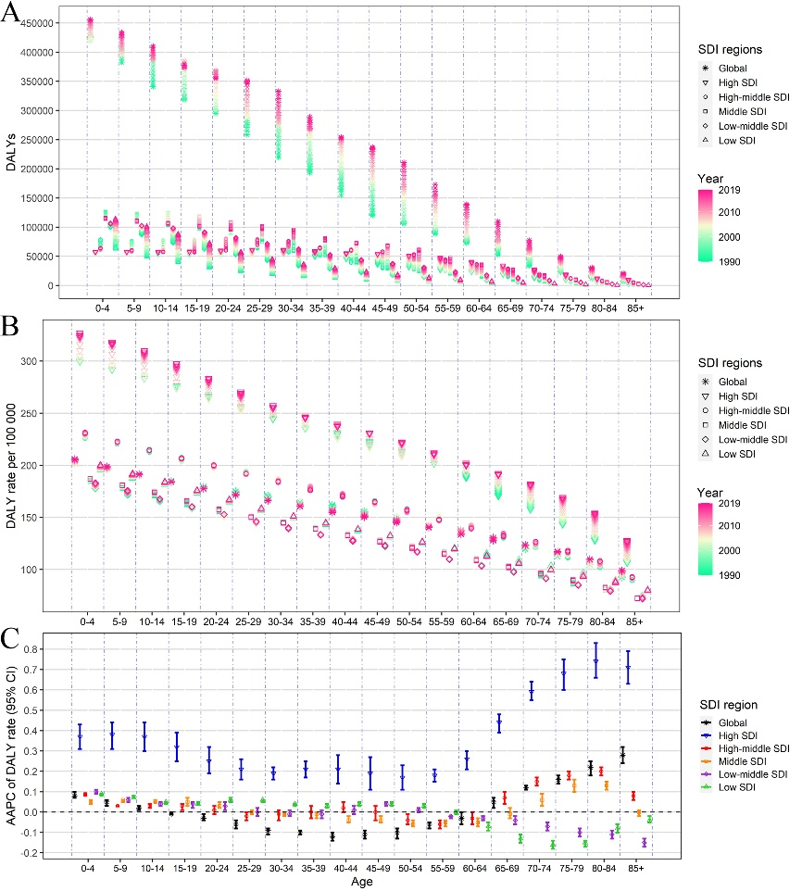
Figure S2. The annual burden and its change of autism spectrum disorder by different age groups, and SDI regions, from 1990 to 2019. (A) DALYs; (B) DALY rate; (C) AAPC of DALY rate. SDI, sociodemographic index; DALYs, disability-adjusted life-years; AAPC, average annual percentage change.

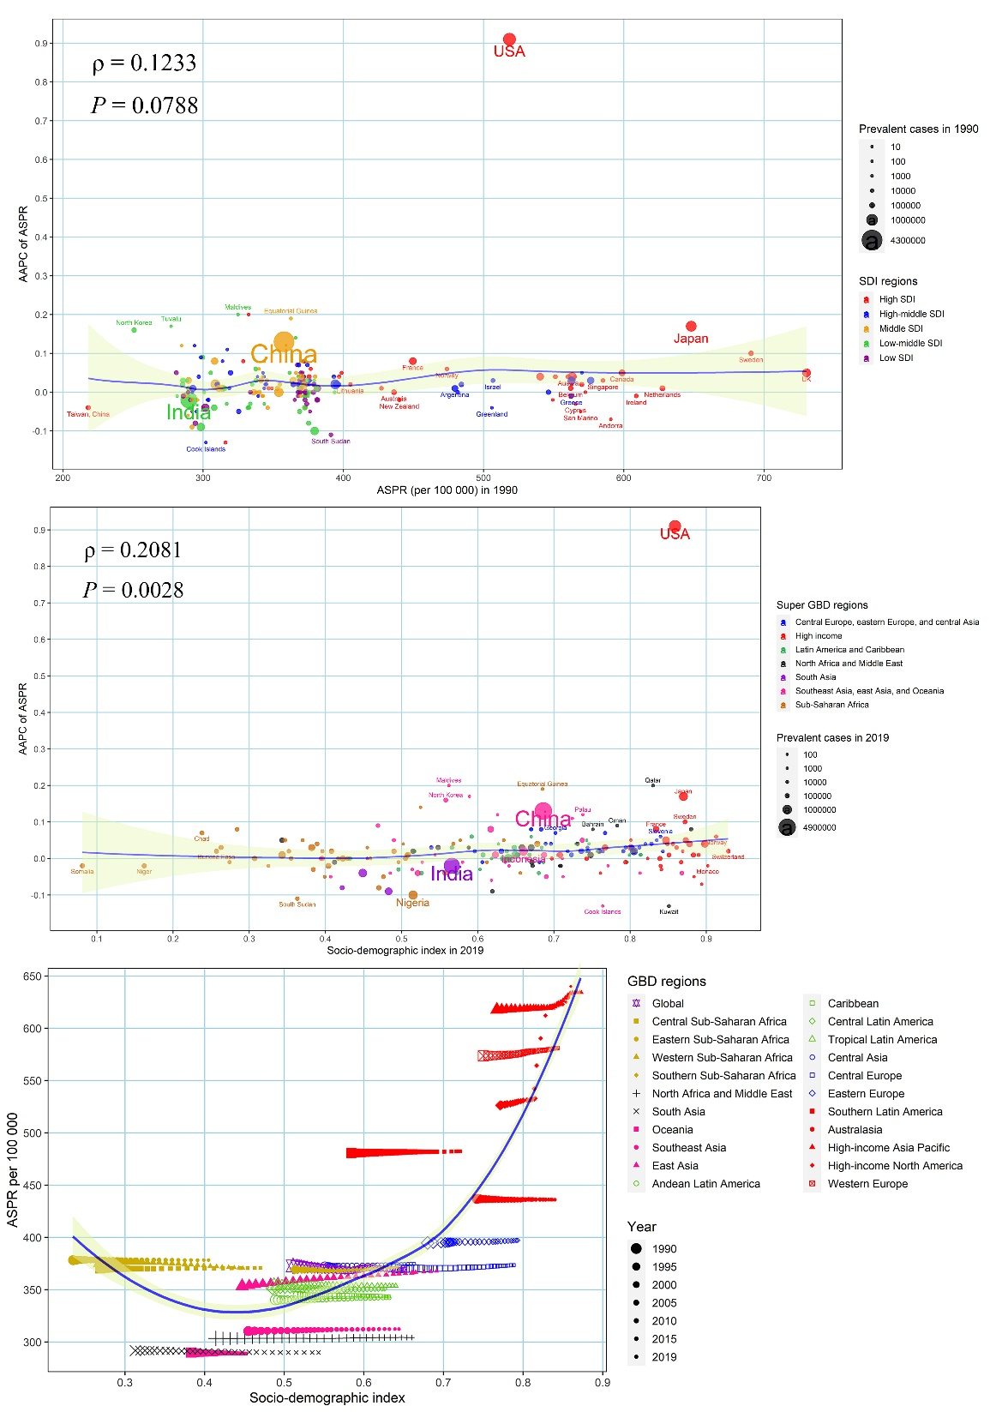
Figure S3. The factors affecting the change of age-standardized prevalence rate of autism spectrum disorder from 1990 to 2019. (A) ASPR in 1990 and AAPC of ASPR at the national level; (B) SDI in 2019 and AAPC of ASPR at the national level; (C) Annual change in ASPR along with the SDI across 21 GBD regions from 1990 to 2019. The blue line was an adaptive association fitted with Loess regression based on all data points. The ρ indices and P values were derived using Spearman rank analysis. ASPR, age-standardized prevalence rate; AAPC, average annual percentage change; SDI, socio-demographic index; GBD, Global Burden of Disease Study.

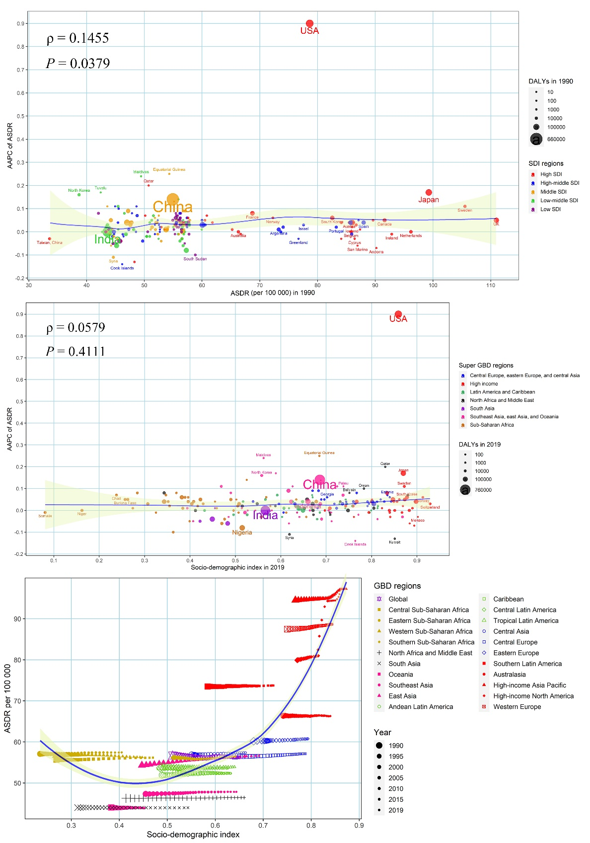
Figure S4. The factors affecting the change of age-standardized DALYs rate of autism spectrum disorder from 1990 to 2019. (A) ASDR in 1990 and AAPC of ASDR at the national level; (B) SDI in 2019 and AAPC of ASDR at the national level; (C) Annual change in ASDR along with the SDI across 21 GBD regions from 1990 to 2019. The blue line was an adaptive association fitted with Loess regression based on all data points. The ρ indices and P values were derived using Spearman rank analysis. ASDR, age-standardized DALYs rate; AAPC, average annual percentage change; SDI, socio-demographic index; GBD, Global Burden of Disease Study.

