Psychometric properties of a brief, self-report measure of social inclusion - the F-SIM16
(Supplementary material)
Figure S1
Tetrachoric Correlation Coefficients (Associated P-value) Between the Individual Items of the F-SIM16
. * Reverse scored items; *** p-value<0.001

Figure S2
MDS Network Plot of Tetrachoric Correlation Coefficients Between the Individual Items of the F-SIM16

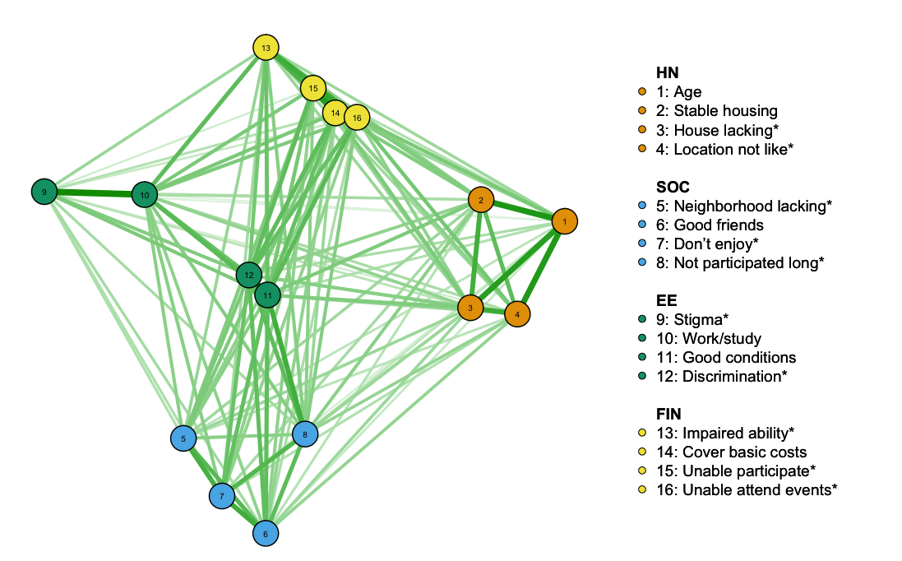
* Reverse scored items

Table S1
Fitting Indices of Three CFA models based on 488 records with complete data
Model | Chi2 | df | RMSEA | CFI | TLI
One-factor CFA | 640 | 104 | 0.103 | 0.93 | 0.92
Four-factor CFA | 90 | 98 | 0.001 | 1.00 | 1.00
Second-order CFA | 105 | 100 | 0.010 | 1.00 | 1.00

Table S2
Responses for the Total Cohort and 5 Population Groups for F-SIM16 Items, Total Score and Sub-domain Total Scores
 | Overall  (N = 506) | Young Psychosis  (N = 149) | Young Clinical Not Psychosis  (N = 26) | Young General Community  (N = 163) | Older Clinical  (N = 64) | Older General Community  (N = 104 )
Housing and Neighbourhood (HN)
Stable housing | 489 (97%) | 135 (91%) | 26 (100%) | 160 (98%) | 64 (100%) | 104 (100%)
House hacking | 73 (15%) | 35 (24%) | 7 (28%) | 12 (7.4%) | 10 (16%) | 9 (8.7%)
Location not like | 115 (23%) | 53 (36%) | 6 (24%) | 25 (15%) | 21 (33%) | 10 (9.6%)
Neighborhood lacking | 85 (17%) | 46 (31%) | 5 (20%) | 16 (9.8%) | 11 (17%) | 7 (6.8%)
HN total score | 86 (25) | 75 (32) | 82 (23) | 91 (20) | 84 (22) | 94 (15)
Social Relationships, Participation and Limitations (SOC)
Good friends | 378 (75%) | 80 (54%) | 18 (69%) | 144 (88%) | 46 (73%) | 90 (87%)
Don’t enjoy | 261 (52%) | 118 (79%) | 22 (85%) | 65 (40%) | 34 (53%) | 22 (21%)
Not participated long | 221 (44%) | 101 (68%) | 20 (77%) | 53 (33%) | 27 (42%) | 20 (19%)
Stigma | 134 (27%) | 71 (48%) | 11 (42%) | 24 (15%) | 22 (34%) | 6 (5.8%)
SOC total score | 63 (34) | 40 (31) | 41 (32) | 75 (28) | 61 (35) | 85 (23)
Employment and Education (EE)
Work/study | 440 (87%) | 114 (77%) | 23 (92%) | 153 (94%) | 53 (83%) | 97 (94%)
Good conditions | 385 (77%) | 80 (54%) | 20 (80%) | 149 (92%) | 44 (70%) | 92 (91%)
Discrimination | 115 (23%) | 77 (52%) | 11 (44%) | 8 (4.9%) | 19 (31%) | 0 (0%)
Impaired ability | 187 (37%) | 114 (77%) | 19 (79%) | 6 (3.7%) | 40 (66%) | 8 (7.8%)
EE total score | 76 (31) | 51 (31) | 61 (28) | 94 (15) | 64 (32) | 94 (14)
Finances (FIN)
Cover basic costs | 363 (73%) | 74 (50%) | 16 (70%) | 136 (84%) | 44 (69%) | 93 (91%)
Unable participate | 199 (40%) | 98 (66%) | 14 (61%) | 36 (22%) | 28 (44%) | 23 (23%)
Unable attend events | 91 (18%) | 50 (34%) | 7 (30%) | 8 (4.9%) | 17 (27%) | 9 (8.8%)
Lack savings | 205 (41%) | 100 (67%) | 15 (65%) | 35 (22%) | 32 (50%) | 23 (23%)
FIN total score | 68 (36) | 46 (37) | 53 (36) | 84 (24) | 62 (38) | 84 (27)
F-SIM16 total score | 73 (23) | 53 (22) | 58 (19) | 86 (12) | 67 (23) | 89 (11)
SUPPLEMENTARY QUESTIONS (HW) - Limited by:
Physical health | 122 (25%) | 52 (35%) | 11 (48%) | 17 (11%) | 25 (40%) | 17 (17%)
Emotional health | 253 (51%) | 120 (81%) | 21 (91%) | 52 (32%) | 39 (62%) | 21 (21%)
Note: F-SIM16 total score and subscale total scores were all scaled between 0 and 100. Statistics reported are counts and percentages for individual items and mean and SD for total scores. Missing data for individual item include: 1 for stable housing and good friends; 2 for don’t enjoy, not participated long, stigma, 3 for location not like, neighbourhood lacking, work/study; 4 for housing lacking; 6 for Good conditions, discrimination, cover basic costs, unable participate, unable attend events, lack savings, 7 for impaired ability, and 10 for limited by physical health and limited by emotional health. The missing data for total scores are 6 for HN, 3 for SOC, 9 for EE, 6 for FIN and 18 for F-SIM16 total score.

Table S3
Comparisons between Sub-groups, Sub-scale and Total Scores of the F-SIM16
 | Young |  |  |  | Older
 | Clinical  (N = 175) | General  Community  (N = 163) | p-value |  | Clinical  (N = 64) | General  Community  (N = 104) | p-value
NH total score | 76 (31) | 91 (20) | <0.001 |  | 84 (22) | 94 (15) | 0.003
SOC total score | 40 (31) | 75 (28) | <0.001 |  | 61 (35) | 85 (23) | <0.001
EE total score | 52 (31) | 94 (15) | <0.001 |  | 64 (32) | 94 (14) | <0.001
FIN total score | 47 (37) | 84 (24) | <0.001 |  | 62 (38) | 84 (27) | <0.001
F-SIM16 total score | 54 (22) | 86 (12) | <0.001 |  | 67 (23) | 89 (11) | <0.001
 | Clinical |  |  |  | General community
 | Young  (N = 175) | Older  (N = 64) | p-value |  | Young  (N = 163) | Older  (N = 104) | p-value
NH total score | 76 (31) | 84 (22) | 0.034 |  | 91 (20) | 94 (15) | 0.278
SOC total score | 40 (31) | 61 (35) | <0.001 |  | 75 (28) | 85 (23) | 0.002
EE total score | 52 (31) | 64 (32) | 0.011 |  | 94 (15) | 94 (14) | 0.940
FIN total score | 47 (37) | 62 (38) | 0.007 |  | 84 (24) | 84 (27) | 0.872
F-SIM16 total score | 54 (22) | 67 (23) | <0.001 |  | 86 (12) | 89 (11) | 0.036
Note: Statistics presented: Mean (SD), and statistical tests performed: t-test using pair-wise complete data. As the sample size of the youth clinical (not psychosis) group was much smaller compared with other groups, it was combined with the youth psychosis group for pairwise comparisons

Figure S3
Domain Mean Score Distributions (Smoothed Density Plots) by Population Group

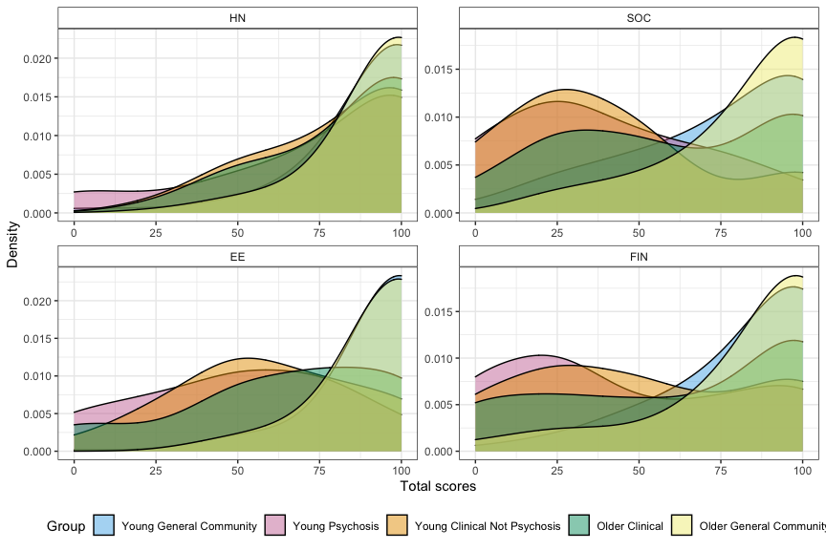

Table S4
Correlations ($r)$with SIS, UCLA-LS
 | HN | SOC | EE | FIN | F-SIM
SIS | 0.30 | 0.73 | 0.60 | 0.51 | 0.74
UCLA Loneliness Scale | -0.32 | -0.71 | -0.48 | -0.46 | -0.68
Note: p<0.001 for all r

