Table S1: The RECORD statement – checklist of items, extended from the STROBE statement, that should be reported in observational studies using routinely collected health data. Items specific to cross-sectional/case-control studies have been removed.

 | Item No. | STROBE items | Page | RECORD items | Page
Title and abstract
 | 1 | (a) Indicate the study’s design with a commonly used term in the title or the abstract (b) Provide in the abstract an informative and balanced summary of what was done and what was found | 1 | RECORD 1.1: The type of data used should be specified in the title or abstract. When possible, the name of the databases used should be included.  RECORD 1.2: If applicable, the geographic region and timeframe within which the study took place should be reported in the title or abstract.  RECORD 1.3: If linkage between databases was conducted for the study, this should be clearly stated in the title or abstract. | 1
Introduction
Background rationale | 2 | Explain the scientific background and rationale for the investigation being reported | 1-2 | N/A
Objectives | 3 | State specific objectives, including any prespecified hypotheses | 2-3 | N/A
Methods
Study Design | 4 | Present key elements of study design early in the paper | 3-4 | N/A
Setting | 5 | Describe the setting, locations, and relevant dates, including periods of recruitment, exposure, follow-up, and data collection | 3-4 | N/A
Participants | 6 | (a) Cohort study - Give the eligibility criteria, and the sources and methods of selection of participants. Describe methods of follow-up  (b) Cohort study - For matched studies, give matching criteria and number of exposed and unexposed | 4 | RECORD 6.1: The methods of study population selection (such as codes or algorithms used to identify subjects) should be listed in detail. If this is not possible, an explanation should be provided.  RECORD 6.2: Any validation studies of the codes or algorithms used to select the population should be referenced. If validation was conducted for this study and not published elsewhere, detailed methods and results should be provided.  RECORD 6.3: If the study involved linkage of databases, consider use of a flow diagram or other graphical display to demonstrate the data linkage process, including the number of individuals with linked data at each stage. | 4
Variables | 7 | Clearly define all outcomes, exposures, predictors, potential confounders, and effect modifiers. Give diagnostic criteria, if applicable. | 5-6 | RECORD 7.1: A complete list of codes and algorithms used to classify exposures, outcomes, confounders, and effect modifiers should be provided. If these cannot be reported, an explanation should be provided. | 5-6
Data sources/ measurement | 8 | For each variable of interest, give sources of data and details of methods of assessment (measurement).  Describe comparability of assessment methods if there is more than one group | 5-6 | N/A
Bias | 9 | Describe any efforts to address potential sources of bias | 6 | N/A
Study size | 10 | Explain how the study size was arrived at | 6-7 | N/A
Quantitative variables | 11 | Explain how quantitative variables were handled in the analyses. If applicable, describe which groupings were chosen, and why | 6 | N/A
Statistical methods | 12 | (a) Describe all statistical methods, including those used to control for confounding  (b) Describe any methods used to examine subgroups and interactions  (c) Explain how missing data were addressed  (d) Cohort study - If applicable, explain how loss to follow-up was addressed  (e) Describe any sensitivity analyses | 6 | N/A
Data access and cleaning methods |  | N/A |  | RECORD 12.1: Authors should describe the extent to which the investigators had access to the database population used to create the study population.  RECORD 12.2: Authors should provide information on the data cleaning methods used in the study. | 12; 5-6
Linkage |  | N/A |  | RECORD 12.3: State whether the study included person-level, institutional-level, or other data linkage across two or more databases. The methods of linkage and methods of linkage quality evaluation should be provided. | 3-4
Results
Participants | 13 | (a) Report the numbers of individuals at each stage of the study (e.g., numbers potentially eligible, examined for eligibility, confirmed eligible, included in the study, completing follow-up, and analysed)  (b) Give reasons for non-participation at each stage.  (c) Consider use of a flow diagram | 6-7 | RECORD 13.1: Describe in detail the selection of the persons included in the study (i.e., study population selection) including filtering based on data quality, data availability and linkage. The selection of included persons can be described in the text and/or by means of the study flow diagram. | 6-7
Descriptive data | 14 | (a) Give characteristics of study participants (e.g., demographic, clinical, social) and information on exposures and potential confounders  (b) Indicate the number of participants with missing data for each variable of interest  (c) Cohort study - summarise follow-up time (e.g., average and total amount) | 7 | N/A
Outcome data | 15 | Cohort study - Report numbers of outcome events or summary measures over time | 7 | N/A
Main results | 16 | (a) Give unadjusted estimates and, if applicable, confounder-adjusted estimates and their precision (e.g., 95% confidence interval). Make clear which confounders were adjusted for and why they were included  (b) Report category boundaries when continuous variables were categorized  (c) If relevant, consider translating estimates of relative risk into absolute risk for a meaningful time period | 7 | N/A
Other analyses | 17 | Report other analyses done—e.g., analyses of subgroups and interactions, and sensitivity analyses | 7 | N/A
Discussion
Key results | 18 | Summarise key results with reference to study objectives | 8 | N/A
Limitations | 19 | Discuss limitations of the study, taking into account sources of potential bias or imprecision. Discuss both direction and magnitude of any potential bias | 9-10 | RECORD 19.1: Discuss the implications of using data that were not created or collected to answer the specific research question(s). Include discussion of misclassification bias, unmeasured confounding, missing data, and changing eligibility over time, as they pertain to the study being reported. | 9-10
Interpretation | 20 | Give a cautious overall interpretation of results considering objectives, limitations, multiplicity of analyses, results from similar studies, and other relevant evidence | 10-11 | N/A
Generalisability | 21 | Discuss the generalisability (external validity) of the study results | 9-10 | N/A
Other Information
Funding | 22 | Give the source of funding and the role of the funders for the present study and, if applicable, for the original study on which the present article is based | 11 | N/A
Accessibility of protocol, raw data, and programming code |  | N/A |  | RECORD 22.1: Authors should provide information on how to access any supplemental information such as the study protocol, raw data, or programming code. | 3

*Reference: Benchimol, E. I., Smeeth, L., Guttmann, A., Harron, K., Moher, D., Petersen, I., ... & RECORD Working Committee. (2015). The REporting of studies Conducted using Observational Routinely-collected health Data (RECORD) statement. PLoS Med, 12(10), e1001885.
*Checklist is protected under Creative Commons Attribution (CC BY) license.

Table S2: Missingness on study variables among pupils eligible for inclusion in analysis by GCSE attainment (frequencies and percentages)
 | <5 A* to C grades  (n=37,819) | ≥5 A* to C grades  (n=45,412) | Total  (n=83,231)
Depression diagnosis before age 15 | 0 (0.0%) | 0 (0.0%) | 0 (0.0%)
Gender | 0 (0.0%) | 0 (0.0%) | 0 (0.0%)
Ethnicity | 9076 (24.0%) | 8996 (19.8%) | 18,072 (21.7%)
Ever eligible for FSM | 1037 (2.7%) | 605 (1.3%) | 1642 (2.0%)
Relative age in school year | 0 (0.0%) | 0 (0.0%) | 0 (0.0%)
Neurodevelopmental diagnosis at any age | 0 (0.0%) | 0 (0.0%) | 0 (0.0%)
Year 6 SATs attainment: Level 4 in both English and maths | 5364 (14.2%) | 3314 (7.3%) | 8678 (10.4%)

Figure S1: Study sample flow diagram
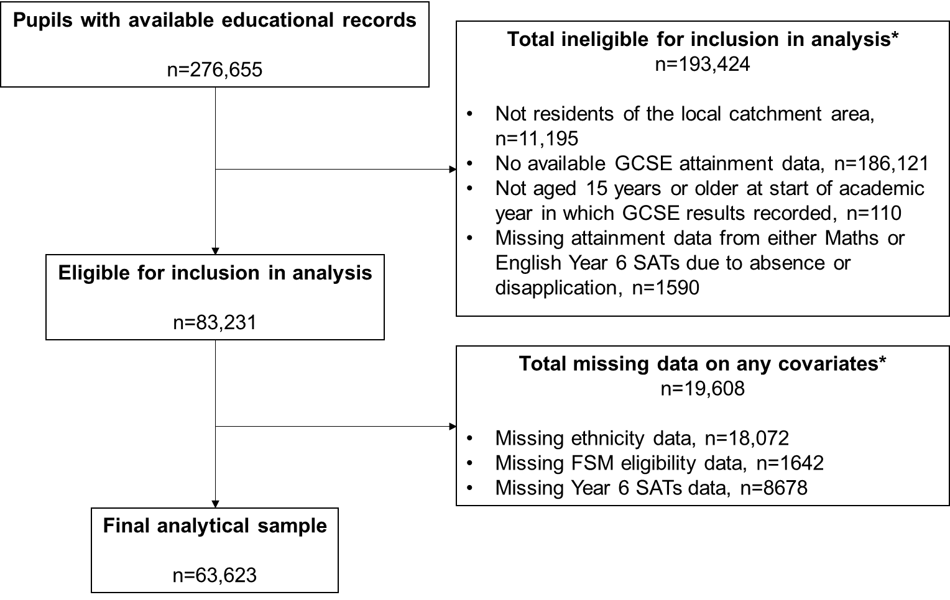
*Note that the numbers given for each individual eligibility criterion/covariate do not sum to the totals, as some pupils did not meet multiple eligibility criteria/were missing multiple covariates.

Figure S2: Study sample flow diagram, stratified by presence of a clinical depression diagnosis before age 15 years
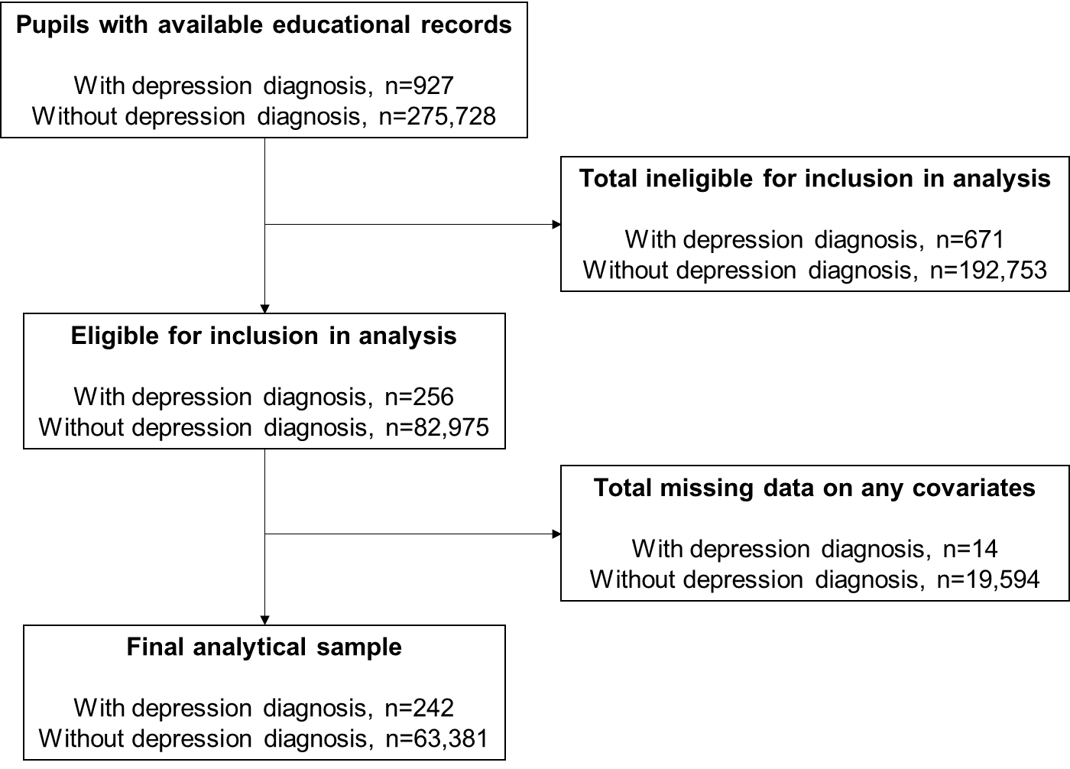

Table S3: Study variables by eligibility and inclusion in analysis (frequencies and percentages)
 | Eligible sample  (n=83,231) | Final analytical sample  (n=63,623)
Depression diagnosis before age 15
No | 82,975 (99.7%) | 63,381 (99.6%)
Yes | 256 (0.3%) | 242 (0.4%)
GCSE attainment: ≥5 A* to C grades
No | 37,819 (45.4%) | 27,823 (43.7%)
Yes | 45,412 (54.6%) | 35,800 (56.3%)
Gender
Female | 41,746 (50.2%) | 32,097 (50.4%)
Male | 41,485 (49.8%) | 31,526 (49.6%)
Ethnicity
White | 27,755 (42.6%) | 27,223 (42.8%)
Black | 23,153 (35.5%) | 22,561 (35.5%)
Other | 14,251 (21.9%) | 13,839 (21.8%)
Ever eligible for FSM
No | 50,933 (62.4%) | 38,862 (61.1%)
Yes | 30,656 (37.6%) | 24,761 (38.9%)
Relative age in school year
Autumn-born | 27,937 (33.6%) | 21,455 (33.7%)
Spring-born | 26,784 (32.2%) | 20,303 (31.9%)
Summer-born | 28,510 (34.3%) | 21,865 (34.4%)
Neurodevelopmental diagnosis at any age
No | 81,742 (98.2%) | 62,291 (97.9%)
Yes | 1489 (1.8%) | 1332 (2.1%)
Year 6 SATs attainment: Level 4 in both English and maths
No | 24,614 (33.0%) | 20,155 (31.7%)
Yes | 49,939 (67.0%) | 43,468 (68.3%)
Note: Data was missing for ethnicity (21.7% in eligible group, none in final analytical sample), FSM eligibility (2.0% in eligible group, none in final analytical sample), and Year 6 SATs attainment (10.4% in eligible group, none in final analytical sample).

Table S4: Study variables by depression diagnosis (unweighted frequencies and percentages)
 | No depression diagnosis before age 15  (n=63,381) | Depression diagnosis before age 15  (n=242) | Total  (n=63,623)
GCSE attainment: ≥5 A* to C grades
No | 27,683 (43.7%) | 140 (57.9%) | 27,823 (43.7%)
Yes | 35,698 (56.3%) | 102 (42.1%) | 35,800 (56.3%)
Gender
Female | 31,930 (50.4%) | 167 (69.0%) | 32,097 (50.4%)
Male | 31,451 (49.6%) | 75 (31.0%) | 31,526 (49.6%)
Ethnicity
White | 27,093 (42.7%) | 130 (53.7%) | 27,223 (42.8%)
Black | 22,499 (35.5%) | 62 (25.6%) | 22,561 (35.5%)
Other | 13,789 (21.8%) | 50 (20.7%) | 13,839 (21.8%)
Ever eligible for FSM
No | 38,745 (61.1%) | 117 (48.3%) | 38,862 (61.1%)
Yes | 24,636 (38.9%) | 125 (51.7%) | 24,761 (38.9%)
Relative age in school year
Autumn-born | 21,395 (33.8%) | 60 (24.8%) | 21,455 (33.7%)
Spring-born | 20,223 (31.9%) | 80 (33.1%) | 20,303 (31.9%)
Summer-born | 21,763 (34.3%) | 102 (42.1%) | 21,865 (34.4%)
Neurodevelopmental diagnosis at any age
No | 62,073 (97.9%) | 218 (90.1%) | 62,291 (97.9%)
Yes | 1308 (2.1%) | 24 (9.9%) | 1332 (2.1%)
Year 6 SATs attainment: Level 4 in both English and Maths
No | 20,071 (31.7%) | 84 (34.7%) | 20,155 (31.7%)
Yes | 43,310 (68.3%) | 158 (65.3%) | 43,468 (68.3%)

