Supplementary Materials

- Table S1. ICD-10 Codes used to define causes of death
- Table S2. Person-years and observed deaths in patients with bipolar disorder by sex and age group
- Fig. S1. Annual natural-cause standardized mortality ratios of patients with bipolar disorder over study period
- Fig. S2. Annual unnatural-cause standardized mortality ratios of patients with bipolar disorder over study period
- Fig. S3. Remaining life expectancy and cause-specific life years lost for men and women with bipolar disorder

Table S1. ICD-10 Codes used to define causes of death
Causes of death | ICD-10 codes
Natural causes | A00–R99
Cardiovascular diseases | I00–I99
Ischemic heart disease | I20– I25
Non-ischemic heart diseases | I00–I09, I11, I13, I26–I51
Cerebrovascular diseases | I60–I69
Neoplasms | C00–D49
Lung cancer | C34
Liver cancer | C22
Colon cancer | C18
Breast cancer | C50
Respiratory diseases | J00–J99
Non-aspiration pneumonia | J15–J18
Aspiration pneumonia | J690
Chronic obstructive pulmonary disease | J40–J44
Digestive diseases | K00–K93
Liver diseases | K70–K77
Pancreaticobiliary diseases | K80–K87
Genitourinary diseases | N00–N99
Renal failure | N17–N19
Infectious and parasitic diseases | A00–B99
Unnatural causes | V01–Y98

Table S2. Person-years and observed deaths in patients with bipolar disorder by sex and age group
 | Sex |  | Age (years)
 | Men | Women | 15-34 | 35-49 | 50-64 | ≥65
Person-years | 198607 | 207576 | 56193 | 142298 | 142461 | 65232
Observed deaths by cause
All causes | 485 | 557 | 70 | 142 | 308 | 522
Natural causes | 301 | 362 | 7 | 53 | 195 | 408
Cardiovascular diseases | 54 | 61 | 1 | 9 | 37 | 68
Ischemic heart disease | 29 | 18 | 0 | 1 | 18 | 28
Non-ischemic heart diseases | 7 | 20 | 0 | 3 | 9 | 15
Cerebrovascular diseases | 15 | 21 | 0 | 5 | 10 | 21
Neoplasms | 62 | 96 | 3 | 18 | 67 | 70
Lung cancer | 17 | 12 | 0 | 1 | 13 | 15
Liver cancer | 4 | 6 | 0 | 3 | 3 | 4
Colon cancer | 11 | 19 | 0 | 1 | 12 | 17
Breast cancer | 0 | 17 | 0 | 5 | 10 | 2
Respiratory diseases | 132 | 143 | 2 | 16 | 55 | 202
Non-aspiration pneumonia | 110 | 120 | 0 | 11 | 46 | 173
Aspiration pneumonia | 7 | 10 | 1 | 1 | 5 | 10
Chronic obstructive pulmonary disease | 5 | 2 | 0 | 1 | 2 | 4
Digestive diseases | 18 | 17 | 0 | 4 | 11 | 20
Liver diseases | 6 | 4 | 0 | 3 | 5 | 2
Pancreaticobiliary diseases | 1 | 5 | 0 | 0 | 1 | 5
Genitourinary diseases | 16 | 24 | 0 | 4 | 8 | 28
Renal failure | 11 | 10 | 0 | 4 | 4 | 13
Infectious and parasitic diseases | 19 | 21 | 1 | 2 | 17 | 20
Unnatural causes | 69 | 89 | 46 | 41 | 46 | 25
Unknown causes | 115 | 106 | 17 | 48 | 67 | 89

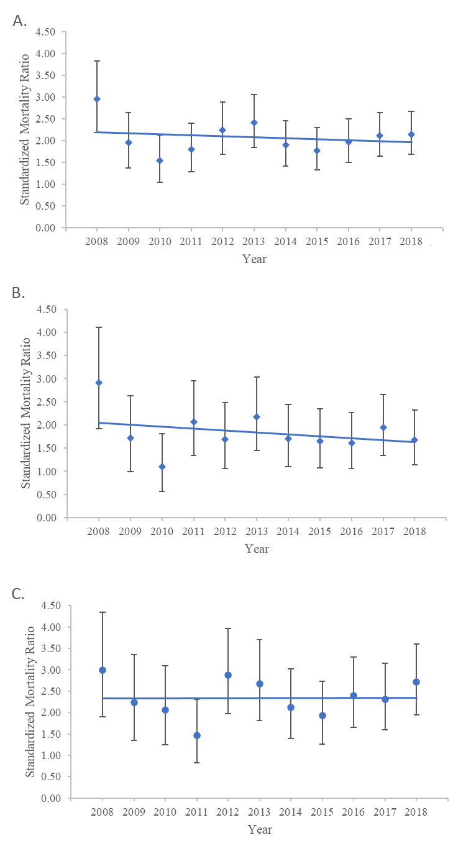
Women

APC = -0.14%
(95% CI: -3.91 – 4.36)
p = 0.940

Men

APC = -2.40%
(95% CI: -6.66 – 2.05)
p = 0.249

Total sample

APC = -1.00%
(95% CI: -4.46 – 2.58)
p = 0.538

Fig. S1. Annual natural-cause standardized mortality ratios of patients with bipolar disorder
over study period: (A) Total sample, (B) Men, and (C) Women
Note: APC, Annual percentage change; CI, Confidence interval.

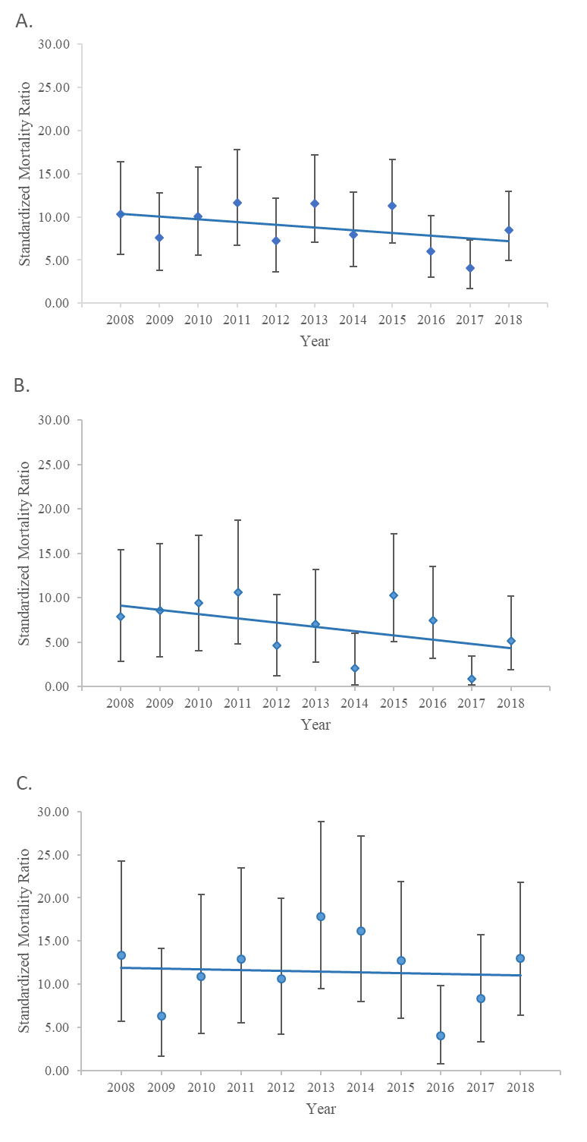
Total sample

APC = -3.24%
(95% CI: -9.09 – 3.00)
p = 0.264

Women

APC = -0.47%
(95% CI: -8.20 – 7.91)
p = 0.898

Men

APC = -4.57%
(95% CI: -13.43 – 5.20)
p = 0.306

Fig. S2. Annual unnatural-cause standardized mortality ratios of patients with bipolar disorder
over study period: (A) Total sample, (B) Men, and (C) Women
Note: APC, Annual percentage change; CI, Confidence interval.

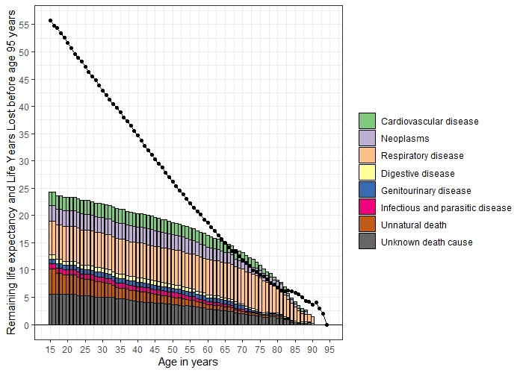
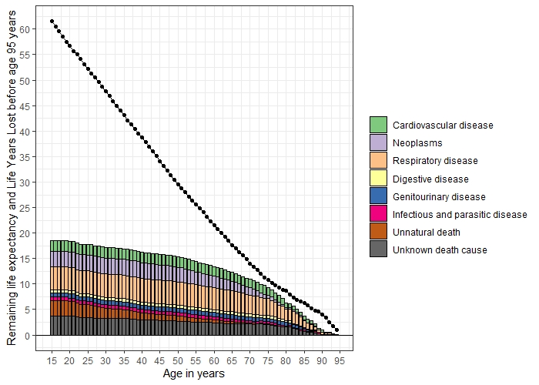
Fig. S3. Remaining life expectancy and cause-specific life years lost for men (left) and women (right) with bipolar disorder
The black dot indicates the remaining life expectancy (with upper-age limit set at 95 years) of patients on the y-axis at any given age of first-recorded diagnosis of bipolar disorder on the x-axis. The colored area represents the total LYLs at any given age of diagnosis on the x-axis, with each color denoting a given cause of death, and the “length” of each color area indicates the number of LYLs attributable to that specific cause of death. Respiratory diseases accounted for the largest share of LYLs for patients of both sexes, and the degree of contribution increased with age, particularly in men (proportion to total LYLs: men: 22.3% at 15 years, 60.6% at 75 years; women: 17.8% at 15 years, 38.0% at 75 years). Cancers and cardiovascular diseases also constituted a major share to LYLs due to natural-cause deaths for both men (Cancers: 5.5% at 15 years, 6.6% at 60 years; Cardiovascular diseases: 11.9% at 15 years, 16.2% at 60 years) and women (Cancers: 16% at 15 years, 19.4% at 60 years; Cardiovascular diseases: 7.0% at 15 years, 9.9% at 60 years) with bipolar disorder, with the proportion of their contributions mildly increased from 15 to 60 years. By contrast, unnatural causes accounted for a decreasing share of LYLs with age in patients of both sexes (men: 25.8% at 15 years, 7.7% at 75 years; women: 27.0% at 15 years, 3.6% at 75 years).

