Global, regional, and national burden of anxiety disorders from 1990 to 2019: Results from the Global Burden of Disease Study 2019

Short title: Global analysis of anxiety disorders

Xiaorong Yang, PhD^{1,2,#}, Yuan Fang, MSc^{3,#}, Hui Chen, MPH^{1,2}, Tongchao Zhang, PhD³, Xiaolin Yin, PhD³, Jinyu Man, MSc³, Lejin Yang, PhD^{4,*}, Ming Lu, PhD, MD^{1,2,3,*}

Supplementary Materials

Table S1. Prevalence and age-standardized prevalence rate per 1000 people for anxiety disorders in 1990 and 2019, and its estimated annual percentage change from 1990 to 2019.
Variables | 1990 |  | 2019 |  | 1990-2019
 | Prevalence cases  No.×10⁶ (95% UI) | ASPR per 1000  No. (95% UI) | Prevalence cases  No.×10⁶ (95% UI) | ASPR per 1000  No. (95% UI) | EAPC in ASIR  No. (95% CI)
Overall | 194.92 (165.1, 231.23) | 37.92 (31.94, 44.77) | 301.39 (252.63, 356) | 37.8 (31.81, 44.73) | -0.02 (-0.05, 0.01)
Sex
Males | 73.43 (61.28, 86.99) | 28.39 (23.89, 33.33) | 113.85 (95.4, 135.15) | 28.6 (23.97, 33.8) | 0.02 (-0.02, 0.07)
Females | 121.49 (101.99, 144.69) | 47.32 (39.83, 56.05) | 187.54 (157.71, 221.6) | 46.95 (39.46, 55.77) | -0.04 (-0.1, 0.02)
SDI region
High SDI | 40.42 (33.99, 48.07) | 46.37 (38.84, 55.3) | 52.41 (44.15, 62.47) | 48.07 (40.17, 57.82) | -0.02 (-0.15, 0.11)
High-middle SDI | 44.36 (37.67, 52.26) | 37.9 (32.22, 44.38) | 58.09 (49.16, 68.18) | 37.54 (31.89, 44.07) | 0.01 (-0.01, 0.03)
Middle SDI | 61.39 (51.48, 73.24) | 37.26 (31.58, 43.74) | 95.17 (80.38, 111.54) | 37.94 (32.21, 44.39) | 0.04 (0, 0.07)
Low-middle SDI | 33.62 (28.07, 40.15) | 33.85 (28.35, 40.22) | 60.59 (50.68, 72.41) | 34.7 (29.09, 40.97) | 0.2 (0.15, 0.25)
Low SDI | 15.01 (12.19, 18.3) | 34.02 (28.02, 41.2) | 34.93 (28.26, 42.72) | 34.95 (28.8, 42.41) | 0.13 (0.09, 0.18)
GBD region
High-income Asia Pacific | 5.19 (4.35, 6.12) | 28.11 (23.55, 33.34) | 5.16 (4.36, 6.06) | 26.16 (21.84, 31.08) | -0.26 (-0.34, -0.19)
High-income North America | 15.55 (13.34, 18.01) | 51.62 (44.35, 60.18) | 21.95 (18.88, 25.64) | 55.6 (46.94, 65.83) | -0.09 (-0.4, 0.23)
Western Europe | 22.57 (18.67, 27.23) | 55.43 (45.76, 67.5) | 26.06 (21.71, 31.45) | 56.27 (46.33, 68.14) | 0.14 (0.08, 0.2)
Australasia | 1.27 (1.01, 1.59) | 59.66 (47.63, 74.95) | 1.8 (1.47, 2.23) | 60.32 (48.85, 74.48) | 0.13 (0.04, 0.21)
Tropical Latin America | 8.39 (7.22, 9.82) | 59 (51.13, 68.36) | 17.76 (15.15, 20.8) | 73.79 (62.96, 86.06) | 0.97 (0.53, 1.41)
Andean Latin America | 1.85 (1.47, 2.35) | 54.03 (43.47, 67.68) | 3.51 (2.84, 4.41) | 54.97 (44.68, 68.93) | 0.08 (0.06, 0.09)
Central Latin America | 5.29 (4.29, 6.46) | 35.21 (29.31, 42.53) | 10.1 (8.34, 12.31) | 39.31 (32.53, 47.83) | 0.36 (0.2, 0.52)
Southern Latin America | 2.53 (2.11, 3.04) | 51.51 (43, 61.89) | 3.57 (3.12, 4.1) | 51.26 (44.6, 58.85) | -0.04 (-0.07, -0.01)
Caribbean | 1.46 (1.15, 1.83) | 42.79 (34.25, 53.55) | 2.15 (1.72, 2.69) | 44.01 (35.22, 55) | 0.1 (0.08, 0.12)
Eastern Europe | 7.68 (6.56, 8.98) | 32.17 (27.43, 37.7) | 7.33 (6.29, 8.5) | 31.89 (27.27, 37.2) | -0.01 (-0.05, 0.02)
Central Europe | 4.28 (3.54, 5.23) | 32.93 (27.15, 40.14) | 4.23 (3.52, 5.12) | 32.76 (26.86, 39.87) | -0.02 (-0.03, -0.01)
Central Asia | 1.45 (1.13, 1.82) | 22.52 (17.74, 28.07) | 2.06 (1.62, 2.59) | 22.22 (17.52, 27.74) | -0.07 (-0.08, -0.06)
North Africa and Middle East | 16.08 (13.1, 19.73) | 49.5 (41.38, 59.22) | 31.88 (25.65, 39.25) | 51.36 (41.65, 62.67) | 0.2 (0.16, 0.23)
South Asia | 28.55 (24.01, 33.99) | 30.23 (25.6, 35.58) | 54.67 (46.46, 64.4) | 30.46 (25.94, 35.47) | 0.23 (0.07, 0.39)
Southeast Asia | 14.91 (12.33, 17.89) | 34.7 (28.9, 41.24) | 25.39 (21.03, 30.37) | 36.33 (30.24, 43.15) | 0.13 (0.1, 0.17)
East Asia | 43.23 (36.38, 51.42) | 35.16 (29.89, 41) | 49.79 (42.82, 57.48) | 31.81 (27.12, 36.64) | -0.49 (-0.59, -0.39)
Oceania | 0.23 (0.18, 0.29) | 39.07 (31.1, 48.44) | 0.5 (0.39, 0.63) | 40.07 (31.83, 49.9) | 0.08 (0.06, 0.09)
Western Sub-Saharan Africa | 5.11 (4.11, 6.35) | 30.19 (24.88, 36.32) | 12.76 (10.26, 15.81) | 30.67 (25.33, 36.83) | 0.11 (0.06, 0.17)
Eastern Sub-Saharan Africa | 5.76 (4.63, 7.14) | 36.94 (30.41, 44.94) | 13.39 (10.79, 16.68) | 37.16 (30.5, 45.31) | 0.01 (-0.02, 0.05)
Central Sub-Saharan Africa | 1.8 (1.39, 2.28) | 38.65 (30.8, 48) | 4.48 (3.49, 5.67) | 38.64 (30.9, 48.26) | 0.01 (0, 0.01)
Southern Sub-Saharan Africa | 1.75 (1.47, 2.11) | 36.42 (30.71, 42.77) | 2.86 (2.4, 3.4) | 36.58 (31, 43.08) | 0.02 (-0.02, 0.05)
No., number; ASPR, age-standardized prevalence rate; UI, uncertainty interval; EAPC, estimated annual percentage change; CI, confidential interval.

Table S2. DALYs and age-standardized DALYs rate per 1000 people for anxiety disorders in 1990 and 2019, and its estimated annual percentage change from 1990 to 2019.
Variables | 1990 |  | 2019 |  | 1990-2019
 | DALYs  No.×10⁶ (95% UI) | Age-standardized DALYs rate  per 1000  No. (95% UI) | DALYs  No.×10⁶ (95% UI) | Age-standardized DALYs rate  per 1000  No. (95% UI) | EAPC in age-standardized DALYs rate  No. (95% CI)
Overall | 18.66 (12.9, 25.55) | 3.61 (2.51, 4.92) | 28.68 (19.86, 39.32) | 3.6 (2.49, 4.94) | -0.01 (-0.04, 0.02)
Sex
Males | 7.11 (4.92, 9.77) | 2.73 (1.9, 3.76) | 10.96 (7.63, 15.06) | 2.75 (1.91, 3.78) | 0.03 (-0.01, 0.08)
Females | 11.55 (7.99, 15.8) | 4.48 (3.11, 6.1) | 17.72 (12.24, 24.28) | 4.45 (3.07, 6.09) | -0.03 (-0.09, 0.03)
SDI region
High SDI | 3.83 (2.65, 5.27) | 4.41 (3.05, 6.08) | 4.91 (3.39, 6.71) | 4.57 (3.13, 6.27) | -0.02 (-0.15, 0.11)
High-middle SDI | 4.25 (2.96, 5.81) | 3.62 (2.52, 4.95) | 5.52 (3.84, 7.51) | 3.6 (2.5, 4.95) | 0.03 (0, 0.05)
Middle SDI | 5.93 (4.09, 8.17) | 3.56 (2.48, 4.84) | 9.1 (6.32, 12.42) | 3.63 (2.53, 4.98) | 0.05 (0.01, 0.08)
Low-middle SDI | 3.21 (2.19, 4.4) | 3.19 (2.22, 4.36) | 5.78 (3.99, 7.98) | 3.29 (2.29, 4.52) | 0.22 (0.17, 0.27)
Low SDI | 1.43 (0.97, 2) | 3.21 (2.19, 4.38) | 3.36 (2.25, 4.69) | 3.31 (2.27, 4.56) | 0.16 (0.12, 0.21)
GBD region
High-income Asia Pacific | 0.5 (0.35, 0.69) | 2.71 (1.88, 3.74) | 0.49 (0.34, 0.67) | 2.53 (1.74, 3.51) | -0.25 (-0.33, -0.17)
High-income North America | 1.46 (1.02, 1.98) | 4.86 (3.39, 6.59) | 2.03 (1.43, 2.75) | 5.22 (3.63, 7.09) | -0.09 (-0.4, 0.23)
Western Europe | 2.14 (1.46, 2.97) | 5.3 (3.61, 7.33) | 2.45 (1.66, 3.37) | 5.38 (3.65, 7.48) | 0.14 (0.09, 0.2)
Australasia | 0.12 (0.08, 0.17) | 5.69 (3.79, 7.94) | 0.17 (0.11, 0.24) | 5.76 (3.84, 8.06) | 0.13 (0.04, 0.22)
Tropical Latin America | 0.8 (0.56, 1.1) | 5.57 (3.91, 7.61) | 1.68 (1.17, 2.3) | 7 (4.87, 9.54) | 0.97 (0.54, 1.41)
Andean Latin America | 0.18 (0.12, 0.25) | 5.16 (3.45, 7.23) | 0.34 (0.22, 0.47) | 5.27 (3.51, 7.42) | 0.09 (0.07, 0.11)
Central Latin America | 0.51 (0.34, 0.71) | 3.36 (2.29, 4.62) | 0.97 (0.66, 1.34) | 3.76 (2.58, 5.21) | 0.37 (0.2, 0.53)
Southern Latin America | 0.24 (0.17, 0.34) | 4.94 (3.38, 6.83) | 0.34 (0.24, 0.46) | 4.91 (3.43, 6.62) | -0.03 (-0.06, 0)
Caribbean | 0.14 (0.09, 0.2) | 4.09 (2.72, 5.73) | 0.2 (0.14, 0.29) | 4.2 (2.79, 5.87) | 0.1 (0.08, 0.12)
Eastern Europe | 0.73 (0.51, 0.99) | 3.06 (2.15, 4.19) | 0.69 (0.49, 0.93) | 3.05 (2.15, 4.14) | 0.01 (-0.03, 0.04)
Central Europe | 0.41 (0.27, 0.57) | 3.14 (2.11, 4.39) | 0.4 (0.27, 0.55) | 3.13 (2.12, 4.35) | 0 (-0.01, 0)
Central Asia | 0.14 (0.09, 0.2) | 2.16 (1.45, 3.02) | 0.2 (0.13, 0.28) | 2.13 (1.43, 2.98) | -0.06 (-0.07, -0.06)
North Africa and Middle East | 1.56 (1.07, 2.15) | 4.74 (3.26, 6.52) | 3.07 (2.07, 4.31) | 4.92 (3.34, 6.85) | 0.2 (0.16, 0.23)
South Asia | 2.71 (1.88, 3.71) | 2.83 (1.98, 3.84) | 5.18 (3.63, 7.06) | 2.86 (2.01, 3.91) | 0.26 (0.09, 0.42)
Southeast Asia | 1.44 (0.98, 1.98) | 3.3 (2.29, 4.5) | 2.43 (1.68, 3.34) | 3.48 (2.42, 4.76) | 0.15 (0.12, 0.19)
East Asia | 4.2 (2.93, 5.78) | 3.38 (2.38, 4.64) | 4.76 (3.36, 6.51) | 3.08 (2.15, 4.22) | -0.47 (-0.57, -0.37)
Oceania | 0.02 (0.01, 0.03) | 3.71 (2.47, 5.21) | 0.05 (0.03, 0.07) | 3.8 (2.54, 5.32) | 0.08 (0.06, 0.1)
Western Sub-Saharan Africa | 0.49 (0.33, 0.68) | 2.88 (1.98, 4) | 1.24 (0.84, 1.72) | 2.93 (2.01, 4.06) | 0.13 (0.07, 0.19)
Eastern Sub-Saharan Africa | 0.55 (0.37, 0.77) | 3.49 (2.37, 4.79) | 1.29 (0.87, 1.82) | 3.54 (2.41, 4.88) | 0.05 (0.01, 0.08)
Central Sub-Saharan Africa | 0.17 (0.11, 0.24) | 3.63 (2.42, 5.1) | 0.43 (0.28, 0.62) | 3.66 (2.45, 5.17) | 0.04 (0.03, 0.05)
Southern Sub-Saharan Africa | 0.17 (0.12, 0.23) | 3.46 (2.41, 4.75) | 0.27 (0.19, 0.37) | 3.45 (2.41, 4.73) | 0 (-0.03, 0.03)
DALYs, Disability-Adjusted Life Years; No., number; UI, uncertainty interval; EAPC, estimated annual percentage change; CI, confidential interval.

Table S3. The countries and territories with the ASIR/1000 in 2019 more than 8.0.
Number | Location | ASIR/1000 in 2019  No. (95% UI) | ASPR/1000 in 2019  No. (95% UI) | Age-standardized  DALYs rate /1000 in 2019  No. (95% UI)
1 | Iran | 10.27 (8.27, 12.44) | 72.68 (62.15, 85.02) | 6.96 (4.83, 9.55)
2 | Portugal | 10.06 (7.73, 12.61) | 80.28 (63.90, 100.09) | 7.68 (5.04, 10.82)
3 | Brazil | 9.94 (7.95, 12.14) | 74.10 (63.27, 86.39) | 7.03 (4.90, 9.59)
4 | New Zealand | 9.75 (7.74, 11.93) | 72.63 (61.67, 86.16) | 6.92 (4.82, 9.41)
5 | Norway | 9.45 (7.61, 11.35) | 67.36 (57.87, 78.43) | 6.44 (4.50, 8.84)
6 | Ireland | 9.18 (7.17, 11.32) | 69.08 (55.44, 84.41) | 6.61 (4.38, 9.15)
7 | Switzerland | 9.04 (7.04, 11.11) | 67.91 (55.14, 81.62) | 6.51 (4.38, 8.95)
8 | Cyprus | 8.81 (6.87, 11.06) | 64.67 (51.26, 80.99) | 6.20 (4.13, 8.75)
9 | Lebanon | 8.66 (6.76, 10.96) | 60.51 (48.11, 76.54) | 5.79 (3.86, 8.17)
10 | Paraguay | 8.63 (6.67, 10.99) | 63.05 (50.78, 79.26) | 6.01 (3.99, 8.36)
11 | Malta | 8.61 (6.73, 10.83) | 62.48 (49.99, 78.69) | 5.98 (3.97, 8.41)
12 | France | 8.51 (6.60, 10.73) | 62.74 (49.91, 78.16) | 6.01 (4.00, 8.38)
13 | Germany | 8.46 (6.61, 10.58) | 62.08 (49.84, 76.83) | 5.93 (3.90, 8.42)
14 | Austria | 8.43 (6.67, 10.47) | 60.06 (48.15, 74.19) | 5.76 (3.87, 7.97)
15 | Syria | 8.30 (6.44, 10.54) | 56.08 (44.51, 69.84) | 5.36 (3.59, 7.58)
16 | Australia | 8.26 (6.37, 10.53) | 58.15 (46.40, 72.72) | 5.55 (3.67, 7.85)
17 | Palestine | 8.23 (6.35, 10.40) | 55.46 (44.28, 69.52) | 5.29 (3.49, 7.42)
18 | USA | 8.22 (6.57, 10.05) | 56.98 (48.43, 67.28) | 5.34 (3.73, 7.25)
19 | Greece | 8.17 (6.32, 10.30) | 57.79 (46.57, 71.79) | 5.54 (3.71, 7.79)
20 | Bolivia | 8.11 (6.27, 10.40) | 57.41 (46.19, 72.65) | 5.49 (3.63, 7.82)
21 | Italy | 8.06 (6.49, 9.64) | 55.62 (47.55, 65.02) | 5.32 (3.73, 7.27)
22 | Libya | 8.04 (6.32, 10.14) | 53.24 (42.77, 66.46) | 5.10 (3.41, 7.13)
ASIR, age-standardized incidence rate; ASPR, age-standardized prevalence rate; DALYs, disability-adjusted life years; No., number; UI, uncertainty interval.

Table S4. The countries and territories with the ASIR/1000 in 2019 less than 5.0.
Number | Location | ASIR/1000 in 2019  No. (95% UI) | ASPR/1000 in 2019  No. (95% UI) | Age-standardized  DALYs rate /1000 in 2019  No. (95% UI)
1 | Uzbekistan | 3.49 (2.73, 4.38) | 20.26 (15.94, 25.77) | 1.94 (1.30, 2.71)
2 | Kyrgyzstan | 3.53 (2.76, 4.42) | 20.60 (16.37, 25.57) | 1.98 (1.34, 2.78)
3 | Kazakhstan | 3.60 (2.80, 4.55) | 21.16 (16.40, 26.63) | 2.02 (1.34, 2.88)
4 | Mongolia | 3.64 (2.85, 4.55) | 21.43 (17.05, 26.57) | 2.05 (1.38, 2.85)
5 | Turkmenistan | 3.89 (3.04, 4.89) | 23.42 (18.74, 29.26) | 2.25 (1.50, 3.19)
6 | Japan | 3.96 (3.26, 4.70) | 23.24 (19.87, 27.02) | 2.25 (1.58, 3.08)
7 | Tajikistan | 3.98 (3.12, 5.07) | 24.04 (19.21, 29.94) | 2.31 (1.53, 3.21)
8 | Vietnam | 4.03 (3.18, 5.05) | 22.87 (18.14, 28.27) | 2.20 (1.49, 3.13)
9 | Azerbaijan | 4.06 (3.16, 5.10) | 24.78 (19.65, 30.65) | 2.38 (1.59, 3.33)
10 | Georgia | 4.07 (3.14, 5.14) | 24.95 (19.97, 31.04) | 2.39 (1.60, 3.34)
11 | Singapore | 4.53 (3.49, 5.68) | 27.08 (21.35, 33.70) | 2.63 (1.75, 3.72)
12 | Mali | 4.59 (3.56, 5.78) | 27.26 (21.64, 33.97) | 2.61 (1.74, 3.69)
13 | Mauritania | 4.61 (3.60, 5.83) | 27.46 (21.67, 34.28) | 2.64 (1.75, 3.73)
14 | Brunei | 4.69 (3.60, 5.88) | 28.57 (22.62, 35.58) | 2.75 (1.86, 3.85)
15 | Senegal | 4.79 (3.74, 6.09) | 28.93 (22.62, 35.89) | 2.77 (1.85, 3.90)
16 | Armenia | 4.80 (3.72, 6.10) | 31.51 (25.23, 39.25) | 3.02 (2.01, 4.27)
17 | India | 4.87 (3.96, 5.81) | 29.67 (25.53, 34.39) | 2.79 (1.96, 3.78)
18 | Niger | 4.89 (3.81, 6.17) | 29.68 (23.32, 36.80) | 2.85 (1.87, 4.02)
19 | Nigeria | 4.90 (3.98, 5.83) | 29.92 (25.69, 34.93) | 2.86 (2.01, 3.92)
20 | Poland | 4.91 (3.98, 5.86) | 30.82 (26.38, 35.78) | 2.95 (2.08, 4.04)
21 | Ghana | 4.91 (3.82, 6.17) | 30.01 (23.57, 37.35) | 2.88 (1.92, 4.12)
22 | Czech | 4.92 (3.82, 6.19) | 31.54 (25.35, 39.09) | 3.01 (2.00, 4.21)
23 | Ukraine | 4.99 (4.06, 5.99) | 31.33 (26.66, 36.41) | 3.00 (2.11, 4.14)
24 | Russia | 4.99 (4.05, 5.97) | 31.34 (26.86, 36.42) | 2.99 (2.11, 4.08)
ASIR, age-standardized incidence rate; ASPR, age-standardized prevalence rate; DALYs, disability-adjusted life years; No., number; UI, uncertainty interval.

Table S5. The countries and territories with the EAPC in ASIR from 1990 to 2019 more than 0.15.
Number | Location |  | EAPC in ASIR  No. (95% CI) | EAPC in ASPR  No. (95% CI) | EAPC in age-standardized DALYs rate  No. (95% CI)
1 | Mexico |  | 0.76 (0.56,0.96) | 0.89 (0.66,1.13) | 0.90 (0.66,1.15)
2 | Brazil |  | 0.53 (0.28,0.77) | 0.99 (0.54,1.44) | 1.00 (0.55,1.44)
3 | Ireland |  | 0.37 (0.24,0.51) | 0.48 (0.30,0.65) | 0.49 (0.30,0.67)
4 | Spain |  | 0.35 (0.22,0.48) | 0.71 (0.44,0.98) | 0.70 (0.43,0.97)
5 | Turkey |  | 0.34 (0.27,0.4) | 0.45 (0.36,0.54) | 0.45 (0.36,0.54)
6 | Lebanon |  | 0.34 (0.21,0.46) | 0.37 (0.21,0.54) | 0.40 (0.23,0.56)
7 | Nepal |  | 0.30 (0.27,0.34) | 0.39 (0.33,0.45) | 0.42 (0.36,0.47)
8 | Chile |  | 0.25 (0.13,0.37) | 0.10 (0.05,0.16) | 0.12 (0.06,0.18)
9 | Bangladesh |  | 0.22 (0.12,0.33) | 0.27 (0.15,0.39) | 0.29 (0.17,0.41)
10 | Laos |  | 0.22 (0.18,0.25) | 0.26 (0.21,0.31) | 0.29 (0.24,0.34)
11 | Egypt |  | 0.22 (0.04,0.41) | 0.25 (0.01,0.50) | 0.27 (0.02,0.51)
12 | India |  | 0.22 (0.02,0.43) | 0.23 (0.02,0.44) | 0.27 (0.05,0.48)
13 | Kuwait |  | 0.21 (0.16,0.26) | 0.29 (0.22,0.36) | 0.29 (0.22,0.35)
14 | Australia |  | 0.20 (0.10,0.29) | 0.2 (0.07,0.33) | 0.20 (0.07,0.33)
15 | Syria |  | 0.18 (0.14,0.21) | 0.22 (0.18,0.27) | 0.21 (0.17,0.24)
16 | Uganda |  | 0.16 (0.13,0.18) | 0.22 (0.19,0.26) | 0.28 (0.24,0.31)
17 | Iraq |  | 0.16 (0.10,0.22) | 0.2 (0.12,0.29) | 0.22 (0.15,0.30)
18 | Israel |  | 0.15 (-0.09,0.39) | 0.24 (-0.09,0.58) | 0.24 (-0.10,0.57)
19 | Venezuela |  | 0.15 (0.12,0.17) | 0.21 (0.17,0.24) | 0.21 (0.17,0.25)
20 | Niger |  | 0.15 (0.12,0.19) | 0.2 (0.16,0.24) | 0.22 (0.18,0.26)
ASIR, age-standardized incidence rate; ASPR, age-standardized prevalence rate; DALYs, disability-adjusted life years; No., number; EAPC, estimated annual percentage change; CI, confidential interval.
Table S6. The countries and territories with the EAPC in ASIR from 1990 to 2019 less than -0.03.
Number | Location | EAPC in ASIR  No. (95% CI) |  | EAPC in ASPR  No. (95% CI) | EAPC in Age-standardized DALYs rate  No. (95% CI)
1 | Japan | -0.5 (-0.59,-0.41) |  | -0.58 (-0.67,-0.48) | -0.57 (-0.66,-0.47)
2 | China | -0.34 (-0.42,-0.25) |  | -0.51 (-0.61,-0.4) | -0.49 (-0.59,-0.38)
3 | Colombia | -0.3 (-0.56,-0.04) |  | -0.45 (-0.83,-0.06) | -0.44 (-0.82,-0.05)
4 | Mongolia | -0.22 (-0.38,-0.05) |  | -0.27 (-0.49,-0.06) | -0.26 (-0.48,-0.05)
5 | Ethiopia | -0.17 (-0.23,-0.1) |  | -0.24 (-0.33,-0.16) | -0.21 (-0.29,-0.12)
6 | Taiwan, China | -0.16 (-0.19,-0.13) |  | -0.16 (-0.2,-0.12) | -0.16 (-0.21,-0.12)
7 | Vietnam | -0.11 (-0.3,0.09) |  | -0.14 (-0.37,0.09) | -0.12 (-0.36,0.11)
8 | Norway | -0.08 (-0.13,-0.04) |  | -0.2 (-0.26,-0.13) | -0.18 (-0.25,-0.12)
9 | Azerbaijan | -0.05 (-0.07,-0.02) |  | -0.07 (-0.09,-0.04) | -0.06 (-0.09,-0.04)
10 | Singapore | -0.05 (-0.09,-0.02) |  | -0.11 (-0.14,-0.08) | -0.09 (-0.12,-0.06)
11 | Somalia | -0.05 (-0.07,-0.04) |  | -0.07 (-0.08,-0.05) | -0.05 (-0.06,-0.04)
12 | New Zealand | -0.05 (-0.12,0.03) |  | -0.07 (-0.14,0.01) | -0.06 (-0.14,0.02)
13 | Georgia | -0.04 (-0.05,-0.02) |  | -0.05 (-0.06,-0.04) | -0.06 (-0.08,-0.05)
14 | Belarus | -0.04 (-0.04,-0.03) |  | -0.05 (-0.06,-0.05) | -0.04 (-0.04,-0.04)
15 | Maldives | -0.04 (-0.06,-0.02) |  | -0.02 (-0.04,0.01) | 0.01 (-0.02,0.04)
16 | Czech | -0.03 (-0.05,-0.02) |  | -0.06 (-0.07,-0.05) | -0.07 (-0.08,-0.05)
17 | Russia | -0.03 (-0.03,-0.02) |  | -0.04 (-0.04,-0.04) | -0.02 (-0.02,-0.01)
18 | Estonia | -0.03 (-0.04,-0.03) |  | -0.05 (-0.06,-0.04) | -0.03 (-0.04,-0.02)
19 | Slovakia | -0.03 (-0.04,-0.01) |  | -0.03 (-0.05,-0.02) | -0.03 (-0.04,-0.01)
ASIR, age-standardized incidence rate; ASPR, age-standardized prevalence rate; DALYs, disability-adjusted life years; No., number; EAPC, estimated annual percentage change; CI, confidential interval.

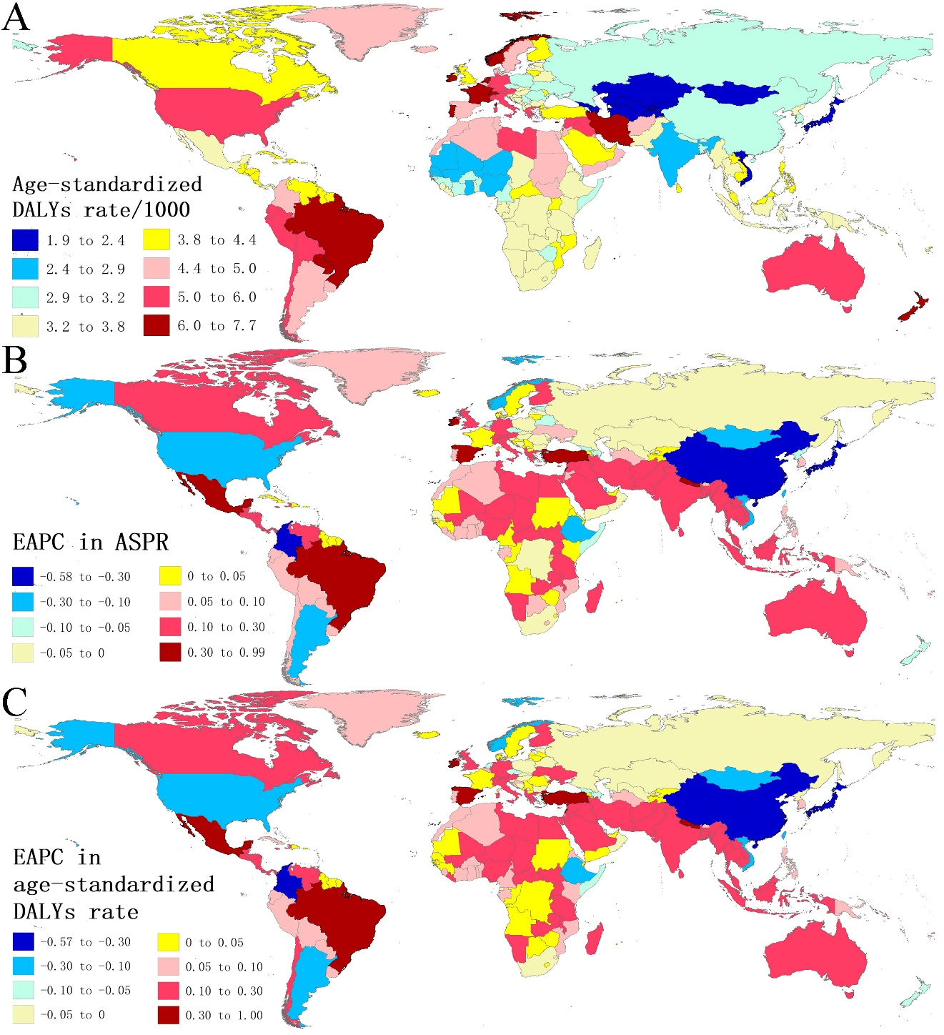
Figure S1. The global disease burden of anxiety disorders in 204 countries and territories. (A) The age-standardized DALYs rate in 2019; (B) The EAPC in ASPR from 1990 to 2019; (C) The EAPC in age-standardized DALYs rate from 1990 to 2019. ASIR, age-standardized incidence rate; DALYs, disability-adjusted life years; ASPR, age-standardized prevalence rate; EAPC, estimated annual percentage change.

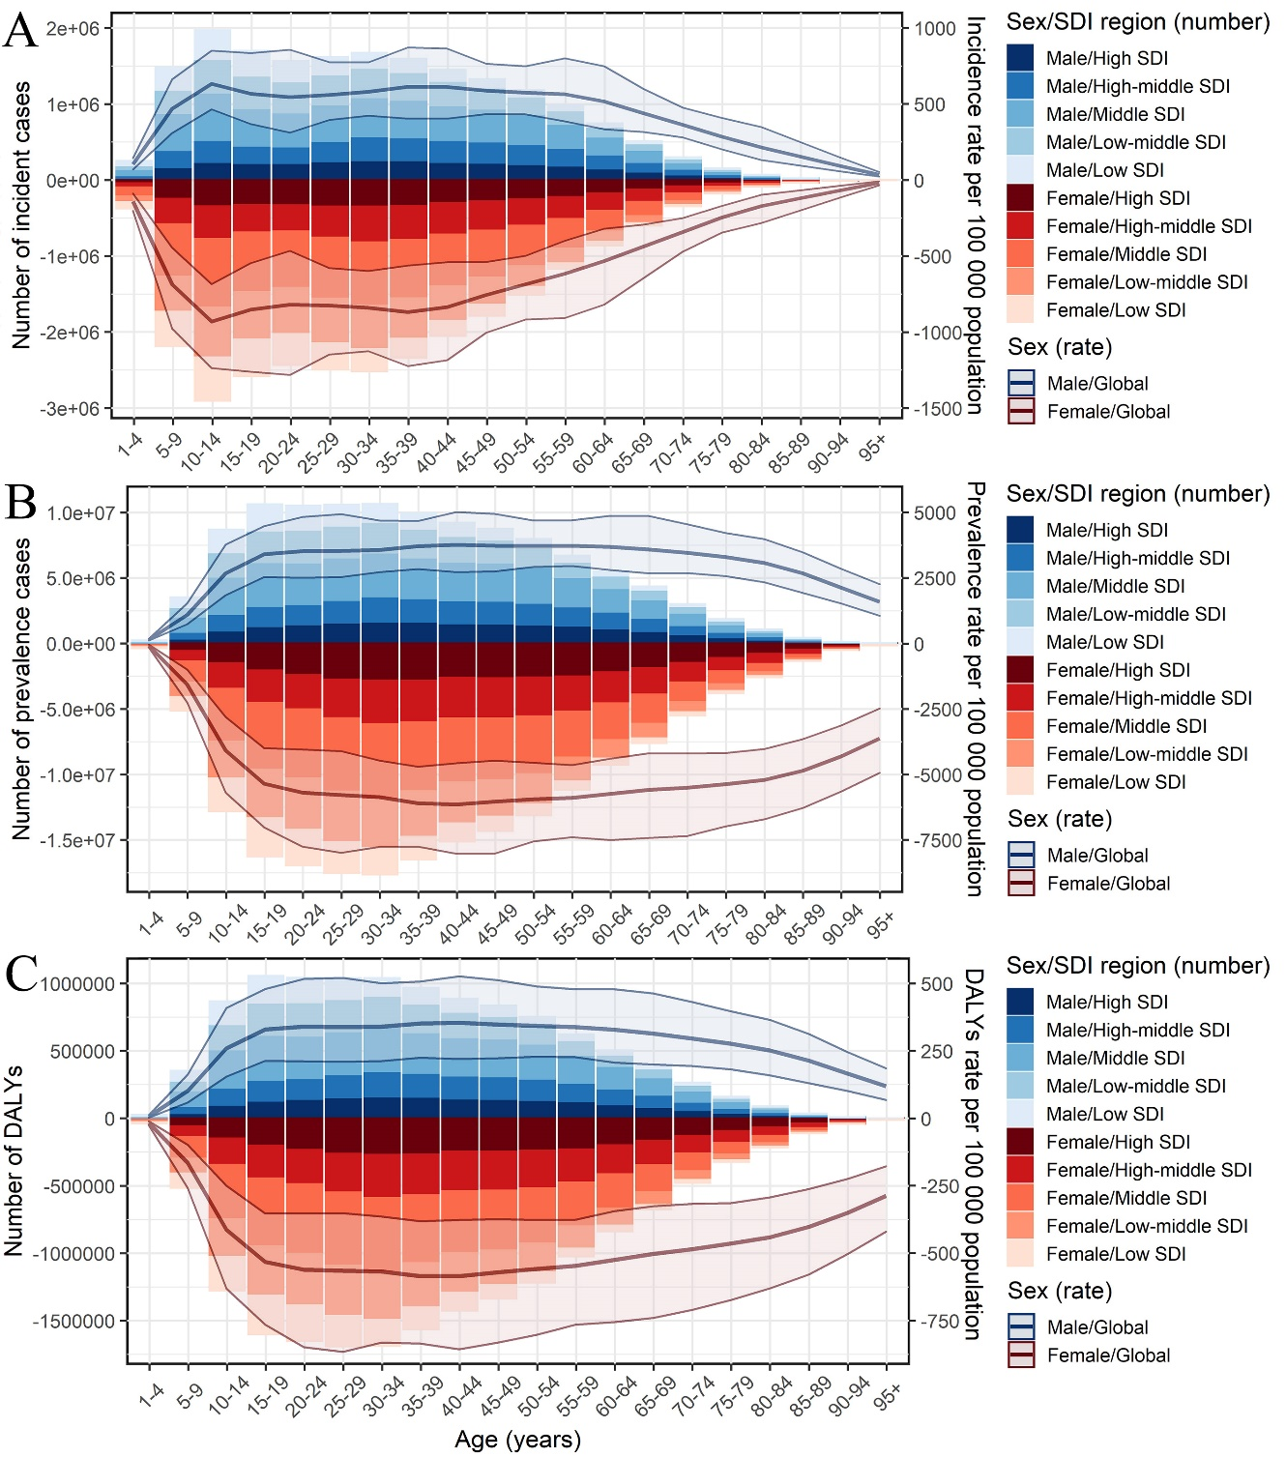
Figure S2. Age-specific counts and rates of anxiety disorders burden by sex and SDI regions, 2019. (A) incidence; (B) prevalence; (B) DALYs. SDI, Socio-demographic index; DALYs, disability-adjusted life years.

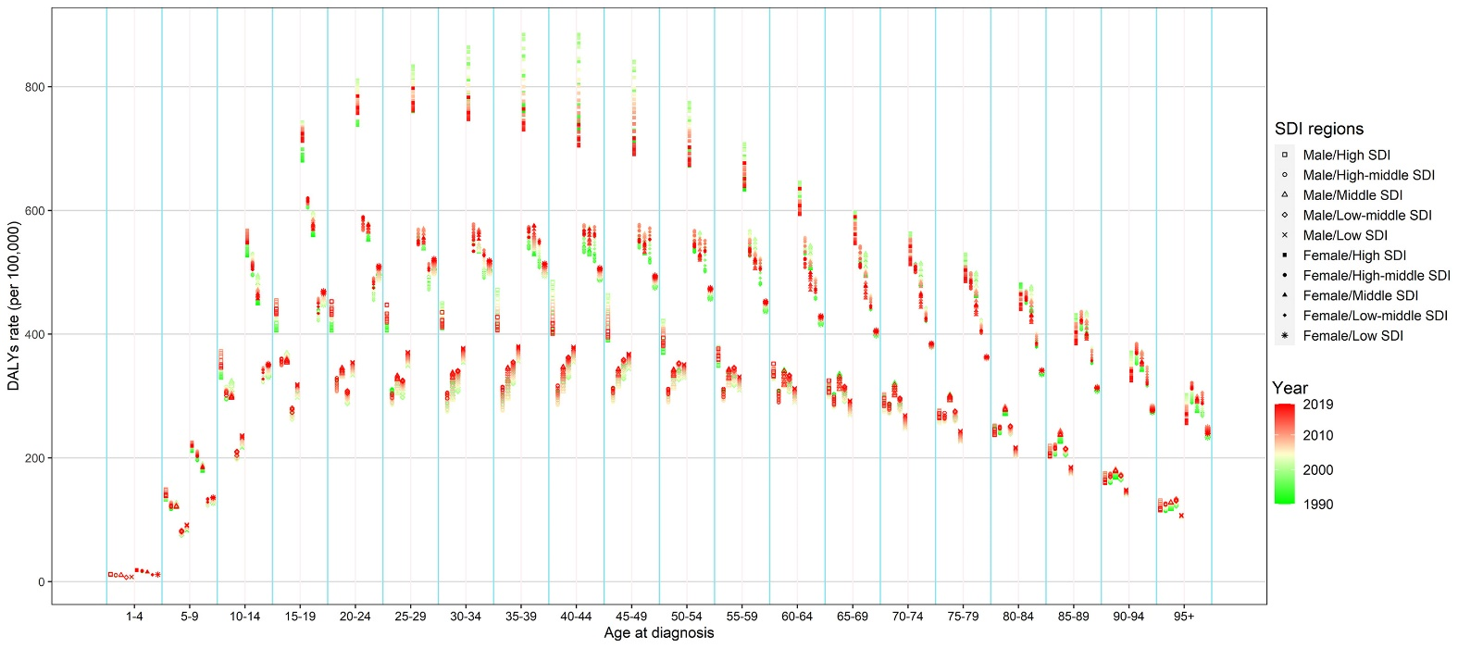
Figure S3. The annual DALYs rate of anxiety disorders by different age groups, two sexes, and SDI regions, from 1990 to 2019.

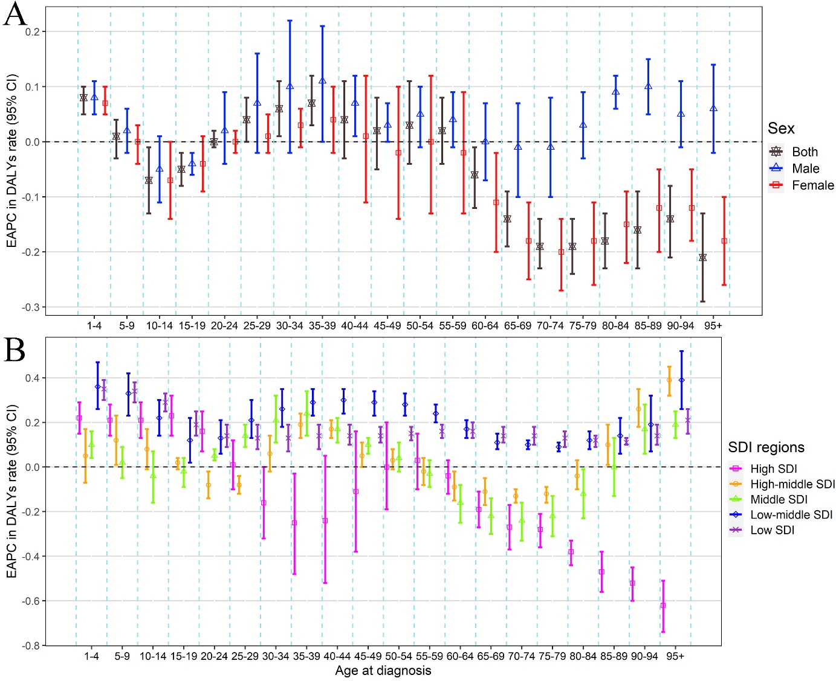
Figure S4. The change of the DALYs rate of anxiety disorders by different age groups, sexes, and SDI regions, from 1990 to 2019. (A) EAPC in DALYs rate by sexes; (B) EAPC in DALYs rate by SDI regions. DALYs, disability-adjusted life years; EAPC, estimated annual percentage change; SDI, Socio-demographic index.

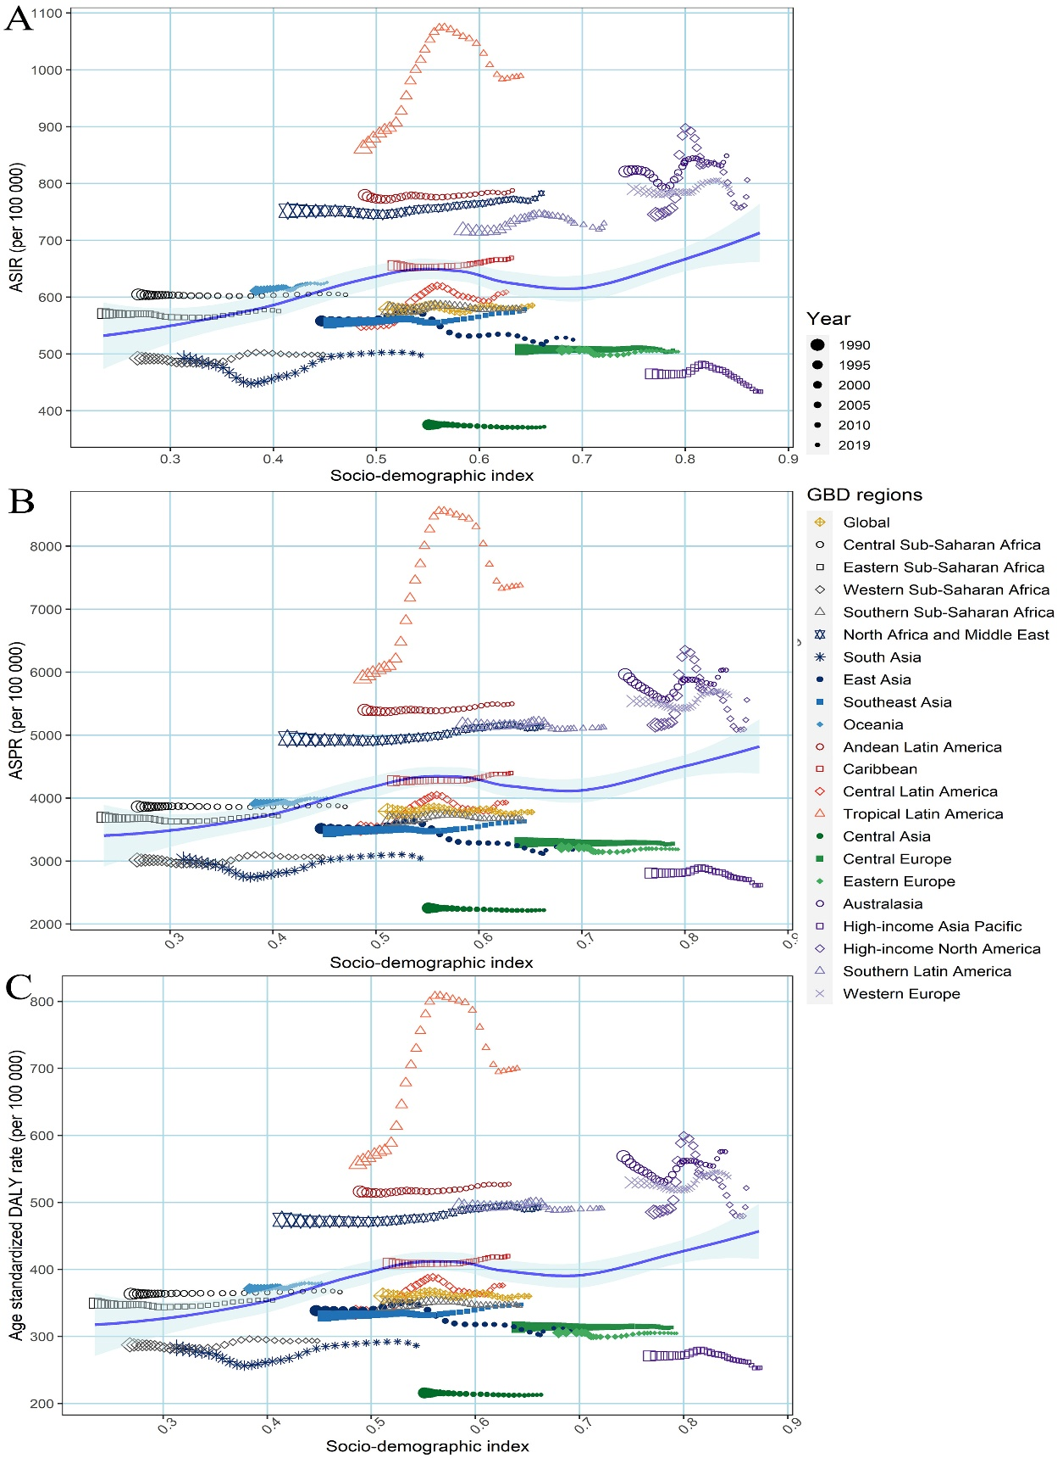
Figure S5. The annual burden in age-standardized burden rates of anxiety disorders across 21 GBD regions with SDI from 1990 to 2019. (A) ASIR; (B) ASPR; (C) age-standardized DALYs rate. GBD, global burden of disease; SDI, socio-demographic index; DALYs, disability-adjusted life years.

