Supplementary Material
Appendix: Search strategy
Pubmed
(Covid-19 OR lockdown OR SARS-Cov-2) AND (mental OR psychiatr* OR psycholog*) AND (repeated OR longitudinal OR wave* OR during [TI])
PsychInfo (via Ovid)
((Covid-19 or lockdown or SARS-Cov-2) and (mental or psychiatr* or psycholog*)).mp. and ((repeated or longitudinal or wave*).mp. or during.ti.) [mp=title, abstract, heading word, table of contents, key concepts, original title, tests & measures, mesh]
PsyArxiv
(Covid-19 OR lockdown OR SARS-Cov-2) AND (mental OR psychiatr* OR psycholog*) AND (repeated OR longitudinal OR wave*) Restricted to 2020

Appendix Figure 1: Quality Appraisal - Judgements about each methodological quality item for each included study assessed by an adapted version of the Joanna Briggs Institute Critical Appraisal (JBI) tools for Prevalence Studies

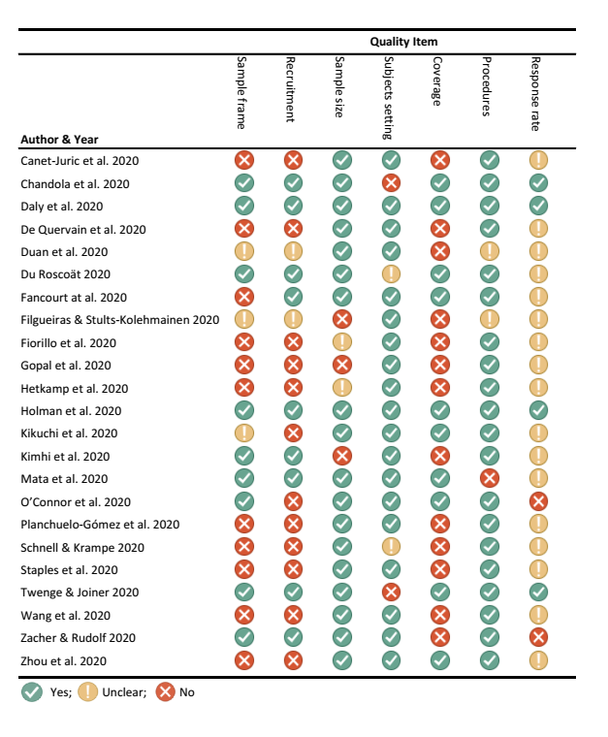

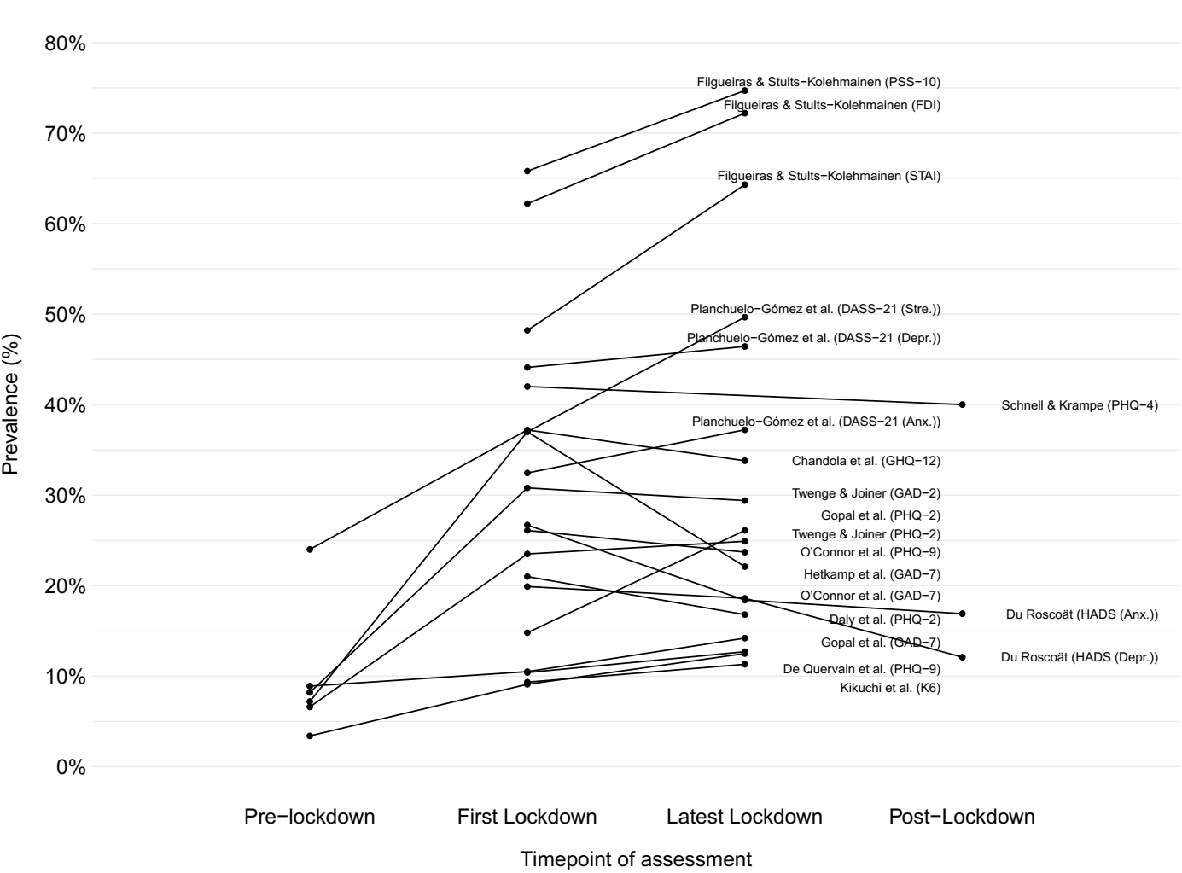
Appendix Figure 2: Prevalence rates of mental health problems during and after lockdown

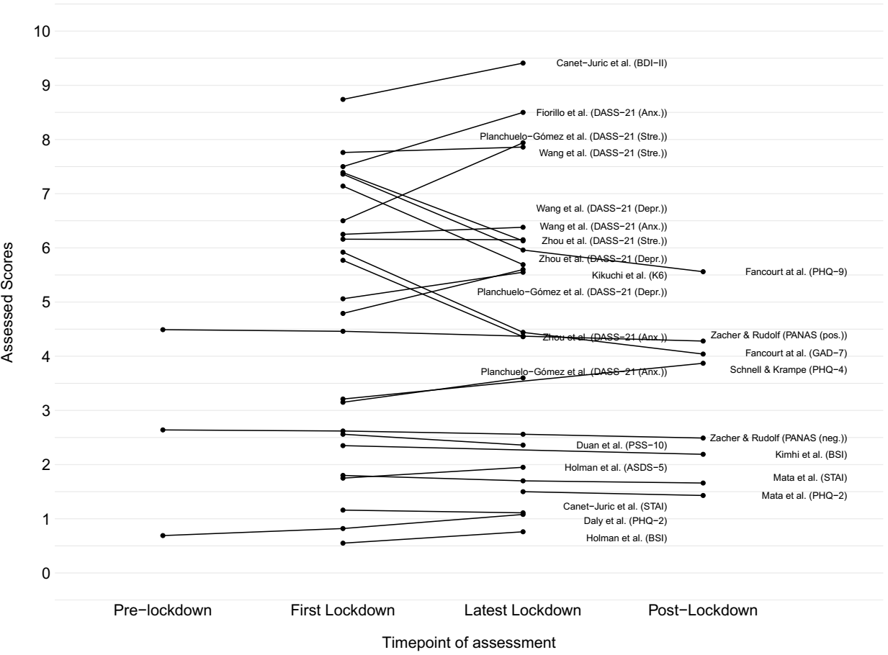
Appendix Figure 3: Low scores (< 10) of mental health problem assessment instruments during and after lockdown

Appendix Figure 4: High scores (> 10) of mental health problem assessment instruments during and after lockdown
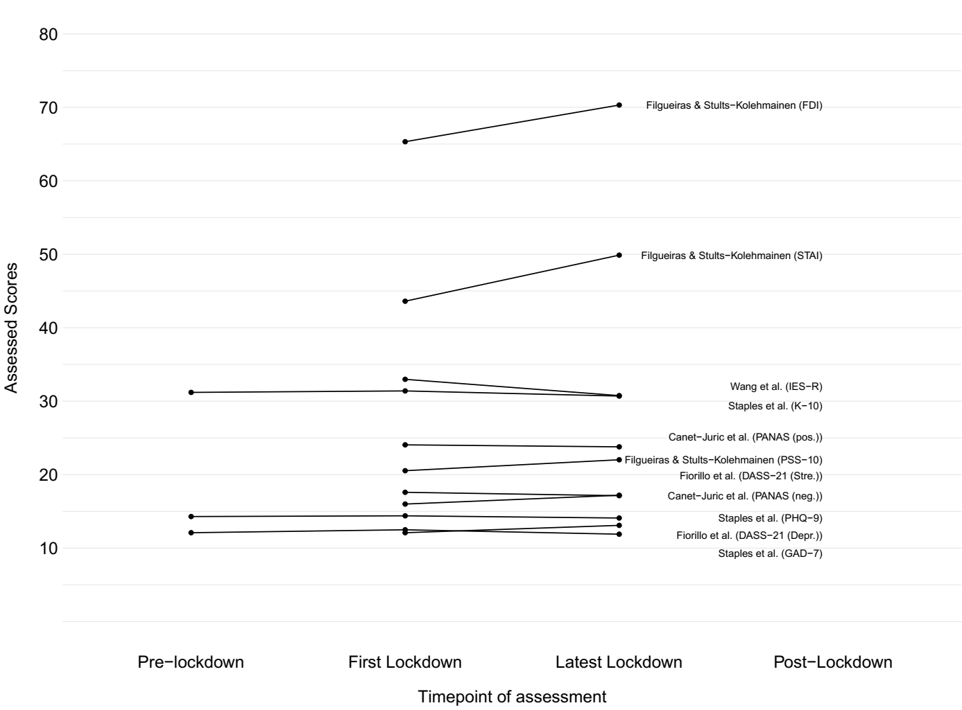

Caption Figure 2 appendix: DASS-21 (Anx.), Depression, Anxiety, Stress Scale - Anxiety; DASS-21 (Depr.), Depression, Anxiety, Stress Scale - Depression; DASS-21 (Stre.), Depression, Anxiety, Stress Scale - Stress; FDI, Filgueiras Depression Inventory; GAD-2, Generalised Anxiety Disorder-2; GAD-7, Generalised Anxiety Disorder-7; GHQ-12, 12-item General Health Questionnaire; HADS (Anx.), Hospital Anxiety and Depression Scale; HADS (Depr.), Hospital Anxiety and Depression Scale; K6, Kessler Psychological Distress Scale; PHQ-2, Patient Health Questionnaire-2; PHQ-4, Patient Health Questionnaire-4; PHQ-9, Patient Health Questionnaire-9; PSS-10, Perceived Stress Scale-10; STAI, State-Trait Anxiety Inventory

Caption Figure 3 appendix: ASDS-5, Acute Stress Disorder Scale-5; BDI-II, Beck Depression Inventory-II; BSI, Brief Symptom Inventory; DASS-21 (Anx.), Depression, Anxiety, Stress Scale - Anxiety; DASS-21 (Depr.), Depression, Anxiety, Stress Scale - Depression; DASS-21 (Stre.), Depression, Anxiety, Stress Scale - Stress; GAD-7, Generalised Anxiety Disorder-7; K6, Kessler Psychological Distress Scale; PANAS (neg.), Positive and Negative Affect Schedule -Negative Affect; PANAS (pos.), Positive and Negative Affect Schedule -Positive Affect; PHQ-2, Patient Health Questionnaire-2; PHQ-4, Patient Health Questionnaire-4; PHQ-9, Patient Health Questionnaire-9; PSS-10, Perceived Stress Scale-10; STAI, State-Trait Anxiety Inventory

Caption Figure 4 appendix: DASS-21 (Depr.), Depression, Anxiety, Stress Scale - Depression; DASS-21 (Stre.), Depression, Anxiety, Stress Scale - Stress; FDI, Filgueiras Depression Inventory; GAD-7, Generalized Anxiety Disorder-7; IES-R, Impact of Event Scale-Revised; K-10, Kessler Psychological Distress Scale; PANAS (neg.), Positive and Negative Affect Schedule -Negative Affect; PANAS (pos.), Positive and Negative Affect Schedule -Positive Affect; PHQ-9, Patient Health Questionnaire-9; PSS-10, Perceived Stress Scale-10; STAI, State-Trait Anxiety Inventory

