SUPPLEMENTARY MATERIAL
Use of Antipsychotics in Denmark 1997-2018: A Nation-wide Drug Utilization Study with Focus on Off-label Use and Associated Diagnoses
Højlund M, Andersen JH, Andersen K, Correll CU, Hallas J. 2021

Contents
Appendix 1: Overview of data sources 2
Appendix 2: ICD-codes used for diagnostic classification 3
Appendix 3: ICD-10 and ATC codes used for covariate assessment in group 6 4
Supplementary Table 1: Sensitivity analysis extending the assessment period for incident users 5
Supplementary Table 2: Users by commonly used antipsychotics and diagnostic groups, Denmark, 2018 6
Supplementary Table 3: Characteristics of antipsychotic users without psychiatric, neurological or cancer diagnoses in Denmark 2018 (n=46,923) 7
Supplementary Table 4: Characteristics of antipsychotic users without psychiatric, neurological or cancer diagnoses in Denmark 2018 for the 10 most commonly used antipsychotics 8
Supplementary Figure 1: Development in all users overall and by diagnostic subgroups, Denmark 1997-2018 10
Supplementary Figure 2: Development in prevalent users overall and by subgroups, Denmark 1997-2018 11
Supplementary Figure 3: Development in incident users overall and by subgroup, Denmark 1997-2018 12

Appendix 1: Overview of data sources
Data source | Coverage | Content | Obtained information | Notes
Danish Register of Medical Product Statistics (DRMPS) | From 1995 | Information on all prescriptions dispensed at Danish community pharmacies, including preparation, amount, and strength. | Prescriptions for antipsychotics.  Prescriptions for other psychotropic medications.  Prescriptions for other drugs for assessment of non-psychiatric comorbidities. | In-hospital use is not covered by DRMPS. Indications not recorded in DRMPS.
Danish National Patient Register (DNPR) | Admissions: From 1977  Outpatient contacts: From 1995 | Information on admissions and outpatient contacts to all public Danish hospitals. | Diagnoses of psychiatric or neurological disorders.  Diagnoses of malignant neoplasms.  Diagnoses of other medical conditions for assessment of co-morbidities. | Private hospitals only accounts for a negligible proportion of health care in the included disease categories.
National Health Insurance Service Register (NHISR) | From 1990 | Information on all contacts to general practitioners and practicing specialists (e.g. practicing psychiatrists).  Based on invoices to regional health administrations (date and type of service). | Health care contacts to:  - General practitioners  - Office-based psychiatrists  - Office-based neurologists | Private practitioners only accounts for a negligible proportion of health care in the included disease categories.
Danish Civil Registration Register (DCRS) | Established in 1968  (covers the entire population) | Information on vital status and civil registration numbers for residents in Denmark. | Civil registration number for register-linkage | Unique identifier (civil registration number) assigned to all Danish residents upon birth or immigration allowing linkage of registers.

Appendix 2: ICD-codes used for diagnostic classification
Group | Subgroups | Codes
Severe or chronic mental disorders  (group 1) | Schizophrenia and schizoaffective disorder | ICD-10: F20, 25  ICD-8: 295.xx
 | Mania and bipolar affective disorder | ICD-10: F30-31  ICD-8: 296.xx
 | Other psychotic disorders | ICD-10: F22-24, 26-29  ICD-8: 297.xx-299.xx
Chronic mental disorders  (group 2) | Dementias | ICD-10: F00-03, G30-31  ICD-8: 290.xx
 | Mental retardation and autism | ICD-10: F70-79, 84  ICD-8: 311.xx-315.xx
Other mental disorders  (group 3) | Organic mental disorders (excl. dementia) | F04-09
 | Psychoactive substance use | F10-19
 | Schizotypal disorder | F21
 | Affective disorders (excl. bipolar affective disorder) | F32-33, 34, 39
 | Neurotic or stress-related disorders | F40-49
 | Other behavioral disorders | F50-59
 | Disorder of adult personality and behavior | F60-69
 | Developmental disorders (excl. autism) | F80-83, 85-89
 | Behavioral and emotional disorders  (e.g. hyperkinetic disorder) | F90-98
 | Unspecified mental disorder | F99
Selected diseases of the nervous system  (group 4) | Encephalitis, myelitis, and encephalomyelitis | G04-05
 | Huntington disease | G10
 | Parkinson disease | G20
 | Multiple sclerosis | G35
 | Episodic and paroxysmal disorders  (e.g. epilepsy, migraine, sleep disorders) | G40-47
 | Other disorders of the nervous system  (e.g. hydrocephalus) | G90-99
Diagnosis of cancer  (group 5) | Malignant neoplasms (excl. non-melanoma skin cancer) | C00-43, 45-97
ICD: World Health Organization International Statistical Classification of Diseases and Related Health Problems 8th/10th revision (10th revision: icd.who.int/browse10/2019/en)

Appendix 3: ICD-10 and ATC codes used for covariate assessment in group 6
Co-medications
Anti-dementia drugs | ATC: N06D
Antidepressants | ATC: N06A
Anxiolytics | ATC: N05B
Drugs used in alcohol dependence | ATC: N07BB
Drugs used in opioid dependence | ATC: N07BC
Hypnotics | ATC: N05C
Mood stabilizers | ATC: N03AX, N05AN01
Psychostimulants | ATC: N06B
Co-morbidities
Chronic obstructive pulmonary disease | ICD-10: J40-44  ATC: R03
Hypertension | ICD-10: I10-15, H350H, I674, O10  ATC: C03A, C08C, C09A
Alcoholism-related disease | ICD-10: E244, E529A, F10, G312, G405, G621, G721, I426, K292, K70, K860, O354, P043, T519, Z502, Z714, Z721  ATC: N07BB
Ischemic heart disease | ICD-10: I200-201, I208-214, I219, I22-23, I241, I252  ATC: N02BA, C01DA
Diabetes | ICD-10: E10-14, E891, G590, G632, G730, G990C, H280, H360, I729A, M142, N083, O240-243  ATC: A10
ATC: Anatomic Therapeutic Chemical Classification System (who.int/classifications/atcddd/en), ICD-10: World Health Organization International Statistical Classification of Diseases and Related Health Problems 10th revision (icd.who.int/browse10/2019/en)

Supplementary Table 1: Sensitivity analysis extending the assessment period for incident users
 | Assessment window
 | 1 year |  | 2 years |  | 5 years
ICD-10 diagnosis | N | %ª | N | % ª | N | % ª
All incident users | 37,478 | 100 | 33,868 | 100 | 29,634 | 100
Severe mental disorders | 5,469 | 15 | 4,246 | 13 | 2,917 | 9.8
Chronic mental disorders | 4,082 | 11 | 3,778 | 11 | 3,452 | 12
Other mental disorders | 9,850 | 26 | 9,268 | 27 | 8,353 | 28
Selected diseases of the nervous system | 1,386 | 3.7 | 1,335 | 3.9 | 1,278 | 4.3
Advanced cancers | 2,217 | 5.9 | 2,190 | 6.5 | 2,152 | 7.3
No relevant diagnoses | 14,474 | 39 | 13,051 | 39 | 11,482 | 39
Notes: ªPercentage of all incident users.
Abbreviations: ICD-10: World Health Organization International Statistical Classification of Diseases and Related Health Problems 10th revision (icd.who.int/browse10/2019/en).

Supplementary Table 2: Users by commonly used antipsychotics and diagnostic groups, Denmark, 2018
ARI: Aripiprazole, CHL: Chlorprothixene, CLO: Clozapine, FLU: Flupentixol, HAL: Haloperidol, LEV: Levomepromazine, OLA: Olanzapine, QUE: Quetiapine, RIS: Risperidone, ZUC: Zuclopenthixol.
 | CLO | ZUC | ARI | OLA | RIS | CHL | QUE | LEV | FLU | HAL
All users
All groups | 3,403 (100) | 4,224 (100) | 12,357 (100) | 17,554 (100) | 16,056 (100) | 14,028 (100) | 64,946 (100) | 4,017 (100) | 3,809 (100) | 7,963 (100)
Severe mental disorders | 3,113 (91) | 3,061 (72) | 8,033 (65) | 10,671 (61) | 6,707 (42) | 3,895 (28) | 17,578 (27) | 811 (20) | 497 (13) | 848 (11)
Chronic mental disorders | 130 (3.8) | 364 (8.6) | 1,159 (9.4) | 1,624 (9.3) | 4,175 (26) | 994 (7.1) | 5,720 (8.8) | 337 (8.4) | 140 (3.7) | 1,482 (19)
Other mental disorders | 21 (.62) | 87 (2.1) | 1,236 (10) | 1,937 (11) | 1,714 (11) | 2,276 (16) | 12,786 (20) | 251 (6.2) | 281 (7.4) | 1,219 (15)
Neurological diagnosis only | 52 (1.5) | 14 (.33) | 77 (.62) | 318 (1.8) | 138 (.86) | 169 (1.2) | 962 (1.5) | 234 (5.8) | 69 (1.8) | 714 (9)
Cancer diagnosis only | - | 16 (.38) | 5 (.04) | 370 (2.1) | 103 (.64) | 144 (1) | 453 (.7) | 82 (2) | 61 (1.6) | 1,816 (23)
No relevant diagnosis | 81 (2.4) | 679 (16) | 1,843 (15) | 2,634 (15) | 3,219 (20) | 6,550 (47) | 27,447 (42) | 2,302 (57) | 2,761 (72) | 1,884 (24)
Prevalent users
All groups | 3,253 (100) | 3,987 (100) | 10,167 (100) | 13,983 (100) | 11,976 (100) | 10,519 (100) | 45,037 (100) | 3,119 (100) | 3,076 (100) | 1,683 (100)
Severe mental disorders | 3,029 (93) | 2,929 (73) | 6,959 (68) | 9,474 (68) | 5,832 (49) | 3,477 (33) | 15,069 (33) | 761 (24) | 460 (15) | 703 (42)
Chronic mental disorders | 108 (3.3) | 341 (8.6) | 947 (9.3) | 1,312 (9.4) | 2,929 (24) | 815 (7.7) | 4,091 (9.1) | 307 (9.8) | 119 (3.9) | 442 (26)
Other mental disorders | 15 (.46) | 63 (1.6) | 743 (7.3) | 968 (6.9) | 827 (6.9) | 1,230 (12) | 6,240 (14) | 138 (4.4) | 175 (5.7) | 143 (8.5)
Neurological diagnosis only | 39 (1.2) | 14 (.35) | 59 (.58) | 96 (.69) | 68 (.57) | 122 (1.2) | 605 (1.3) | 78 (2.5) | 57 (1.9) | 54 (3.2)
Cancer diagnosis only | - | 16 (.4) | 5 (.049) | 73 (.52) | 40 (.33) | 110 (1) | 252 (.56) | 55 (1.8) | 50 (1.6) | 86 (5.1)
No relevant diagnosis | 58 (1.8) | 624 (16) | 1,454 (14) | 2,060 (15) | 2,280 (19) | 4,765 (45) | 18,780 (42) | 1,780 (57) | 2,215 (72) | 255 (15)
Incident users
All groups | 150 (100) | 237 (100) | 2,190 (100) | 3,571 (100) | 4,080 (100) | 3,509 (100) | 19,909 (100) | 898 (100) | 733 (100) | 6,280 (100)
Severe mental disorders | 84 (56) | 132 (56) | 1,074 (49) | 1,197 (34) | 875 (21) | 418 (12) | 2,509 (13) | 50 (5.6) | 37 (5) | 145 (2.3)
Chronic mental disorders | 22 (15) | 23 (9.7) | 212 (9.7) | 312 (8.7) | 1,246 (31) | 179 (5.1) | 1,629 (8.2) | 30 (3.3) | 21 (2.9) | 1,040 (17)
Other mental disorders | 6 (4) | 24 (10) | 493 (23) | 969 (27) | 887 (22) | 1,046 (30) | 6,546 (33) | 113 (13) | 106 (14) | 1,076 (17)
Neurological diagnosis only | 13 (8.7) | - | 18 (.82) | 222 (6.2) | 70 (1.7) | 47 (1.3) | 357 (1.8) | 156 (17) | 12 (1.6) | 660 (11)
Cancer diagnosis only | - | - | - | 297 (8.3) | 63 (1.5) | 34 (.97) | 201 (1) | 27 (3) | 11 (1.5) | 1,730 (28)
No relevant diagnosis | 23 (15) | 55 (23) | 389 (18) | 574 (16) | 939 (23) | 1,785 (51) | 8,667 (44) | 522 (58) | 546 (74) | 1,629 (26)

Supplementary Table 3: Characteristics of antipsychotic users without psychiatric, neurological or cancer diagnoses in Denmark 2018 (n=46,923)
Characteristic | N | %
Age
0-12 years | 65 | 0.1
13-17 years | 236 | 0.5
18-24 years | 2,286 | 4.9
25-44 years | 11,759 | 25.1
45-64 years | 17,669 | 37.7
65-79 years | 9,445 | 20.1
80+ years | 5,463 | 11.6
Sex
Female | 26,917 | 57.4
Antipsychotic drugs
Quetiapine | 27,447 | 58.5
Chlorprothixene | 6,550 | 14.0
Risperidone | 3,219 | 6.9
Flupentixol | 2,761 | 5.9
Olanzapine | 2,634 | 5.6
Levomepromazine | 2,302 | 4.9
Haloperidol | 1,884 | 4.0
Aripiprazole | 1,843 | 3.9
Zuclopenthixol | 679 | 1.4
Clozapine | 81 | 0.2
Number of antipsychotic prescriptions
1 | 13,368 | 28.5
2 | 5,433 | 11.6
3-5 | 14,415 | 30.7
>5 | 13,707 | 29.2
Number of antipsychotic drugs
1 | 43,620 | 93.0
2 | 3,009 | 6.4
>2 | 294 | 0.6
Total amount redeemed
≤90 DDD | 37,640 | 80.2
91-180 DDD | 4,635 | 9.9
181-365 DDD | 2,984 | 6.4
>365 DDD | 1,633 | 3.5
Concurrent use of psychotropic co-medication
Antidepressants (N06A) | 24,064 | 51.3
Hypnotics (N05C) | 8,793 | 18.7
Mood stabilizers (N03AX+N05AN01) | 7,499 | 16.0
Anxiolytics (N05B) | 5,804 | 12.4
Psychostimulants (N06B) | 2,535 | 5.4
Drugs for alcohol dependence (N07BB) | 829 | 1.8
Drugs for opioid dependence (N07BC) | 591 | 1.3
Anti-dementia drugs (N06D) | 270 | 0.6
Somatic comorbidity
Chronic obstructive pulmonary disease | 20,999 | 44.8
Hypertension | 19,853 | 42.3
Alcoholism-related disease | 9,199 | 19.6
Ischemic heart disease | 8,142 | 17.4
Diabetes | 5,793 | 12.3
First prescriber*
Psychiatrist | 1,721 | 11.9
General practitioner | 9,434 | 65.2
Other practicing specialist | 134 | 0.9
Hospital | 467 | 3.2
Psychiatric hospital | 247 | 1.7
No information | 2,718 | 18.8
Healthcare utilization*
Contact with GP only | 11,527 | 79.6
Contact with practicing psychiatrist | 2,383 | 16.5
Contact with other practicing specialist | 309 | 2.1
No information | 255 | 1.8
*Among incident users in 2018 (n = 14,474)

Supplementary Table 4: Characteristics of antipsychotic users without psychiatric, neurological or cancer diagnoses in Denmark 2018 for the 10 most commonly used antipsychotics
ARI: Aripiprazole, CHL: Chlorprothixene, CLO: Clozapine, FLU: Flupentixol, HAL: Haloperidol, LEV: Levomepromazine, OLA: Olanzapine, QUE: Quetiapine, RIS: Risperidone, ZUC: Zuclopenthixol. (Cells filled with – means few or zero observations and have been blinded due to confidentiality issues).
 | QUE | OLA | RIS | CHL | ARI
 | n = 27,447 | n = 2,634 | n = 3,219 | n = 6,550 | n = 1,843
Age, median (IQR) | 50 (38-62) | 58 (46-72) | 59 (43-79) | 54 (43-66) | 44 (30-56)
Sex
Female | 15,485 (56.4%) | 1,288 (48.9%) | 1,677 (52.1%) | 3,684 (56.2%) | 1,018 (55.2%)
Starting year, median (IQR) | 2014 (2009-2017) | 2011 (2003-2016) | 2013 (2005-2017) | 2010 (2003-2015) | 2012 (2006-2016)
Number of antipsychotic prescriptions
1 | 7,581 (27.6%) | 372 (14.1%) | 517 (16.1%) | 1,835 (28.0%) | 200 (10.9%)
2 | 3,317 (12.1%) | 263 (10.0%) | 348 (10.8%) | 706 (10.8%) | 197 (10.7%)
3-5 | 8,827 (32.2%) | 729 (27.7%) | 738 (22.9%) | 1,755 (26.8%) | 552 (30.0%)
>5 | 7,722 (28.1%) | 1,270 (48.2%) | 1,616 (50.2%) | 2,254 (34.4%) | 894 (48.5%)
Total amount redeemed
≤90 DDD | 22,575 (82.2%) | 982 (37.3%) | 2,203 (68.4%) | 5,475 (83.6%) | 648 (35.2%)
91-180 DDD | 2,365 (8.6%) | 628 (23.8%) | 539 (16.7%) | 552 (8.4%) | 538 (29.2%)
181-365 DDD | 1,593 (5.8%) | 553 (21.0%) | 350 (10.9%) | 316 (4.8%) | 388 (21.1%)
>365 DDD | 900 (3.3%) | 466 (17.7%) | 122 (3.8%) | 201 (3.1%) | 264 (14.3%)
First prescriber
Psychiatrist | 1,161 (13.4%) | 119 (20.7%) | 143 (15.2%) | 174 (9.7%) | 182 (46.8%)
General practitioner | 5,848 (67.5%) | 287 (50.0%) | 512 (54.5%) | 1,284 (71.9%) | 81 (20.8%)
Hospital | 100 (1.2%) | 53 (9.2%) | 45 (4.8%) | 8 (0.4%) | -
Healthcare utilization
Contact with GP only | 6,775 (78.2%) | 412 (71.8%) | 734 (78.2%) | 1,429 (80.1%) | 167 (42.9%)
Contact with practicing psychiatrist | 1,624 (18.7%) | 145 (25.3%) | 181 (19.3%) | 288 (16.1%) | 203 (52.2%)

Supplementary Table 4 (cont.)
 | HAL | ZUC | LEV | FLU | CLO
 | n = 1,884 | n = 679 | n = 2,302 | n = 2,761 | n = 81
Age, median (IQR) | 87 (79-93) | 67 (56-76) | 67 (58-76) | 66 (53-76) | 71 (56-77)
Sex
Female | 1,128 (59.9%) | 1,547 (67.2%) | 425 (62.6%) | 1,929 (69.9%) | 36 (44.4%)
Starting year, median (IQR) | 2018 (2018-2018) | 2003 (1995-2014) | 1995 (1995-2002) | 2003 (1995-2013) | 2013 (2002-2017)
Number of antipsychotic prescriptions
1 | 1,316 (69.9%) | 656 (28.5%) | 64 (9.4%) | 608 (22.0%) | 17 (21.0%)
2 | 263 (14.0%) | 274 (11.9%) | 48 (7.1%) | 296 (10.7%) | 15 (18.5%)
3-5 | 174 (9.2%) | 687 (29.8%) | 255 (37.6%) | 1,181 (42.8%) | 23 (28.4%)
>5 | 131 (7.0%) | 685 (29.8%) | 312 (45.9%) | 676 (24.5%) | 26 (32.1%)
Total amount redeemed
≤90 DDD | 1,707 (90.6%) | 2,131 (92.6%) | 464 (68.3%) | 2,410 (87.3%) | 59 (72.8%)
91-180 DDD | 91 (4.8%) | 81 (3.5%) | 103 (15.2%) | 247 (8.9%) | 7 (8.6%)
181-365 DDD | 52 (2.8%) | 46 (2.0%) | 69 (10.2%) | 78 (2.8%) | 9 (11.1%)
>365 DDD | 30 (1.6%) | 41 (1.8%) | 40 (5.9%) | 24 (0.9%) | 6 (7.4%)
First prescriber
Psychiatrist | - | 18 (3.4%) | 7 (12.7%) | 109 (20.0%) | -
General practitioner | 1,043 (64.0%) | 305 (58.4%) | 26 (47.3%) | 368 (67.4%) | 10 (43.5%)
Hospital | 261 (16.0%) | 21 (4.0%) | - | - | -
Healthcare utilization
Contact with GP only | 1,562 (95.9%) | 397 (76.1%) | 43 (78.2%) | 393 (72.0%) | 18 (78.3%)
Contact with practicing psychiatrist | 5 (0.3%) | 28 (5.4%) | 10 (18.2%) | 140 (25.6%) | -

Supplementary Figure 1: Development in all users overall and by diagnostic subgroups, Denmark 1997-2018
A) Groups 1 to 6, B) Severe and chronic mental disorders, C) Other mental disorders, D) Neurological disorders
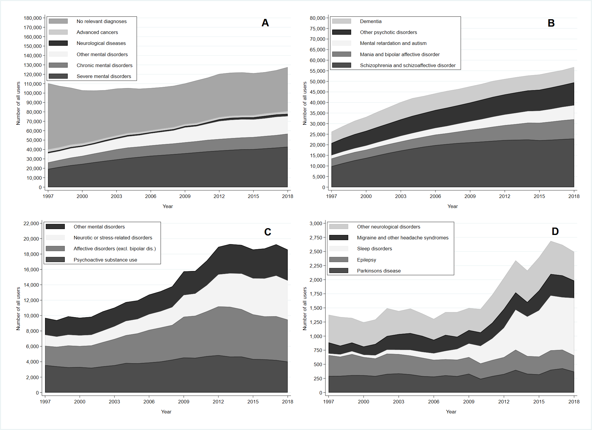

Supplementary Figure 2: Development in prevalent users overall and by subgroups, Denmark 1997-2018
A) Groups 1 to 6, B) Severe and chronic mental disorders, C) Other mental disorders, D) Neurological disorders
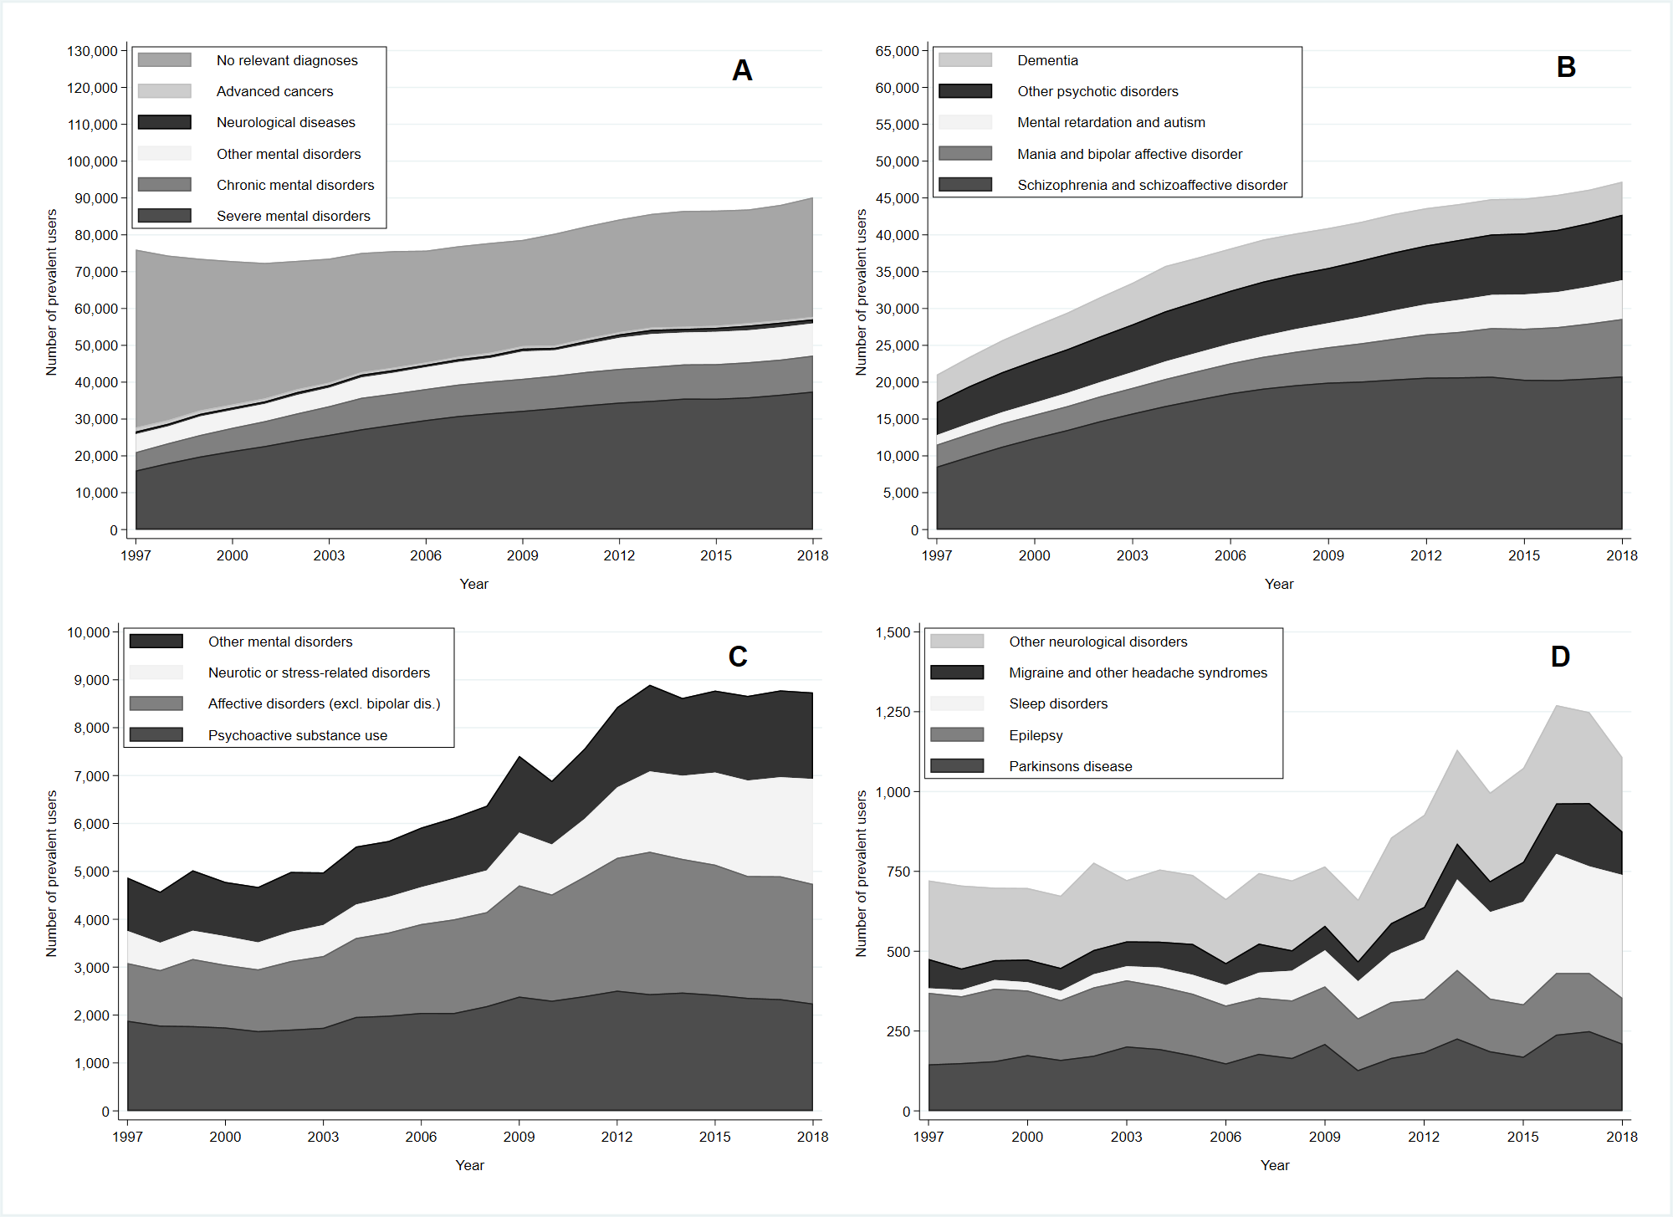

Supplementary Figure 3: Development in incident users overall and by subgroup, Denmark 1997-2018
A) Groups 1 to 6, B) Severe and chronic mental disorders, C) Other mental disorders, D) Neurological disorders

