Online supplements
Table S1. Characteristics of missing data for earnings
Table S2. Characteristics of missing data for depression in young adulthood
Table S3. Ratio of mean earnings between depressed and non-depressed females and males, year 1996 to 2016
Table S4. The mediating effect of recurrent depression in early adulthood (19-30 years) on CPI-adjusted earnings in mid-adulthood (age 31-40) in females and males with a history of persistent depressive disorder in adolescence
Table S5. The mediating effect of recurrent depression in early adulthood (19-30 years) on CPI-adjusted earnings in mid-adulthood (age 31-40) in females with a history of persistent depressive disorder in adolescence
Table S6. The mediating effect of recurrent depression in early adulthood (19-30 years) on CPI-adjusted earnings in mid-adulthood (age 31-40) in males with a history of persistent depressive disorder in adolescence
Table S7. Ratio of mean earnings between depressed and non-depressed females and males, year 1996 to 2016 – complete cases
Table S8. Ratio of mean earnings between analysis groups, year 1996 to 2016 – complete cases
Table S9. The mediating effect of recurrent depression in early adulthood (19-30 years) on CPI-adjusted earnings in mid-adulthood (age 31-40) in females and males with a history of persistent depressive disorder in adolescence – complete cases
Table S10. The mediating effect of recurrent depression in early adulthood (19-30 years) on CPI-adjusted earnings in mid-adulthood (age 31-40) in females with a history of persistent depressive disorder in adolescence – complete cases
Table S11. The mediating effect of recurrent depression in early adulthood (19-30 years) on CPI-adjusted earnings in mid-adulthood (age 31-40) in males with a history of persistent depressive disorder in adolescence – complete cases
Fig. S1. Mean earnings (95% CI) of females with or without a history of depressive disorders in adolescence, year 1996 to 2016
Fig. S2. Mean earnings (95% CI) of males with or without a history of depressive disorders in adolescence, year 1996 to 2016
Fig. S3. Ratio of mean earnings between females with a history of depressive disorders and non-depressed peers at 25th, 50th and 75th percentile of the distribution in each group, year 1996 to 2016
Fig. S4. Ratio of mean earnings between males with a history of depressive disorders and non-depressed peers at 25th, 50th and 75th percentile of the distribution in each group, year 1996 to 2016
Table S1. Characteristics of missing data for earnings
Total  (n=539) | Total  (n=539) |  | Persistent depressive disorder (PDD)  (n=175) |  | Major depressive disorder (MDD)  (n=82) |  | Subthreshold depression  (n=64) |  | No depression  (n=218)
 | Complete data  n=472 | Incomplete data  n=67 | Complete data  n=148 | Incomplete data  n=27 | Complete data  n=68 | Incomplete data  n=14 | Complete data  n=53 | Incomplete data  n=11 | Complete data  n=203 | Incomplete data  n=15
Sex, No. females (%)ª | 371 (78.6) | 54 (80.6) | 120 (81.1) | 20 (74.1) | 56 (82.4) | 12 (85.7) | 37 (69.8) | 9 (81.8) | 158 (77.8) | 13 (86.2)
Age at screening, mean (SD), yª | 16.4 (0.6) | 16.4 (0.6) | 16.5 (0.6) | 16.4 (0.6) | 16.4 (0.7) | 16.4 (0.5) | 16.4 (0.7) | 16.5 (0.7) | 16.4 (0.6) | 16.5 (0.6)
Childhood or adolescent anxiety disorder, No. (%)ª | 154 (32.6) | 23 (34.3) | 91 (61.5) | 14 (51.9) | 28 (41.2) | 6 (42.9) | 4 (7.5) | 2 (18.2) | 31 (15.3) | 1 (6.7)
Disruptive behavior disorder, No. (%)^{b} | 88 (18.6) | 24 (35.8) | 46 (31.1) | 14 (51.9) | 18 (26.5) | 2 (14.3) | 10 (18.9) | 6 (54.5) | 14 (6.9) | 2 (13.3)
Low parental education, high school or less, No. (%)ª | 242 (51.3) | 19 (28.4) | 71 (48.0) | 11 (40.7) | 43 (29.1) | 7 (50.0) | 29 (54.7) | 6 (54.6) | 99 (48.8) | 5 (33.4)
Parental income (USD), mean, (SD)ª | 26565 (11164) | 24708 (11178) | 26242 (8874) | 23074 (8638) | 23915 (8651) | 29529 (14409) | 25179 (10106) | 23098 (10618) | 28051 (13306) | 24330 (12107)
ªNo significant differences between incomplete and complete data. ^{b} Significant differences between incomplete and complete data for the total sample, PDD and subthreshold subgroup.

Table S2. Characteristics of missing data for depression in young adulthood
Total  (n=539) | Total  (n=539) |  | Persistent depressive disorder (PDD)  (n=175) |  | Major depressive disorder (MDD)  (n=82) |  | Subthreshold depression  (n=64) |  | No depression  (n=218)
 | Complete data  n=351 | Incomplete data  n=188 | Complete data  n=115 | Incomplete data  n=60 | Complete data  n=59 | Incomplete data  n=23 | Complete data  n=30 | Incomplete data  n=34 | Complete data  n=147 | Incomplete data  n=71
Sex, No. females (%)ª | 283 (80.6) | 142 (75.5) | 93 (80.9) | 47 (78.3) | 50 (84.7) | 18 (78.3) | 22 (73.3) | 24 (70.6) | 118 (80.3) | 53 (74.6)
Age at screening, mean (SD), yª | 16.4 (0.6) | 16.5 (0.6) | 16.4 (0.6) | 16.6 (0.6) | 16.4 (0.6) | 16.5 (0.6) | 16.5 (0.6) | 16.3 (0.7) | 16.4 (0.6) | 16.4 (0.6)
Childhood anxiety disorder, No. (%)ª | 123 (35.0) | 54 (28.7) | 73 (63.5) | 32 (53.3) | 27 (45.8) | 7 (30.4) | 2 (6.7) | 4 (11.8) | 21 (14.3) | 11 (15.5)
Disruptive behavior disorder, No. (%)ª | 67 (19.1) | 45 (23.9) | 36 (31.3) | 24 (40.0) | 15 (25.4) | 5 (21.7) | 7 (23.3) | 9 (26.5) | 9 (6.1) | 7 (9.9)
Low parental education, high school or less, No. (%)^{b} | 163 (46.5) | 108 (57.4) | 46 (40.0) | 36 (60.0) | 36 (61.0) | 14 (60.8) | 14 (46.7) | 21 (61.8) | 67 (45.6) | 37 (52.1)
Parental income (USD), mean, (SD)^{c} | 27280 (11280) | 24570 (10778) | 26940 (7804) | 23478 (10358) | 24455 (8871) | 25946 (12575) | 24630 (9180) | 24990 (11053) | 29220 (14175) | 24846 (10527)
ª No significant differences between incomplete and complete data. ^{b} Significant differences between incomplete and complete data for the total sample and PDD subgroup. ^{c} Significant differences between incomplete and complete data for the total sample, PDD subgroup and the non-depressed group.

Table S3. Ratio of mean earnings between depressed and non-depressed females and males, year 1996 to 2016
Variable |  | Ratio of mean earnings (95% CI)  p-value
 |  | All |  | Females |  | Males
 |  | Unadjusted | Adjustedª | Unadjusted | Adjusted^{b} | Unadjusted | Adjusted^{b}
 | Depression during adolescence | 0.85 (0.78 - 0.92)  <.001 | 0.89 (0.82 - 0.97)  .009 | 0.87 (0.80 - 0.96)  .003 | 0.90 (0.82 - 0.99)  .04 | 0.77 (0.65 - 0.92)  .003 | 0.84 (0.70 - 1.02)  .08
Confounding factors | Female sex | N/A | 0.78 (0.71 - 0.86)  <.001 | N/A | N/A | N/A | N/A
 | Disruptive behavior disorder | N/A | 0.83 (0.75 - 0.91)  <.001 | N/A | 0.82 (0.73 - 0.91)  <.001 | N/A | 0.88 (0.71 - 1.08)  .22
 | Childhood anxiety disorder | N/A | 1.02 (0.94 - 1.11)  .63 | N/A | 1.04 (0.95 - 1.14)  .37 | N/A | 0.94 (0.78 - 1.13)  .50
 | Parental education,  College or university vs High school or lower | N/A | 1.02 (0.94 - 1.10)  .70 | N/A | 1.07 (0.98 - 1.17)  .12 | N/A | 0.86 (0.72 - 1.02)  .08
 | Parental income,  By 10,000 USD increase | N/A | 1.05 (1.01 - 1.09)  .020 | N/A | 1.04 (1.00 - 1.08)  .04 | N/A | 1.08 (0.96 - 1.21)  .21
Note: N/A = not available
ª Adjusted for sex, disruptive behavior disorders, childhood anxiety disorders, parental education level, and income.
^{b} Adjusted for disruptive behavior disorders, childhood anxiety disorders, parental education level, and income.

Table S4. The mediating effect of recurrent depression in early adulthood (19-30 years) on CPI-adjusted earnings in mid-adulthood (age 31-40) in females and males with a history of persistent depressive disorder in adolescence
Depression status during adolescence | Depression during early adulthood |  | Ratio of mean earnings (95% CI) / p-value  compared to non-depressed peers |  |  | Proportion mediated
 | Proportion (95% CI)ª | Relative risk (95% CI)  compared to non-depressed peers | Total effect | Direct effect | Indirect effect
Unadjusted
No depression (n=218) | 0.23 (0.17; 0.32) | N/A | N/A | N/A | N/A | N/A
Persistent depressive disorder (n=175) | 0.62 (0.51; 0.76) | 2.71 (1.86; 3.93)  <.001 | 0.79 (0.71 - 0.88)  <.001 | 0.87 (0.77 - 0.97)  .02 | 0.91 (0.86 - 0.96)  .002 | 0.42
Adjusted^{b}
No depression (n=218) | 0.26 (0.17; 0.39) | N/A | N/A | N/A | N/A | N/A
Persistent depressive disorder (n=175) | 0.60 (0.46; 0.78) | 2.31 (1.49; 3.60)  <.001 | 0.83 (0.74 - 0.93)  .002 | 0.90 (0.80 - 1.03)  .12 | 0.92 (0.86 - 0.98)  .006 | 0.48
Note: N/A = not available
ª In adjusted analysis, all other variables are fixed at their mean levels
^{b} Adjusted for sex, disruptive behavior disorders, childhood anxiety disorders, parental education, and parental income

Table S5. The mediating effect of recurrent depression in early adulthood (19-30 years) on CPI-adjusted earnings in mid-adulthood (age 31-40) in females with a history of persistent depressive disorder in adolescence
Depression status during adolescence | Depression during early adulthood |  | Ratio of mean earnings (95% CI) / p-value  compared to non-depressed peers |  |  | Proportion mediated
 | Proportion  (95% CI)ª | Relative risk (95% CI)  compared to non-depressed peers | Total effect | Direct effect | Indirect effect
Unadjusted
No depression (n=171) | 0.24 (0.17 - 0.35) | N/A | N/A | N/A | N/A | N/A
Persistent depressive disorder (n=140) | 0.63 (0.51 - 0.79) | 2.58 (1.71; 3.91)  <.001 | 0.83 (0.74 - 0.94)  .003 | 0.91 (0.80 - 1.03)  .13 | 0.92 (0.87 - 0.98)  .008 | 0.47
Adjusted^{b}
No depression (n=171) | 0.27 (0.17 - 0.42) | N/A | N/A | N/A | N/A | N/A
Persistent depressive disorder (n=140) | 0.63 (0.49 - 0.80) | 2.31 (1.41; 3.78)  <.001 | 0.87 (0.77 - 0.98)  .03 | 0.94 (0.82 - 1.08)  .41 | 0.92 (0.86 - 0.98)  .01 | 0.61
Note: N/A = not available
ª In adjusted analysis, all other variables are fixed at their mean levels.
^{b} Adjusted for disruptive behavior disorders, childhood anxiety disorders, parental education, and parental income

Table S6. The mediating effect of recurrent depression in early adulthood (19-30 years) on CPI-adjusted earnings in mid-adulthood (age 31-40) in males with a history of persistent depressive disorder in adolescence
Depression status during adolescence | Depression during early adulthood |  | Ratio of mean earnings (95% CI) / p-value  compared to non-depressed peers |  |  | Proportion mediated
 | Proportion  (95% CI)ª | Relative risk (95% CI)  compared to non-depressed peers | Total effect | Direct effect | Indirect effect
Unadjusted
No depression (n=47) | 0.17 (0.07; 0.39) | N/A | N/A | N/A | N/A | N/A
Persistent depressive disorder (n=35) | 0.57 (0.35; 0.92) | 3.40 (1.33; 8.65)  .010 | 0.67 (0.53 - 0.84)  <.001 | 0.75 (0.59 - 0.95)  .02 | 0.89 (0.78 - 1.02)  .10 | 0.32
Adjusted^{b}
No depression (n=47) | 0.22 (0.09; 0.55) | N/A | N/A | N/A | N/A | N/A
Persistent depressive disorder (n=35) | 0.53 (0.30; 0.92) | 2.40 (0.83; 6.94)  .11 | 0.71 (0.53 - 0.94)  .02 | 0.77 (0.58 - 1.03)  .08 | 0.92 (0.79 - 1.06)  .23 | 0.29
Note: N/A = not available
ª In adjusted analysis, all other variables are fixed at their mean levels.
^{b} Adjusted for disruptive behavior disorders, childhood anxiety disorders, parental education, and parental income

Table S7. Ratio of mean earnings between depressed and non-depressed females and males, year 1996 to 2016 – complete cases
Variable |  | Ratio of mean earnings (95% CI)  p-value
 |  | All |  | Females |  | Males
 |  | Unadjusted | Adjustedª | Unadjusted | Adjusted^{b} | Unadjusted | Adjusted^{b}
 | Depression during adolescence | 0.85 (0.78 - 0.92)  <.001 | 0.89 (0.82 - 0.97)  .01 | 0.88 (0.80 - 0.96)  .004 | 0.91 (0.82 - 1.00)  .04 | 0.77 (0.65 - 0.92)  .004 | 0.84 (0.69 - 1.02)  .07
Confounding factors | Female sex | N/A | 0.78 (0.71 - 0.86)  <.001 | N/A | N/A | N/A | N/A
 | Disruptive behavior disorder | N/A | 0.83 (0.75 - 0.91)  <.001 | N/A | 0.82 (0.74 - 0.91)  <.001 | N/A | 0.87 (0.70 - 1.08)  .20
 | Childhood anxiety disorder | N/A | 1.02 (0.94 - 1.11)  .63 | N/A | 1.04 (0.95 - 1.14)  .35 | N/A | 0.94 (0.78 - 1.13)  .50
 | Parental education,  College or university vs High school or lower | N/A | 1.02 (0.94 - 1.11)  .66 | N/A | 1.08 (0.99 - 1.18)  .10 | N/A | 0.86 (0.72 - 1.02)  .09
 | Parental income,  By 10,000 USD increase | N/A | 1.05 (1.01 - 1.09)  .02 | N/A | 1.04 (1.00 - 1.09)  .04 | N/A | 1.07 (0.96 - 1.21)  .23
Note: N/A = not available
ª Adjusted for sex, disruptive behavior disorder, childhood anxiety, parental education level and income.
^{b} Adjusted for disruptive behavior disorder, childhood anxiety, parental education level and income.

Table S8. Ratio of mean earnings between analysis groups, year 1996 to 2016 – complete cases
Variable |  | Ratio of mean earnings (95% CI)  p-value
 |  | All |  | Females |  | Males
 |  | Unadjusted | Adjustedª | Unadjusted | Adjusted^{b} | Unadjusted | Adjusted^{b}
Depression in Adolescence | Persistent depressive disorder vs No depression | 0.79 (0.72 - 0.87)  <.001 | 0.83 (0.75 - 0.91)  <.001 | 0.84 (0.76 - 0.93)  <.001 | 0.85 (0.77 - 0.95)  .004 | 0.65 (0.52 - 0.82)  <.001 | 0.74 (0.58 - 0.95)  .02
 | Major depressive disorder vs No depression | 0.98 (0.86 - 1.11)  .71 | 1.03 (0.90 - 1.17)  .69 | 0.96 (0.83 - 1.11)  .61 | 1.00 (0.86 - 1.16)  .98 | 1.07 (0.86 - 1.35)  .53 | 1.21 (0.93 - 1.56)  .15
 | Subthreshold depression vs No depression | 0.85 (0.75 - 0.96)  .009 | 0.87 (0.78 - 0.98)  .02 | 0.86 (0.77 - 0.98)  =0.02 | 0.90 (0.80 - 1.01)  .08 | 0.76 (0.57 - 1.00)  .05 | 0.79 (0.61 - 1.03)  .08
Confounding factors | Female sex | N/A | 0.78 (0.71 - 0.86)  <.001 | N/A | N/A | N/A | N/A
 | Disruptive behavior disorder | N/A | 0.83 (0.76 - 0.92)  <.001 | N/A | 0.83 (0.75 - 0.92)  <.001 | N/A | 0.86 (0.70 - 1.06)  .17
 | Childhood anxiety disorder | N/A | 1.04 (0.95 - 1.13)  .43 | N/A | 1.06 (0.97 - 1.17)  .19 | N/A | 0.87 (0.71 - 1.07)  .19
 | Parental education,  College or university vs High school or lower | N/A | 1.03 (0.95 - 1.12)  .49 | N/A | 1.08 (0.99 - 1.19)  .09 | N/A | 0.90 (0.76 - 1.07)  .24
 | Parental income,  By 10,000 USD increase | N/A | 1.05 (1.01 - 1.09)  .021 | N/A | 1.04 (1.00 - 1.09)  .04 | N/A | 1.05 (0.93 - 1.17)  .44
Note: N/A = not available
ª Adjusted for sex, disruptive behavior disorder, childhood anxiety, parental education level and income.
^{b} Adjusted for disruptive behavior disorder, childhood anxiety, parental education level and income.

Table S9. The mediating effect of recurrent depression in early adulthood (19-30 years) on CPI-adjusted earnings in mid-adulthood (age 31-40) in females and males with a history of persistent depressive disorder in adolescence – complete cases
Depression status during adolescence | Depression during early adulthood |  | Ratio of mean earnings (95% CI) / p-value  compared to non-depressed peers |  |  | Proportion mediated
 | Proportion (95% CI)ª | Relative risk (95% CI)  compared to non-depressed peers | Total effect | Direct effect | Indirect effect
Unadjusted
No depression (n=147) | 0.21 (0.15; 0.30) | N/A | N/A | N/A | N/A | N/A
Persistent depressive disorder (n=115) | 0.62 (0.49; 0.78) | 2.93 (1.92; 4.46)  <.001 | 0.79 (0.70 - 0.88)  <.001 | 0.86 (0.76 - 0.97)  .02 | 0.92 (0.87 - 0.97)  .004 | 0.38
Adjusted^{b}
No depression (n=147) | 0.23 (0.15; 0.36) | N/A | N/A | N/A | N/A | N/A
Persistent depressive disorder (n=115) | 0.61 (0.45; 0.82) | 2.60 (1.58; 4.28)  <.001 | 0.82 (0.72 - 0.93)  .002 | 0.89 (0.77 - 1.02)  .10 | 0.92 (0.86 - 0.98)  .008 | 0.44
Note: N/A = not available
ª In adjusted analysis, all other variables are fixed at their mean levels.
^{b} Adjusted for disruptive behavior disorders, childhood anxiety disorders, parental education, and parental income

Table S10. The mediating effect of recurrent depression in early adulthood (19-30 years) on CPI-adjusted earnings in mid-adulthood (age 31-40) in females with a history of persistent depressive disorder in adolescence – complete cases

Depression status during adolescence | Depression during early adulthood |  | Ratio of mean earnings (95% CI) / p-value  compared to non-depressed peers |  |  | Proportion mediated
 | Proportion (95% CI)ª | Relative risk (95% CI)  compared to non-depressed peers | Total effect | Direct effect | Indirect effect
Unadjusted
No depression (n=118) | 0.23 (0.16; 0.33) | N/A | N/A | N/A | N/A | N/A
Persistent depressive disorder (n=93) | 0.62 (0.48; 0.81) | 2.73 (4.30; 1.73)  <.001 | 0.83 (0.72 - 0.95)  .006 | 0.89 (0.77 - 1.03)  .13 | 0.93 (0.87 - 0.99)  .02 | 0.41
Adjusted^{b}
No depression (n=118) | 0.24 (0.15; 0.38) | N/A | N/A | N/A | N/A | N/A
Persistent depressive disorder (n=93) | 0.62 (0.46; 0.83) | 2.60 (4.46; 1.52)  <.001 | 0.85 (0.73 - 0.99)  .04 | 0.93 (0.78 - 1.10)  .37 | 0.92 (0.86 - 0.99)  .02 | 0.54
Note: N/A = not available
ª In adjusted analysis, all other variables are fixed at their mean levels.
^{b} Adjusted for disruptive behavior disorders, childhood anxiety disorders, parental education, and parental income

Table S11. The mediating effect of recurrent depression in early adulthood (19-30 years) on CPI-adjusted earnings in mid-adulthood (age 31-40) in males with a history of persistent depressive disorder in adolescence – complete cases

Depression status during adolescence | Depression during early adulthood |  | Ratio of mean earnings (95% CI) / p-value  compared to non-depressed peers |  |  | Proportion mediated
 | Proportion (95% CI)ª | Relative risk (95% CI)  compared to non-depressed peers | Total effect | Direct effect | Indirect effect
Unadjusted
No depression (n=29) | 0.14 (0.05; 0.37) | N/A | N/A | N/A | N/A | N/A
Persistent depressive disorder (n=22) | 0.59 (0.34; 1.02) | 4.28 (13.14; 1.40)  .01 | 0.65 (0.47 - 0.89)  .007 | 0.71 (0.55 - 0.92)  .008 | 0.91 (0.72 - 1.16)  .44 | 0.25
Adjusted^{b}
No depression (n=29) | 0.19 (0.06; 0.55) | N/A | N/A | N/A | N/A | N/A
Persistent depressive disorder (n=22) | 0.53 (0.29; 0.97) | 2.83 (10.54; 0.76)  .12 | 0.71 (0.50 - 1.01)  .06 | 0.74 (0.54 - 1.03)  .07 | 0.95 (0.75 - 1.21)  .70 | 0.16
Note: N/A = not available
ª In adjusted analysis, all other variables are fixed at their mean levels.
^{b} Adjusted for disruptive behavior disorders, childhood anxiety disorders, parental education, and parental income

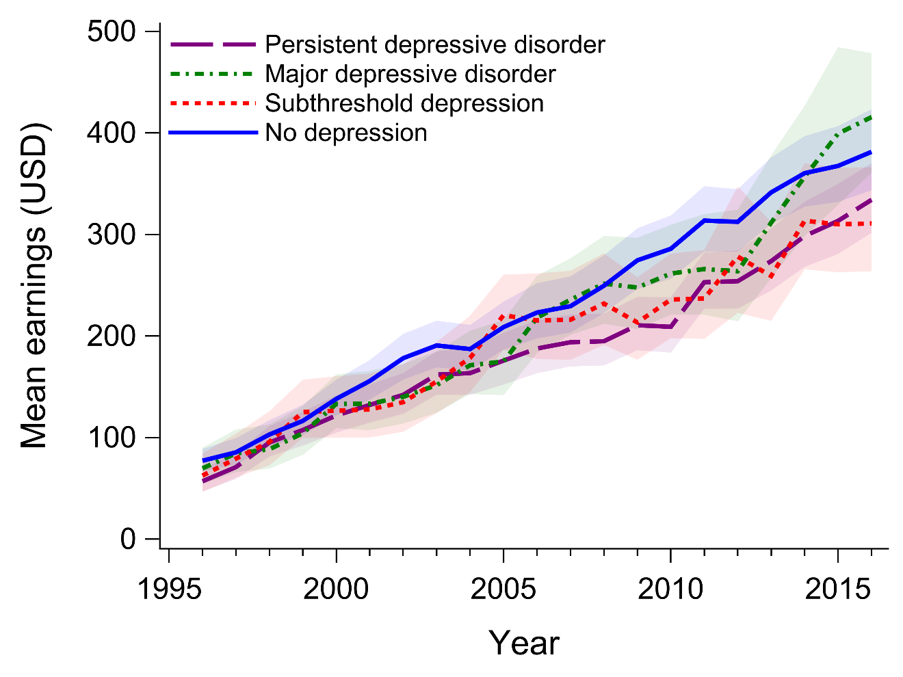
Fig. S1. Mean earnings (95% CI) of females with or without a history of depressive disorders in adolescence, year 1996 to 2016

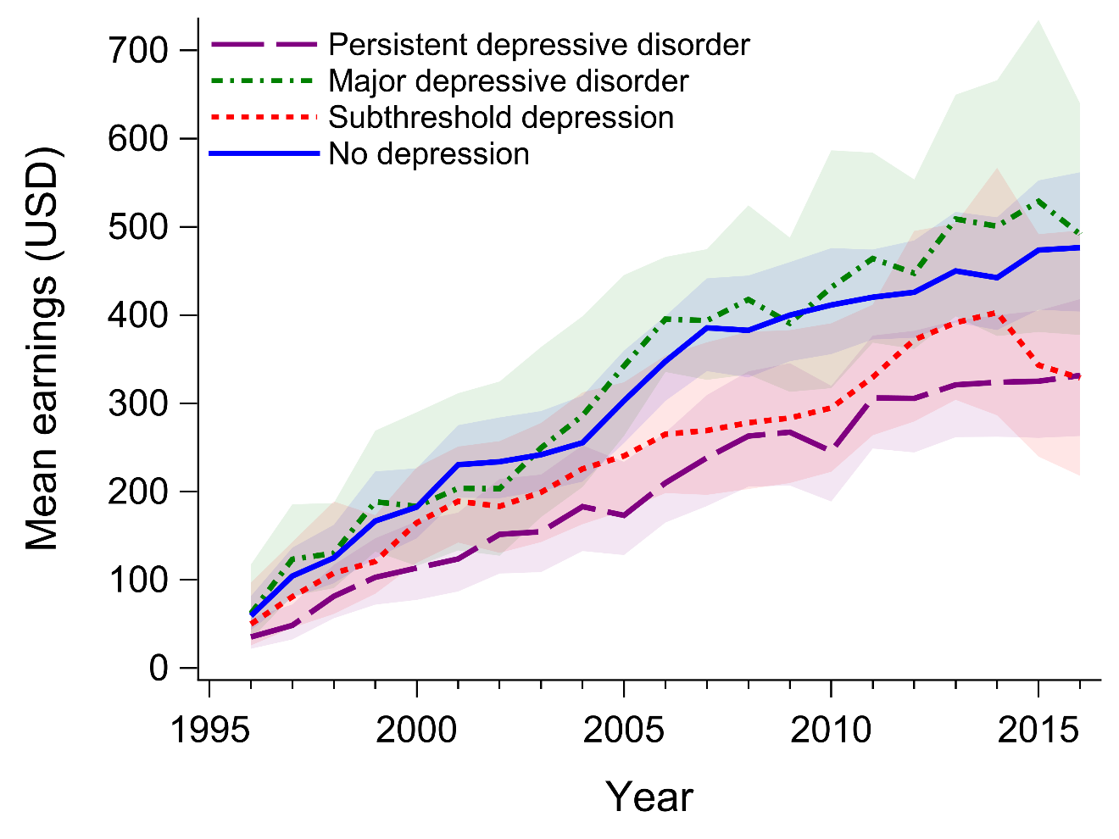
Fig. S2. Mean earnings (95% CI) of males with or without a history of depressive disorders in adolescence, year 1996 to 2016

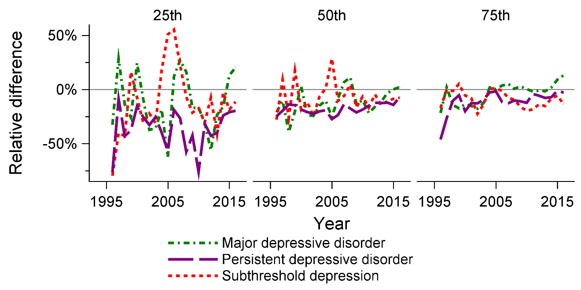
Fig. S3. Ratio of mean earnings between females with a history of depressive disorders and non-depressed peers at 25th, 50th and 75th percentile of the distribution in each group, year 1996 to 2016

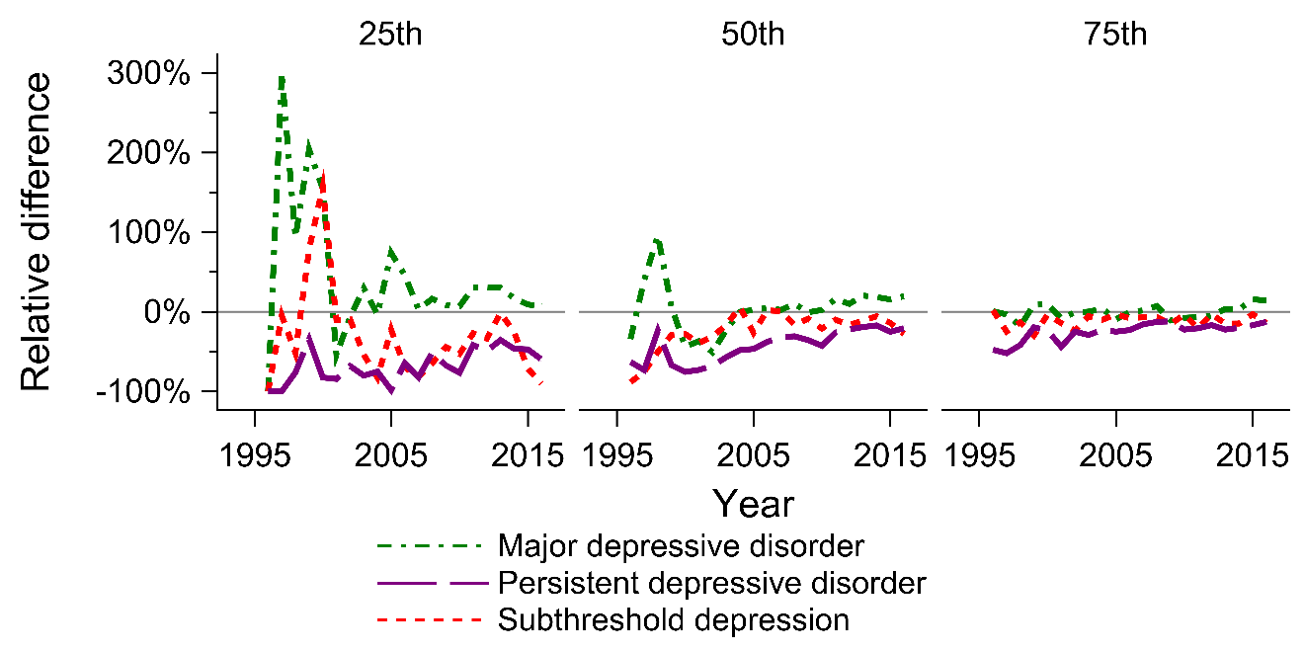
Fig. S4. Ratio of mean earnings between males with a history of depressive disorders and non-depressed peers at 25th, 50th and 75th percentile of the distribution in each group, year 1996 to 2016

