Supplementary materials
Table 1S. The number of pesticide suicides and population aged 15 or older in South Korea (1983–2014)
 | 1983 |  | 1984 |  | 1985 |  | 1986 |  | 1987 |  | 1988 |  | 1989 |  | 1990
 | Pesticide suicides | Population count | Pesticide suicides | Population count | Pesticide suicides | Population count | Pesticide suicides | Population count | Pesticide suicides | Population count | Pesticide suicides | Population count | Pesticide suicides | Population count | Pesticide suicides | Population count
Total | 742 | 27109435 | 830 | 27814196 | 950 | 28501202 | 878 | 29183841 | 840 | 29875313 | 699 | 30543802 | 813 | 31187907 | 698 | 32256057
Sex
Male | 541 | 13510834 | 610 | 13863956 | 686 | 14217259 | 625 | 14546242 | 589 | 14879849 | 470 | 15202258 | 521 | 15512462 | 463 | 15990514
Female | 201 | 13598601 | 220 | 13950240 | 264 | 14283943 | 253 | 14637599 | 251 | 14995464 | 229 | 15341544 | 292 | 15675445 | 235 | 16265543
Age
15–49 | 511 | 21859606 | 589 | 22347352 | 659 | 22803710 | 582 | 23269439 | 583 | 23720333 | 486 | 24133248 | 576 | 24511537 | 474 | 25303888
50–59 | 118 | 2699521 | 114 | 2815628 | 132 | 2945338 | 136 | 3078498 | 115 | 3222598 | 87 | 3369072 | 103 | 3511584 | 113 | 3632871
60–69 | 74 | 1610037 | 89 | 1668340 | 98 | 1722513 | 95 | 1774538 | 93 | 1830316 | 70 | 1896280 | 65 | 1977854 | 67 | 2057373
≥ 70 | 39 | 940271 | 38 | 982876 | 61 | 1029641 | 65 | 1061366 | 49 | 1102066 | 56 | 1145202 | 69 | 1186932 | 44 | 1261925
 | 1991 |  | 1992 |  | 1993 |  | 1994 |  | 1995 |  | 1996 |  | 1997 |  | 1998
 | Pesticide suicides | Population count | Pesticide suicides | Population count | Pesticide suicides | Population count | Pesticide suicides | Population count | Pesticide suicides | Population count | Pesticide suicides | Population count | Pesticide suicides | Population count | Pesticide suicides | Population count
Total | 623 | 32256057 | 820 | 33750335 | 1008 | 34255716 | 1001 | 34802329 | 1367 | 35380553 | 1367 | 35953819 | 1174 | 36526385 | 1576 | 36751666
Sex
Male | 419 | 15990514 | 539 | 16740905 | 643 | 16993595 | 651 | 17255311 | 933 | 17540739 | 910 | 17819417 | 809 | 18098414 | 1072 | 18207569
Female | 204 | 16265543 | 281 | 17009430 | 365 | 17262121 | 350 | 17547018 | 434 | 17839814 | 457 | 18134402 | 365 | 18427971 | 504 | 18544097
Age
15–49 | 420 | 25303888 | 529 | 26195173 | 654 | 26456199 | 640 | 26788391 | 871 | 27182385 | 794 | 27535198 | 657 | 27790459 | 878 | 27865754
50–59 | 90 | 3632871 | 144 | 3943076 | 169 | 4036004 | 149 | 4078818 | 228 | 4070567 | 220 | 4096086 | 190 | 4214981 | 269 | 4259274
60–69 | 67 | 2057373 | 91 | 2162333 | 114 | 2237984 | 117 | 2360985 | 150 | 2498579 | 180 | 2637600 | 173 | 2763198 | 248 | 2827482
≥ 70 | 46 | 1261925 | 56 | 1449753 | 71 | 1525529 | 95 | 1574135 | 118 | 1629022 | 173 | 1684935 | 154 | 1757747 | 181 | 1799156

(Continued)
 | 1999 |  | 2000 |  | 2001 |  | 2002 |  | 2003 |  | 2004 |  | 2005 |  | 2006
 | Pesticide suicides | Population count | Pesticide suicides | Population count | Pesticide suicides | Population count | Pesticide suicides | Population count | Pesticide suicides | Population count | Pesticide suicides | Population count | Pesticide suicides | Population count | Pesticide suicides | Population count
Total | 1456 | 37170729 | 1483 | 37569140 | 1705 | 37952596 | 2627 | 38298236 | 3299 | 38613892 | 3530 | 38940565 | 3124 | 39321365 | 2747 | 39758636
Sex
Male | 979 | 18411678 | 980 | 18608047 | 1166 | 18798753 | 1773 | 18968672 | 2197 | 19123726 | 2356 | 19288034 | 2130 | 19484318 | 1831 | 19711677
Female | 477 | 18759051 | 503 | 18961093 | 539 | 19153843 | 854 | 19329564 | 1102 | 19490166 | 1174 | 19652531 | 994 | 19837047 | 916 | 20046959
Age
15–49 | 763 | 27988068 | 732 | 28097158 | 773 | 28212733 | 1191 | 28230324 | 1389 | 28174868 | 1254 | 28120647 | 976 | 28019150 | 733 | 27933357
50–59 | 250 | 4335489 | 267 | 4407216 | 251 | 4450388 | 430 | 4499575 | 528 | 4609405 | 632 | 4785260 | 479 | 5079574 | 477 | 5411368
60–69 | 237 | 2964704 | 242 | 3097799 | 329 | 3236454 | 483 | 3416878 | 650 | 3565446 | 734 | 3640881 | 757 | 3674785 | 637 | 3701995
≥ 70 | 206 | 1882468 | 242 | 1966967 | 352 | 2053021 | 523 | 2151459 | 732 | 2264173 | 910 | 2393777 | 912 | 2547856 | 900 | 2711916
 | 2007 |  | 2008 |  | 2009 |  | 2010 |  | 2011 |  | 2012 |  | 2013 |  | 2014
 | Pesticide suicides | Population count | Pesticide suicides | Population count | Pesticide suicides | Population count | Pesticide suicides | Population count | Pesticide suicides | Population count | Pesticide suicides | Population count | Pesticide suicides | Population count | Pesticide suicides | Population count
Total | 2880 | 40248599 | 2799 | 40762825 | 2741 | 41272778 | 2719 | 41750637 | 2580 | 42205994 | 2103 | 42636198 | 1442 | 43037651 | 1072 | 43426251
Sex
Male | 1937 | 19965899 | 1879 | 20235429 | 1838 | 20501764 | 1875 | 20746013 | 1764 | 20975553 | 1423 | 21188643 | 978 | 21385918 | 736 | 21578663
Female | 943 | 20282700 | 920 | 20527396 | 903 | 20771014 | 844 | 21004624 | 816 | 21230441 | 680 | 21447555 | 464 | 21651733 | 336 | 21847588
Age
15–49 | 692 | 27879053 | 709 | 27807152 | 579 | 27692755 | 534 | 27487268 | 451 | 27239550 | 322 | 26998474 | 169 | 26797618 | 118 | 26607569
50–59 | 464 | 5701710 | 451 | 5991652 | 477 | 6324326 | 421 | 6726716 | 471 | 7175714 | 357 | 7537309 | 245 | 7786325 | 179 | 8000584
60–69 | 672 | 3789400 | 608 | 3909751 | 568 | 4006145 | 591 | 4092726 | 541 | 4150539 | 402 | 4217736 | 260 | 4343385 | 208 | 4529947
≥ 70 | 1052 | 2878436 | 1031 | 3054270 | 1117 | 3249552 | 1173 | 3443927 | 1117 | 3640191 | 1022 | 3882679 | 768 | 4110323 | 567 | 4288151

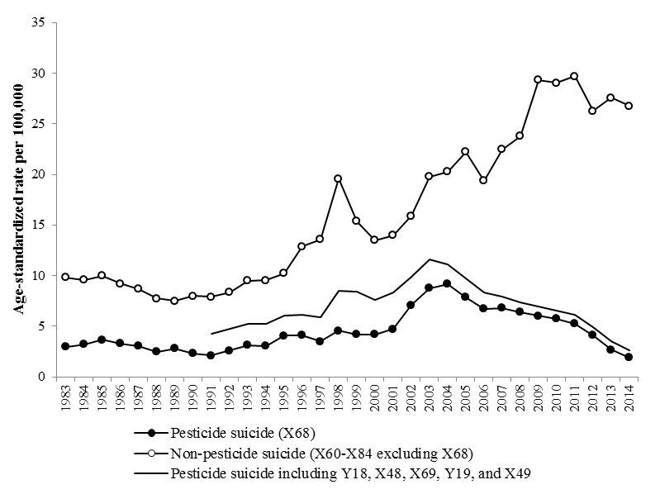
Figure 1S. Trends in age-standardized mortality rate of suicides in South Korea, 1983–2014

Figure 2S. Trends in mortality rate of pesticide suicide by sex, age group, and area in South Korea, 1991–2014
(a) Male, by age
(b) Female, by age
Note: Using the administrative residential districts provided in the mortality data, we identified three urbanization levels: (i) “metropolises,” including Seoul and six major cities (ii) “small- and medium-sized cities” and (iii) “rural areas.” Cities and rural areas were determined by considering population sizes, with cities requiring a population of more than 50,000. Lines depict estimated linear trends from joinpoint regression analysis.

