Supplemental Figure 1. Funnel plot of publication bias for the lifetime prevalence of SA with the 13 studies in the meta-analysis

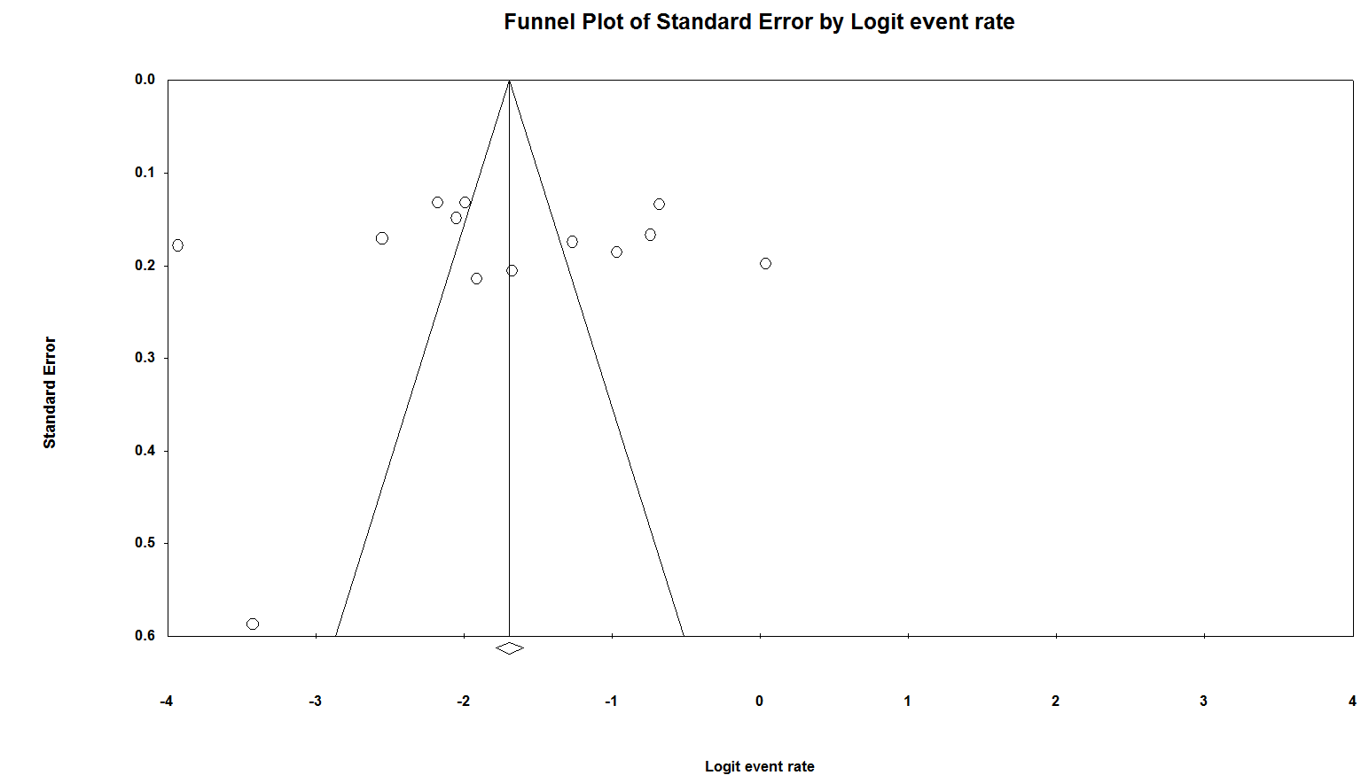

Supplemental material: search strategy
Details in Pubmed
(((((((((("suicide"[MeSH Terms] OR "suicide"[All Fields]) OR ("self injurious behaviour"[All Fields] OR "self-injurious behavior"[MeSH Terms] OR ("self-injurious"[All Fields] AND "behavior"[All Fields]) OR "self-injurious behavior"[All Fields] OR ("self"[All Fields] AND "injurious"[All Fields] AND "behavior"[All Fields]) OR "self injurious behavior"[All Fields])) OR ("self mutilation"[MeSH Terms] OR ("self"[All Fields] AND "mutilation"[All Fields]) OR "self mutilation"[All Fields])) OR self-immolation[All Fields]) OR self-harm[All Fields]) OR self-inflicted[All Fields]) OR self-injury[All Fields]) OR self-destruction[All Fields]) AND ((("schizophrenia"[MeSH Terms] OR "schizophrenia"[All Fields]) OR ("psychotic disorders"[MeSH Terms] OR ("psychotic"[All Fields] AND "disorders"[All Fields]) OR "psychotic disorders"[All Fields] OR ("psychotic"[All Fields] AND "disorder"[All Fields]) OR "psychotic disorder"[All Fields])) OR ("psychotic disorders"[MeSH Terms] OR ("psychotic"[All Fields] AND "disorders"[All Fields]) OR "psychotic disorders"[All Fields] OR "psychosis"[All Fields]))) AND (((((((("epidemiology"[Subheading] OR "epidemiology"[All Fields] OR "epidemiology"[MeSH Terms]) OR ("cross-sectional studies"[MeSH Terms] OR ("cross-sectional"[All Fields] AND "studies"[All Fields]) OR "cross-sectional studies"[All Fields] OR ("cross"[All Fields] AND "sectional"[All Fields] AND "study"[All Fields]) OR "cross sectional study"[All Fields])) OR ("epidemiology"[Subheading] OR "epidemiology"[All Fields] OR "prevalence"[All Fields] OR "prevalence"[MeSH Terms])) OR ("J Rehabil Assist Technol Eng"[Journal] OR "rate"[All Fields])) OR ("risk factors"[MeSH Terms] OR ("risk"[All Fields] AND "factors"[All Fields]) OR "risk factors"[All Fields] OR ("risk"[All Fields] AND "factor"[All Fields]) OR "risk factor"[All Fields])) OR ("cohort studies"[MeSH Terms] OR ("cohort"[All Fields] AND "studies"[All Fields]) OR "cohort studies"[All Fields] OR ("cohort"[All Fields] AND "study"[All Fields]) OR "cohort study"[All Fields])) OR ("case-control studies"[MeSH Terms] OR ("case-control"[All Fields] AND "studies"[All Fields]) OR "case-control studies"[All Fields] OR ("case"[All Fields] AND "control"[All Fields] AND "study"[All Fields]) OR "case control study"[All Fields])) OR ("observational study"[Publication Type] OR "observational studies as topic"[MeSH Terms] OR "observational study"[All Fields]))) AND (("china"[MeSH Terms] OR "china"[All Fields]) OR ("asian continental ancestry group"[MeSH Terms] OR ("asian"[All Fields] AND "continental"[All Fields] AND "ancestry"[All Fields] AND "group"[All Fields]) OR "asian continental ancestry group"[All Fields] OR "chinese"[All Fields]))

Details in Embase
'suicide' OR 'self-injurious behavior'/exp OR 'self-injurious behavior' OR 'self-mutilation'/exp OR 'self-mutilation' OR 'self-immolation' OR 'self-harm'/exp OR 'self-harm' OR 'self-inflicted' OR 'self-injury'/exp OR 'self-injury' OR 'self-slaughter' OR 'self-destruction' AND ('schizophrenia'/exp OR 'schizophrenia' OR 'psychotic disorder' OR 'psychosis'/exp OR 'psychosis') AND ('epidemiology'/exp OR 'epidemiology' OR 'cross-sectional study'/exp OR 'cross-sectional study' OR 'prevalence'/exp OR 'prevalence' OR 'rate' OR 'risk factor'/exp OR 'risk factor' OR 'cohort study'/exp OR 'cohort study' OR 'case-control study'/exp OR 'case-control study' OR 'observational study'/exp OR 'observational study') AND ('china'/exp OR 'china' OR 'chinese'/exp OR 'chinese') AND [1988-2016]/py

Details in PsycINFO
(“suicide*” or “self-injurious behavior” or “self-mutilation” or “self-immolation” or “self-harm” or “self-inflicted” or “self-injury” or “self-slaughter” or “self-destruction”) and (“schizophrenia” or “psychotic disorder” or “psychosis”) and (“epidemiology” or “cross-sectional study” or “prevalence” or “rate” or “risk factor” or “cohort study” or “case-control study” or “observational study”) and (“China” or “Chinese”)

