Appendix 2.

Trends in work disability due to mental diagnoses among social workers in Finland and Sweden in 2005–2012
Epidemiology and Psychiatric Sciences

O. Rantonen¹*, K. Alexanderson², J. Pentti¹, L. Kjeldgård ², J. Hämäläinen³, E. Mittendorfer-Rutz², M. Kivimäki^{1,4,5}, J. Vahtera^{1,6} and P. Salo^{1,7}

¹ Finnish Institute of Occupational Health, PL 18, 00391 Helsinki, Finland
² Department of Clinical Neuroscience, Division of Insurance Medicine, Karolinska Institutet, SE-171 77 Stockholm, Sweden
³ Department of Social Sciences, University of Eastern Finland, Kuopio, Finland
⁴ Department of Epidemiology and Public Health, University College London Medical School, London, United Kingdom
⁵ Clinicum, Faculty of Medicine, University of Helsinki, Helsinki, Finland
⁶ Department of Public Health, University of Turku and Turku University Hospital, Turku, Finland
⁷ Department of Psychology, University of Turku, Turku, Finland
Appendix 2. The probability of return to work from work disability with mental diagnoses by work disability duration in Finland and in Sweden (FPS and IMAS)
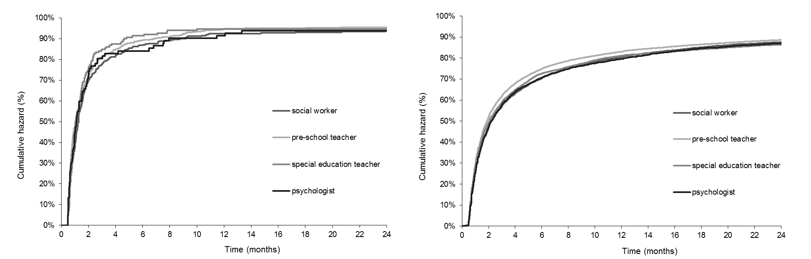

*Address for correspondence: O. Rantonen, Finnish Institute of Occupational Health, Lemminkäisenkatu 14-18 B (DataCity, 6th floor), FI-20520 Turku, Finland. (email: otso.rantonen@gmail.com)

