APPENDIX I

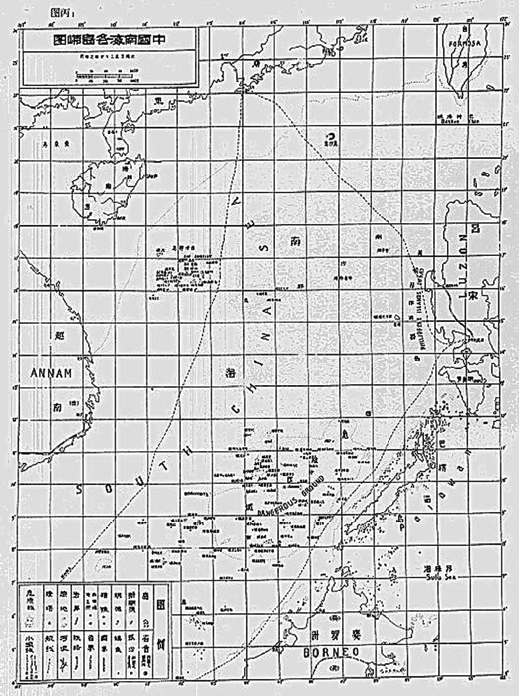
Map of Chinese Islands in the South China Sea in Volume II of the Journal of the Committee for the Review of Maps of Lands and Waters published in April 1935.

APPENDIX II
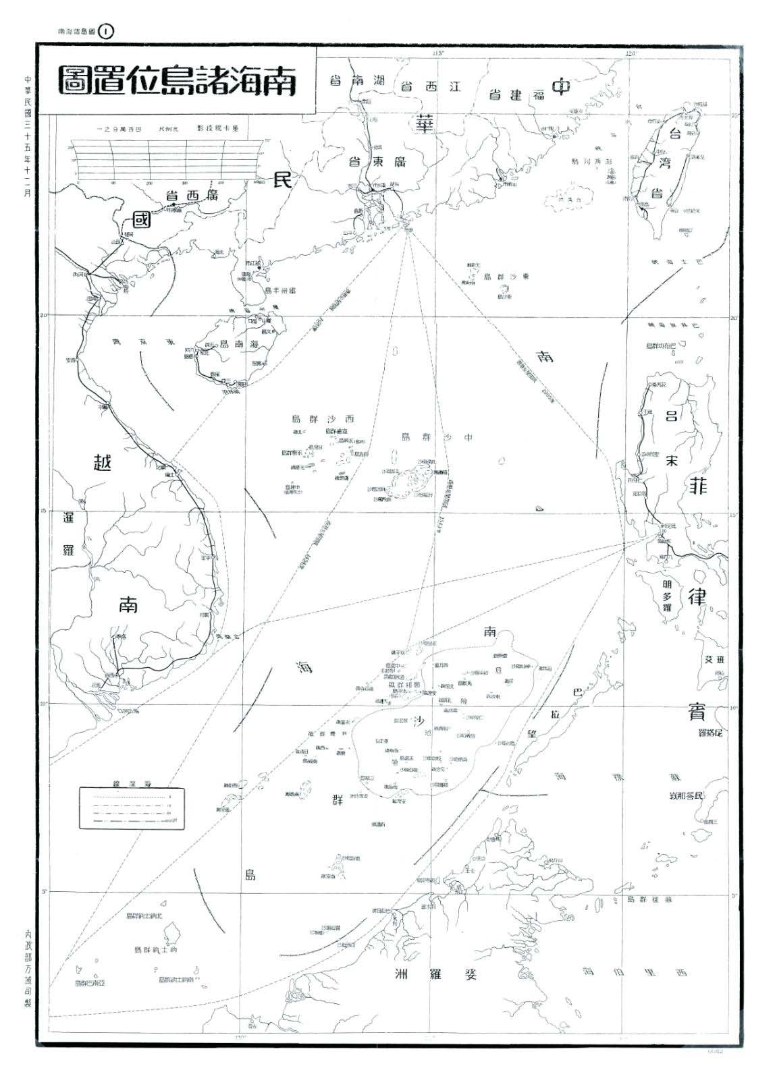
Location Map of the South China Sea Islands in the Atlas of Administrative Areas of the Republic of China, published in February 1948. Available online: Ministry of the Interior, Republic of China (Taiwan) <http://maritimeinfo.moi.gov.tw/marineweb/img/%E5%8D%97%E6%B5%B71.jpg>.
APPENDIX III
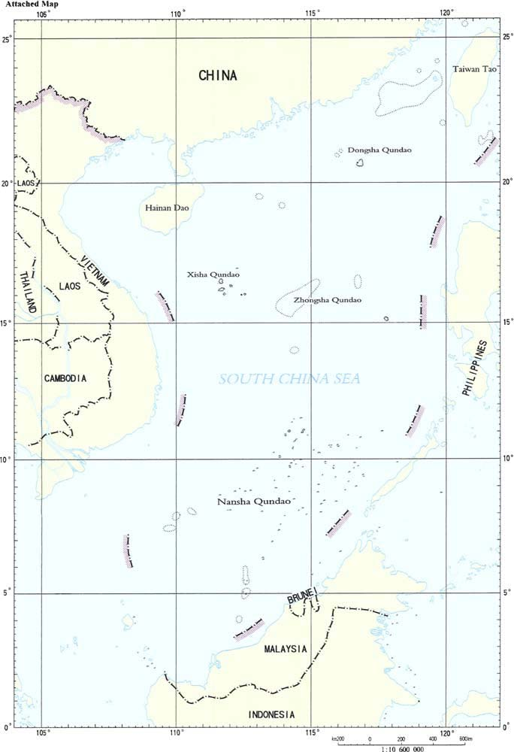
Map attached to United Nations, “People’s Republic of China, Letter to the Secretary-General of the United Nations-CML/17/2009 (Translation)” (7 May 2009), online: UN <http://www.un.org/Depts/los/clcs_new/submissions_files/mysvnm33_09/chn_2009re_mys_vnm_e.pdf>.
APPENDIX IV

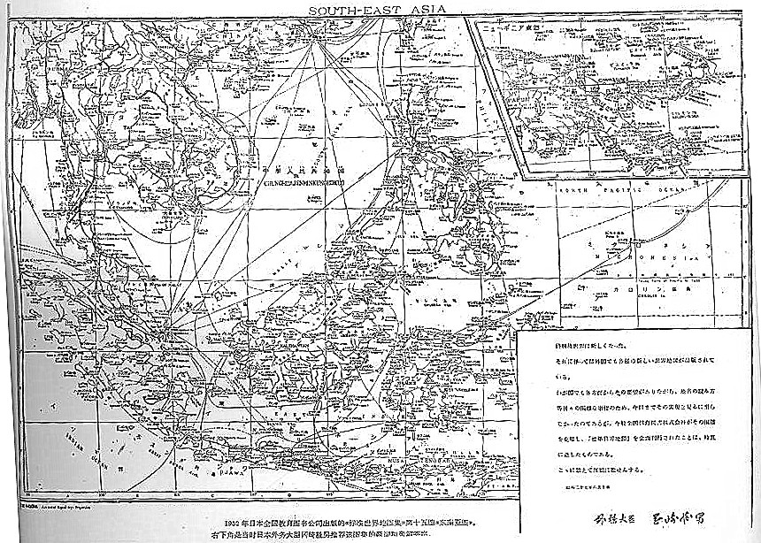
The Map of Southeast Asia, the fifteenth map of A Collection of Standard World Atlases published by the Japan National Education Book Company in 1952.

APPENDIX V

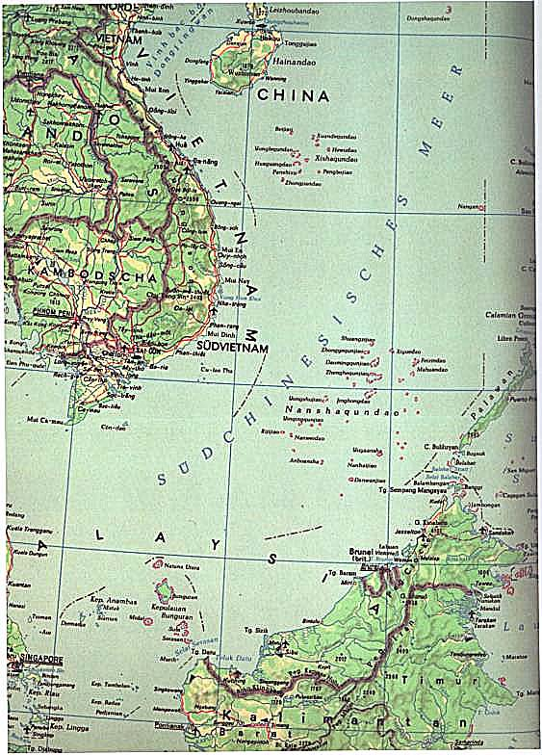
Haack Welt Atlas published by German Democratic in 1968, p. 28, scale: 1:12,000,000.

APPENDIX VI
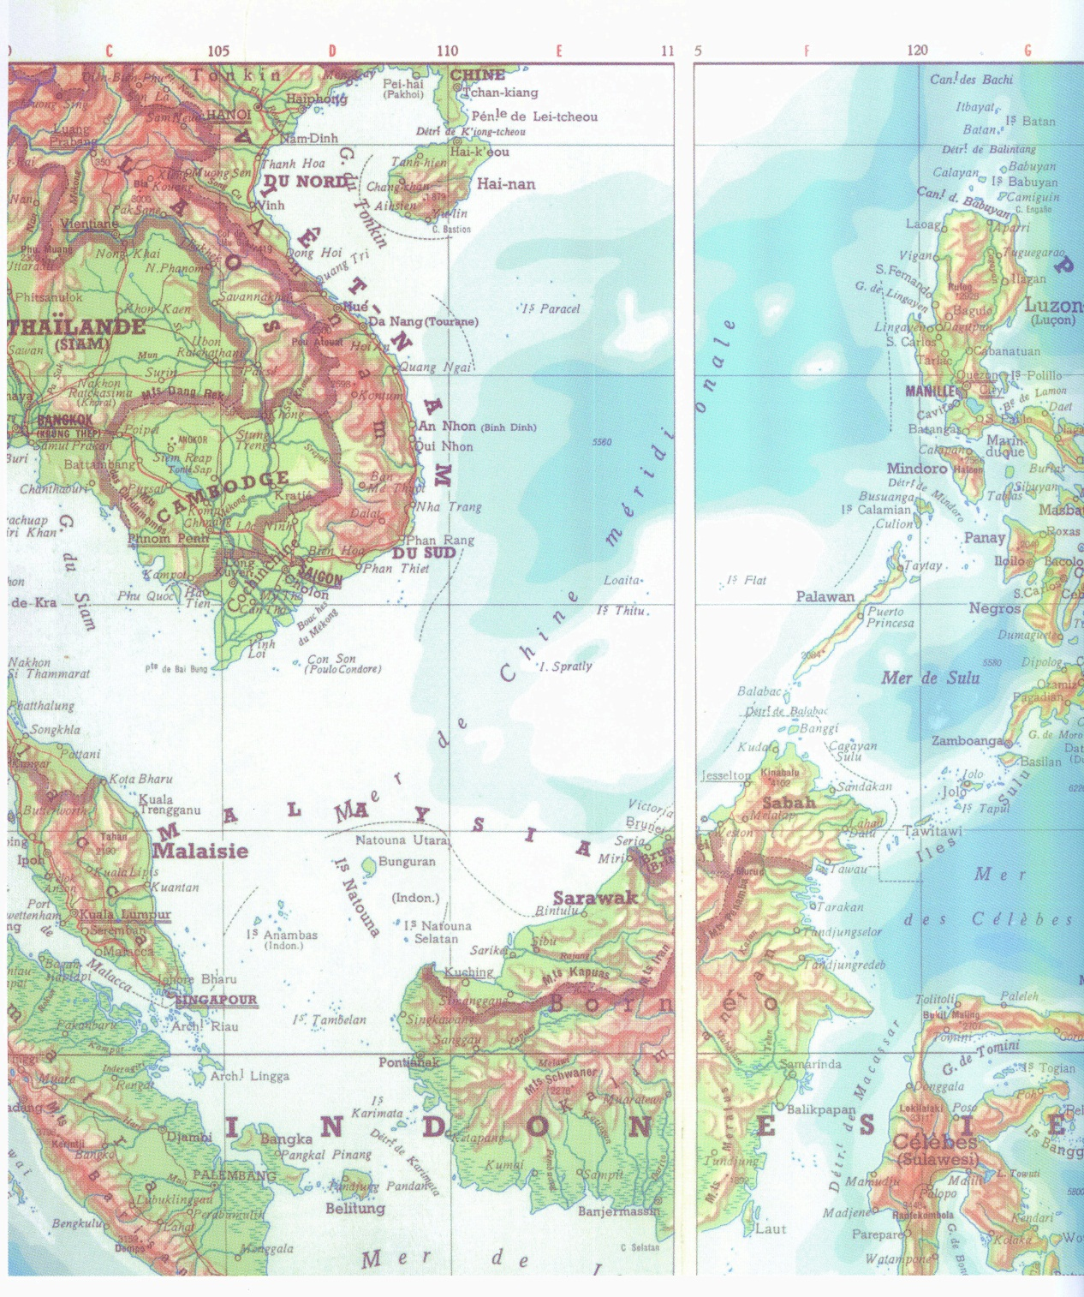
Atlas Moderne Larousse published by Larousse France in 1969, p. 99, scale: 1: 15,000,000.

