Supplementary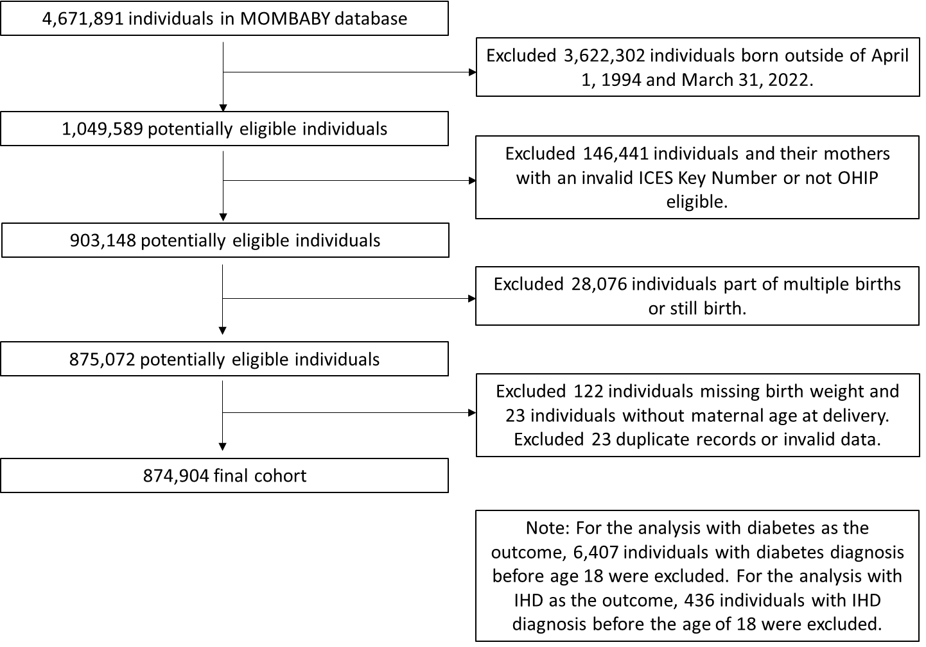
Figure S1: Flow chart of study participants

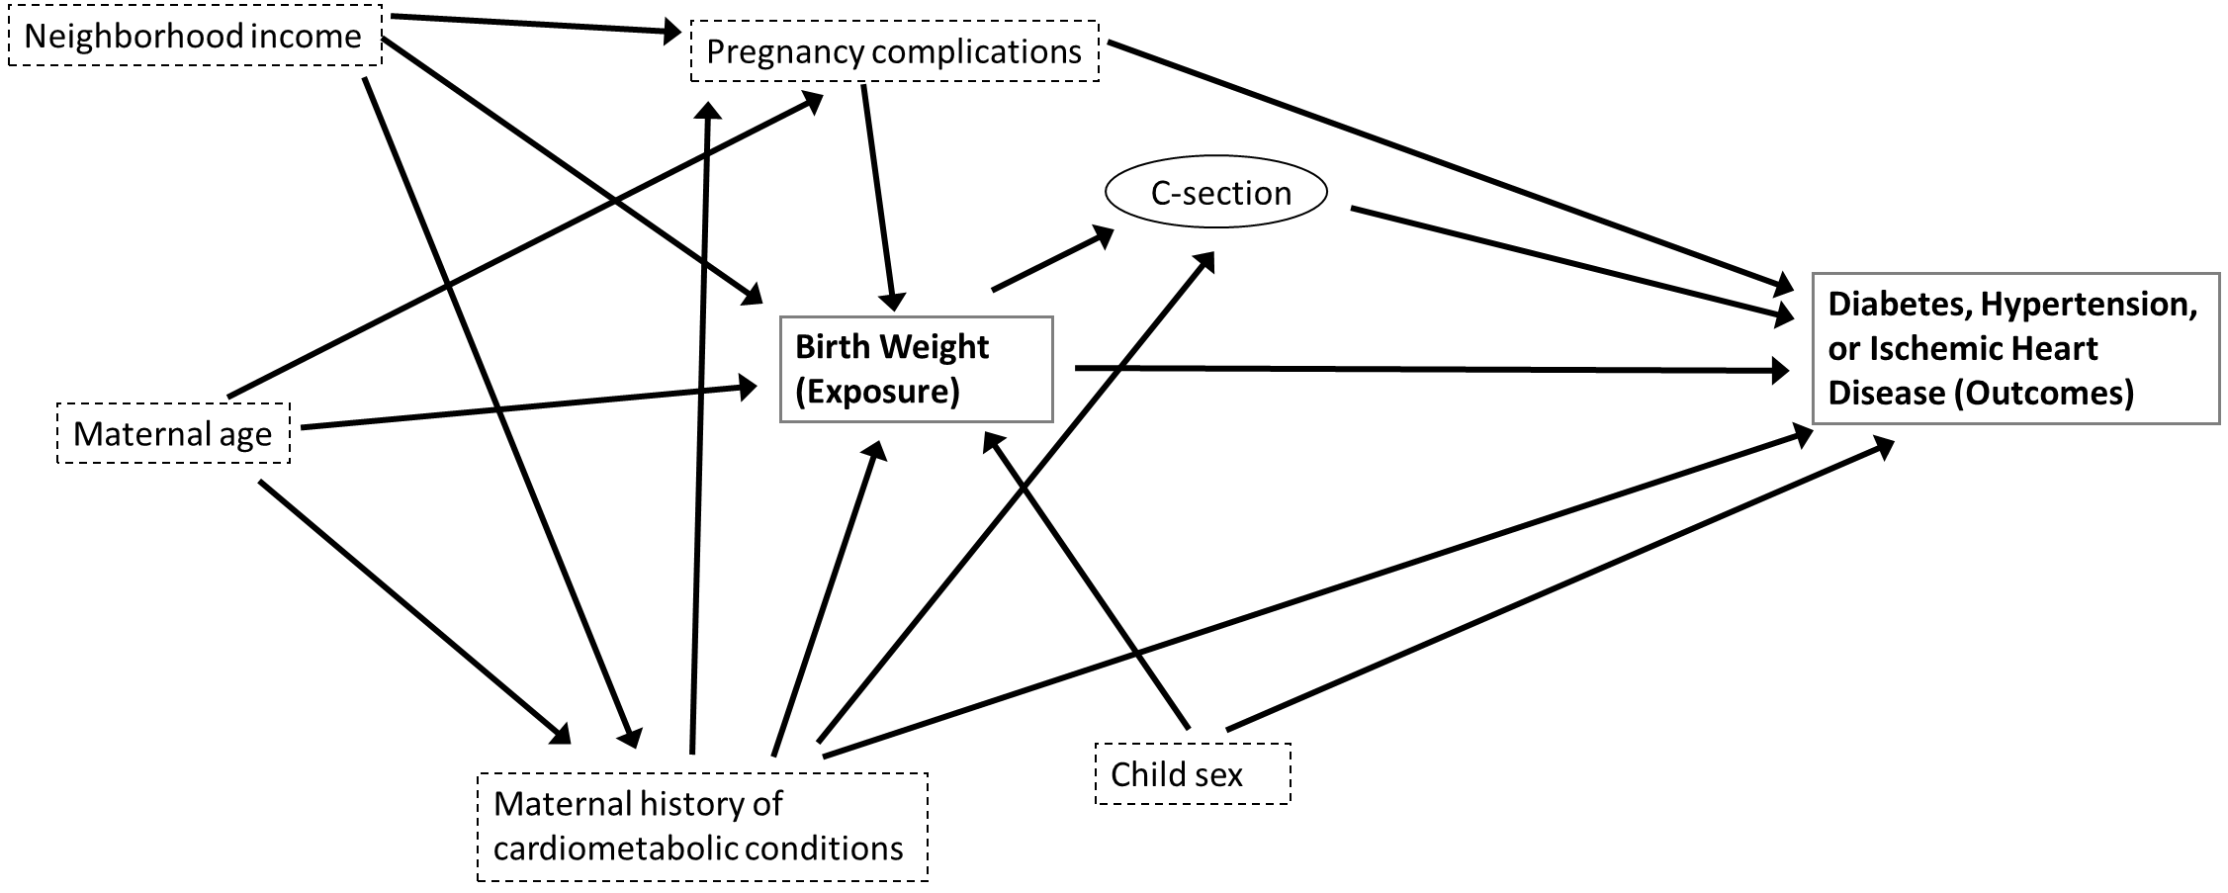
Figure S2: Directed acyclic graph (DAG) for the relationship between birthweight and diabetes, hypertension or ischemic heart disease identifying the minimum sufficient set of potential confounders dotted boxes and a potential mediator (which were not conditioned on) in a circle. Unobserved variables were not included.
Table S1: Variable definitions
Variable | Definition | Data source
Primary Exposure
Birthweight | Birthweight categorized as: <2500g, 2500-4000g and >4000g | MOMBABY
Primary Outcome
Cardiometabolic outcomes | - Incident chronic diabetes: Two physician billing claims with a diagnosis for diabetes (OHIP diagnosis code: 250) or one inpatient hospitalization or same day surgery record with a diagnosis for diabetes (ICD-9 diagnosis code: 250; ICD-10 diagnosis codes: E10, E11, E13, E14; in any diagnostic code space) within a 2-year period, as per Shariff et al. Lancet Public Health 2022;7(7): e366-377.  - Incident chronic hypertension: One hospital admission/same day surgery record with a hypertension diagnosis (ICD-9: 401x, 402x, 403x, 404x, 405x or ICD-10: I10, I11, I12, I13, I15), or one OHIP claim (401, 402, 403, 404, or 405) with a hypertension diagnosis followed by either an OHIP claim or a hospital admission/same day surgery record with a hypertension diagnosis within two years, as per Shariff et al. Lancet Public Health 2022;7(7): e366-377.  - Incident ischemic heart disease: Two physician visits with at least one being with a specialist or general practitioner/family physician in a hospital or emergency room setting (OHIP: 410, 412, 413) or one hospitalization or emergency department visit (ICD-9: 410–414 ICD-10: I20–I25), as per Tu et al. Can J Cardiol 2010;26(7): e225-e228. | - ODD  - HYPER  - DAD, NACRS, OHIP
Covariates
Maternal characteristics
Maternal age | Maternal age at delivery, continuous in years | MOMBABY
History of IHD | Ischemic heart disease: Two physician visits with at least one being with a specialist or general practitioner/family physician in a hospital or emergency room setting (OHIP: 410, 412, 413) or one hospitalization or emergency department visit (ICD-9: 410–414 ICD-10: I20–I25) as per Tu et al. Can J Cardiol 2010;26(7): e225-e228 in the 2 years prior to or after the index pregnancy birth date. | DAD, OHIP
History of stroke | Stroke or transient ischemic attack: Two physician visits (OHIP: 432, 435, 436) or one hospitalization or emergency department visit (ICD-9: 362.3, 430, 431, 434.x, 435.x, 436; ICD-10: I60.x, I61.x, I63.x except I63.6, I64, H34.0, H 34.1, G45.x except G45.4) as per Tu et al. Can J Cardiol 2013;29:1388-1394 in the 2 years prior to or after the index pregnancy birth date. | DAD, OHIP
History of diabetes | Chronic diabetes within 2 years lookback of child’s birthdate | ODD
History of hypertension | Chronic hypertension within 2 years lookback of child’s birthdate | HYPER
Perinatal characteristics
Gestational diabetes | Gestational diabetes: dxcode in (ICD9 ‘250’, ‘648.0’), dx10code in (ICD10 ‘E10, E11, E13, E14’ or ‘O244’) in any DAD record OR 2 physician service claims OHIP 250. Unless woman has pre-existing diabetes (i.e. in ODD) prior to the start of pregnancy (from baby’s birth date – 280 days). | DAD, OHIP
Gestational hypertension | Gestational hypertension dxcode in (ICD9 ‘6423.x’, ‘4010‘, ‘4011’, ‘4019’, ‘40501’, ‘40511’, ‘40591’, ‘40509’, ‘40519’, ‘40599’) dx10code in (ICD10: ‘I10’, ‘I15’) or 2 physician service claims OHIP 401. Unless woman has pre-existing hypertension (i.e. in HYPER) prior to the start of pregnancy (from baby’s birth date – 280 days). | DAD, OHIP
Preeclampsia or eclampsia | Preeclampsia or eclampsia dxcode in (ICD9 ‘642.4x’, ‘642.5x’, ‘642.6x’, ‘642.7’) and dx10code in (ICD10 ‘O14’, ‘O15’, ‘O11’) within pregnancy (280 days prior to baby’s birth date) or 42 days of delivery | DAD
C-section | Caesarean section during delivery hospitalization defined as CCI code (incode variable) 5.MD.6, or CCP code (prcode variable) 86. | DAD
Young adult characteristics
Sex | Young adult’s sex categorized as: Female; Male | RPDB
Age at outcome | Young adults’s age at diagnosis continuous in years | ODD, HYPER, and for IHD: OHIP, DAD, RPDB
Sociodemographic characteristics
Neighbourhood income quintile | Neighbourhood median after-tax household income using residential postal code (incquint for Nearest Census Based Neighbourhood Income Quintile (within CMA/CA) categorized as quintiles: 1 being the lowest and 5 being the highest | RPDB
DAD: Discharge Abstract Database, HYPER: Ontario Hypertension Dataset, MOMBABY: Ontario Mother-Baby Linked Dataset, NACRS: National Ambulatory Care Reporting System, ODD: Ontario Diabetes Dataset, RPDB: Registered Persons Database

Table S2: Association between continuous birthweight and hazard of diabetes, hypertension, or IHD attained between 18-26 years in Ontario, Canada from 2012 to 2020
 | Hazard Ratio (95% CI)
Birthweight (continuous) | Unadjusted | Adjustedª | Unadjusted | Adjustedª | Unadjusted | Adjustedª
Diabetes |  |  | Hypertension |  | IHD
2500g^{b} | 0.97 (0.96, 0.98) | 0.97 (0.96, 0.98) | 0.97 (0.96, 0.98) | 0.98 (0.97, 0.99) | 0.98 (0.95, 1.02) | 0.99 (0.95, 1.02)
2600g | 0.97 (0.96, 0.98) | 0.97 (0.96, 0.98) | 0.97 (0.96, 0.98) | 0.98 (0.97, 0.99) | 0.98 (0.95, 1.02) | 0.99 (0.95, 1.02)
2700g | 0.97 (0.96, 0.98) | 0.97 (0.96, 0.98) | 0.97 (0.96, 0.98) | 0.98 (0.97, 0.99) | 0.98 (0.95, 1.02) | 0.99 (0.95, 1.02)
2800g | 0.97 (0.96, 0.98) | 0.97 (0.96, 0.98) | 0.97 (0.96, 0.98) | 0.98 (0.97, 0.99) | 0.98 (0.95, 1.02) | 0.99 (0.95, 1.02)
2900g | 0.97 (0.96, 0.98) | 0.97 (0.96, 0.98) | 0.97 (0.96, 0.98) | 0.98 (0.97, 0.99) | 0.98 (0.95, 1.02) | 0.99 (0.95, 1.02)
3000g | 0.96 (0.95, 0.97) | 0.97 (0.96, 0.98) | 0.97 (0.96, 0.98) | 0.98 (0.97, 0.99) | 0.98 (0.95, 1.02) | 0.99 (0.95, 1.02)
3100g | 0.93 (0.90, 0.97) | 0.97 (0.96, 0.98) | 0.97 (0.96, 0.98) | 0.98 (0.97, 0.99) | 0.98 (0.95, 1.01) | 0.98 (0.95, 1.01)
3200g | 0.91 (0.86, 0.97) | 0.96 (0.95, 0.97) | 0.97 (0.96, 0.98) | 0.98 (0.96, 0.98) | 0.97 (0.94, 1.00) | 0.96 (0.93, 1.00)
3300g | 0.93 (0.90, 0.97) | 0.94 (0.92, 0.97) | 0.97 (0.95, 0.99) | 0.97 (0.94, 0.99) | 0.95 (0.89, 1.04) | 0.94 (0.88, 1.01)
3400g | 0.96 (0.88, 1.05) | 0.94 (0.92, 0.97) | 0.97 (0.94, 1.00) | 0.97 (0.94, 1.00) | 0.95 (0.86, 1.04) | 0.93 (0.85, 1.02)
3500g | 0.97 (0.93, 1.01) | 0.97 (0.94, 0.99) | 0.98 (0.96, 1.01) | 0.97 (0.95, 1.00) | 0.96 (0.90, 1.03) | 0.95 (0.89, 1.02)
3600g | 0.97 (0.91, 1.03) | 1.00 (0.99, 1.01) | 0.99 (0.98, 1.00) | 0.99 (0.97, 1.00) | 0.99 (0.95, 1.02) | 0.98 (0.95, 1.02)
3700g | 1.00 (0.95, 1.05) | 1.03 (1.02, 1.04) | 1.00 (0.98, 1.01) | 0.99 (0.98, 1.01) | 1.01 (0.97, 1.05) | 1.00 (0.97, 1.05)
3800g | 1.03 (1.01, 1.05) | 1.04 (1.03, 1.06) | 1.00 (0.98, 1.02) | 1.00 (0.98, 1.02) | 1.02 (0.97, 1.05) | 1.01 (0.96, 1.07)
3900g | 1.04 (1.03, 1.06) | 1.04 (1.03, 1.06) | 1.00 (0.98, 1.02) | 1.00 (0.98, 1.02) | 1.02 (0.96, 1.07) | 1.02 (0.96, 1.07)
4000g | 1.05 (1.03, 1.07) | 1.04 (1.03, 1.06) | 1.00 (0.98, 1.02) | 1.00 (0.98, 1.02) | 1.02 (0.96, 1.07) | 1.02 (0.96, 1.07)
ªAdjusted for young adult sex, neighbourhood income, perinatal characteristics (gestational diabetes, gestational hypertension, pre-eclampsia/eclampsia), and maternal characteristics (maternal: age, IHD, stroke, diabetes, and hypertension)
^{b}Effect estimates and 95% confidence intervals obtained for birthweights <2500g and >4000g were the same as those obtained for birthweights 2500g and 4000g, respectively.

Table S3: Association between birthweight with hazard of diabetes attained between 18-26 years by caesarean section (p<0.01) in Ontario, Canada from 2012 to 2020
 | Hazard Ratio (95% CI)
Birthweight | Unadjusted |  | Adjustedª
 | Caesarean section | No caesarean section | Caesarean section | No caesarean section
Less than 2500g | 1.44 (1.10, 1.89) | 1.72 (1.48, 2.01) | 1.28 (0.96, 1.71) | 1.57 (1.34, 1.84)
2500 to 4000g | Referent | Referent | Referent | Referent
Greater than 4000g | 1.42 (1.19, 1.69) | 0.85 (0.75, 0.96) | 1.50 (1.26, 1.80) | 0.95 (0.84, 1.08)
ªAdjusted for young adult sex, neighbourhood income, perinatal characteristics (gestational diabetes, gestational hypertension, and preeclampsia/eclampsia) and maternal characteristics (maternal: age, IHD, stroke, diabetes, and hypertension)

Table S4: Association between birthweight with hazard of diabetes attained between 18-26 years by maternal history of cardiometabolic conditions (p=0.04) in Ontario, Canada from 2012 to 2020
 | Hazard Ratio (95% CI)
Birthweight | Unadjusted |  | Adjustedª
 | Maternal history of cardiometabolic conditions | No maternal history of cardiometabolic conditions | Maternal history of cardiometabolic conditions | No maternal history of cardiometabolic conditions
Less than 2500g | 1.04 (0.60, 1.81) | 1.68 (1.47, 1.93) | 1.01 (0.56, 1.81) | 1.54 (1.33, 1.77)
2500 to 4000g | Referent | Referent | Referent | Referent
Greater than 4000g | 1.63 (1.14, 2.33) | 0.97 (0.87, 1.08) | 1.63 (1.12, 2.37) | 1.09 (0.98, 1.21)
ªAdjusted for young adult sex, neighbourhood income, maternal age, and perinatal characteristics (gestational diabetes, gestational hypertension, and preeclampsia/eclampsia)

Table S5: Association between birthweight with hazard of diabetes attained between 18-26 years by maternal age (p=0.04) in Ontario, Canada from 2012 to 2020
 | Hazard Ratio (95% CI)
Birthweight | Unadjusted |  | Adjustedª
 | ≥35 years | <35 years | ≥35 years | <35 years
Less than 2500g | 2.23 (1.68, 2.95) | 1.55 (1.33, 1.80) | 1.89 (1.40, 2.55) | 1.40 (1.20, 1.64)
2500 to 4000g | Referent | Referent | Referent | Referent
Greater than 4000g | 0.95 (0.74, 1.22) | 1.02 (0.91, 1.14) | 1.03 (0.80, 1.33) | 1.12 (1.00, 1.25)
ªAdjusted for young adult sex, neighbourhood income, perinatal characteristics (gestational diabetes, gestational hypertension, and preeclampsia/eclampsia), and maternal characteristics (maternal: IHD, stroke, diabetes, and hypertension)

Table S6: Association between birthweight with hazard of diabetes attained between 18-26 years by sex (p=0.07) in Ontario, Canada from 2012 to 2020
 | Hazard Ratio (95% CI)
Birthweight | Unadjusted |  | Adjustedª
 | Female | Male | Female | Male
Less than 2500g | 1.64 (1.40, 1.93) | 1.68 (1.32, 2.12) | 1.48 (1.25, 1.75) | 1.53 (1.19, 1.92)
2500 to 4000g | Referent | Referent | Referent | Referent
Greater than 4000g | 1.22 (1.08, 1.39) | 0.98 (0.83, 1.15) | 1.22 (1.07, 1.39) | 0.96 (0.81, 1.13)
ªAdjusted for neighbourhood income, perinatal characteristics (gestational diabetes, gestational hypertension, and preeclampsia/eclampsia), and maternal characteristics (maternal: age, IHD, stroke, diabetes, and hypertension)

Table S7: Association between birthweight with hazard of hypertension attained between 20-26 years by sex (p=0.77) in Ontario, Canada from 2014 to 2020
 | Hazard Ratio (95% CI)
Birthweight | Unadjusted |  | Adjustedª
 | Female | Male | Female | Male
Less than 2500g | 1.58 (1.27, 1.96) | 1.43 (1.16, 1.75) | 1.41 (1.12, 1.76) | 1.30 (1.05, 1.60)
2500 to 4000g | Referent | Referent | Referent | Referent
Greater than 4000g | 0.89 (0.74, 1.08) | 0.85 (0.74, 0.97) | 0.89 (0.74, 1.09) | 0.85 (0.74, 0.97)
ªAdjusted for neighbourhood income, perinatal characteristics (gestational diabetes, gestational hypertension, and preeclampsia/eclampsia), and maternal characteristics (maternal: age, IHD, stroke, diabetes, and hypertension)

Table S8: Association between birthweight with hazard of IHD attained between 18-26 years by sex (p=0.28) in Ontario, Canada from 2012 to 2020
 | Hazard Ratio (95% CI)
Birthweight | Unadjusted |  | Adjustedª
 | Female | Male | Female | Male
Less than 2500g | 0.78 (0.32, 1.92) | 1.69 (0.98, 2.91) | 0.72 (0.29, 1.82) | 1.73 (1.00, 2.97)
2500 to 4000g | Referent | Referent | Referent | Referent
Greater than 4000g | 1.07 (0.63, 1.80) | 0.89 (0.61, 1.31) | 1.08 (0.65, 1.82) | 0.91 (0.62, 1.34)
ªAdjusted for neighbourhood income, perinatal characteristics (gestational diabetes, gestational hypertension, and preeclampsia/eclampsia), and maternal characteristics (maternal: age, IHD, stroke, diabetes, and hypertension)

