Supplementary Figure S1. Exclusion Criteria Flowchart.
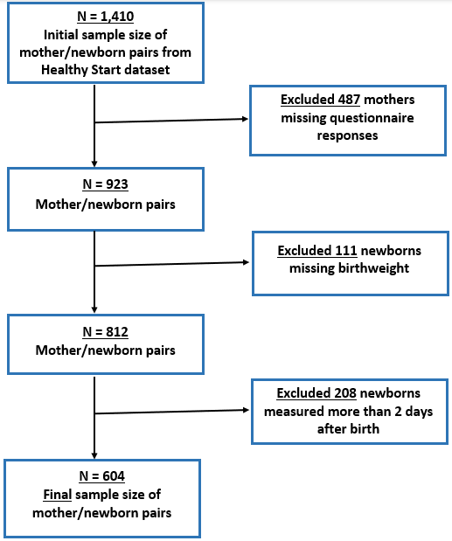

Supplementary Figure S2: Directed acyclic graph (DAG) for selecting covariates.
