Supplementary Materials
S1. Flowchart of participant inclusion of the Dutch Famine birth cohort follow-up study and schematic presentation of gestational famine exposure. Schematic presentation of gestational famine exposure was copied from Bleker et al¹.
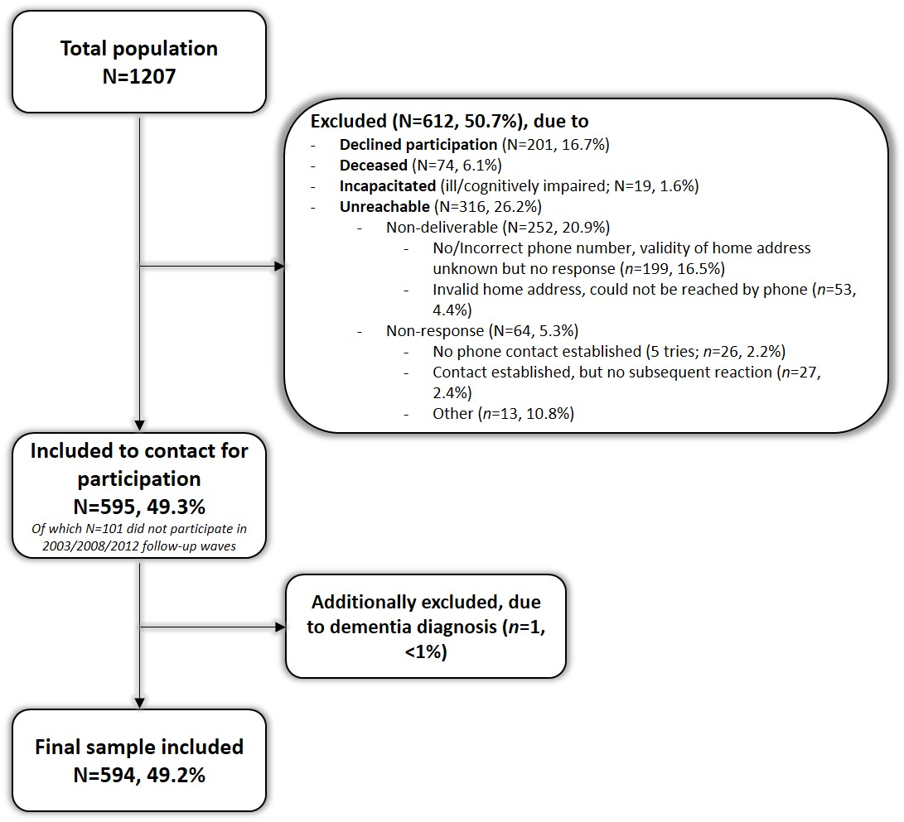

S2. Overview of exposure to prenatal undernutrition during gestation
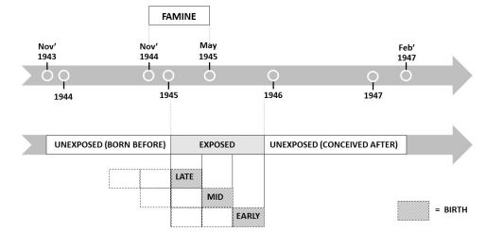

S3.1 Results of Latent Profile Analyses (LPA) on best-fitted classification model in men and women using pre-identified criteria and selection indicators.
 | 1-class model | 2-class model | 3-class model | 4-class model | 5-class model
 | 1-class model | 2-class model | 3-class model | 4-class model | 5-class model
Men (n=249)
AIC | 7819.071 | 7188.439 | 6995.689 | 6877.281
BIC | 7868.315 | 8265.823 | 7101.213 | 7010.945
Adjusted-AIC | 7823.934 | 7196.082 | 7006.111 | 6890.483
Entropy | - | 0.965 | 0.961 | 0.967
LMR-A  Value  p-value | -  - | 632.307  .0069 | 204.125  .1481 | 131.430  .7597
BLRT  -2LL difference  p-value | -  - | 646.632  <.001 | 208.749  <.001 | 134.408  <.001
Women (n=277)
AIC | 9649.041 | 8824.544 | 8428.428 | 8335.714 | 8230.576
BIC | 9699.777 | 8904.272 | 8537.149 | 8473.427 | 8397.280
Adjusted-AIC | 9655.385 | 8834.513 | 8442.023 | 8352.934 | 8251.421
Entropy | - | 0.950 | 0.962 | 0.936 | 0.972
LMR-A
Value | - | 822.223 | 403.155 | 106.350 | 118.505
p-value | - | .1323 | .0014 | .5293 | .2301
BLRT
-2LL difference | - | 840.497 | 412.115 | 108.714 | 121.139
p-value | - | <.001 | <.001 | <.001 | <.001

AIC: Akaike Information Criterion; BIC: Bayesian Information Criterion; LMR-A: Lo-Mendell-Rubin-adjusted likelihood ratio test; BLRT: bootstrap likelihood ratio test; -2LL: -2 times log-likelihood difference between an NK class solution and K–1 class solution.

S3.2 Final model selection and latent symptom profiles
In men, model indicators were compared across 1-, 2-, 3-, 4-, and 5-class models. However, increasing the number of classes to a 5-class model resulted in an unreliable model due to non-convergence and non-replication of the best log likelihood values and diminished gains. With the inclusion of 2-, 3- and 4-classed the model improved as increasing the number of latent classes was accompanied by significance of BLRT (p<.001) and decreasing values for BIC, AIC and adjusted-BIC, with lowest values in the 4-class model^{2,3}. LMR-A significantly improved only with inclusion of 2 classes (p=.007) and not with inclusion of 3 or 4 classes. Classification quality according to entropy statistics was considered adequate for all classes (p>0.961), indicating marginal and substantive information gain by increasing the number of latent classes. A negligible 0.4% decrease in entropy took place with inclusion of a 3- over a 2-class model and 0.6% increase in a 4- over 3-class model. In consideration of all indicators – particularly AIC, BIC, adjusted-BIC, BLRT and entropy comparisons, the 4-class model was likely the most meaningful and acceptable fit with acceptable interpretability of average assignment class-probabilities and high precision (class-1 0.955; class-2 0.934; class-3 0.995; class-4 0.996).
In women, increasing the number of latent classes in a 1- till 6-class model were compared. Increasing the number of classes to a 6-class model resulted in an unreliable model due to non-convergence and non-replication of the best log likelihood values. Similarly as in men, increasing the number of classes was accompanied by decreasing values for BIC, AIC and adjusted-BIC and significance of BLRT (p<.001; table 2). Entropy statistics was considered adequate for all classes (p>.936), with lowest values in the 5-class model. LMR-A significantly improved only with inclusion of 3 classes (p=.001) and not with inclusion of 2, 4 or 5 classes. A negligible 1.3% increase in entropy took place with inclusion of a 3- over a 2-class model, 2.7% decrease in a 4- over 3-class model, and 3.9% increase in a 5- over 4-class model. Considering particularly AIC, BIC, adjusted-BIC, BLRT and entropy comparisons, the 5-class model was likely the most meaningful and acceptable fit with acceptable interpretability of average assignment class-probabilities and high precision (class-1 0.994; class-2 0.97; class-3 0.997; class-4 0.925; class-5 0.999).

Table S4. Multinomial regression analysis for associations between life adversities and probability of profile assignment in men without covariates.
 | Anxiety/Depression symptoms |  |  |  | Mild symptoms |  |  |  | High symptoms
Men (N=249) | Versus low symptoms |  |  |  | Versus low symptoms |  |  |  | Versus low symptoms
 | Odds | SE Odds | 95% CI Odds | p | Odds | SE  Odds | 95% CI Odds | p | Odds | SE Odds | 95% CI  Odds | p
Model 1 (N=249) Prenatal undernutrition due to famine exposure
Early gestation  Mid gestation  Late gestation | 2.9  0.6  0.3 | 2.6  0.7  0.4 | 0.5-16.3  0.1-6.1  <0.1-3.2 | .221  .705  .321 | 3.7  0.8  1.0 | 2.3  0.6  0.5 | 1.1-12.3  0.2-3.4  0.4-2.7 | .031*  .816  .970 | 2.6  1.2  0.6 | 3.0  1.4  0.7 | 0.3-24.7  0.1-10.8  0.1-5.3 | .403  .861  .649
Model 2 (N=248) Childhood traumatic maltreatment
Childhood maltreatment¹ | 1.1 | <0.1 | 1.0-1.1 | .004* | 1.1 | <0.1 | 1.0-1.1 | .001* | 1.1 | <0.1 | 1.0-1.2 | .002*
Model 3 (N=248) Childhood traumatic maltreatment subtypes
Emotional abuse¹  Physical abuse¹  Sexual abuse¹  Emotional neglect¹  Physical neglect¹ | 0.8  1.2  1.1  1.1  1.3 | 0.1  0.2  0.2  0.1  0.2 | 0.7-2.0  0.9-1.6  0.8-1.4  0.9-1.3  1.0-1.7 | .022*  .175  .500  .302  .120 | 1.2  0.9  0.9  1.0  1.1 | 0.1  0.1  0.2  0.1  0.1 | 1.0-1.4  0.7-1.1  0.7-1.2  0.9-1.2  0.9-1.4 | .011**  .216  .400  .541  .353 | 1.3  0.6  1.1  0.9  1.4 | 0.2  0.2  0.4  0.1  0.2 | 1.0-1.8  0.4-1.1  0.5-2.2  0.7-1.2  1.1-1.9 | .034*  .028*  .948  .752  .021**
Model 4 (N=249) Adulthood trauma
Adulthood trauma² | 0.6 | 0.2 | 0.3-1.2 | .175 | 1.2 | 0.2 | 0.9-1.6 | .156 | 2.0 | 0.4 | 1.4-2.8 | <.001*
¹Childhood traumatic maltreatment subtypes was measured using the Childhood Trauma Questionnaire (CTQ); ²Adulthood trauma was measured with LEC-5: Life Events Checklist, number of experienced traumatic event types in the past 15 years when experienced personally, witnessed it, learned about it happening to close family members or friends, or if it happened at work; Odds indicates the B value corresponding to the log odds, with Odds>1 representing higher odds – higher probability for assignment into the target profile versus the low-symptom severity profile, and Odds<1 lower odds – lower probability for assignment into the target profile versus the low-symptom severity profile; SES: Social economic status, SE: Standard error, CI: Confidence interval of B log odds. **Results did not survive FDR multiple comparison corrections (p=0.05).

Table S5. Multinomial regression analysis of estimates and odds for associations between life adversities and probability of profile assignment in women without covariates.
 | Mild-symptoms |  |  |  | PTSD symptoms |  |  |  | Anxiety/Depression symptoms |  |  |  | High symptoms
Women (N=277) | Versus low symptoms |  |  |  | Versus low symptoms |  |  |  | Versus low symptoms |  |  |  | Versus low symptoms
 | Odds | SE Odds | 95% CI Odds | p | Odds | SE Odds | 95% CI Odds | p | Odds | SE Odds | 95% CI Odds | p | Odds | SE Odds | 95% CI  Odds |  | P
Model 1 (N=277) Prenatal undernutrition due to famine exposure
Early gestation  Mid gestation  Late gestation | 0.6  1.2  0.8 | 0.4  0.5  0.4 | 0.1-2.3  0.5-2.8  0.3-1.9 | .427  .625  .563 | 0.6  2.1  0.3 | 0.7  1.1  0.3 | 0.1-5.1  0.7-6.1  <0.1-2.4 | .649  .195  .252 | 1.5  0.6  0.3 | 1.0  0.4  0.3 | 0.4-5.5  0.1-2.5  0.1-1.9 | .503  .478  .215 | 0.7  0.4  0.7 | 0.8  0.5  0.6 | 0.1-6.4  0.1-3.5  0.1-3.5 |  | .788  .418  .684
Model 2 (N=275) Childhood traumatic maltreatment
Childhood maltreatment¹ | 1.0 | <0.1 | 1.0-1.1 | .001* | 1.1 | <0.1 | 1.0-1.1 | .001* | 1.0 | <0.1 | 1.0-1.1 | .496 | 1.1 | <0.1 | 1.0-1.1 |  | <.001*
Model 3 (N=272) Childhood traumatic maltreatment subtypes
Emotional abuse¹  Physical abuse¹  Sexual abuse¹  Emotional neglect¹  Physical neglect¹ | 1.1  0.9  1.1  <1.0  1.1 | 0.1  0.1  0.1  0.1  0.1 | 1.0-1.3  0.8-1.2  <1.0-1.3  0.9-1.1  0.9-1.3 | .065  .768  .209  .750  .776 | 1.1  1.0  1.1  1.1  1.0 | 0.1  0.1  0.1  0.1  0.1 | 0.9-1.3  0.8-1.3  <1.0-1.3  <1.0-1.2  0.8-1.2 | .559  .925  .091  .047*  .477 | 1.2  <1.0  0.9  1.0  0.8 | 0.1  0.1  0.2  0.1  0.2 | <1.0-1.4  0.7-1.3  0.6-1.4  0.8-1.2  0.6-1.2 | .042**  .424  .552  .870  .353 | 1.1  0.8  1.3  1.1  <1.0 | 0.1  0.1  0.1  0.1  0.1 | <1.0-1.3  0.5-1.1  1.0-1.6  <1.0-1.3  0.7-1.2 |  | .041**  .115  .058  .004*  .193
Model 4 (N=277) Adulthood trauma
Adulthood trauma² | 1.3 | 0.2 | 1.0-1.6 | .020* | 1.5 | 0.2 | 1.1-1.9 | .007* | 1.3 | 0.2 | 1.0-1.7 | .042* | 1.5 | 0.3 | 1.0-2.3 |  | .055
¹Childhood traumatic maltreatment subtypes was measured using the Childhood Trauma Questionnaire (CTQ); ²Adulthood trauma was measured with LEC-5: Life Events Checklist, number of experienced traumatic event types in the past 15 years when experienced personally, witnessed it, learned about it happening to close family members or friends, or if it happened at work; Odds indicates the B value corresponding to the log odds, with Odds>1 representing higher odds – higher probability for assignment into the target profile versus the low-symptom severity profile, and Odds<1 lower odds – lower probability for assignment into the target profile versus the low-symptom severity profile; SE: Standard error, CI: Confidence interval of log odds. **Result did not survive FDR multiple comparison corrections (p=0.05).

References
1. Bleker LS, De Rooij SR, Painter RC, Ravelli ACJ, Roseboom TJ. Cohort profile: the Dutch famine birth cohort (DFBC)— a prospective birth cohort study in the Netherlands. BMJ Open. 2021; 11(3), e042078. https://doi.org/10.1136/bmjopen-2020-042078
2. Yang C. Evaluating latent class analysis models in qualitative phenotype identification. Computational Statistics & Data Analysis. 2006; 50, 1090–104.
3. Nylund KL, Asparouhov T, Muthén BO. Deciding on the Number of Classes in Latent Class Analysis and Growth Mixture Modeling: A Monte Carlo Simulation
Study. Structural Equation Modeling: A Multidisciplinary Journal. 2007; 14(4), 535–69. Available from: https://www.tandfonline.com/doi/full/10.1080/10705510701575396

