Supplementary Materials for “Potential long consequences from internal and external ecology: loss of gut microbiota antifragility in children from an industrialized population compared with an indigenous rural lifestyle.”
Isaac G-Santoyo^{1,2}, Elvia Ramírez-Carrillo¹, Jonathan Dominguez Sanchez¹, Oliver López-Corona^{3,4,5}

¹ NeuroEcology Lab, Faculty of Psychology, Facultad de Psicología, UNAM, Mexico, 04510.
² Unidad de Investigación en Psicobiología y Neurociencias, Department of Psychology, UNAM, México, 04510.
³ Centro de Ciencias de la Complejidad, UNAM, Mexico.
⁴ Cátedras CONACyT, Instituto de Investigaciones en Matemáticas Aplicadas y Sistemas (IIMAS), UNAM, México 04510.
⁵ Former: Cátedras CONACyT, Comisión Nacional para el Conocimiento y Uso de la Biodiversidad (CONABIO), Mexico.

Correspondance authors:
IG-S: isantoyo83@gmail.com
ER-C: elviarc@otrasenda.org
OL-C: lopezoliverx@ciencias.unam.mx

Glossary for uncommon terms used in the introduction
Mainly from Santamaría-Bonfil G, Gershenson C and Fernández N (2017) A Package for Measuring Emergence, Self-organization, and Complexity Based on Shannon Entropy. Front. Robot. AI 4:10. doi: 10.3389/frobt.2017.00010 and Complexity explained booklet consulted on abril 04, 2023 https://complexityexplained.github.io/ComplexityExplained.pdf

Concept | Definition
Gut microbiota ecosystem | Gut microbiota ecosystem: A complex ecosystem mainly composed of millions of bacterial species that self-organize to exhibit non-trivial global structures and behaviors at larger scales, giving place to properties that may not be understood or predicted from even the full knowledge of the species biology alone.
Emergence | Emergence refers to the phenomenon where the properties of a complex system cannot be predicted or understood solely based on the properties of its individual components. In other words, novel information and collective behaviors arise from the interactions between the components of the system, leading to non-trivial structures and behaviors at larger scales. This is in contrast to simple systems, where the properties of the whole can be deduced from the properties of its parts. The emergence phenomenon highlights that the whole is more than the sum of its parts in complex systems. More specifically, emergence measures the average ratio of uncertainty a process produces by new information that results from changes in (a) dynamics or (b) scale.
 | In its broadest sense, self-organization can be viewed as a decrease in entropy (Gershenson and Heylighen, 2003). The opposite of emergence, self-organization is related to order and regularity as a result of changes in the dynamics or scale of the process. In this sense, the level of organization is highest for a Dirac delta distribution and lowest for an entirely random process (such as the uniform distribution). The process of self-organization may produce physical or functional structures, as well as dynamic or informational behaviors. As the system becomes more organized through this process, new interaction patterns may emerge, potentially leading to the production of greater complexity. In some cases, self-organized systems may reach a critical state that exists in a subtle balance between randomness and regularity, and patterns that arise in such states often show peculiar properties like self-similarity and power-law distributions of pattern properties. Examples of self-organization include the growth of cities, the formation of complex shapes of organisms from a single egg cell, and the flocking patterns of starlings.
Complexity | Latin plexus, which means interwoven, is a possible source of the word complexity. As a result, separation of something complex is challenging. This indicates that its constituent parts are interdependent, i.e., their interactions affect their future in some way. Systems are able to adapt in a robust way thanks to complexity, which is a balance between change and regularity (Kaufmann, 1993). While change allows for the exploration of new possibilities, which is crucial for adaptability, regularity ensures the survival of information. In this sense, complexity can also be used to describe living systems or synthetic adaptive systems, particularly when contrasting them with their surroundings (Fernández et al., 2014). A system's behavior is more precisely described by this function in terms of the typical uncertainty caused by recurring and emergent global patterns as described by its probability distribution.
Criticality | Systems in criticality exhibits scale invariant dynamics, that maintains the system in an equable trade-off between flexibility (emergence) and robustness (self-organization) in a specific scale of observation, usually associated with maximum inference and computational capabilities. It is present in all living systems.
Antifragility | Antifragility is a property of living systems that enables them to not only withstand but also benefit from external perturbations, variability, and uncertainty. Unlike robust or resilient systems that remain the same or tolerate stress, antifragile structures are able to adapt, learn, and gain from stress. The immune system is a notable example of an antifragile system, as it improves and gains new capabilities when subjected to various germs at a young age. Antifragility is considered the exact opposite of fragility, as fragile systems are damaged by environmental variability, whereas antifragile systems enhance their functional capacity in response to external perturbations. More rigorous a system is antifragile with respect of a particular payoff function if under a well defined perturbation it response in a nonlinear convex way.

Supplementary figures

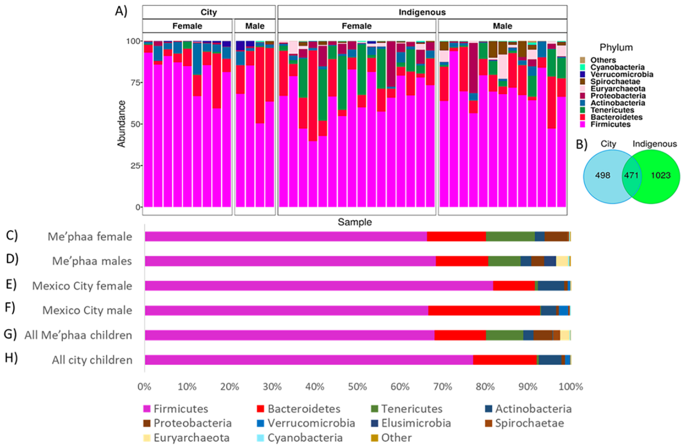
Figure 6. Microbiota relative abundance (A) The distribution of bacteria (16S rRNA V4) at the phylum level in male and female students from Mexico City and the Me'phaa community; phyla with relative abundances 1% were included in the "others" category; (B) Venn diagram of ASVs from México City and the Me'phaa community; (C) relative abundance of gut microbiota (GM) from female Me'phaa community children; (D) relative abundance of GM from male Me'phaa community children; (E) relative abundance of GM from female México City children; (F) relative abundance of GM from male México City community children; (G) relative abundance of GM from all Me' phaa community children Figure reproduced from
Sánchez-Quinto, A., Cerqueda-García, D., Falcón, L. I., Gaona, O., Martínez-Correa, S., Nieto, J., & G-Santoyo, I. (2020). Gut microbiome in children from indigenous and urban communities in México: Different subsistence models, different microbiomes. Microorganisms, 8(10), 1592; under appropriate licenses right as showed at: https://www.mdpi.com/authors/rights

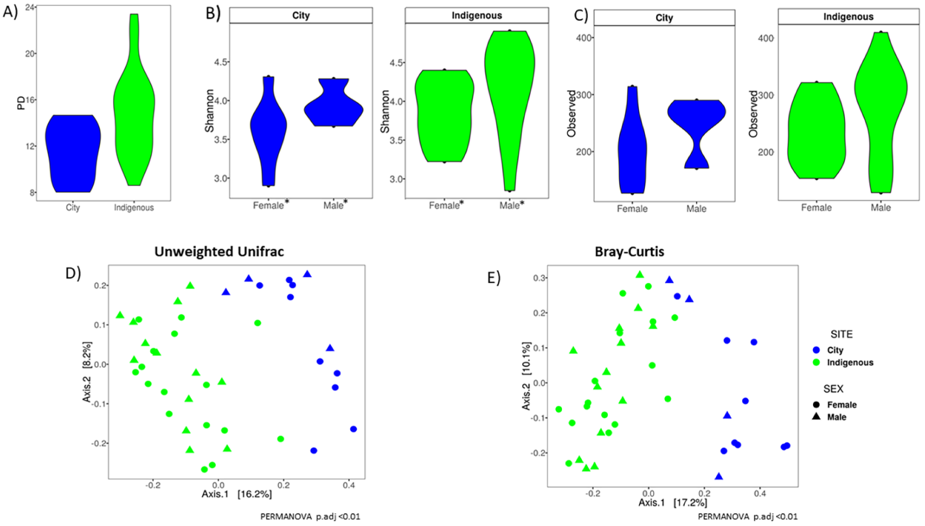
Figure 7. Alpha diversity indexes and Beta ordinations of children GM by population and sex. The violin plot with median of (A) Faith’s phylogenetic diversity (PD) index by population; (B) Shannon index; (C) Observed ASV’s. * corresponds to significant differences (p < 0.05); (D) Corresponds to Unweighted Unifrac; (E) Corresponds to the Bray–Curtis GM children analysis. For México City (City) and indigenous (Me´phaa) communities, blue and green were used, respectively. Differences were statistically significant in the PERMANOVA test at a level of p < 0.01 only for location, but not for the gender of the child in both distance metrics (D,E). Figure reproduced from Sánchez-Quinto, A., Cerqueda-García, D., Falcón, L. I., Gaona, O., Martínez-Correa, S., Nieto, J., & G-Santoyo, I. (2020). Gut microbiome in children from indigenous and urban communities in México: Different subsistence models, different microbiomes. Microorganisms, 8(10), 1592; under appropriate licenses right as showed at: https://www.mdpi.com/authors/rights

Supplementary tables

Supplementary Table S1. Relative abundances of the most abundant phyla found in fecal samples from children in Mexico City and the Me'phaa communities. Table reproduced from Sánchez-Quinto, A., Cerqueda-García, D., Falcón, L. I., Gaona, O., Martínez-Correa, S., Nieto, J., & G-Santoyo, I. (2020). Gut microbiome in children from indigenous and urban communities in México: Different subsistence models, different microbiomes. Microorganisms, 8(10), 1592; under appropriate licenses right as showed at: https://www.mdpi.com/authors/rights

Mexico City
Phylum | Relative abundance
Firmicutes | 77.103613522
Bacteroidetes | 14.8497693691
Actinobacteria | 5.3471919457
Verrumicrobia | 1.1493073747
Proteobacteria | 0.744833246
Tenericutes | 0.5744705016
Spirochaetae | 0.1458158544
Cyanobacteria | 0.0560548385
Euryarchaeota | 0.027477862
Fusobacteria | 0.000732743
Elusimicrobia | 0.0003663715
Saccharibacteria | 0.0003663715
Indigenous (Me’phaa)
Phylum | Relative abundance
Firmicutes | 68.0491496599
Bacteroidetes | 12.0734693878
Tenericutes | 8.7302721088
Proteobacteria | 4.4933673469
Actinobacteria | 2.4447278912
Euryarchaeota | 2.1181972789
Spirochaetae | 1.6964285714
Cyanobacteria | 0.2472789116
Verrumicrobia | 0.0826530612
Chloroflexi | 0.0163265306
Elusimicrobia | 0.0120748299
Deinococcus-Thermus | 0.0079931973
Acidobacteria | 0.0071428571
Fibrobacteres | 0.0049319728
Planctomycetes | 0.0040816327
Gemmatimonadetes | 0.0035714286
Fusobacteria | 0.0034013605
Latescibacteria | 0.0022108844
Nitrospirae | 0.0011904762
Lentisphaerae | 0.0010204082
Hydrogenedentes | 0.0003401361
Aminicenantes | 0.000170068

