Supplemental Information

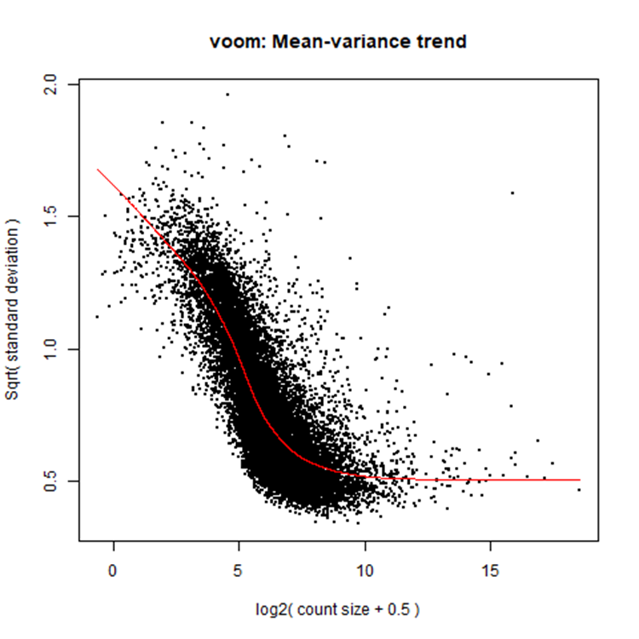

Figure S1 – Mean-variance trend fit. The relationship between average expression and the estimated variant for each gene after filtering. The smoothed curve is used to obtain weights for each gene and sample that used in the final linear model.

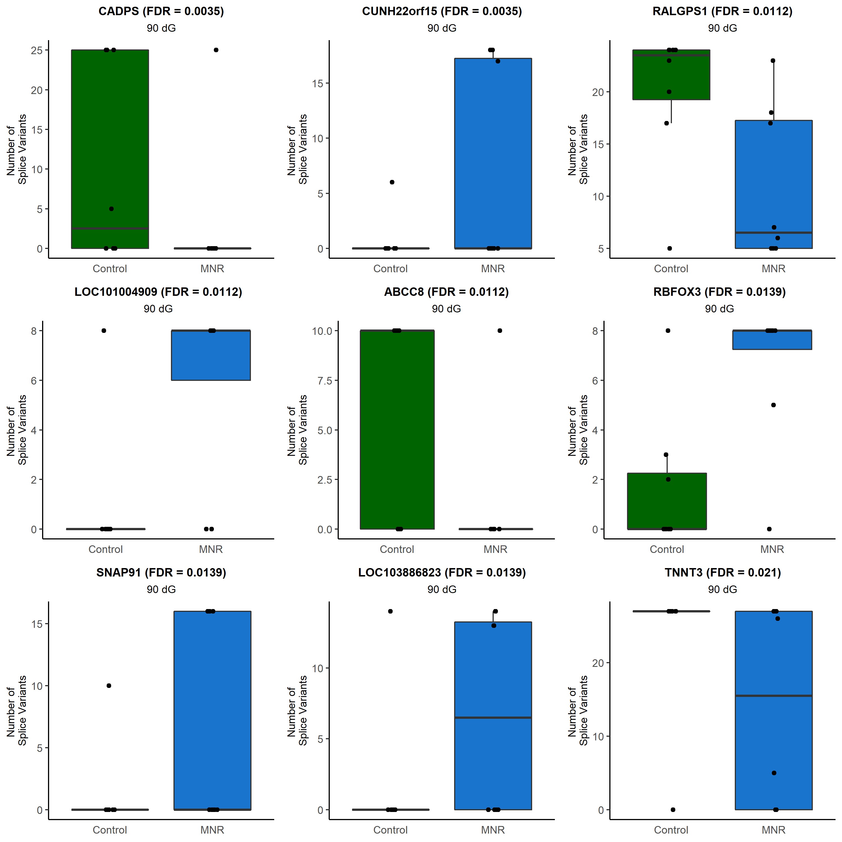

Figure S2 – Splicing differences at 90dG. Standard boxplots of the number of splice variants for each gene that demonstrated significant differences between MNR and control animals at 90dG. In order to be counted, a splice variant had to have at least one read present for that particular gene’s splice variant. The center line represents the median. The lower and upper box limits represent the 25% and 75% quantiles, respectively. The whiskers extend to the largest observation within the box limit ±1.5 × interquartile range. FDR p-values are reported in parentheses next to the gene names.
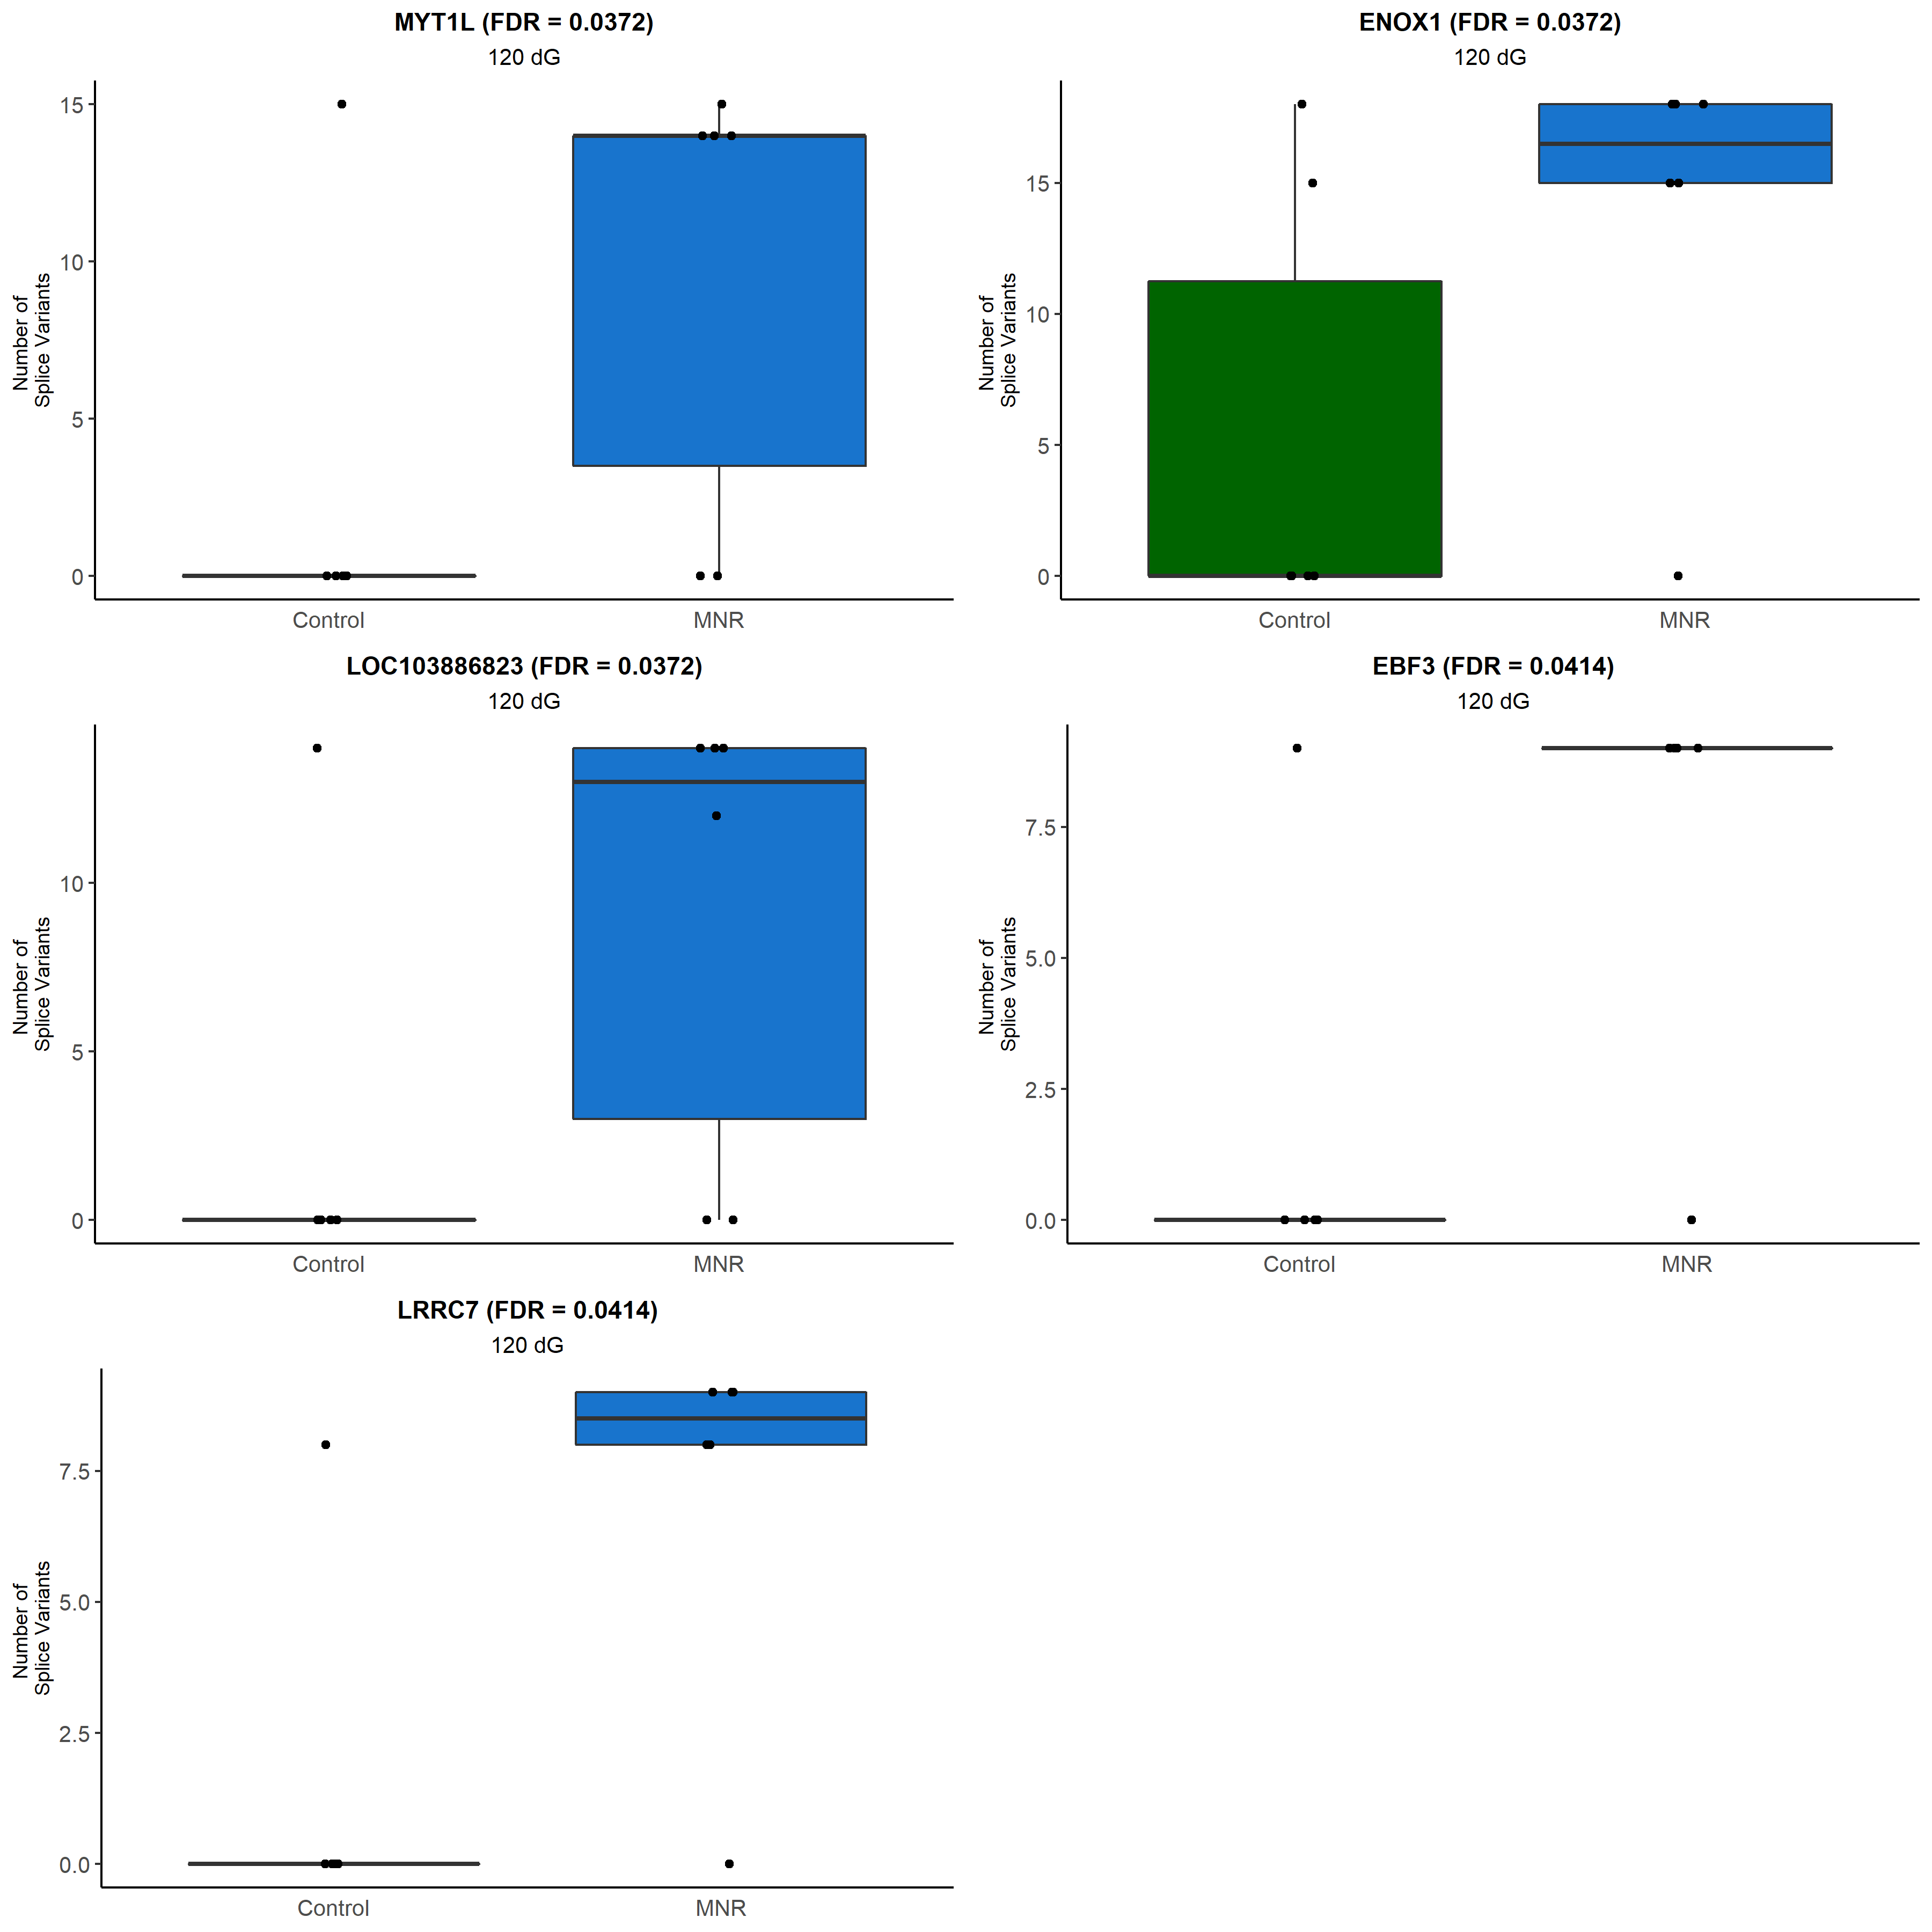
Figure S3 – Splicing differences at 120dG. Standard boxplots of the number of splice variants for each gene that demonstrated significant differences between MNR and control animals at 120dG. In order to be counted, a splice variant had to have at least one read present for that particular gene’s splice variant. The center line represents the median. The lower and upper box limits represent the 25% and 75% quantiles, respectively. The whiskers extend to the largest observation within the box limit ±1.5 × interquartile range. FDR p-values are reported in parentheses next to the gene names.
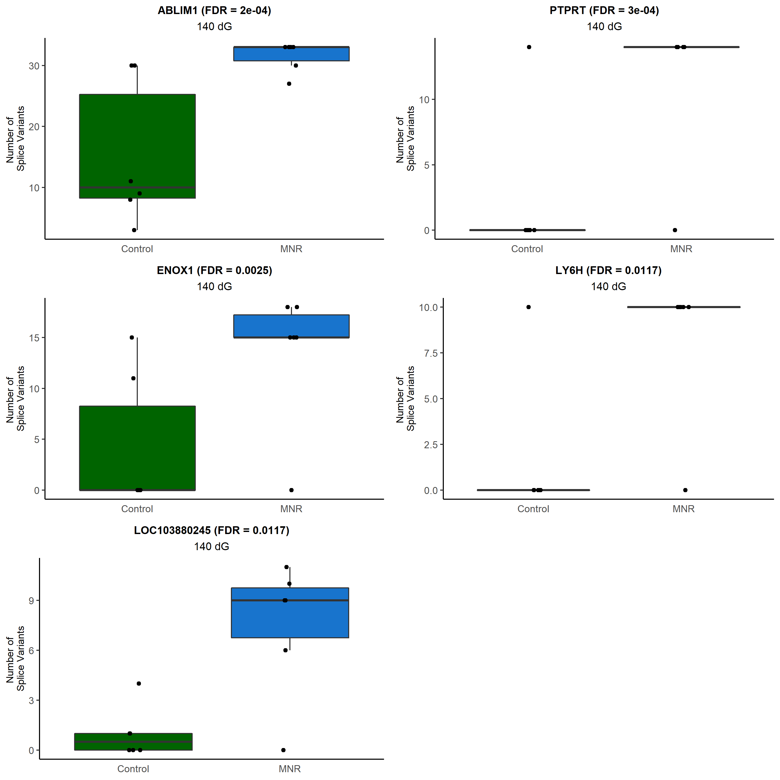
Figure S4 – Splicing differences at 140dG. Standard boxplots of the number of splice variants for each gene that demonstrated significant differences between MNR and control animals at 140dG. In order to be counted, a splice variant had to have at least one read present for that particular gene’s splice variant. The center line represents the median. The lower and upper box limits represent the 25% and 75% quantiles, respectively. The whiskers extend to the largest observation within the box limit ±1.5 × interquartile range. FDR p-values are reported in parentheses next to the gene names.

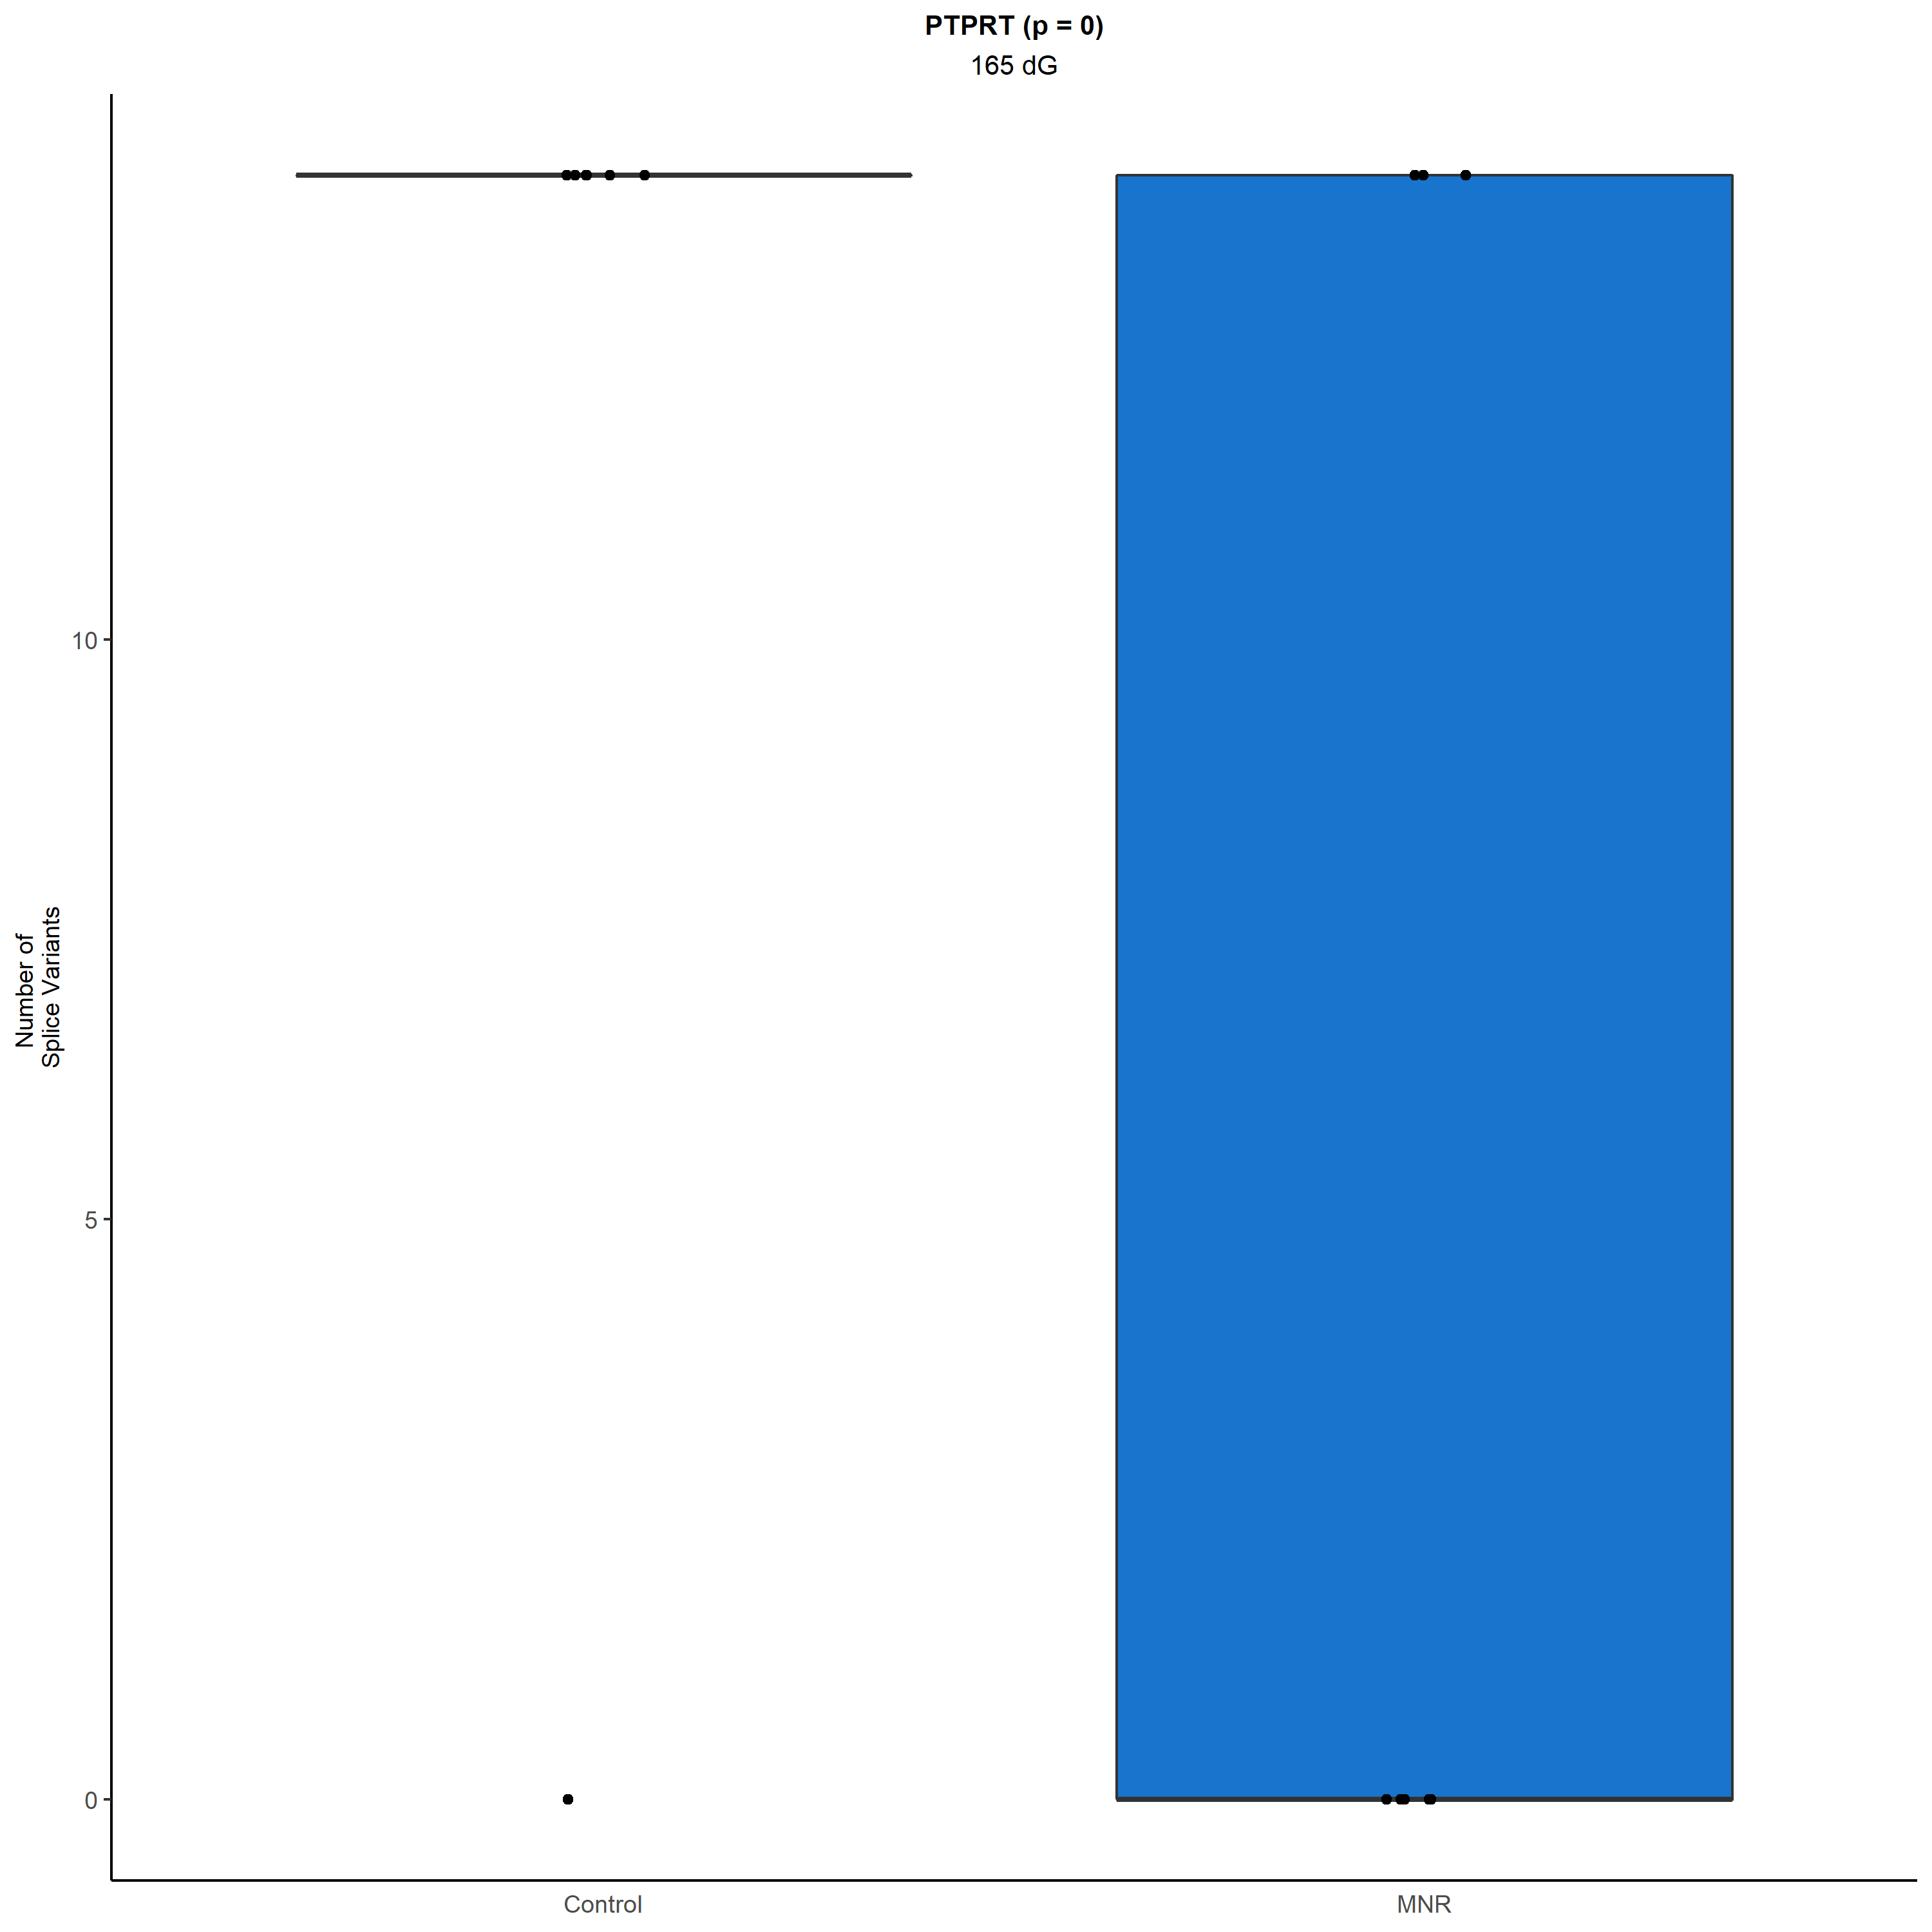
Figure S4 – Splicing differences at 165dG. Standard boxplots of the number of splice variants for each gene that demonstrated significant differences between MNR and control animals at 165dG. In order to be counted, a splice variant had to have at least one read present for that particular gene’s splice variant. The center line represents the median. The lower and upper box limits represent the 25% and 75% quantiles, respectively. The whiskers extend to the largest observation within the box limit ±1.5 × interquartile range. FDR p-values are reported in parentheses next to the gene names.

Table S1 – Differentially expressed transcripts (FDR < 0.1) in MNR animals. Transcripts are listed along with gene symbol, effect size, p-value, FDR adjusted p-value, and from which contrast they were significant. Repeated genes across both contrasts are in bold to highlight how much overlap exists between the two contrasts.
Transcript | Gene Symbol | Effect Size [95% CI] | p-value | FDR | Contrast
XM_009201803.1 | LOC103882414 | -1.31 [-1.77:-0.86] | 3.50x10⁻⁰⁷ | 0.005 | MNR
XM_009193929.3 | SLC25A42 | -0.86 [-1.24:-0.48] | 2.92x10⁻⁰⁵ | 0.085 | MNR
XM_003911357.4 | HSDL2 | -0.63 [-0.91:-0.35] | 2.99x10⁻⁰⁵ | 0.085 | MNR
XM_003911822.3 | NMRK1 | -0.8 [-1.15:-0.45] | 3.03x10⁻⁰⁵ | 0.085 | MNR
XM_003908369.3 | HADHB | -0.72 [-1.05:-0.4] | 3.55x10⁻⁰⁵ | 0.085 | MNR
XM_021934972.1 | ST6GAL1 | -1.56 [-2.27:-0.85] | 4.96x10⁻⁰⁵ | 0.085 | MNR
XM_017953498.2 | CDH1 | -0.66 [-0.97:-0.36] | 5.85x10⁻⁰⁵ | 0.085 | MNR
XM_021938982.1 | ACSL1 | -1 [-1.46:-0.54] | 6.20x10⁻⁰⁵ | 0.085 | MNR
XM_003912220.3 | ACADVL | -0.58 [-0.85:-0.31] | 7.27x10⁻⁰⁵ | 0.085 | MNR
XM_009188596.3 | GALT | -0.77 [-1.13:-0.41] | 7.45x10⁻⁰⁵ | 0.085 | MNR
XM_009209923.1 | IVD | 0.57 [0.3:0.84] | 7.97x10⁻⁰⁵ | 0.085 | MNR
XM_021923228.1 | ERGIC2 | -0.6 [-0.89:-0.32] | 8.52x10⁻⁰⁵ | 0.085 | MNR
XR_001905774.2 | DPYS | 0.0013 [0.0008:0.0018] | 5.32x10⁻⁰⁶ | 0.044 | Quadratic
XM_009201803.1 | LOC103882414 | 0.001 [0.0006:0.0014] | 7.25x10⁻⁰⁶ | 0.044 | Quadratic
XM_003908369.3 | HADHB | 0.0007 [0.0004:0.001] | 1.47x10⁻⁰⁵ | 0.044 | Quadratic
XM_009201909.3 | ST6GAL1 | 0.0014 [0.0008:0.0019] | 1.54x10⁻⁰⁵ | 0.044 | Quadratic
XM_003913970.3 | EDNRB | 0.0018 [0.001:0.0025] | 1.89x10⁻⁰⁵ | 0.044 | Quadratic
XM_021934975.1 | BCL6 | 0.0008 [0.0004:0.0011] | 3.19x10⁻⁰⁵ | 0.044 | Quadratic
XM_017961245.2 | LOC101014452 | 0.0013 [0.0007:0.0019] | 3.22x10⁻⁰⁵ | 0.044 | Quadratic
XM_003898170.3 | VNN1 | 0.0008 [0.0005:0.0012] | 3.29x10⁻⁰⁵ | 0.044 | Quadratic
XM_021938982.1 | ACSL1 | 0.001 [0.0005:0.0014] | 3.59x10⁻⁰⁵ | 0.044 | Quadratic
XM_021937511.1 | PHIP | 0.0009 [0.0005:0.0013] | 4.92x10⁻⁰⁵ | 0.045 | Quadratic
XM_003907888.3 | IDH1 | 0.001 [0.0006:0.0015] | 5.14x10⁻⁰⁵ | 0.045 | Quadratic
XM_003912220.3 | ACADVL | 0.0006 [0.0003:0.0008] | 5.46x10⁻⁰⁵ | 0.045 | Quadratic
XM_009193929.3 | SLC25A42 | 0.0007 [0.0004:0.0011] | 6.14x10⁻⁰⁵ | 0.045 | Quadratic
XM_009205936.2 | SHPRH | 0.0006 [0.0003:0.0009] | 6.23x10⁻⁰⁵ | 0.045 | Quadratic
XM_021929339.1 | PRKAR1A | 0.0019 [0.001:0.0027] | 6.28x10⁻⁰⁵ | 0.045 | Quadratic
XM_021934131.1 | HACD2 | 0.001 [0.0005:0.0014] | 6.99x10⁻⁰⁵ | 0.046 | Quadratic
XM_017954419.2 | F9 | 0.001 [0.0005:0.0015] | 7.10x10⁻⁰⁵ | 0.046 | Quadratic
XM_021923228.1 | ERGIC2 | 0.0006 [0.0003:0.0008] | 7.74x10⁻⁰⁵ | 0.048 | Quadratic
XM_009209825.3 | MTMR10 | 0.0008 [0.0004:0.0012] | 8.17x10⁻⁰⁵ | 0.049 | Quadratic
XM_003913834.3 | SLC25A30 | 0.0006 [0.0003:0.0008] | 1.19x10⁻⁰⁴ | 0.065 | Quadratic
XM_009211314.2 | CIDEB | 0.0004 [0.0002:0.0006] | 1.22x10⁻⁰⁴ | 0.065 | Quadratic
XM_003892503.4 | SEC22B | 0.0011 [0.0005:0.0016] | 1.48x10⁻⁰⁴ | 0.076 | Quadratic
XM_009188596.3 | GALT | 0.0007 [0.0003:0.001] | 1.56x10⁻⁰⁴ | 0.078 | Quadratic
XM_021924041.1 | WDFY1 | 0.0009 [0.0004:0.0013] | 1.80x10⁻⁰⁴ | 0.087 | Quadratic
XM_003911822.3 | NMRK1 | 0.0007 [0.0003:0.001] | 1.93x10⁻⁰⁴ | 0.090 | Quadratic
XM_009208387.3 | NNT | 0.0013 [0.0006:0.002] | 2.28x10⁻⁰⁴ | 0.095 | Quadratic
XM_003917166.3 | COG4 | -0.0007 [-0.001:-0.0003] | 2.32x10⁻⁰⁴ | 0.095 | Quadratic
XR_001905819.2 | COLEC10 | 0.0013 [0.0007:0.002] | 2.34x10⁻⁰⁴ | 0.095 | Quadratic

