SUPPLEMENTARY MATERIALS

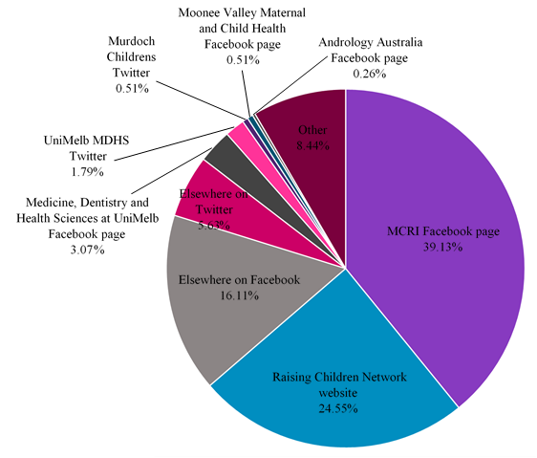
Figure S1. Response as a function of recruitment method (n = 391)

Table S1. Summary of participant demographics
Variable | Responses  (n) | (%)
Gender (n = 391)  Female  Male  Other | 370  20  1 | 94.6  5.1  0.3
Self-identification as a parent (n = 345)  Parent  Non-parent | 265  80 | 76.8  23.2
Age (years) (n = 391)  Mean = 37.5  Median = 36  <25  25-29  30-34  35-39  40-44  45-49  50-54  55-59  60-64  65-69  70-74  75-79  >79 | 30  45  93  90  58  26  16  21  8  2  1  0  1 | 7.7  11.5  23.8  23.2  14.8  6.7  4.1  5.4  2.1  0.5  0.3  0  0.3
Pregnancy status* (n = 90)  Currently pregnant  Not currently pregnant | 1  89 | 1.1  98.9
Number of children (n = 254)  Mean = 1.9  0  1  2  3  4  5 | 1  98  103  44  5  3 | 0.4  38.6  40.6  17.3  2.0  1.2
Ages of children (years) (n = 251)
Mean = 8.3
Median = 5
*A branching logic error in REDCap, which was later rectified, meant that this question was not visible to the first 273 participants (71.1% of female participants)
Table S1. Summary of participant demographics (continued)
Variable | Response (n) | (%)
Marital status (n = 369)  Single  Married  Living with partner  Not living with partner  Divorced  Separated but not divorced  Widowed | 49  232  60  9  10  5  4 | 13.3  62.8  16.3  2.4  2.7  1.4  1.1
Private health insurance (n = 366)  Yes  No | 252  114 | 68.9  31.2
Main source of income for household (n = 367)  Wages or salary  Pension or benefit  Other | 344  15  8 | 93.7  4.1  2.2
Highest level of education (n = 367)  Up to Year 10  Year 11-12  Trade/apprenticeship  College Certificate/Diploma  Undergraduate Degree  Postgraduate Degree | 3  23  3  48  124  166 | 0.8  6.3  0.8  13.1  33.8  45.2
Country of birth (n = 365)  Australia  New Zealand  United Kingdom  United States of America  Other | 300  14  12  8  31 | 82.2  3.8  3.3  2.2  8.5
Current country of residence (n = 370)  Australia  New Zealand  United Kingdom  United States of America  Other | 350  4  0  4  12 | 94.6  1.1  0  1.1  3.2

Table S1. Summary of participant demographics (continued)
Variable | Response (n) | (%)
Religion (n = 367)  None  Catholicism  Christian (non-denominational)  Anglican  Buddhism  Judaism  Other | 226  65  22  22  5  3  24 | 61.6  17.7  6.0  6.0  1.4  0.8  6.5
Language(s) spoken at home (n = 334)  English only  English and 1 other  English and 2 others  English and 3 others  Not English | 303  21  4  1  5 | 90.7  6.3  1.2  0.3  1.5
Ethnicity (n = 367)  Australian  Northern European  New Zealander  South East Asian  Southern European  North American  Eastern European  South Asian  Aboriginal/Torres Strait Islander  Maori/Pacific Islander  Central/South American  Other | 296  21  12  8  6  5  4  4  1  1  1  8 | 80.7  5.7  3.3  2.2  1.6  1.4  1.1  1.1  0.3  0.3  0.3  2.2

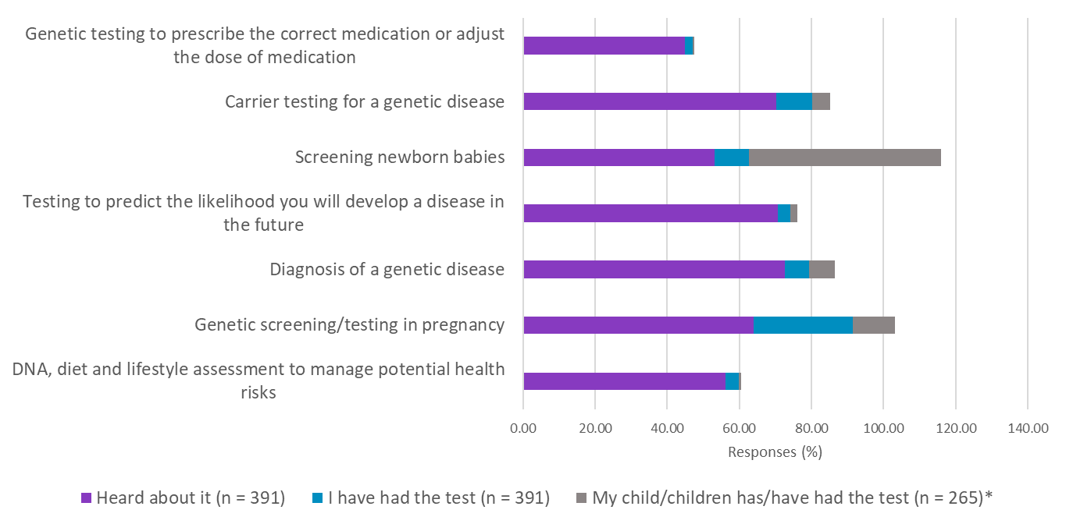
Figure S2. Participant’s knowledge and experience of genetic testing
*Only participants who indicated they were parents were able to see this question

Table S2. Effect of participants’ age on knowledge of epigenetics and epigenetic concepts
Variable | Participant group |  |  |  | Study total | p-value¹
 | ≤29  n (%) | 30-39  n (%) | 40-49  n (%) | ≥50  n (%)
“epigenetics”  Heard of it  Not heard of it | 45 (60.8)  29 (39.2) | 94 (51.4)  89 (48.6) | 59 (70.2)  25 (29.8) | 26 (53.1)  23 (46.9) | 224 (57.4)  166 (42.6) | 0.028
“you are what you eat”  Heard of it  Not heard of it | 74 (100.0)  0 (0) | 181 (99.5)  1 (0.6) | 81 (98.8)  1 (1.2) | 49 (100.0)  0 (0) | 385 (99.5)  2 (0.5) | 0.70
“you are what your mother/grandmother ate”  Heard of it  Not heard of it | 22 (29.7)  52 (70.3) | 43 (23.9)  137 (76.1) | 26 (31.7)  56 (68.3) | 19 (38.8)  30 (61.2) | 110 (28.6)  275 (71.4) | 0.18
“you can change your genes”  Heard of it  Not heard of it | 17 (23.0)  57 (77.0) | 43 (23.6)  139 (76.4) | 20 (24.4)  62 (75.6) | 13 (27.1)  35 (72.9) | 93 (24.1)  293 (75.9) | 0.96
“Developmental Origins of Health and Disease”  Heard of it  Not heard of it | 27 (36.5)  47 (63.5) | 50 (27.6)  131 (72.4) | 29 (34.9)  54 (65.1) | 19 (40.4)  28 (59.6) | 125 (32.5)  260 (67.5) | 0.25
“the First 1000 Days”  Heard of it  Not heard of it | 21 (28.8)  52 (71.2) | 59 (32.4)  123 (68.3) | 26 (31.7)  56 (68.3) | 15 (31.9)  32 (68.1) | 121 (31.5)  263 (68.5) | 0.95
¹calculated using the Pearson χ² test with one degree of freedom

Table S3. Effect of participants’ gender on knowledge of epigenetics and epigenetic concepts
Variable | Participant group |  | Study total | p-value¹
 | Female  n (%) | Male  n (%)
“epigenetics”  Heard of it  Not heard of it | 212 (57.5)  157 (42.6) | 11 (55.0)  9 (45.0) | 223 (57.3)  166 (42.7) | 0.83
“you are what you eat”  Heard of it  Not heard of it | 364 (99.5)  2 (0.6) | 20 (100)  0 (0) | 384 (99.5)  2 (0.5) | 0.74
“you are what your mother/grandmother ate”  Heard of it  Not heard of it | 104 (28.6)  260 (71.4) | 5 (25.0)  15 (75.0) | 109 (28.4)  275 (71.6) | 0.73
“you can change your genes”  Heard of it  Not heard of it | 87 (23.8)  278 (76.2) | 6 (30.0)  14 (70.0) | 93 (24.2)  292 (75.8) | 0.53
“Developmental Origins of Health and Disease”  Heard of it  Not heard of it | 118 (32.3)  247 (67.7) | 6 (31.6)  13 (68.4) | 124 (32.3)  260 (67.7) | 0.95
“the First 1000 Days”  Heard of it  Not heard of it | 114 (31.4)  249 (68.6) | 7 (35.0)  13 (65.0) | 121 (31.6)  262 (68.4) | 0.74
¹calculated using the Pearson χ² test with one degree of freedom

Table S4. Effect of participants’ education on knowledge of epigenetics and epigenetic concepts
Variable | Participant group |  | Study total | p-value¹
 | Tertiary educated  n (%) | Non-tertiary educated  n (%)
“epigenetics”  Heard of it  Not heard of it | 201 (59.5)  137 (40.5) | 11 (37.9)  18 (62.1) | 212 (57.8)  155 (42.2) | 0.02
“you are what you eat”  Heard of it  Not heard of it | 334 (99.4)  2 (0.6) | 29 (100)  0 (0) | 363 (99.5)  2 (0.5) | 0.68
“you are what your mother/grandmother ate”  Heard of it  Not heard of it | 95 (28.4)  239 (71.6) | 8 (27.6)  21 (72.4) | 103 (28.4)  260 (71.6) | 0.92
“you can change your genes”  Heard of it  Not heard of it | 82 (24.5)  253 (75.5) | 3 (10.3)  26 (89.7) | 85 (23.4)  279 (76.6) | 0.08
“Developmental Origins of Health and Disease”  Heard of it  Not heard of it | 113 (33.7)  222 (66.3) | 5 (17.2)  24 (82.8) | 118 (32.4)  246 (67.6) | 0.07
“the First 1000 Days”  Heard of it  Not heard of it | 110 (33.0)  223 (67.0) | 6 (20.7)  23 (79.3) | 116 (32.0)  246 (68.0) | 0.17
¹calculated using the Pearson 2 test with one degree of freedom

Table S5. Effect of participants’ parent status on knowledge of epigenetics and epigenetic concepts
Variable | Participant group |  | Study total | p-value¹
 | Parents  n (%) | Non-parents  n (%)
“epigenetics”  Heard of it  Not heard of it | 133 (50.4)  131 (49.6) | 63 (78.7)  17 (21.3) | 196 (57.0)  148 (43.0) | <0.001
“you are what you eat”  Heard of it  Not heard of it | 260 (99.2)  2 (0.8) | 79 (100)  0 (0) | 339 (99.4)  2 (0.6) | 0.44
“you are what your mother/grandmother ate”  Heard of it  Not heard of it | 74 (28.3)  186 (71.5) | 22 (27.9)  57 (72.1) | 96 (28.3)  243 (71.7) | 0.92
“you can change your genes”  Heard of it  Not heard of it | 62 (23.8)  199 (76.2) | 23 (29.1)  56 (70.9) | 85 (25.0)  255 (75.0) | 0.34
“Developmental Origins of Health and Disease”  Heard of it  Not heard of it | 79 (30.4)  181 (69.6) | 30 (38.0)  49 (62.0) | 109 (32.2)  230 (67.9) | 0.21
“the First 1000 Days”  Heard of it  Not heard of it | 77 (29.7)  182 (70.3) | 24 (30.4)  55 (69.6) | 101 (29.9)  237 (70.1) | 0.91
¹calculated using the Pearson χ² test with one degree of freedom

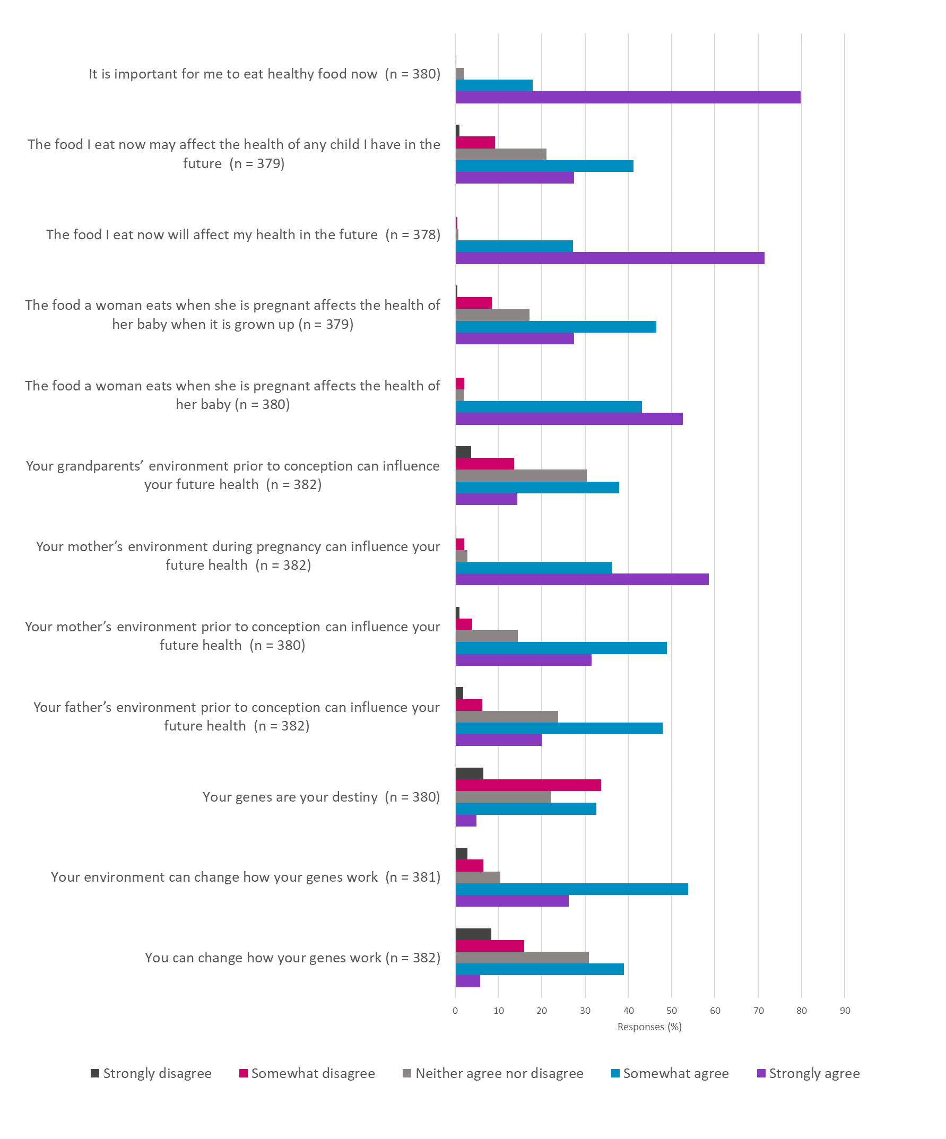
Figure S3. Participants’ agreement with a set of statements about epigenetic concepts
Questionnaire








