Supplementary Materials

Supplementary Figures
Supplementary Figure S1: Meta-analysis of the association of one standard deviation increase in birth weight with annual earnings, twin studies only
Supplementary Figure S2: Meta-analysis of the association of one standard deviation increase in birth weight with annual earnings, high income countries only

Supplementary Figure S3: Meta-analysis of the association of one standard deviation increase in birth weight with annual earnings, by continuous birth weight measure
Supplementary Figure S4: Meta-analysis of the association of one standard deviation increase in birth eight with annual earnings, studies that do not adjust for education

Appendix 1

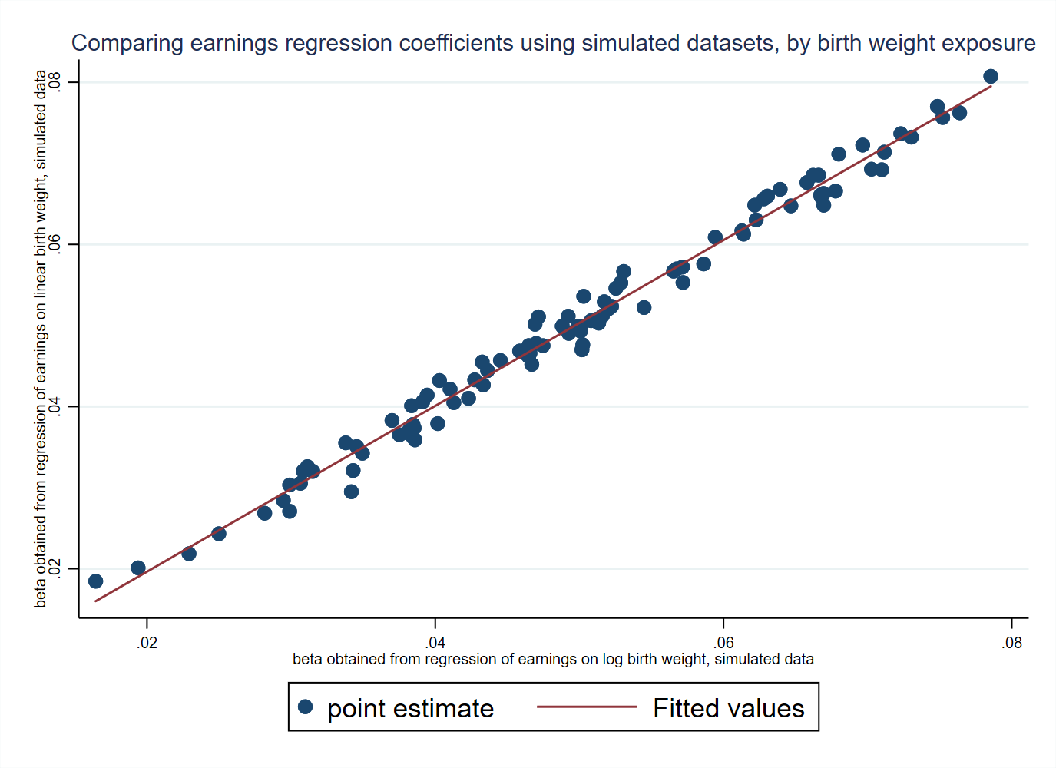
Note: the coefficients are based on regressions of normally distributed simulated earnings and birth weight data.

