SUPPLEMENTARY DATA
Table S1. Rat genomic DNA (gDNA) specific primers (within an intron of Actb) used in qPCR to check for gDNA contamination of extracted RNA samples. Cycling conditions: 98ºC for 3 minutes, (98ºC for 10 seconds, 60ºC for 30 seconds) – repeated for 40 cycles, followed by melt curve: 65ºC to 90ºC with 0.5ºC increment per 5 seconds.
Gene | Primers | Sequence (5’ to 3’) | Primer length | PCR product size gDNA (bp)
Actb | ActbFgDNA | CACTACCTCGCTGCAGGAT | 19 | 151
 | ActbRgDNA | TGTCTACACCGCGGGAAT | 18

Table S2. Primer sequences and qPCR cycling conditions for rat reference, imprinted, and epigenetic genes. Primers were optimised at the following cycling conditions: 98ºC for 3 minutes, (98ºC for 10 seconds, 63 or 65ºC for 30 seconds (*)) – repeated for 40 cycles, followed by melt curve analysis: 65ºC to 90ºC with 0.5ºC increment per 5 seconds.
Gene | Primers | Sequence (5’ to 3’) | Primer length | PCR product length (bp) | Annealing temperature (*)
Hprt | RTHprtF | CCTTGACTATAATGAGCACTTC | 22 | 126 | 63ºC
 | RTHprtR | GCCACATCAACAGGACTC | 18
Tbp | RTTbpF | CTAACCACAGCACCATTG | 18 | 152 | 63ºC
 | RTTbpR | TTACAGCCAAGATTCACG | 18
Ywhaz | RTYwhazF | ACCCACTCCGGACACAGAAT | 20 | 111 | 63ºC
 | RTYwhazR | GACTTCATGCAGGCTGCCA | 19
Rpl13a | RTRpl13aF | GGATCCCTCCACCCTATGACA | 21 | 131 | 63ºC
 | RTFpl13aR | CTGGTACTTCCACCCGACCTC | 21
Sdha | RTSdhaF | GATGTCACCAAGGAGCCCAT | 20 | 105 | 65ºC
 | RTSdhaR | CTGGCCGTTCACGTGCTT | 18
Gusb | RTGusbF | CTTCCACCGGGGACCATT | 18 | 105 | 63ºC
 | RTGusbR | GTGCAGCCCCGCATAGTT | 18
Peg3 | Peg3F | AAACTCACCACTCTGTTGGAGA | 22 | 98 | 65ºC
 | Peg3R | CTCCCACTTCGGCTCATGTC | 20
Cdkn1c | Cdkn1cF | AGGGTGTCCCTCTCCTAACG | 20 | 97 | 63ºC
 | Cdkn1cR | CTGGCCGTTAGGCTCTAAACT | 21
Snrpn | SnrpnF | AATTGGACTTCCCCCTGCTC | 20 | 117 | 65ºC
 | SnrpnR | TAGGGTCTTGGTGGACGCAT | 20
Kcnq1 | RTKcnq1F | CTATGTCCGGAAGCCTGCTC | 20 | 118 | 63ºC
 | RTKcnq1R | AGGACTCAGCCCGTTATCCT | 20
Dnmt1 | RTDnmt1F | CTCATTGGCTTTTCTACCGCAT | 22 | 117 | 63ºC
 | RTDnmt1R | CTCGACCACAATCTTGCTGATG | 22
Dnmt3a | RTDnmt3aF | ACGGCAGAATAGCCAAGTTC | 20 | 118 | 63ºC
 | RTDnmt3aR | CAGAGGATGTCTTCCTTCTC | 20

Table S3. Statistical analyses of sham and IUGR rat phenotypic data and gene expression using Tukey’s test(s) following linear mixed effects models. N/A: not applicable. *** p < 0.001, ** p < 0.01, * p < 0.05, . p < 0.1.
F1 generation
Time point | Phenotype/Gene |  | Linear mixed effect models | Tukey's test for post-hoc analysis
E20 | Pup weight |  | Chisq Df Pr(>Chisq)  Control_Restricted 44.5793 1 2.443e-11 ***  Sex 0.8343 1 0.3610  Control_Restricted:Sex 0.2089 1 0.6476 | N/A
 | Left kidney weight (g) |  | Chisq Df Pr(>Chisq)  Control_Restricted 3.0234 1 0.08207 .  Sex 2.8296 1 0.09254 .  Control_Restricted:Sex 0.0781 1 0.77987 | N/A
 | Left kidney weight (%) |  | Chisq Df Pr(>Chisq)  Control_Restricted 1.6041 1 0.20533  Sex 0.7769 1 0.37809  Control_Restricted:Sex 3.1490 1 0.07597 . | N/A
 | Dnmt1 |  | Chisq Df Pr(>Chisq)  Control_Restricted 2.7733 1 0.09585 .  Sex 3.5038 1 0.06123 .  Control_Restricted:Sex 0.0795 1 0.77793 | N/A
 | Dnmt3a |  | Chisq Df Pr(>Chisq)  Control_Restricted 9.8818 1 0.001669 **  Sex 0.0449 1 0.832168  Control_Restricted:Sex 0.2779 1 0.598063 | N/A
 | Kcnq1 |  | Chisq Df Pr(>Chisq)  Control_Restricted 2.2076 1 0.1373  Sex 0.1924 1 0.6610  Control_Restricted:Sex 1.5595 1 0.2117 | N/A
 | Cdkn1c |  | Chisq Df Pr(>Chisq)  Control_Restricted 1.3072 1 0.25291  Sex 5.2082 1 0.02248 *  Control_Restricted:Sex 4.6166 1 0.03166 * | Estimate Std. Error z value Pr(>|z|)  sham.female - sham.male == 0 -0.01948 0.08466 -0.230 0.99436  iugr.female - iugr.male == 0 -0.28863 0.09233 -3.126 0.00658 **  sham.female - iugr.female == 0 0.21213 0.09104 2.330 0.06885 .  sham.male - iugr.male == 0 -0.05703 0.08833 -0.646 0.89512
 | Peg3 |  | Chisq Df Pr(>Chisq)  Control_Restricted 2.7165 1 0.09932 .  Sex 0.0045 1 0.94635  Control_Restricted:Sex 0.1713 1 0.67898 | N/A
 | Snrpn |  | Chisq Df Pr(>Chisq)  Control_Restricted 0.0071 1 0.93283  Sex 3.2688 1 0.07061 .  Control_Restricted:Sex 5.4711 1 0.01933 * | Estimate Std. Error z value Pr(>|z|)  sham.female - sham.male == 0 0.03087 0.10522 0.293 0.9884  iugr.female - iugr.male == 0 -0.32734 0.11127 -2.942 0.0119 *  sham.female - iugr.female == 0 0.18667 0.10862 1.718 0.2584  sham.male - iugr.male == 0 -0.17154 0.10795 -1.589 0.3238
PN1 | Pup weight |  | Chisq Df Pr(>Chisq)  Control_Restricted 1.9938 1 0.15795  Sex 3.8418 1 0.04999 *  Control_Restricted:Sex 0.2126 1 0.64477 | N/A
 | Left kidney weight (g) |  | Chisq Df Pr(>Chisq)  Control_Restricted 6.8140 1 0.009045 **  Sex 0.0067 1 0.934823  Control_Restricted:Sex 2.4344 1 0.118700 | N/A
 | Left kidney weight (%) |  | Chisq Df Pr(>Chisq)  Control_Restricted 4.2726 1 0.03873 *  Sex 2.7528 1 0.09708 .  Control_Restricted:Sex 1.3077 1 0.25281 | N/A
 | Dnmt1 |  | Chisq Df Pr(>Chisq)  Control_Restricted 0.1401 1 0.7082  Sex 0.0781 1 0.7798  Control_Restricted:Sex 1.1364 1 0.2864 | N/A
 | Dnmt3a |  | Chisq Df Pr(>Chisq)  Control_Restricted 0.1920 1 0.6613  Sex 0.3201 1 0.5715  Control_Restricted:Sex 0.5699 1 0.4503 | N/A
 | Kcnq1 |  | Chisq Df Pr(>Chisq)  Control_Restricted 7.3854 1 0.006576 **  Sex 0.8703 1 0.350875  Control_Restricted:Sex 0.0009 1 0.976116 | N/A
 | Cdkn1c |  | Chisq Df Pr(>Chisq)  Control_Restricted 5.4527 1 0.01954 *  Sex 0.1085 1 0.74183  Control_Restricted:Sex 0.1967 1 0.65739 | N/A
 | Peg3 |  | Chisq Df Pr(>Chisq)  Control_Restricted 0.6312 1 0.4269  Sex 0.2347 1 0.6281  Control_Restricted:Sex 0.2670 1 0.6054 | N/A
 | Snrpn |  | Chisq Df Pr(>Chisq)  Control_Restricted 0.4730 1 0.4916  Sex 0.2364 1 0.6268  Control_Restricted:Sex 0.1896 1 0.6632 | N/A
F2 generation (maternal line)
Time point |  | Phenotype/Gene | Linear regression | Tukey's test for post-hoc analysis
6 and 12 months |  | Pup weight | Chisq Df Pr(>Chisq)  Control_Restricted 0.0028 1 0.957883  Sex 516.3233 1 < 2.2e-16 ***  Timepoint 28.8380 1 7.869e-08 ***  Control_Restricted:Sex 0.0812 1 0.775682  Control_Restricted:Timepoint 0.0020 1 0.964664  Sex:Timepoint 8.4197 1 0.003712 **  Control_Restricted:Sex:Timepoint 0.0347 1 0.852152 | Estimate Std. Error z value Pr(>|z|)  6mo.female - 6mo.male == 0 -137.605 9.186 -14.980 <0.001 ***  12mo.female - 12mo.male == 0 -177.479 9.410 -18.861 <0.001 ***  6mo.female - 12mo.female == 0 -18.459 8.871 -2.081 0.124  6mo.male - 12mo.male == 0 -58.333 9.700 -6.014 <0.001 ***
 |  | Left kidney weight (g) | Chisq Df Pr(>Chisq)  Control_Restricted 0.2811 1 0.5960  Sex 587.0468 1 < 2.2e-16 ***  Timepoint 15.5807 1 7.906e-05 ***  Control_Restricted:Sex 2.1565 1 0.1420  Control_Restricted:Timepoint 0.0538 1 0.8166  Sex:Timepoint 0.1282 1 0.7203  Control_Restricted:Sex:Timepoint 2.6729 1 0.1021 | N/A
 |  | Left kidney weight (%) | Chisq Df Pr(>Chisq)  Control_Restricted 0.0652 1 0.7985  Sex 0.5796 1 0.4465  Timepoint 0.2784 1 0.5977  Control_Restricted:Sex 0.9601 1 0.3272  Control_Restricted:Timepoint 1.4265 1 0.2323  Sex:Timepoint 2.6378 1 0.1043  Control_Restricted:Sex:Timepoint 0.7527 1 0.3856 | N/A
 |  | Dnmt1 | Chisq Df Pr(>Chisq)  Control_Restricted 0.0886 1 0.76598  Sex 5.1559 1 0.02317 *  Timepoint 1.7224 1 0.18938  Control_Restricted:Sex 0.9365 1 0.33318  Control_Restricted:Timepoint 1.8124 1 0.17821  Sex:Timepoint 0.8893 1 0.34568  Control_Restricted:Sex:Timepoint 0.6047 1 0.43680 | N/A
 |  | Dnmt3a | Chisq Df Pr(>Chisq)  Control_Restricted 0.0863 1 0.76890  Sex 5.5247 1 0.01875 *  Timepoint 0.1669 1 0.68287  Control_Restricted:Sex 1.2281 1 0.26777  Control_Restricted:Timepoint 0.5130 1 0.47385  Sex:Timepoint 0.8796 1 0.34830  Control_Restricted:Sex:Timepoint 0.0088 1 0.92541 | N/A
 |  | Kcnq1 | Chisq Df Pr(>Chisq)  Control_Restricted 0.0064 1 0.936318  Sex 7.7496 1 0.005372 **  Timepoint 2.1290 1 0.144534  Control_Restricted:Sex 0.6701 1 0.413031  Control_Restricted:Timepoint 0.0318 1 0.858427  Sex:Timepoint 0.0102 1 0.919592  Control_Restricted:Sex:Timepoint 0.4272 1 0.513359 | N/A
 |  | Cdkn1c | Chisq Df Pr(>Chisq)  Control_Restricted 3.1730 1 0.07487 .  Sex 46.2562 1 1.038e-11 ***  Timepoint 2.3748 1 0.12331  Control_Restricted:Sex 2.3427 1 0.12587  Control_Restricted:Timepoint 0.3592 1 0.54897  Sex:Timepoint 0.0052 1 0.94246  Control_Restricted:Sex:Timepoint 0.1499 1 0.69862 | N/A
 |  | Peg3 | Chisq Df Pr(>Chisq)  Control_Restricted 3.5434 1 0.059783 .  Sex 8.7722 1 0.003059 **  Timepoint 0.0007 1 0.978543  Control_Restricted:Sex 4.0768 1 0.043476 *  Control_Restricted:Timepoint 0.1145 1 0.735060  Sex:Timepoint 1.4295 1 0.231843  Control_Restricted:Sex:Timepoint 0.4231 1 0.515409 | Estimate Std. Error z value Pr(>|z|)  sham.female - sham.male == 0 0.044169 0.012338 3.580 0.00169 **  iugr.female - iugr.male == 0 0.008535 0.012055 0.708 0.86942  sham.female - iugr.female == 0 0.038059 0.013155 2.893 0.01449 *  sham.male - iugr.male == 0 0.002426 0.013932 0.174 0.99758
 |  | Snrpn | Chisq Df Pr(>Chisq)  Control_Restricted 1.5709 1 0.21007  Sex 3.1590 1 0.07551 .  Timepoint 0.2033 1 0.65211  Control_Restricted:Sex 1.2150 1 0.27034  Control_Restricted:Timepoint 0.2503 1 0.61685  Sex:Timepoint 0.1516 1 0.69698  Control_Restricted:Sex:Timepoint 0.7615 1 0.38286 | N/A
F2 generation (paternal line)
Time point |  | Phenotype/Gene | Linear regression | Tukey's test for post-hoc analysis
6 and 12 months |  | Pup weight | Chisq Df Pr(>Chisq)  Control_Restricted 2.7513 1 0.09717 .  Sex 2268.0795 1 < 2.2e-16 ***  Timepoint 109.8332 1 < 2.2e-16 ***  Control_Restricted:Sex 1.2591 1 0.26182  Control_Restricted:Timepoint 0.4779 1 0.48938  Sex:Timepoint 52.5351 1 4.226e-13 ***  Control_Restricted:Sex:Timepoint 3.6796 1 0.05508 . | Estimate Std. Error z value Pr(>|z|)  6mo.female - 6mo.male == 0 -151.105 5.055 -29.894 <0.001 ***  12mo.female - 12mo.male == 0 -203.570 5.581 -36.474 <0.001 ***  6mo.female - 12mo.female == 0 -13.693 5.208 -2.629 0.0308 *  6mo.male - 12mo.male == 0 -66.157 5.495 -12.040 <0.001 ***
 |  | Left kidney weight (g) | Chisq Df Pr(>Chisq)  Control_Restricted 0.7531 1 0.38550  Sex 600.6765 1 < 2.2e-16 ***  Timepoint 9.3095 1 0.00228 **  Control_Restricted:Sex 1.3006 1 0.25410  Control_Restricted:Timepoint 0.2790 1 0.59737  Sex:Timepoint 16.1915 1 5.725e-05 ***  Control_Restricted:Sex:Timepoint 1.1988 1 0.27357 | Estimate Std. Error z value Pr(>|z|)  6mo.female - 6mo.male == 0 -151.105 5.055 -29.894 <0.001 ***  12mo.female - 12mo.male == 0 -203.570 5.581 -36.474 <0.001 ***  6mo.female - 12mo.female == 0 -13.693 5.208 -2.629 0.0313 *  6mo.male - 12mo.male == 0 -66.157 5.495 -12.040 <0.001 ***
 |  | Left kidney weight (%) | Chisq Df Pr(>Chisq)  Control_Restricted 0.6101 1 0.4347526  Sex 16.7718 1 4.216e-05 ***  Timepoint 13.6170 1 0.0002241 ***  Control_Restricted:Sex 0.4429 1 0.5057165  Control_Restricted:Timepoint 0.8549 1 0.3551804  Sex:Timepoint 0.6314 1 0.4268342  Control_Restricted:Sex:Timepoint 0.0458 1 0.8305030 | N/A
 |  | Dnmt1 | Chisq Df Pr(>Chisq)  Control_Restricted 0.1322 1 0.71617  Sex 4.9019 1 0.02683 *  Timepoint 0.3472 1 0.55571  Control_Restricted:Sex 0.3214 1 0.57079  Control_Restricted:Timepoint 0.5880 1 0.44318  Sex:Timepoint 1.6525 1 0.19862  Control_Restricted:Sex:Timepoint 2.9119 1 0.08793 . | N/A
 |  | Dnmt3a | Chisq Df Pr(>Chisq)  Control_Restricted 0.2415 1 0.6231  Sex 2.2698 1 0.1319  Timepoint 0.8078 1 0.3688  Control_Restricted:Sex 0.1766 1 0.6743  Control_Restricted:Timepoint 0.1240 1 0.7247  Sex:Timepoint 0.8828 1 0.3474  Control_Restricted:Sex:Timepoint 0.4643 1 0.4956 | N/A
 |  | Kcnq1 | Chisq Df Pr(>Chisq)  Control_Restricted 0.1799 1 0.6714  Sex 10.6507 1 0.0011 **  Timepoint 0.0150 1 0.9024  Control_Restricted:Sex 0.5414 1 0.4619  Control_Restricted:Timepoint 1.5421 1 0.2143  Sex:Timepoint 0.7322 1 0.3922  Control_Restricted:Sex:Timepoint 0.1152 1 0.7343 | N/A
 |  | Cdkn1c | Chisq Df Pr(>Chisq)  Control_Restricted 0.9137 1 0.3391  Sex 34.9325 1 3.413e-09 ***  Timepoint 2.3638 1 0.1242  Control_Restricted:Sex 0.0251 1 0.8740  Control_Restricted:Timepoint 0.4260 1 0.5140  Sex:Timepoint 0.1507 1 0.6978  Control_Restricted:Sex:Timepoint 0.2698 1 0.6034 | N/A
 |  | Peg3 | Chisq Df Pr(>Chisq)  Control_Restricted 0.9355 1 0.333429  Sex 10.4275 1 0.001242 **  Timepoint 0.1190 1 0.730110  Control_Restricted:Sex 0.7633 1 0.382308  Control_Restricted:Timepoint 0.2764 1 0.599042  Sex:Timepoint 0.0884 1 0.766169  Control_Restricted:Sex:Timepoint 0.8262 1 0.363374 | N/A
 |  | Snrpn | Chisq Df Pr(>Chisq)  Control_Restricted 0.0779 1 0.78019  Sex 3.3026 1 0.06917 .  Timepoint 0.2135 1 0.64408  Control_Restricted:Sex 2.7467 1 0.09746 .  Control_Restricted:Timepoint 2.5195 1 0.11245  Sex:Timepoint 0.4384 1 0.50788  Control_Restricted:Sex:Timepoint 3.5347 1 0.06010 . | N/A

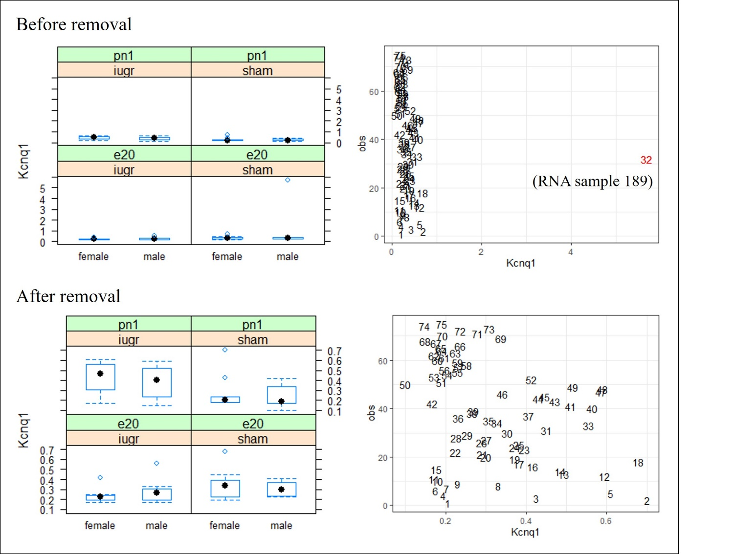
Fig S1.1. Example of outlier detection for the gene expression data (Kcnq1 gene in the F1 generation) using bw plots (left) and gg plots (right) in RStudio software. Values beyond ± 3 standard deviations from the mean were indicated as an outlier and is shown in red. This outlier was removed for the statistical analysis for this gene.

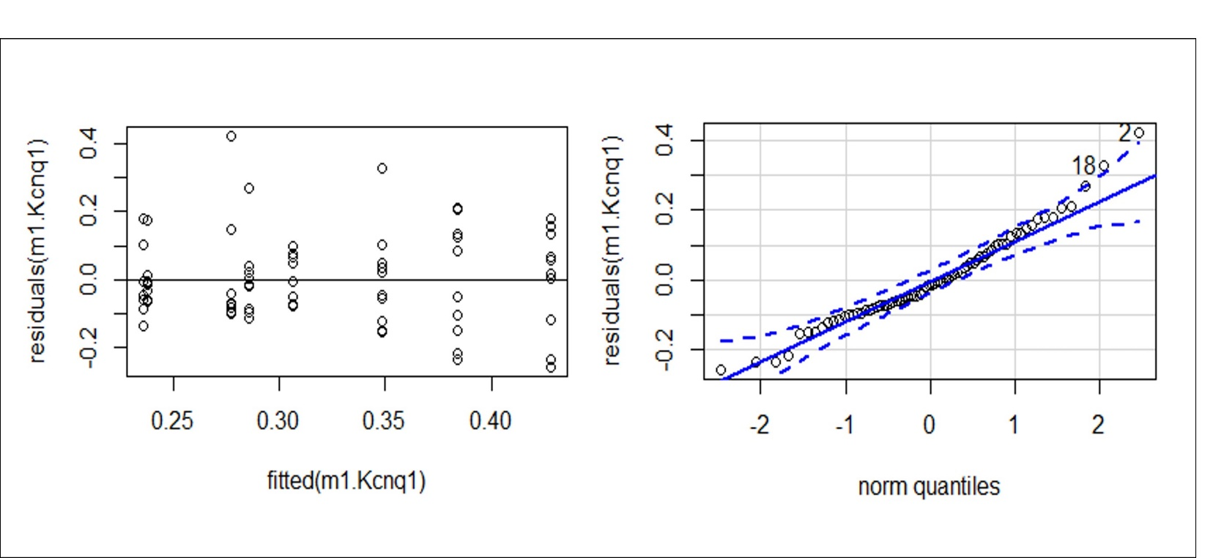
Fig S1.2. Example of homoscedasticity assessment for the gene expression data (Kcnq1 gene in the F1 generation) using residuals versus fits plot (top) and qq plot (bottom) in RStudio software. The data was confirmed to have a normal distribution as datapoints were normally and equally spread in the residuals versus fits plot and fall close to the reference line within the qq plot.

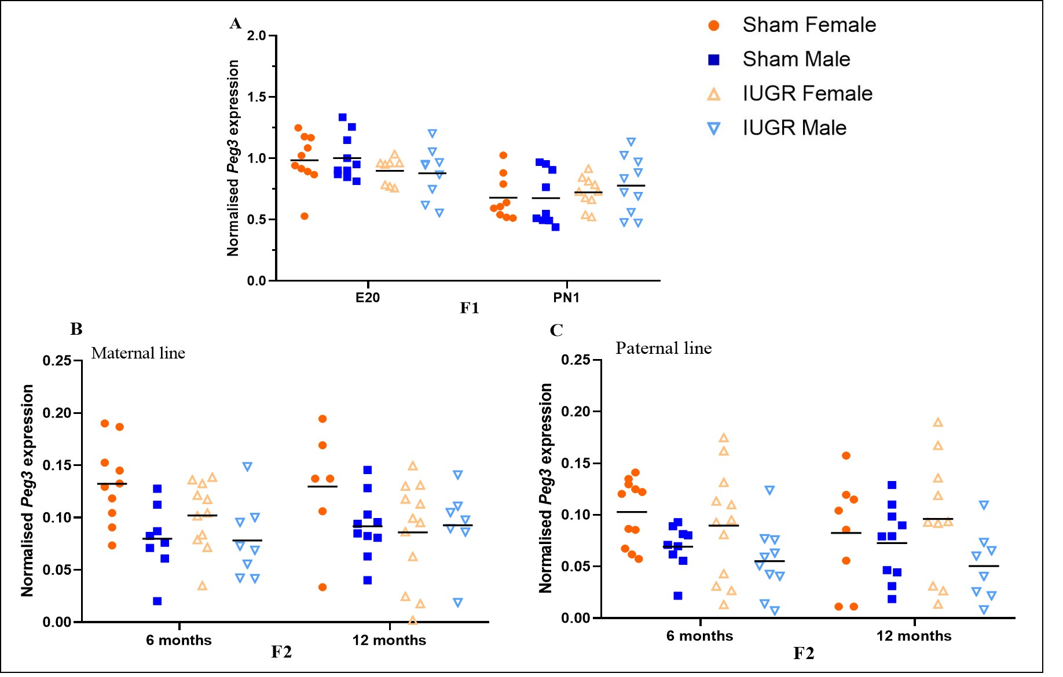
Fig S2. Normalised expression of Peg3 in kidney tissues of sham and IUGR rat offspring in first (F1; A) and second (F2; B, C) generations. The mean value within each group is indicated by a black line. Significance was determined by a Tukeys post-hoc test following Linear mixed effect models in each generation and parental line (n = 6 – 13 samples per group).
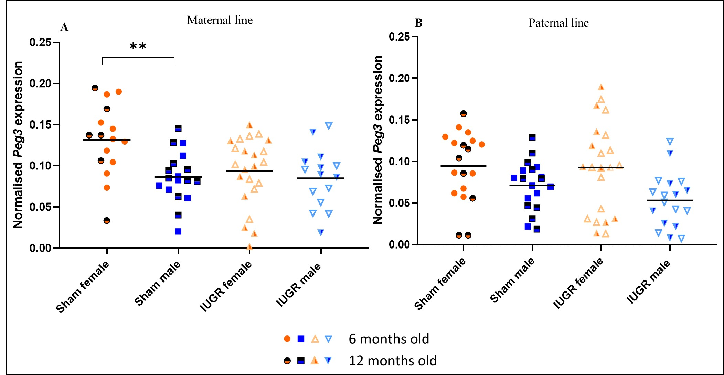
Fig S3. Normalised expression of Peg3 in kidney tissues of sham and IUGR rat offspring in F2 maternal (A) and paternal (B) lines. The mean value within each group is indicated by a black line. Significance was determined by a Tukeys post-hoc test following Linear mixed effect models in each generation and parental line (** p < 0.01; n = 6 – 13 samples per group).

