Supplementary files
P2: Figure S1: Flow-chart inclusion
P3: Table S1: Food intake by quintile of the Lifelines Diet Score
P4: Figure S2: Overweight incidence and remission
P5: Table S2: Linear regression LLDS vs. BMI-z, stratified by gender
P6: Table S3: Linear regression sensitivity analysis LLDS components

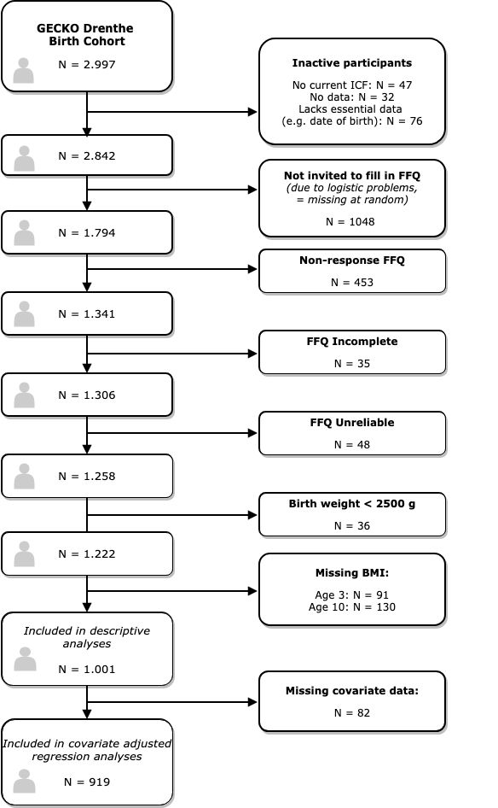
Figure S1: Flow-chart inclusion.

 |  |  | Quintile of LLDS
 | Total | 1 |  | 2 | 3 | 4 | 5
LLDS-scoreª | 21 [4-41] | 13 [4-15] |  | 18 [16-19] | 21 [20-22] | 24 [23-26] | 29 [27-41]
Energy intake (kcal)^{b} | 1387 ± 293 | 1447 ± 325 |  | 1413 ± 299 | 1389 ± 290 | 1362 ± 282 | 1329 ± 257
Positive components
Vegetables | 42 [25-62] | 31 [20-46] |  | 37 [22-51] | 42 [23-58] | 46 [30-65] | 58 [41-83]
Fruit | 113 [79-172] | 82 [48-112] |  | 112 [77-120] | 113 [82-169] | 121 [111-223] | 167 [112-224]
Whole grain products | 39 [3-69] | 1 [0-33] |  | 23 [1-60] | 41 [4-69] | 50 [12-74] | 65 [42-98]
Legumes & Nuts | 6 [1-14] | 2 [0-6] |  | 5 [0-10] | 7 [1-15] | 9 [4-16] | 11 [5-21]
Fish | 4 [2-9] | 3 [0-5] |  | 4 [0-7] | 4 [2-9] | 5 [2-11] | 7 [4-11]
Oils & soft margarines | 13 [7-17] | 9 [3-14] |  | 12 [5-16] | 12 [7-17] | 13 [11-18] | 16 [12-19]
Unsweetened dairy | 186 [59-333] | 80 [13-201] |  | 139 [38-288] | 214 [66-332] | 211 [96-369] | 284 [167-389]
Tea | 0 [0-54] | 0 [0-0] |  | 0 [0-18] | 0 [0-43] | 5 [0-71] | 39 [0-129]
Negative components
Red & processed meat | 43 [29-58] | 55 [42-78] |  | 47 [32-64] | 45 [29-57] | 40 [28-51] | 32 [23-46]
Butter, hard margarines | 5 [1-11] | 9 [3-16] |  | 6 [3-11] | 6 [1-11] | 3 [1-6] | 3 [0-6]
Sugar-sweetened beverages | 135 [72-238] | 244 [156-399] |  | 168 [105-295] | 136 [71-230] | 111 [61-172] | 73 [44-113]
ª Median score + Full Range
^{b} Mean + SD
Table S1: Median intake [25th – 75th percentile] in grams per day for each food group,
stratified by quintile of the Lifelines Diet Score.

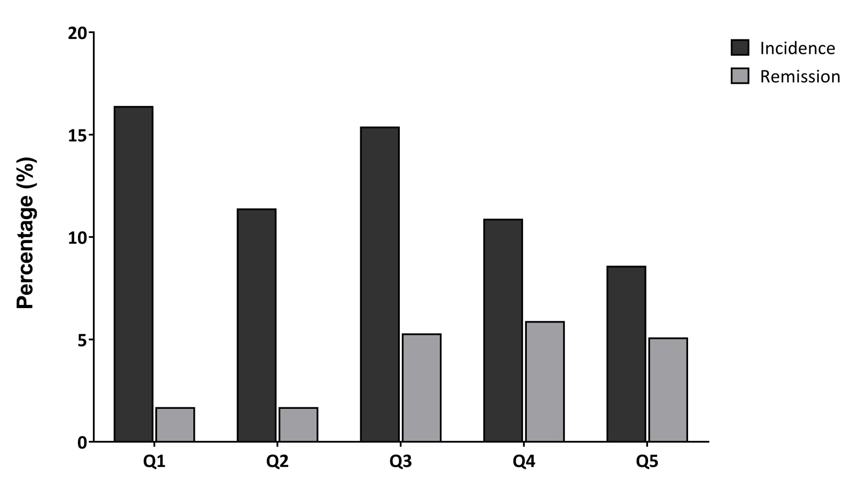
Figure S2: Overweight incidence and remission between age three and 10, in different quintiles of the Lifelines Diet Score.

Table S2: Linear regression analyses to investigate the association between LLDS in quintiles and change in BMI-z between age three and ten, stratified by sex. β for estimated difference in change in BMI-z corresponding to an increase in 1 quintile of the LLDS , N_{boys}=468, N_{girls}=451.
 | β | 95% CI | p-value
Boys
Crude | -.071 | -.126 ; -.015 | .012
1A | -.070 | -.126 ; -.015 | .013
1B | -.060 | -.113 ; -.007 | .028
1C | -.058 | -.112 ; -.005 | .033
2 | -.041 | -.093 ; .011 | .122
Girls
Crude | -.074 | -.129 ; -.018 | .010
1A | -.065 | -.121 ; -.009 | .022
1B | -.066 | -.118 ; -.013 | .014
1C | -.071 | -.124 ; -.018 | .008
2 | -.044 | -.094 ; .006 | .084
Crude) LLDS (in quintiles)
Model 1A) crude + birth weight, gestational age, breastfeeding at 1 month
Model 1B) 1A + BMI z-score at age three
Model 2) 1B + BMI father, BMI mother, smoking during pregnancy, age mother, education level mother

Table S3: Linear regression analyses to investigate the association between LLDS in quintiles, leaving out one food group at the time, and change in BMI-z between age three and ten. β for estimated difference in change in BMI-z corresponding to an increase in 1 quintile of the LLDS , N=919. Scores ranked on degree of attenuation in final model 2.
 | Model 1C |  |  |  | Model 2
 | β | 95% CI | P-value | % attenuation | β | 95% CI | P-value | % attenuation
Total LLDS | -.064 | -.101 ; -.026 | .001 | 0 (REF) | -.043 | -.079 ; -.007 | .019 | 0 (REF)
LLDS w/o Dairy | -.046 | -.083 ; -.009 | .014 | 28.1 % | -.028 | -.063 ; .008 | .125 | 34.9 %
LLDS w/o Whole grain | -.056 | -.093 ; -.019 | .003 | 12.5 % | -.034 | -.070 ; .001 | .056 | 20.9 %
LLDS w/o Fruit | -.057 | -.093 ; -.020 | .002 | 10.9 % | -.037 | -.071 ; -.002 | .038 | 14.0 %
LLDS w/o Meat | -.058 | -.094 ; -.021 | .002 | 9.4 % | -.043 | -.078 ; -.008 | .015 | 0 %
LLDS w/o Oils | -.060 | -.097 ; -.023 | .001 | 6.3 % | -.036 | -.071 ; -.001 | .043 | 16.3 %
LLDS w/o Tea | -.060 | -.097 ; -.023 | .002 | 6.3 % | -.040 | -.075 ; -.004 | .029 | 7.0 %
LLDS w/o Vegetables | -.063 | -.100 ; -.026 | .001 | 1.6% | -.045 | -.080 ; -.010 | .012 | +4.7 %
LLDS w/o Fish | -.064 | -.101 ; -.027 | .001 | 0 % | -.045 | -.080 ; -.009 | .013 | +4.7 %
LLDS w/o butter | -.066 | -.103 ; -.030 | .001 | +3.1 % | -.044 | -.079 ; -.010 | .013 | +2.3 %
LLDS w/o SSB | -.066 | -.103 ; -.028 | .001 | +3.1 % | -.045 | -.081 ; -.009 | .014 | +4.7 %
LLDS w/o Legumes&Nuts | -.067 | -.104 ; -.030 | <.001 | + 4.7 % | -.048 | -.083 ; -.013 | .008 | +11.6 %
LLDS (in quintiles) vs. BMI change, adjusted for birth weight, sex, gestational age, breastfeeding at 1 month, BMI z-score at age three and total energy intake (Model 1C), and additionally adjusted for BMI father, BMI mother, smoking during pregnancy, age mother and education level mother in Model 2.

Table S4: Baseline characteristics of participants included in the study vs. those who dropped out between age 3 and 10, and for whom outcome data was therefore not available.
Child characteristics | Included (N=1001) | Lost to follow-up (N=130)
Sex, n(%)  Boy  Girl | 508 (50.7)  493 (49.3) | 78 (60.0)  52 (40.0)
Birth weight (gram) | 3605 ± 494 | 3574 ± 525
Gestational age (weeks) | 39.9 ± 1.4 | 39.9 ± 1.7
Breastfeeding at 1 month, n(%) | 651 (65.8) | 62 (49.2)
BMI z-score age three (SD) | 0.10 ± 0.89 | 0.05 ± 1.03
Overweight age three, n (%) | 83 (8.3) | 15 (11.5)
Energy Intake (kcal/day)  Boy  Girl | 1387 ± 293  1430 ± 293  1342 ± 289 | 1395 ± 272  1402 ± 278  1383 ± 264
Lifelines Diet Score | 21.2 ± 6.1 | 20.8 ± 6.6
Parental characteristics
Maternal age at birth (years) | 31.2 ± 4.1 | 31.0 ± 4.5
Paternal age at birth (years) | 33.8 ± 4.6 | 33.2 ± 5.4
Maternal BMI before pregnancy (kg/m²) | 24.8 ± 4.8 | 25.4 ± 4.7
Paternal BMI before pregnancy (kg/m²) | 25.4 ± 3.2 | 26.0 ± 4.0
Maternal education level, n(%)  Low  Middle  High | 248 (24.9)  337 (33.9)  409 (41.1) | 54 (43.2)  38 (30.4)  33 (26.4)
Smoking during pregnancy, n(%) | 100 (10.1) | 14 (11.1)

