Dyslipidemia, Insulin Resistance, and Impairment of Placental Metabolism in the Offspring of Obese Mothers
Matthew Bucher^{1, 2}, Kim Ramil C. Montaniel^{1, 3}, Leslie Myatt², Susan Weintraub⁴, Hagai Tavori¹, and Alina Maloyan^{1,3*}

¹Knight Cardiovascular Institute, Oregon Health & Science University, Portland, OR, 97239
²Department of OB/GYN, Oregon Health & Science University, Portland, OR, 97239
³Chemical Physiology and Biochemistry Graduate Program, Oregon Health & Science University, Portland, OR, 97239
⁴The Metabolomics Core Facility, Institutional Mass Spectrometry Laboratory, University of Texas Health, San Antonio, Texas, 78229.

Running Title: Maternal obesity, and placental and fetal metabolism
Keywords: maternal obesity, lipid profile, placental function, metabolomics, insulin resistance.

Corresponding author: Alina Maloyan, Knight Cardiovascular Institute, Oregon Health & Science University, 3181 SW Sam Jackson Park Rd, Portland, Oregon, 97239.
Email: maloyan@ohsu.edu; phone: 503-346-1115

Supplemental Data
Table S1.
 | Maternal blood (n=33) |  |  |  |  |  | Cord Blood (n=26)
 | NW |  |  | OB |  |  | NW |  |  | OB
 |  | M | F |  | M | F |  | M | F |  | M | F
Plasma Insulin  (µIU/mL) |  | 9.59  (1.94-43.46) | 13.9  (2.45-21.29) |  | 17.27  (1.8-38.17) | 12.6  (7.09-16.40) |  | 6.34  (3.32-10.45) | 6.38  (2.45-9.69) |  | 10.2*  (3.03-12.87) | 12.52*  (1.24-5.32)
Blood Glucose  (mg/dL) |  | 78  (44-94) | 85  (49-92) |  | 79  (68-99) | 65  (45-88) |  | 90.5  (69-93) | 99.5  (77-105) |  | 72.0  (38-110) | 91.00  (58-115)
HOMA-IR |  | 1.72  (0.21-8.37) | 2.16  (0.29-4.57) |  | 3.38  (0.44-7.26) | 1.97  (0.99-3.46) |  | 1.32  (0.75-1.94) | 1.36  (0.5-2.54) |  | 2.00^  (0.82-2.83) | 3.06*  (1.24-5.32)

Table S1. Plasma Insulin, Glucose, and Homeostasis Model Assessment of Insulin Resistance (HOMA-IR) values for maternal and cord blood samples from NW and OB women separated by fetal sex. Data are presented as median (range). *, p<0.05, and ^, p<0.1 NW vs. OB

Table S2.
 | Maternal blood (n=33) |  |  |  |  |  | Cord Blood (n=26)
 | NW |  |  | OB |  |  | NW |  |  | OB
 |  | M | F |  | M | F |  | M | F |  | M | F
TC  (mg/dL) |  | 253  (223-304) | 252  (197-329) |  | 218^  (149-282) | 230  (174-256) |  | 58  (48-65) | 60  (49-70) |  | 49^  (33-67) | 50  (45-68)
HDLcalc  (mg/dL) |  | 69  (28-101) | 70  (52-96) |  | 54  (29-77) | 68  (50-92) |  | 25  (19-29) | 27  (20-34) |  | 17*  (13-31) | 22*  (17-29)
LDL-calc  (mg/dL) |  | 146  (90-210) | 136  (101-189) |  | 131^  (75-184) | 109^  (86-156) |  | 28  (22-32) | 25  (24-32) |  | 25  (17-36) | 23  (19-33)
TRIG  (mg/dL) |  | 207  (140-538) | 229  (120-403) |  | 218  (149-282) | 192  (148-382) |  | 21  (16-37) | 21  (18-33) |  | 22  (16-56) | 28  (24-31)

Table S2. Lipid analysis data separated by fetal sex. TC, total cholesterol; HDL-c, High- density lipoprotein cholesterol; LDL-c, Low-density lipoprotein cholesterol; TG, triglycerides. Data are presented as median (range). *, p<0.05; ^ p<0.1 NW vs. OB.

Figure S1.
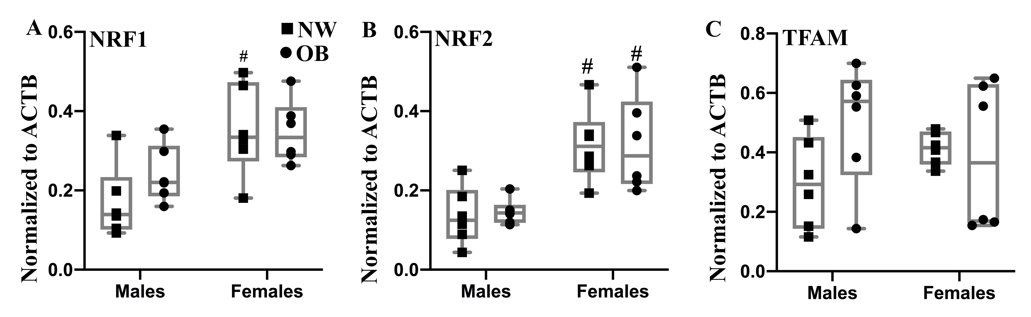

Figure S1. Placental expression of PGC-1a target genes NRF1 (A), NRF2 (B), and TFAM (C) measured by western blot and normalized to the expression of ACTB. N=6/group/sex. #, p<0.05 females vs. males within the same group of maternal adiposity.

