Search Strategy Prepared for Medline and adapted for other search engines

1# “birth, preterm”[MESH] OR Premature Birth [MESH]
2# “Preterm birth” [tiab] OR "premature birth"[tiab] OR prematurity[tiab] OR “pre-term birth”[tiab]
3# 1# OR 2#
4# offspring [tiab] OR newborn[tiab] OR baby[tiab] OR babies[tiab] OR children[tiab] OR infant[tiab] OR neonat*[tiab] OR adolescen*[tiab] OR adult[tiab]
5# 3# AND 4#
5# “Diabetes, Gestational”[MESH] OR “Blood Pressure”[MESH] OR “hypertension”[MESH] OR “cholesterol”[MESH] OR “lipids”[MESH] OR “triglyceride”[MESH] OR “body mass index”[MESH] OR “insulin”[MESH] OR “glucose”[MESH]
6# “blood pressure” OR diabetes OR cardiovascular OR metabolic OR hypertension OR BMI or “body mass index” OR obesity OR overweight OR lipids OR lipid OR cholesterol OR triglyceride* OR glucose OR insulin OR vascular
7# 5# AND 6#
8# 3# AND 5# AND 7#
9# 8# AND humans[limit]

Supplementary Figure 1 Mean difference in body mass index (BMI) between those born preterm and term
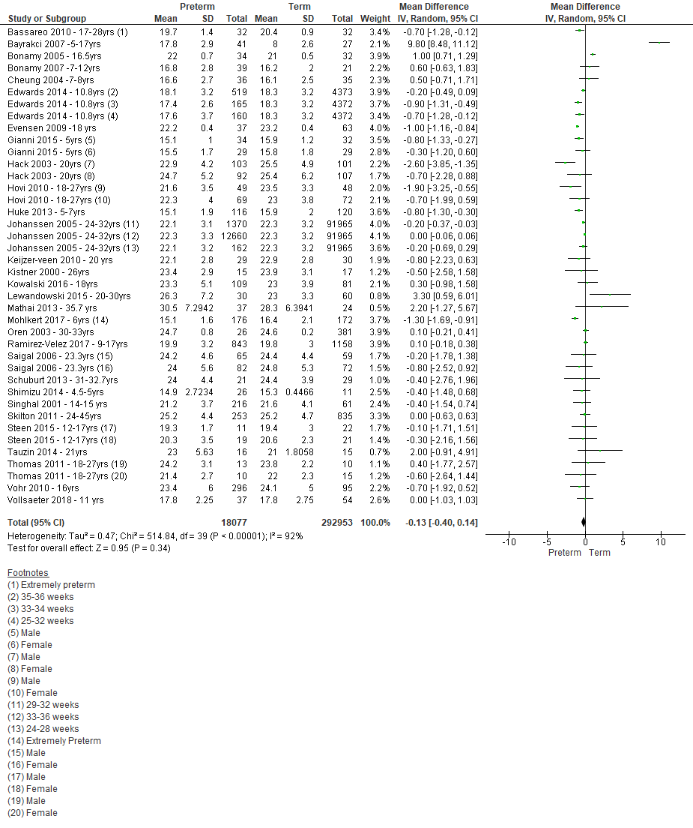

Body mass index (BMI) in kg/m2; IV, inverse variance

Supplementary Figure 2 Mean difference in total cholesterol between those born preterm and term

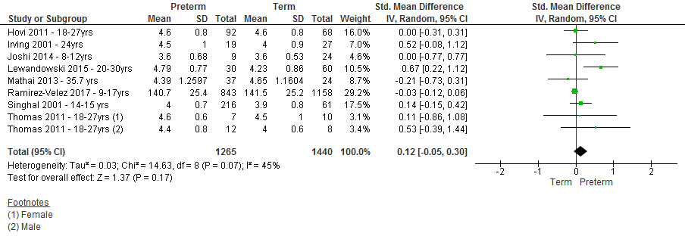

IV, inverse variance

Supplementary Figure 3 Mean difference in LDL cholesterol between those born preterm and term

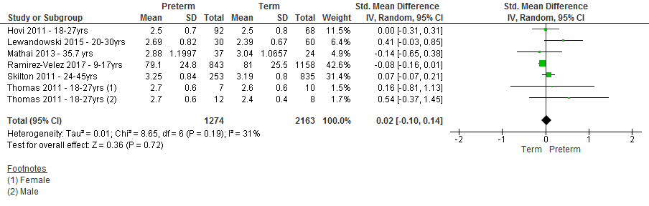
IV, inverse variance

Supplementary Figure 4 Mean difference in HDL cholesterol between those born preterm and term

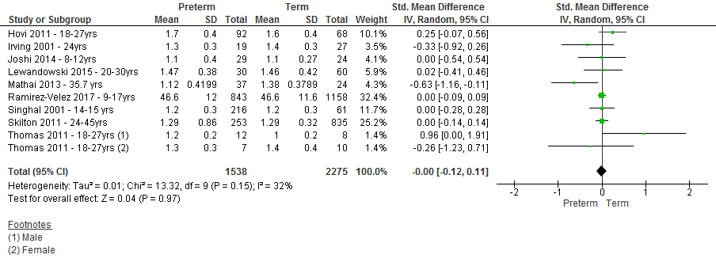

IV, inverse variance

Supplementary Figure 5 Mean difference triglycerides between those born preterm and term

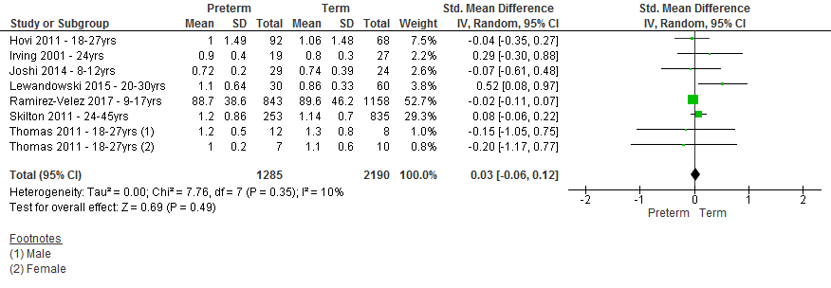

IV, inverse variance

Supplementary Figure 6 Mean difference fasting blood glucose between those born preterm and term

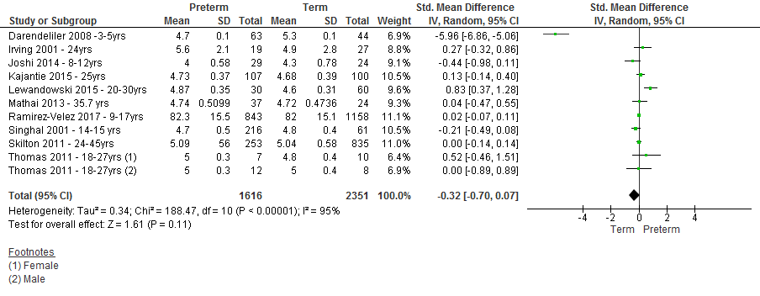
IV, inverse variance

Supplementary Figure 7 Mean difference fasting insulin between those born preterm and term

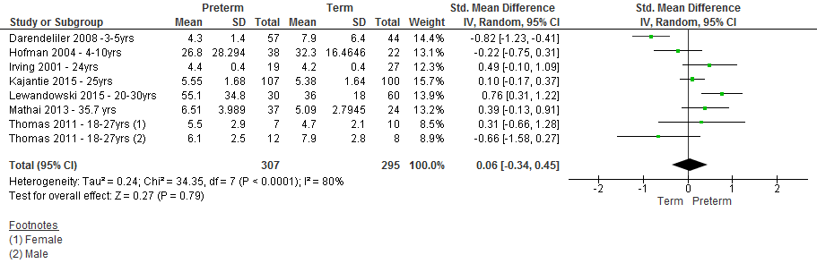

IV, inverse variance

Supplementary Figure 8: Funnel plot for systolic blood pressure

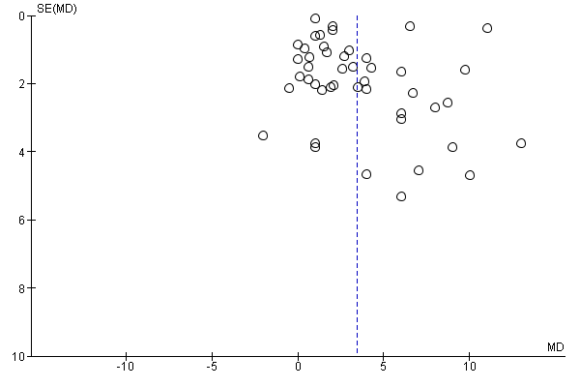

Supplementary Figure 9: Funnel plot for diastolic blood pressure

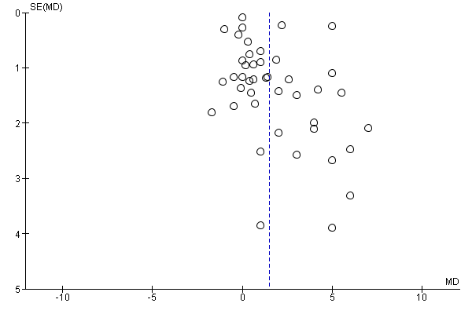

Supplementary Figure 10: Funnel plot for body mass index

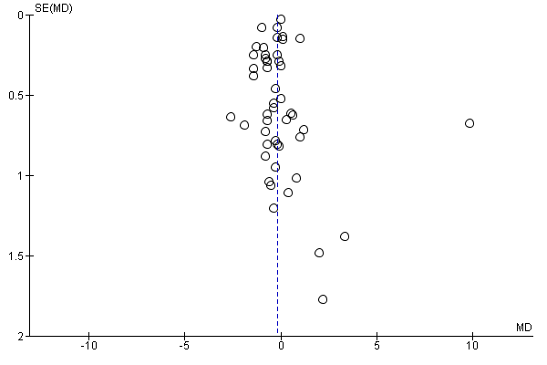

Supplementary Figure 11: Funnel plot for fasting blood glucose

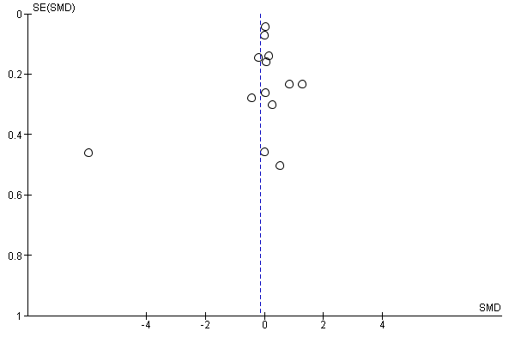

Supplementary figure 12: Mean difference in systolic blood pressure between those born preterm and term (after excluding studies reporting results with large standard deviations)
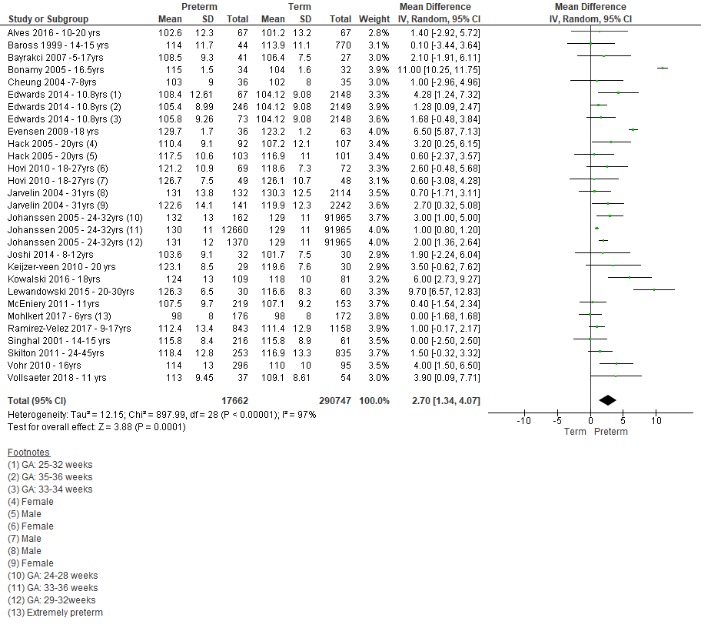

Supplementary figure 13: Funnel plot for systolic blood pressure (after excluding studies reporting results with large standard deviations)

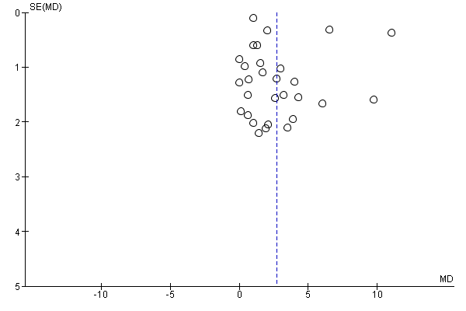
Supplementary figure 14: Mean difference in diastolic blood pressure between those born preterm and term (after excluding studies reporting results with large standard deviations)

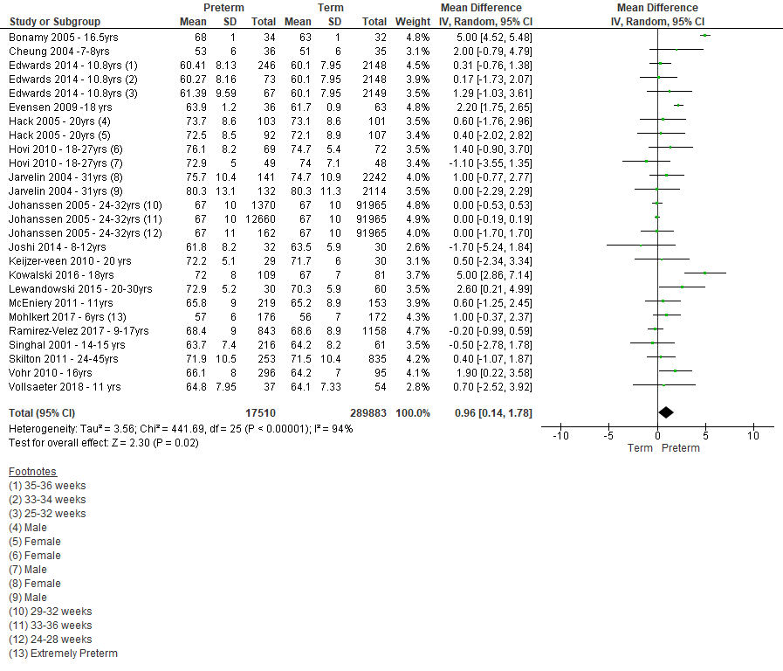

Supplementary figure 15: Funnel plot for diastolic blood pressure (after excluding studies reporting results with large standard deviations)

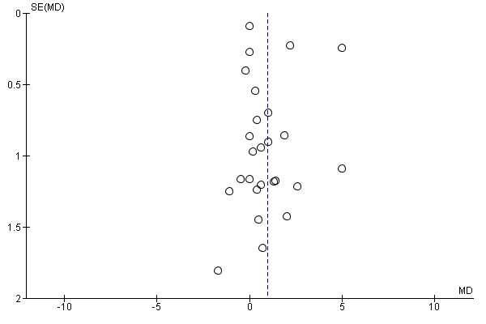

Supplementary Table 1: Risk factors reported in studies not included in the meta-analyses

Risk factor and study | Results
SBP (mmHg)
Chan et al. 2010 | Term AGA - Median 103 (IQR 103-105)
 | Preterm AGA - Median 101 (IQR 101-107.5)
Cooper et al. 2009 | A reduction in SBP of 0.53mmHg (95% CI: 0.32, 0.75) for every 1-week increase in gestational age after adjusting for confounders
Hovi et al. 2016 | 3.4 mm Hg (95% confidence interval, 2.2–4.6) higher SBP among those born preterm compared to term after adjusting for confounders
Lee et al. 2014 | Increased compared to reference values; females 119±8, z score 1.23; males 118±11, z score 1.14 mm Hg)
DBP (mmHg)
Chan et al. 2010 | Term AGA - Median 60 (IQR 60-65)
 | Preterm AGA - Median 61 (IQR 60-70)
Cooper et al. 2009 | Those born < 37 weeks had 2.59 (1.19, 3.99) compared to those born at 40 weeks after adjusting for confounders
Hovi et al. 2016 | 2.1 mmHg (95% confidence interval, 1.3 - 3.0) higher DBP among those born preterm compared to term after adjusting for confounders
BMI (kg/m2)
Alves et al. 2016 | Obesity (BMI>97th percentile) among 13.4% of preterm compared to 11.9% of term
Darendeliler et al. 2008 | BMI SDS -0.5 ± 0.2 in preterm compared to 0.1 ± 0.2 in term
Hui et al. 2015 | Late preterm birth was not associated with BMI at age 14 years after adjusting for confounders
Morsing et al. 2014 | BMI SDS 0.2 ± 1.4 in preterm compared to 0.5 ± 1.1 in term
Crump el al. 2020 | Overweight (BMI 25.0 -29.9) term: 6.2%, very preterm:5.2%, extremely preterm:5.2%; Obese (BMI>30.0) term:1.5%, very preterm:1.8%, extremely preterm:2.2%
Total cholesterol
Alves et al. 2016 | 145mg/dl in preterm vs 145.2mg/dl in term, p = 0.95
Cooper et al. 2009 | A reduction of 0.02mmol/l for every 1-week increase in gestational age after adjusting for confounders in women
LDL
Alves et al. 2016 | 86.9 mg/dl in preterm vs 85.2 mg/dl in term, p = 0.43
Cooper et al. 2009 | No association
HDL
Alves et al. 2016 | 42.7 mg/dl in preterm vs 44.9 mg/dl in term, p = 0.23
Cooper et al. 2009 | No association
TG
Alves et al. 2016 | 75.1 mg/dl in preterm vs 73.2 mg/dl in term, p = 0.61
Cooper et al. 2009 | No association
Glocose
Alves et al. 2016 | 79.0 mg/dl in preterm vs 82.4 mg/dl in term, p = 0.37
Insulin
Hofman et al.2004 | 26pmol/l (95% CI 17.5-41.0) in preterm vs 32.3pmol/l (25.0-41.7) in term, NS

Supplementary table 2: Quality assessment of included studies

Study | Selection |  |  |  | Comparability | Exposure |  |  | Total Score
 | 1 | 2 | 3 | 4 | 1 | 1 | 2 | 3
Alves et al 2016 | a* | a* | b | a* | a+b** | a* | a* | c | 6 out of 8
Baross et al 1999 | a* | a* | b | a* | a+b** | a* | a* | c | 6 out of 8
Bassareo et al 2010 | a* | a* | b | a* | a* | a* | a* | c | 6 out of 8
Bayrakci et al 2007 | a* | a* | b | a* | a+b** | a* | a* | c | 6 out of 8
Bonamy et al 2005 | a* | a* | b | a* | a+b** | a* | a* | b | 6 out of 8
Bonamy et al 2007 | a* | a* | b | b | a+b** | a* | a* | b | 6 out of 8
Chan et al 2010 | a* | a* | b | b | a+b** | a* | a* | c | 6 out of 8
Cheung et al 2004 | a* | a* | a* | a* | a+b** | a* | a* | b | 6 out of 8
Cohen et al 2007 | a* | a* | b | a* | a+b** | a* | a* | c | 6 out of 8
Cooper et al 2009 | a* | a* | a* | a* | a+b** | a* | a* | b | 6 out of 8
Dalziel et al 2007 | a* | a* | b | a* | a+b** | a* | a* | b | 6 out of 8
Mathai et al 2013 | a* | a* | b | a* | a+b** | a* | a* | c | 6 out of 8
Darendeliler et al 2008 | a* | a* | b | a* | a+b** | a* | a* | c | 6 out of 8
Doyle et al 2003 | a* | a* | b | a* | a+b** | a* | a* | c | 6 out of 8
Edwards et al 2014 | a* | a* | b | a* | a+b** | a* | a* | c | 6 out of 8
Evensen et al 2009 | a* | a* | b | a* | a+b** | a* | a* | c | 6 out of 8
Farooqi et al 2006 | a* | a* | b | a* | a* | a* | a* | c | 6 out of 8
Fewtreil et al 2004 | c | a* | b | a* | a* | a* | a* | c | 5 out of 8
Lewandowski et al 2011 | c | a* | b | a* | a* | a* | a* | c | 5 out of 8
Singhal et al 2001 | c | a* | b | a* | a+b** | a* | a* | c | 6 out of 8
Singhal et al 2003 | a* | a* | a* | a* | a* | a* | a* | c | 7 out of 8
Gianni et al 2015 | a* | a* | b | a* | a* | a* | a* | c | 6 out of 8
Goldani et al 2007 | a* | a* | b | a* | a* | a* | a* | c | 6 out of 8
Gunay et al 2014 | a* | a* | b | a* | a+b** | a* | a* | c | 6 out of 8
Hack et al 2003 | a* | a* | b | a* | a* | a* | a* | c | 6 out of 8
Hack et al 2005 | a* | a* | b | a* | a+b** | a* | a* | c | 6 out of 8
Hofman et al 2004 | a* | a* | b | a* | a+b** | a* | a* | c | 6 out of 8
Hovi et al 2007 | a* | a* | b | a* | a+b** | a* | a* | c | 6 out of 8
Hovi et al 2010 | a* | a* | b | a* | a+b** | a* | a* | c | 6 out of 8
Hovi et al 2011 | a* | a* | b | a* | a+b** | a* | a* | b | 6 out of 8
Kajantie et al 2015 | a* | a* | b | a* | a* | a* | a* | c | 6 out of 8
Hovi et al 2016 | a* | a* | b | a* | a+b** | a* | a* | c | 6 out of 8
Hui et al 2015 | a* | a* | b | a* | a* | a* | a* | b | 6 out of 8
Huke et al 2013 | a* | a* | a* | a* | a* | a* | a* | c | 7 out of 8
Irving et al 2000 | a* | a* | b | a* | a+b** | a* | a* | c | 6 out of 8
Jarvelin et al 2004 | a* | a* | b | a* | a+b** | a* | b | c | 5 out of 8
Johanssen et al 2005 | a* | a* | b | a* | a+b** | a* | a* | c | 6 out of 8
Joshi et al 2014 | a* | a* | a* | a* | a+b** | a* | a* | c | 7 out of 8
Kaijser et al 2009 | a* | a* | b | b | a+b** | a* | a* | c | 5 out of 8
Keizer-Veen et al 2010 | a* | a* | b | a* | a+b** | a* | a* | b | 6 out of 8
Rotteveel et al 2008 | a* | a* | b | a* | a+b** | e | a* | c | 5 out of 8
Rotteveel et al 2011 | a* | a* | b | b | a+b** | a* | a* | c | 5 out of 8
Kistner et al 2000 | a* | a* | b | a* | a+b** | a* | a* | c | 6 out of 8
Kistner et al 2004 | a* | a* | b | a* | a+b** | a* | a* | c | 6 out of 8
Kowalski et al 2016 | a* | a* | b | a* | a+b** | a* | a* | c | 6 out of 8
Kwinta et al 2011 | a* | a* | b | a* | a+b** | a* | a* | c | 6 out of 8
Lee et al 2014 | c | a* | b | a* | a+b** | a+b** | a* | b | 4 out of 8
Lewandowski et al 2015 | c | a* | c | a* | a+b** | a* | a* | c | 5 out of 8
Lazdam et al 2010 | a* | a* | b | b | a+b** | a | a* | c | 4 out of 8
McEinery et al 2011 | a* | a* | b | a* | a+b** | a* | a* | b | 6 out of 8
Bolton et al 2012 | a* | a* | b | a* | a+b** | a* | a* | b | 7 out of 8
Bracewell et al 2008 | a* | a* | b | a* | a+b** | a* | a* | b | 6 out of 8
Mikkola et al 2007 | a* | a* | a* | b | a* | a* | a* | c | 6 out of 8
Mohlkert et al 2017 | a* | a* | b | b | a+b** | a* | a* | c | 6 out of 8
Bonamy et al 2012 | a* | b | a* | b | a+b** | a* | a* | b | 5 out of 8
Morsing et al 2014 | a* | a* | b | b | a+b** | a* | a* | b | 5 out of 8
Oren et al 2003 | b | a* | c | b | a* | a* | b | c | 3 out of 8
Pilgaard et al 2010 | a* | a* | a* | b | a+b** | a* | a* | c | 6 out of 8
Ramirez-Velez et al 2017 | a* | a* | c | b | a+b** | a* | a* | c | 5 out of 8
Rossi et al 2011 | a* | a* | a* | a* | a+b** | a* | a* | b | 7 out of 8
Tauzin et al 2014 | a* | a* | a* | a* | a+b** | a* | a* | c | 7 out of 8
Saigal et al 2006 | b | a* | a* | b | a+b** | a* | a* | c | 5 out of 8
Schubert et al 2013 | a* | a* | b | b | a+b** | a* | a* | c | 5 out of 8
Shimizu et al 2014 | a* | b | a* | b | a* | a* | a* | c | 5 out of 8
Sipola-Leppanen et al 2014 | a* | a* | a* | b | a+b** | a* | a* | c | 6 out of 8
Sipola-Leppanen et al 2014 | a* | a* | a* | b | a+b** | a* | a* | c | 6 out of 8
Skilton et al 2011 | a* | a* | a* | a* | a+b** | a* | a* | c | 7 out of 8
Hussain et al 2015 | a* | a* | a* | b | a+b** | a* | a* | c | 6 out of 8
Juonala et al 2015 | a* | a* | a* | b | a+b** | a* | a* | c | 6 out of 8
Steen et al 2015 | c | a* | a* | b | a+b** | a* | a* | b | 5 out of 8
Thomas et al 2011 | a* | a* | c | b | a+b** | a* | b | c | 4 out of 8
Toumba et al 2005 | a* | b | b | b | a* | a* | a* | c | 4 out of 8
Vohr et al 2010 | c | a* | a* | b | a+b** | a* | a* | c | 5 out of 8
Willemsen et al 2009 | a* | a* | a* | a* | a+b** | a* | a* | c | 7 out of 8
Vollsaeter et al 2018 | c | a* | a* | b | a+b** | a* | a* | b | 5 out of 8

