Supplementary table 1 Results of studies not included in the meta analyses
Study | Results in GDM group | Results in control group | P
SBP (mmHg)
Krishnaveni 2010☨ | 5 years (Girls): Mean (99.0) SD (8.2) | 5 years (Girls): Mean (95.0) SD (8.1) | 0.08
 | 5 years (Boys): Mean (95.4) SD (9.4) | 5 years (Boys): 97.2 SD (8.9) | 0.1
 | 9.5 years (Girls): Mean (103.8) SD (8.0) | 9.5 years (Girls): Girls: Mean (99.4) SD (8.5) | 0.02
 | 9.5 years (Boys): Mean (106) SD (12) | 9.5 years (Boys): Mean (101.9) SD (8.9) | 0.2
Lee 2007 | Mean (93.3) SD (9.3) | IGT: Mean (92.3) SD (8.7) | NS
Page 2013⁘ Ω | Mean (105.0) SEM (10.0) | Mean (100.0) SEM (10.0) | 0.15
Tam 2008☨ | Mean (94) SD (9.5) | Mean (88) SD (8.9) | <0.001
Tam 2017Ω | Mean (104) SD (8.7) | Mean (102) SD (8.9) | 0.01
Tsadok 2011 Ω | Mean (121.56) SD (12.30) | Mean (119.84) SD (12.06) | <0.05
Vaarasmaki 2009 | Median 117 IQR (111–125) | Median 115 IQR (106–123) | NS
DBP (mmHg)
Krishnaveni 2010☨ | Girls: Mean (59.8) SD (4.8) | Girls: Mean (57.9) SD (6.6) | 0.09
 | Boys: Mean (60.3) SD (7.6) | Boys: Mean (58.6) SD (6.9) | 0.4
Lee 2007 | Mean (59.6) SD (8.5) | IGT: Mean (59.0) SD (7.5) | NS
Page 2013⁘ Ω | Mean (60) SEM (6) | Mean (60) SEM (9) | 0.62
Tam 2008☨ | Mean (62) SD (6.3) | Mean (57) SD (6.0) | <0.001
Tam 2017 Ω | Mean (63) SD (8.1) | Mean (62) SD (7.9) | 0.06
Tsadok 2011 Ω | Mean (75.12) SD (7.44) | Mean (73.47) SD (8.30) | <0.05
Vaarasmaki 2009 | Median (68) IQR (65-73) | 67 (62-72) | NS
BMI (kg/m2)
Baptise-Roberts 2012# | Age 3: Mean (15.5) SD (1.65) | Age 3: Mean (15.4) SD (3.0) | 0.721
 | Age 4 Mean (15.67) SD (1.91) | Age 4: Mean (15.36) SD (3.54) | 0.31
 | Age 7: Mean (16.35) SD (2.57) | Age 7: Mean (15.64) SD (1.99) | <0.001
Krishnaveni 2005 * | 1 year: Mean (15.6) SD (1.7) | 1 year: Mean (15.7) SD (1.4) | 0.9
 | 5 years: (14.0) SD (1.2) | 5 years: Mean (13.6) SD (1.2) | 0.03
Krishnaveni 2010 * | Girls: Median (16.4) IQR (14.8-17.8) | Girls: 14.3 (13.13-15.4) | <0.001
 | Boys: Median (15.2) IQR (13.8-16.6) | Boys: Median (14.2) IQR (13.4-15.4) | 0.07
Lee 2007 | Mean (16.1) SD (1.9) | IGT: Mean (16.1) SD (1.7) | NS
Nehring 2013 Ω | Mean (16.1) 95% CI (15.8-16.4) | Mean (15.5) 95% CI (15.5-15.5) | NS
Nielsen Ω | Mean (26.2) SD (5.6) | Mean (23.3) SD (4) | NR
Page 2012⁘ Ω | Mean (20.8) SD (1.3) | Mean (16.1) SD (1.4) | 0.004
Pirokla 2010 | Normal weight: Mean (24.3) 95% CI (23.4-25.1) | Control: Mean (23.7) 95% CI (23.6-23.8) | NR
 | Overweight: Mean (26.7) 95% CI (25.3-28.1)
Silverman 1998# | Mean (26.0) SD (5.5) | Mean (20.9) SD (3.4) | <0.001
Tam 2008☨ | Mean (16.2) SD (3.1) | Mean (16.2) SD (3.0) | 0.86
Tam 2017 Ω | Mean (15.3) SD (2.1) | Mean (15.0) SD (2.3) | 0.04
Tsadok 2011 Ω | Mean (22.47) SD (3.86) | Mean (21.18) SD (3.11) | <0.05
Vaarasmaki 2009 | Median (20.8) IQR (19.4-23.8) | Mean (20.2) (18.8-22.1) | NS
Vohr 1995 | AGA: Mean (12.5) SD (0.9) | AGA: Mean (12.6) SD (0.9) | NS
 | LGA: Mean (14.1) SD (1.2) | LGA: Mean (14.2) SD (1.0) | NS
Vohr 1999 | AGA: Mean (12.8) SD (1) | AGA: Mean (13.0) SD (1) | NS
 | LGA: Mean (14.7) SD (1) | LGA: Mean (14.8) SD (1) | NS
BMI percentiles (Centiles highlighted next to author name)
Boney 2005 (>85th) | LGA: 13/39 (33%) | LGA: 11/41 (27%) | NS
 | AGA: 7/49 (14%) | AGA: 9/41 (22%) | NS
Baptise-Roberts 2012 (>85th) | Age 3: Mean (15) SD (11.7) | Age 3: Mean (724) SD (7.0) | 0.041
 | Age 4: Mean (29) SD (21.2) | Age 4: Mean (1063) SD (9.0) | <0.001
 | Age 7: Mean (90) SD (23.3) | Age 7: Mean (2795) SD (12.6) | <0.001
Boerschmann 2010 (≥ 90th) | Pre-pregnancy BMI Overweight (BMI 25-29.9 kg/m²): 18/49  Pre-pregnancy BMI Obese (≥ BMI 30 kg/m²): 24/57 | 24/71 | NR
Chandler Laney 2012  (≥ 95th) | Normal weight: Mean (55.3) SEM (5.3) | Normal weight: Mean (49.1) SEM (4.0) | NS
 | Overweight: Mean (96.1) SEM (4.9) | Normal weight: Mean (94.2) SEM (6.2) | NS
Davis 2013 (≥85th) | Mean (97.3) SD (3.0) | Mean (97.3) SD (3.4) | NS
Gillman 2003(85th-95th) | Female: 35 (15.2%) | Female: 966 (13.1%) | NR
 | Male: 37 (19.5%) | Male: 951 (15.6%) | NR
Farfel 2013 (≥85th) | Female (15.9%) | Female (15.6%) | <0.01
 | Male (27.0%) | Male (16.1%) | 0.01
Koing 2014 (>50th) | Female 40 (67.8%) | Female: 17 (53%) | 0.18
Hammound 2017 (based on International Obesity Task Force cut-offs) | 4/24 (17%) | T1D: 2/27 (7%)  T2D: 8/22 (36%) | NR
 | Male: 20 (55.56%) | Male: 13 (50%) | 0.8
Lee 2007 (≥ 95th) | 17 (8.5%) | 4 (4.3%) | NS
Le Moullec 2018 (based on International Obesity Task Force cut-offs) | 25.5 | 14.2 | <0.001
Page 2014✝ (NR) | Mean (73.7) SEM (5) | Mean (52.5) SEM (6) | 0.61
Page 2015✝ (NR) | Mean (63) SD (30) | Mean (61) SD (36) | 0.87
Pham 2013 (>85th or >95th) | Mean (51.8) SD (33.1) | Mean (55.2) SD (30.6) | 0.12
Rutwoska 2015 (>90th) | 54.80% | 29.00% | 0.04
Tam 2008☨ (≥85th) | Mean (19) SEM (30.2) | Mean (26) SEM (25.5) | 0.86
Tam 2017 (≥85th) | 30 (22.7%) | 121 (15.3%) | 0.03
Wilk 2015 (≥85th) | 38% | 41% | 0.19
Whitaker 1998 (≥85th) | 11/58 (19%) | 62/257 (24%) | NR
Wright 2009 (>95th obese,  >85th-95th overweight ) | Obese: 7 (14%)  Overweight: 9 (18%) | Obese: 91 (9%)  Overweight: 169 (17%) | NR
Zhao 2015Boys: Obese (⩾82nd) Overweight (⩾96.3)  Girls: Obese (⩾87.4) Obese (⩾98th) | Obese: 115 (10.7%)  Overweight: 178 (16.6%) | Obese: 212 (12.0%)  Overweight: 222 (12.6%) | NR
BMI Z-Scores
Baptise-Roberts 2012 | Age 3: Mean (-0.51) SD (1.30) | Age 3: Mean (-1.29) SD (65.11) | 0.892
 | Age 4 Mean (-0.13) SD (1.44) | Age 4: Mean (-0.42) SD (1.71) | 0.05
 | Age 7: Mean (0.16) SD (1.16) | Age 7: Mean (-0.17) SD (1.16) | <0.001
Lawlor 2010^ | Mean (0.302) SD (1.225) | Mean (-0.006) SD (0.991) | NR
Page 2012✝ | Mean (0.9) SD (0.4) | Mean (0.3) SD (0.4) | 0.04
Page 2013✝ | Mean (0.7) SD (1) | Mean (0.4) SD (1) | 0.37
Retnakaran 2013 | Median (0.28) IQR (-0.37- 0.75) | Median (-0.08) IQR (-0.58-0.55) | 0.2
BMI SDS
Bozkurt 2016 | Mean (0.05) SD (1.1) | Mean (0.32) SD (1.0) | NR
BMI Peak
Hakanen 2016 | 417 (17.9) | 5688 (17.7) | NR
Total Cholesterol
Serum
Lee 2007 | Mean (4.4) SD (0.7) | IGT: Mean (4.2) SD (0.8) | NS
Tam 2008☨ | Mean (0.83) SD (0.48) | Mean (4.6) SD (0.8) | 0.62
Vaarasmaki 2009 | Median (4.20) IQR (3.90–4.75) | Median (4.20) IQR (3.70–4.70) | NS
Tam 2017 Ω | Mean (4.52) ¹⁻⁸SD (0.68) | Mean (4.47) SD (0.74) | 0.41
LDL
Cord Blood
Elsamain 2013 Ω | Mean (2.3) SD (0.18) | Mean (2.6) SD (0.3) | 0.08
Serum
Retnakaran 2013 | Median (2.60) IQR (2.15-3.15) | Median (2.60) IQR (2.30-3.20) | 0.58
Tam 2008☨ | Mean (2.7) SD (0.8) | Mean (2.5) SD (0.8) | 0.08
Tam 2017 Ω | Mean (2.53) SD (0.61) | Mean (2.47) SD (0.64) | 0.33
Vaarasmaki 2009 | Median (2.20) IQR (2.00–2.70) | Median (2.20) IQR (1.90–2.60) | NS
HDL
Serum
Krishnaveni 2010☨ | Girls: Mean (1.0) SD (0.2) | Girls: Mean (1.1) SD (0.1) | 0.2
 | Boys: Mean (1.2) SD (0.3) | Boys: Mean (1.1) SD (0.2) | 0.4
Lee 2007 | Mean (1.4) SD (0.3) | IGT: Mean (1.4) SD (0.3) | NS
Retnakaran 2013 | Median (1.10) IQR (1.00-1.30) | Median (1.10) IQR (0.90-1.30) | 0.54
Tam 2008☨ | Mean (1.58) SD (0.32) | Mean (1.71) SD (0.30) | 0.019
Tam 2017 Ω | Mean (1.65) SD (0.31) | Mean (1.66) SD 0.35 | 0.73
Vaarasmaki 2009 | Median (1.33) IQR (1.17–1.56) | Median (1.39) IQR (1.20–1.60) | NS
Triglycerides (mmol/L)
Serum
Krishnaveni 2010☨ | Girls: Mean (1.1) SD (0.5) | Girls: Mean (1.0) SD (0.4) | 0.2
 | Boys: Mean (0.8) SD (0.3) | Boys: Mean (0.8) SD (0.3) | 0.6
Lee 2007 | Mean (0.8) SD (0.3) | Mean (0.9) SD (0.4) | NS
Tam 2008☨ | Mean (0.83) SD (0.48) | Mean (0.92) Mean (0.4) | 0.27
Tam 2017 Ω | Mean (0.78) SD (0.34) | Mean (0.74) SD (0.33) | 0.24
Vaarasmaki 2009 | Median (0.79) IQR (0.63–0.97) | Median (0.72) IQR (0.57–0.96) | NS
Glucose
Cord blood
Lopez Morales 2016 | Mean (74.28) SD (12.58) | Mean (79.28) SD (7.68) | 0.04
Serum
Borgono 2012 ∞ | Median (4.5) IQR (4.2–4.8) | Median (4.5) IQR (4.3–4.8) | 0.67
Jaber 2006 | Diet: Mean (2.82) SD (0.92) | Control: Mean (4.03) SD (0.35) | <0.001
 | Insulin: Mean (3.23) SD (1.00) |  | <0.05
Krishnaveni 2005 *☨ | Mean (4.8) SD (0.5) | Mean (4.8) SD (0.5) | 0.8
Krishnaveni 2010 *☨ | Girls: Mean (4.6) SD (0.4) | Girls: Mean (4.7) SD (0.4) | 0.7
 | Boys: Mean (4.7) SD (0.4) | Boys: Mean (4.7) SD (0.4) | 0.6
Lee 2007 | Mean (4.8) SD (0.5) | IGT: Mean (4.7) SD (0.5) | NS
Plagermann 1997 | Mean (4.90) SD (0.20) | PreGDM: Mean (4.57) SD (0.09) | NS
Page 2013⁘ Ω | Mean (93) SEM (6) | Mean (86) SEM (5) | <0.001
Retnakaran 2013 ∞ | Median (4.5) IQR (4.2-4.8) | Median (4.5) IQR (4.3-4.8) | 0.67
Tam 2008☨ | Mean (4.7) SD (0.48) | Mean (4.7) SD (0.4) | 0.78
Tam 2017 Ω | Mean (4.64) SD (0.49) | Mean (4.57) SD (0.35) | 0.12
Vaarasmaki 2009 | Median (5.30) IQR (5.00–5.50) | Median (5.10) IQR (4.90–5.40) | NS
Vohr 1999 | LGA: 95 ± 11 | NR | NR
 | AGA: 96 ± 15 | NR | NR
Insulin
Cord blood
Jahan 2011 | Mean (21) IQR (2.6-67.0) | Mean (8.03) IQR (2.1-29.7) | NR
Serum
Borgono 2012 | Median (7.5) IQR (5.0–14.0) | Median (7.5) IQR (3.5–13.5) | 0.67
Bozkurt 2016 | Median (4.1) IQR (2.1-5.9) | Median (3.15) IQR (1.0-4.7) | NR
Jaber 2006 | Diet: Mean (6.23) SD (5.98) | Mean (4.65) SD (4.72) | <0.05
 | Insulin: Mean (7.84) SD (5.45) |  | <0.05
Krishnaveni 2010 * | Girls: Median (35) IQR (25048) | Girls: Median (25) IQR (18-37) | 0.003
 | Boys: Median (25) IQR (18-37) | Boys: Median (26) IQR (18-34) | 0.95
Krishnaveni 2015 * | Median (54.3) IQR (37.0, 73.3) | Median (42.5) IQR (30.7, 53.2) | 0.02
Lee 2007 | Mean (4.2) SD (1.1) | IGT: Mean (6.8) SD (3.5) | NS
Page 2013⁘ Ω | Mean (10) SEM (7) | Mean (12) SEM (10) | 0.78
Plagermann 1997 | Mean (64.2) SD (19.2) | PreGDM: Mean (118.3) SD (15.4) | <0.005
Plagermann 1997 | Mean (40.3) SD (5.47) | PreGDM: Mean (78.1) SD (5.95) | <0.001
Tam 2008☨ | Mean (66.4) SD (52.5) | Mean (64.7) SD (51.2) | 0.84
Tam 2017 Ω | Mean (3.77) SD (3.57) | Mean (4.07) SD (5.33) | 0.53
Vaarasmaki 2009 | Median (10.20) IQR (8.45–14.30) | Median (9.30) IQR (7.30–11.90) | NR

^- Lawlor and Patel studies of same cohort | NR - not reported for a direct comparison between GDM and non-GDM exposed offspring
*- Krishnaveni studies of same cohort | NS - not significant
⁘ - Page studies of the same cohort
☨ - the study with the oldest cohort was included in the meta-analysis
# - sample size unknown for outcome
Ω - adjusted values
∞ - Retnakaran study is a substudy of Borgono study

Supplementary table 2: Quality assessment using the Newcastle-Ottawa Scale

Quality assessment | Selection |  |  |  | Comparability | Exposure |  |  |  | Total Score
 | 1 | 2 | 3 | 4 | 1 | 1 | 2 | 3
Baptise-Roberts | a | a | a | a | a | a | a | b | 7
Boney | a | b | b | a | a | a | b | b | 3
Borgono | a | a | a | a | a | a | a | c | 7
Bozkurt | a | a | b | a | a | a | a | a | 7
Boerschermann | a | a | c | b | a | a | a | c | 5
Buzinaro | a | a | c | b | a | a | a | b | 5
Catalano | a | a | a | a | a | a | a | a | 8
Chandler-Laney | b | b | c | b | b | d | a | c | 1
Chang | a | a | a | a | a | a | a | c | 6
Clausen | a | a | a | a | a | a | a | b | 7
Davis | b | b | a | b | not adjusted | d | a | a | 3
Elsamian | a | a | b | a | a | a | a | a | 7
Farfel | a | a | a | a | a | a | a | a | 7
Gilliman | b | a | c | a | a+b | d | a | c | 4
Hakanen | a | b | b | a | a | a | a | a | 5
Holder | b | b | a | a | a | d | a | a | 5
Jaber | a | a | a | a | a | a | a | a | 8
Jahan | a | a | a | a | a+b | a | a | a | 8
Kavesa | a | a | a | a | a | a | a | b | 7
Kearney | a | b | a | a | a | a | a | c | 6
Koing | a | b | a | a | a | a | a | a | 7
Krishnaveni (2005) | a | a | a | a | a | a | a | b | 7
Krishnaveni (2010) | a | a | a | a | a | a | a | c | 7
Krishnaveni (2015) | a | a | a | a | a | a | a | b | 7
Lawlor | a | a | a | a | a | a | a | c | 7
Lee | a | a | c | a | a | a | a | b | 6
Le Moullec | a | b | b | a | a | a | a | b | 5
Li | b | a | c | a | a+b | d | a | c | b
Lopes-Morales | a | a | a | a | a+b | a | a | a | 8
Mietten | a | a | a | a | a | a | a | b | 7
Nehring | a | b | a | b | a | a | a | a | 5
Nielsen | a | a | b | a | a | a | a | c | 6
Page 2012 | a | a | c | a | not adjusted | d | a | c | 3
Page 2013 | a | a | c | a | not adjusted | d | a | c | 3
Page 2014 | a | a | c | a | not adjusted | d | a | c | 3
Page 2015 | a | a | c | a | not adjusted | d | a | c | 3
Patel | a | a | a | a | a | a | a | b | 7
Pham | a | a | a | a | not adjusted | a | a | c | 6
Pirkola (2008) | a | a | b | a | a | a | a | b | 6
Piroka (2010) | a | b | a | a | a | a | a | b | 6
Plagemann 1997 | a | b | a | a | a | a | a | c | 6
Plagemann 1997 | a | b | a | a | a | a | a | c | 6
Retnakaran | a | a | a | a | a | a | a | c | 6
Rutowska | c | b | c | a | not known | e | b | a | 2
Silverman | c | b | c | a | a | e | ? | c | 2
Tam (2008) | a | a | a | a | a | a | a | c | 7
Tam (2010) | a | a | a | a | a | a | a | c | 7
Tam (2017) | a | a | a | a | a | a | a | b | 7
Teng | a | a | a | b | not adjusted | a | a | c | 5
Tsadok | a | b | a | a | a | a | a | c | 6
Vaarsamarki | a | a | a | a | a | a | a | c | 7
Vohr 1995 | a | a | a | a | not adjusted | a | a | a | 6
Vohr 1999 | a | a | a | a | not adjusted | a | a | c | 6
Whitaker | a | a | a | a | a | a | a | b | 6
Wang 2018 | a | a | a | a | a | a | a | a | 8
Wilk | a | a | a | a | not adjusted | a | a | a | 7
Wright | a | a | a | a | a | a | a | b | 7
Zhao | a | a | a | b | a | a | a | b | 6
Zhao (2016) | a | b | a | b | not adjusted | a | a | b | 4

1:
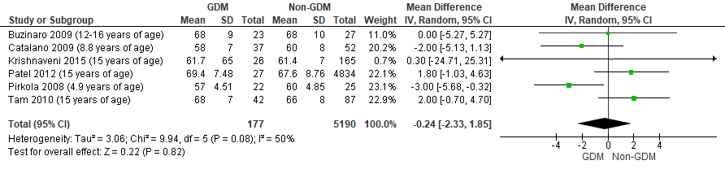
Supplementary Figure 1: Mean difference in diastolic blood pressure (mm Hg) in those exposed to GDM in utero and controls

Supplementary Table 3: Sensitivity analysis for BMI Z-Score
Analysis | Studies | N= | SMD | 95% CI | Chi² P= | I² (%)
Normal | 9 | 31,485 | 0.11 | 0.02,0.20 | 0.15 | 34
Sensitivity | 8 | 31,275 | 0.13 | 0.01,0.25 | 0.10 | 42

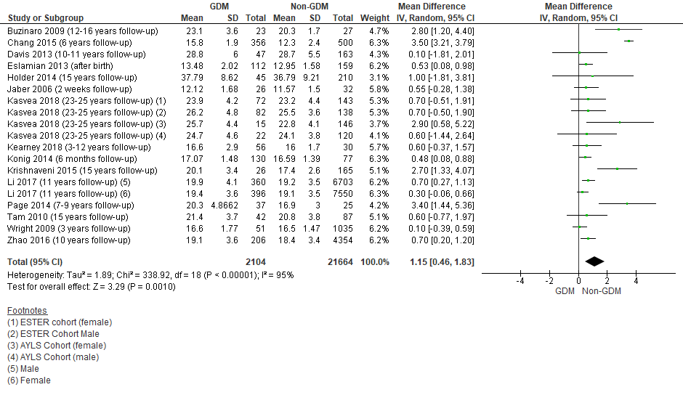
Supplementary Figure 2: Mean difference in BMI (kg/m²) in those exposed to GDM in utero and controls

Supplementary Table 4: Sensitivity analysis for BMI (kg/m²)
Analysis | Studies | N= | SMD | 95% CI | Chi² P= | I² (%)
Normal | 16 | 23,768 | 1.15 | 0.46,1.83 | <0.00001 | 95
Sensitivity | 15 | 23,654 | 1.10 | 0.42, 1.78 | <0.00001 | 95

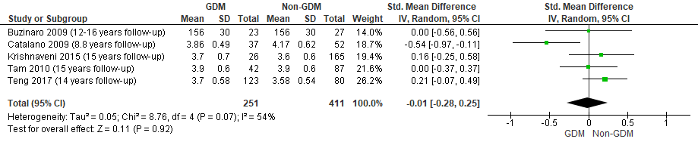
3A:
3B:
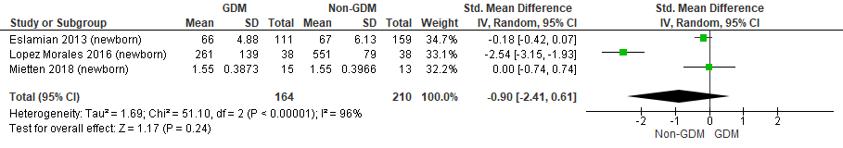

Supplementary Figure 3: (A) Standard mean difference in serum blood total cholesterol in those exposed to GDM in utero and controls (B) Standard mean difference in cord blood total cholesterol in those exposed to GDM in utero and controls

4A:
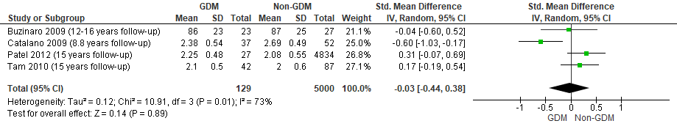

4B:
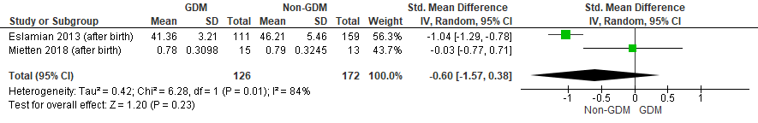Supplementary Figure 4: (A) Standard mean difference in serum LDL cholesterol in those exposed to GDM in utero and controls (B) Standard mean difference in cord blood LDL cholesterol in those exposed to GDM in utero and control

5A:
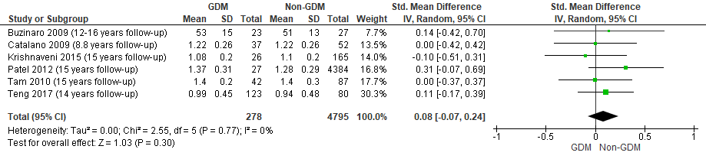
5B:
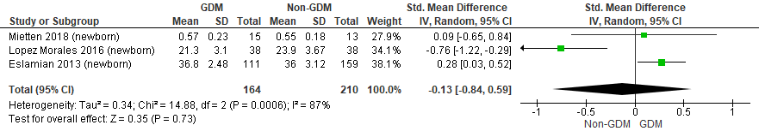

Supplementary Figure 5: (A) Standard mean difference in serum blood HDL cholesterol in those exposed to GDM in utero and controls (B) Standard mean difference in cord blood HDL cholesterol in those exposed to GDM in utero and controls

6A:
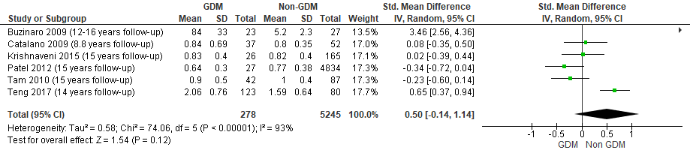
6B:
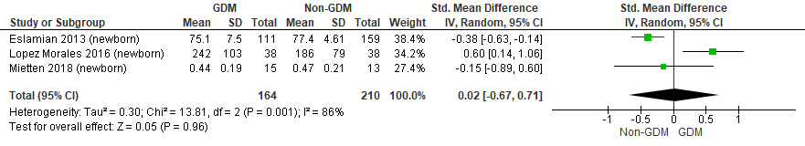
Supplementary Figure 6: (A) Standard mean difference in serum triglycerides in those exposed to GDM in utero and controls (B) Standard mean difference in cord blood triglycerides in those exposed to GDM in utero and controls

7A:
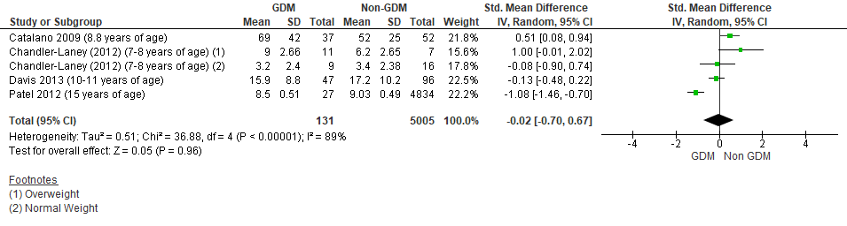
7B:
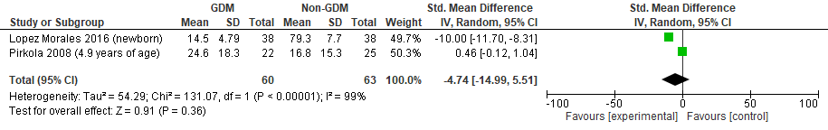
Supplementary Figure 7: (A) Standard mean difference in serum insulin in those exposed to GDM in utero and controls (B) Standard mean difference in cord blood insulin in those exposed to GDM in utero and controls

Supplementary Table 5: Sensitivity analysis for serum insulin
Analysis | Studies | N= | SMD | 95% CI | Chi² P= | I² (%)
Normal | 4 | 5136 | -0.02 | -0.70,0.67 | <0.00001 | 89
Sensitivity | 3 | 5093 | -0.24 | -1.11,0.63 | <0.00001 | 94

Supplementary Table 6: Sensitivity analysis for serum glucose
Analysis | Studies | N= | SMD | 95% CI | Chi² P= | I² (%)
Normal | 11 | 6,423 | 0.43 | 0.08,0.77 | <0.00001 | 89
Sensitivity | 9 | 6,380 | 0.47 | 0.09,0.84 | <0.00001 | 91

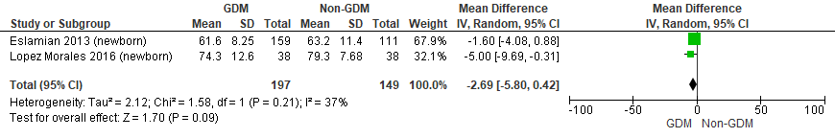

Supplementary Figure 8: Standard mean difference in cord blood glucose in those exposed to GDM in utero and controls

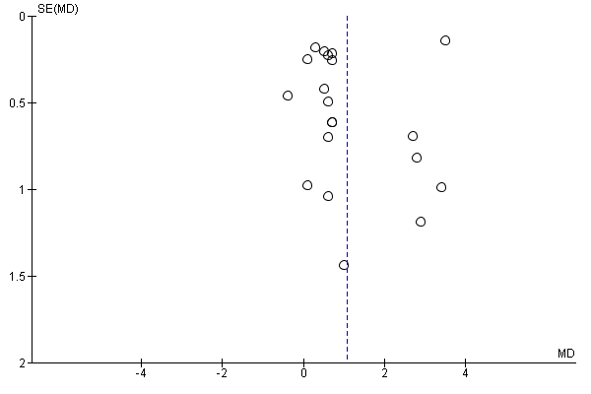
2 (A)

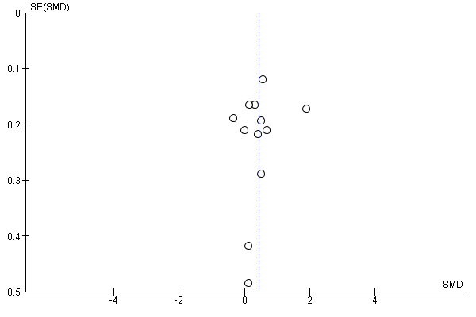
(B)

Supplementary Figure 9: Funnel plot of studies for all outcomes: (A) BMI (B) Fasting glucose

