The loss of ERE-dependent ERα signaling potentiates the effects of maternal high-fat diet on energy homeostasis in female offspring on a high-fat diet

Troy A. Roepke¹⁻⁴*, Ali Yasrebi^{1,2}, Alejandra Villalobos¹, Elizabeth A. Krumm^{1,2}, Jennifer A. Yang^{1,2}**, Kyle J. Mamounis^{1,3}***
¹Department of Animal Sciences, School of Environmental and Biological Sciences, Rutgers, The State University of New Jersey, New Brunswick, NJ. USA
²Graduate Program in Endocrinology and Animal Biosciences, Rutgers, The State University of New Jersey, New Brunswick, NJ. USA
³Nutritional Sciences Graduate Program, Rutgers, The State University of New Jersey, New Brunswick, NJ. USA
⁴New Jersey Institute for Food, Nutrition, and Health, Rutgers, The State University of New Jersey, New Brunswick, NJ. USA

Supplemental Data

Supplemental Figure S1
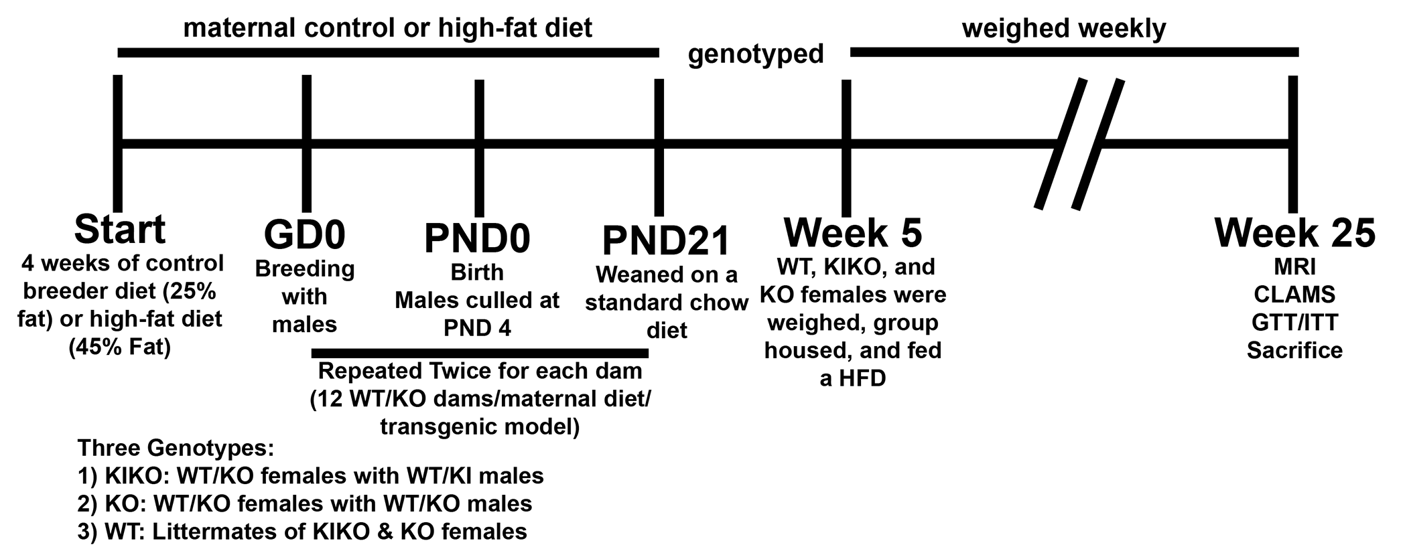

Supplemental Figure S1. Timeline of the experimental design for maternal high-fat diet and assessment of adult female offspring energy and glucose homeostasis.

Supplemental Table S1. Primer sequences
Gene Name | Forward Primer | Reverse Primer | Accession #
Actb | GCCCTGAGGCTCTTTTCCA | TAGTTTCATGGATGCCACAGGA | NM_007393.3
Agrp | CTCCACTGAAGGGCATCAGAA | ATCTAGCACCTCCGCCAAA | NM_007427.2
Cart | GCTCAAGAGTAAACGCATTCC | GTCCCTTCACAAGCACTTCAA | NM_013732
Dgat2 | ACTCTGGAGGTTGGCACCAT | GGGTGTGGCTCAGGAGGAT | NM_026384.3
Esr1 | GCGCAAGTGTTACGAAGTG | TTCGGCCTTCCAAGTCATC | NM_007956
Fas | GGGTTCTAGCCAGCAGAGTC | TCAGCCACTTGAGTGTCCTC | NM_007988.3
G6pase | GCCTCCTGTCGGATACAGAA | TGCACCGCAAGAGCATT | NM_008061.4
Gapdh | TGACGTGCCGCCTGGAGAAA | AGTGTAGCCCAAGATGCCCTTCAG | NM_008084.2
Hprt | GCTTGCTGGTGAAAAGGACCTCTCGAAG | CCCTGAAGTACTCATTATAGTCAAGGGCAT | NM_013556
Insr | GTGTTCGGAACCTGATGAC | GTGATACCAGAGCATAGGAG | NM_010568
Kiss1 | TGATCTCAATGGCTTCTTGGCAGC | CTCTCTGCATACCGCGATTCCTTT | NM_178260
Lepr | AGAATGACGCAGGGCTGTAT | TCCTTGTGCCCAGGAACAAT | NM_146146.2
Npy | ACTGACCCTCGCTCTATCTC | TCTCAGGGCTGGATCTCTTG | NM_023456
Pepck | AGCGGATATGGTGGGAAC | GGTCTCCACTCCTTGTTC | NM_011044.2
Pomc | GGAAGATGCCGAGATTCTGC | TCCGTTGCCAGGAAACAC | NM_008895
Srepb1 | TTGATAGAAGACCGGTAGCGC | CAGCTCAGAGCCGTGGTGA | NM_0114803

Supplemental Figure S2.
Supplemental Figure S2. A: Average daily RER as a function of body weight. ANCOVA: no significance. B: Daytime energy expenditure (kCal/hr) as a function of body weight. ANCOVA: maternal diet: F (1, 53) = 9.42, P < .01. C: Nighttime energy expenditure (kCal/hr) as a function of body weight. ANCOVA: maternal diet: F (1, 53) = 13.48, P < .001.

Supplemental Table S2. Arcuate and liver gene expression
Gene Name | Treatment | WT | KIKO | KO
ARC Insr | Control | 0.97 ± 0.29 | 1.39 ± 0.51 | 1.69 ± 0.51
 | HFD | 2.23 ± 0.70a | 0.52 ± 0.12** | 0.24 ± 0.08a,**
ARC Lepr | Control | 0.91 ± 0.14 | 1.54 ± 0.42 | 0.45 ± 0.06#
 | HFD | 0.96 ± 0.15 | 2.42 ± 0.57*** | 0.40 ± 0.07####
Liver Insr | Control | 1.03 ± 0.14 | 1.10 ± 0.45 | 0.99 ± 0.11
 | HFD | 1.45 ± 0.23 | 0.65 ± 0.20 | 1.22 ± 0.17
Liver Lepr | Control | 0.96 ± 0.09 | 0.86 ± 0.08 | 0.75 ± 0.05
 | HFD | 1.08 ± 0.13 | 0.75 ± 0.11* | 067 ± 0.03*
a = compared to Control within genotype, * compared to WT, # = compared to KIKO. (a/*/# = P < .05;
b/**/## = P < .01; c/***/### = P < .001; d/****/#### = P < .0001

Supplemental Table S3. ANOVA statistics for each physiological endpoint
Endpoint | Genotype | Maternal Diet | Time | Interactions
weight 5 wks | F(2,58)=7.42, P<.01 | F(1,58)=38.58, P<.0001
weight 25 wks | F(2,54)=11.87, P<.0001 | F(1,54)=17.09, P<.001 |  | F(2,54)=5.06, P<.01
fat mass | F(2,54)=8.45, P<.001 | F(2,54)=21.87, P<.0001 |  | F(2,54)=7.75, P<.01
lean mass
V.O₂ | F(2,108)=15.17, P<.0001 | F(1,108)=4.02, P<.05 | F(1,108)=27.01, P<.0001 | g*m: F(2,108)=3.56, P<.05
V.CO₂ | F(2,108)=9.70, P<.001 | F(1,108)=5.06, P<.05 | F(1,108)=12.88, P<.001 | g*m: F(2,108)=3.08, P<.05
RER
Heat (energy expenditure) | F(2, 108)=9.60, P<.001 | F(1,108)=4.72, P<.05 | F(1,108)=8.25, P<.01
X | F(2,108)=38.55, P<.0001 |  | F(1,108)=127.4, P<.0001 | g*m: F(2,108)=3.36, P<.05  g*t: F(2,108)=26.57, P<.0001  m*t: F(1,108)=4.69, P<.05
Z | F(2,108)=12.56, P<.0001 |  | F(1,108)=69.56, P<.0001 | g*t: F(2,108)=10.32, P<.0001
Triglycerides
Fasting Glucose |  |  |  | F(2,53)=3.51, P<.05
GTT | F(2,52)=9.83, P<.001 | F(1,52)=5.25, P<.05 | F(6,312)=105.1, P<.0001 | g*t: F(12,312)=4.31, P<.0001
GTT AUC | F(2,52)=10.24, P<.001 | F(1,52)=4.42, P<.05
ITT | F(2,53)=7.68, P<.01 | F(1,53)=4.87, P<.05 | F(5,265)=122.1, P<.0001 | g*t: F(10,265)=3.71, P<.001
ITT AUC | F(2,53)=7.54, P<.01
E2 | F(2,36)=16.28, P<.0001 |  |  | F(2,36)=4.60, P<.05
insulin | F(2,52)=22.70, P<.0001 | F(1,52)=20.87, P<.0001 |  | F(2,52)=16.71, P<.0001
leptin
IL-6 |  | F(1,52)=8.77, P<.01 |  | F(2,52)=4.35, P<.05
MCP-1 |  | F(1,52)=9.24, P<.01
TNFα
Interaction terms are defined as follows: g*m = genotype*maternal diet; m*t = time*maternal diet; g*t = genotype*time.

Supplemental Table S4. ANOVA statistics for arcuate nucleus gene expression
Arcuate | Genotype | Maternal Diet | Interactions
Agrp | F(2,54)=3.32, P<.05 |  | F(2,53)=10.86, P<.001
Cart | F(2,54)=7.70, P<.01
Esr1 | F(2,54)=13.92, P<.0001
Insr |  |  | F(2,54)=6.37, P<.01
Kiss1 |  |  | F(2,54)=9.823, P<.001
Lepr | F(2,54)=16.15, P<.0001
Npy | F(2,54)=11.54, P<.0001
Pomc | F(2,54)=12.95, P<.0001 |  | F(2,54)=4.11, P<.05

Supplemental Table S5. ANOVA statistics for liver gene expression
Liver | Genotype | Maternal Diet | Interactions
Dgat2
Esr1 | F(2,54)=53.06, P<.0001 | F(1,54)=11.59, P<.01 | F(2,54)=13.16, P<.0001
Fas |  | F(1,55)=7.21, P<.01
G6pc | F(2,55)=17.51, P<.0001
Insr
Lepr | F(2,54)=6.70, P<.01
Pepck | F(2,54)=3.47, P<.05 |  | F(2,54)=5.55, P<.01
Srebp1 | F(2,54)=8.93, P<.001

