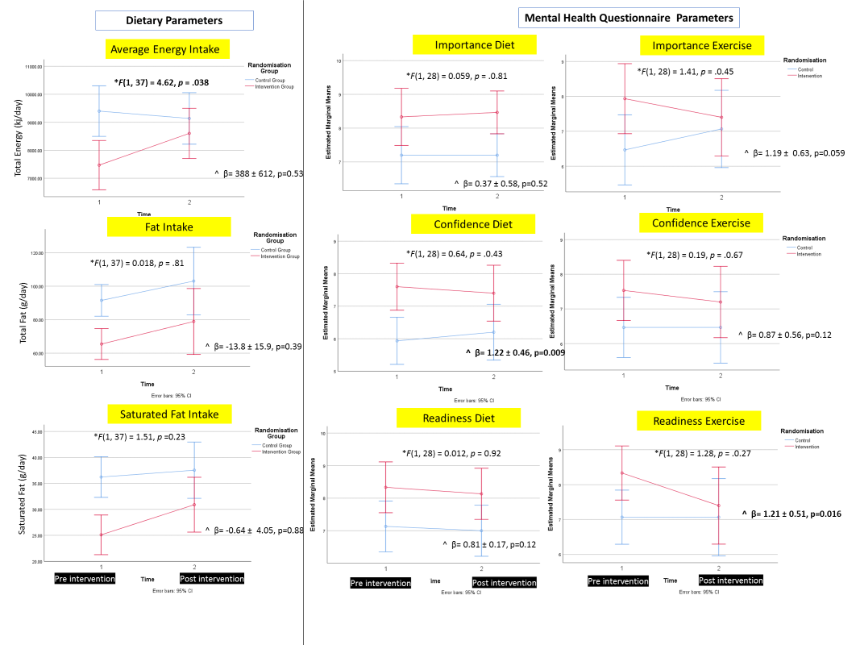Figure 1: Estimated Marginal Means for selected dietary and Mental Health Questionaire outcomes at pre- and post- 12 week intervention. The estimated marginal mean and 95% Confidence intervals are shown. The blue lines represent the control and red lines the intervention group. Nominally significant results are shown in bold font. * indicates the F-statistic from a repeated measures ANOVA as F(dftime x treatment group, dferror)=F-value, p=p-value for the slope of the line (interaction term time*treatment group) when repeated measures ANOVA performed. ^ indicates the β ±SE when ANCOVA performed for the outcome of post-intervention value adjusted for pre-intervention value.

Supplemental Table 1: Effect of the intervention on maternal adiposity

|  |  |  |  |
| --- | --- | --- | --- |
|  | **Control Group**  **n=19** | **Intervention Group**  **n=23** | **P-value** |
| **Change in girth over intervention period\*** | | | |
| Waist circumference (cm) | 9.73  (7.56-11.90) | 8.40  (6.08-10.72) | 0.392 |
| Hip circumference (cm) | 3.30  (1.12-5.49) | 3.51  (1.90-5.12) | 0.871 |
| Upper arm circumference relaxed (cm) | 0.50  (-0.17-1.18) | 0.13  (-0.38-0.64) | 0.352 |
| **Change in skin fold thickness over intervention period\*** | | | |
| Triceps (cm) | 0.20  (-0.04-0.44) | -0.05  (-0.48-0.37) | 0.308 |
| Biceps (cm) | -0.02  (-0.25-0.22) | 0.20  (-0.14-0.53) | 0.299 |
| Subscapular (cm) | 0.04  (-0.20-0.29) | -0.06  (-0.33-0.21) | 0.550 |
| Suprailiac (cm) | 0.33  (0.40-0.63) | 0.08  (-0.33-0.63), n=19 | 0.297 |
| Thigh (cm) | 0.31  (-0.33-0.94) | -0.32  (-1.10-0.46) | 0.214 |

**Supplemental table 2.** Pregnancy and birth outcomes. For categorical variables, the number (%) is shown. For continuous variables, the mean (95% confidence interval) is shown.

|  |  |  |  |  |  |
| --- | --- | --- | --- | --- | --- |
|  | **Control group** | | **PLAN Intervention group** | | **P-value** |
| Number of Births | *n* = 19 | | *n* = 20 | | 0.784 |
| **Delivery and Labour** | | | | | |
| Commencement of Labour |  | |  | |  |
| Spontaneous  Induced (± augmentation)  Augmented  Spontaneous  (± augmentation and/or induction)  No Labour  Unknown | 4  6  0  1  7  1 | (21.1%)  (31.6%)  (0%)  (5.3%)  (36.8%)  (5.3%) | 3  3  1  3  8  2 | (15.0%)  (15.0%)  (5.0%)  (15.0%)  (36.8%)  (10.0%) | 0.686^ |
| Delivery Method |  | |  | |  |
| Spontaneous  Elective Caesarean  Non-elective Caesarean  Vacuum Extraction  Unknown | 9  5  2  1  2 | (47.4%)  (26.3%)  (10.5%)  (5.3%)  (10.5%) | 4  5  6  3  2 | (20.0%)  (25.0%)  (30.0%)  (15.0%)  (10.0%) | 0.337^ |
| Group B Steptococcus | (*n* = 11) | | (*n* = 13) | |  |
| 0 | (0%) | 3 | (16.7%) | 0.223^ |
| Pre-eclampsia | (*n* = 17) | | (*n* = 18) | |  |
| 2 | (11.8%) | 2 | (11.1%) | 1.000^ |
| Premature Rupture Membrane | (*n* = 18) | | (*n* = 18) | |  |
| 2 | (11.1%) | 0 | (0%) | 0.486^ |
| Ante-partum Hemorrhage | (*n* = 17) | | (*n* = 18) | |  |
| 0 | (0%) | 1 | (5.6%) | 1.000^ |
|  |  |  |  |  |  |
| Congenital Abnormalities | (*n* = 17) | (*n* = 18) |  |  |  |
| Ankyloglossia | 2 | (11.8%) | 2 | (11.1%) | 1.000^ |
| Gestational Age at Delivery (weeks) | 38.0 (36.9 to 39.1) | | 38.4 (37.9 to 39.1) | | 0.456 |
| APGAR Score 1min | (*n* = 17) | (*n* = 18) |  |  |  |
| 9  <9 | 16  1 | (94.1%)  (5.9%) | 14  4 | (77.8%)  (22.2%) | 0.338^ |

^Fishers Exact test as expected counts within cells <5