Supplementary Table 1. Characteristics of participants included in dietary pattern analysis and excluded due to missing information in the food frequency questionnaire.
 | Women excluded |  | Women included | P-value
Continuous variables
(median and interquartile range) | N = 596 |  | N = 715
Age (years) | 23 (20; 27) |  | 22 (20; 27) | 0.054
Body mass index (kg/m²) | 22.1 (20.5; 25.0) |  | 22.2 (20.4; 25.2) | 0.650
Categorical variables
(n and %)
Skin color
White | 394 (70.2) |  | 499 (70.3) | 0.985
Non-white | 167 (29.8) |  | 211 (29.7)
Alcohol intake
Never | 373 (65.7) |  | 494 (69.1) | 0.423
<1 time/week | 111 (19.5) |  | 124 (17.3)
≥ 1 time/ week | 84 (14.8) |  | 97 (13.6)
Graduation in nutrition
First half | 277 (48.8) |  | 355 (49.6) | 0.010
Second half | 219 (38.5) |  | 305 (42.7)
Graduate | 72 (12.7) |  | 55 (7.7)
Family income
(number of minimum wagesª)
< 6 | 373 (73.0) |  | 440 (66.6) | 0.059
6-10 | 86 (16.8) |  | 135 (20.4)
> 10 | 52 (10.2) |  | 86 (13.0)
Breastfeeding duration (months)
< 6 | 35 (31.8) |  | 178 (30.3) | 0.694
6 to <12 | 34 (30.9) |  | 206 (35.1)
≥ 12 | 41 (37.3) |  | 203 (34.6)
ª One minimum wage is equivalent to 724.0 Brazilian real (or US$ 212.9).

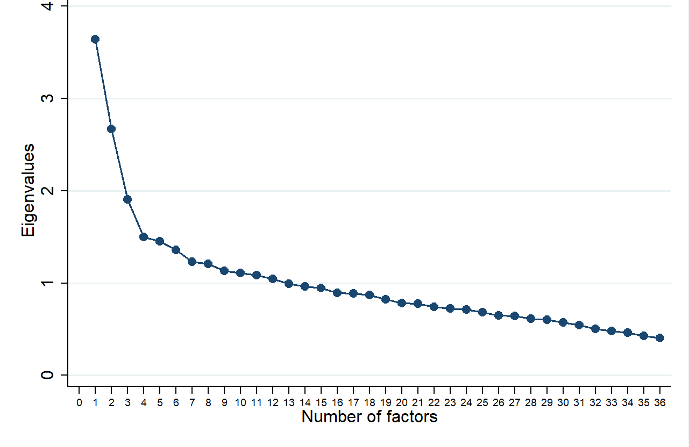
Supplementary Figure 1. Scree Plot of Eigenvalues according to number of factors retained in factor analysis by principal component.

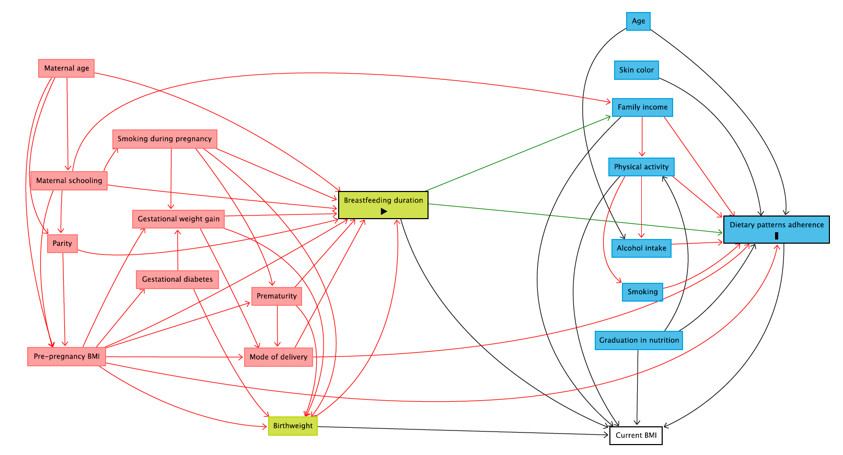
Suplementary Figure 2. Directed Acyclic Graph (DAG) for the association between breastfeeding and dietary patterns adherence.
Notes: Minimal sufficient adjustment: Maternal pre-pregnancy BMI, maternal schooling and mode of delivery.
Legend= exposure; outcome; ancestor of outcome; ancestor of exposure; ancestor of exposure and outcome; other variable; causal path; biasing path. BMI, Body mass index

