SUPPLEMENTARY MATERIAL
NOTE: Curve estimation parameters for linear, quadratic and cubic models are displayed for comparison purposes only. Curve fit models showed that linear models were a significantly better fit for our data overall than cubic and quadratic models.

GIRLS
Variables
Vaginal Maturation Index & Areolar Pigmentation

Standardized coefficient and significance (linear model)
β=0.338; 95% CI=0.031 to 0.637; p=0.031

Graph
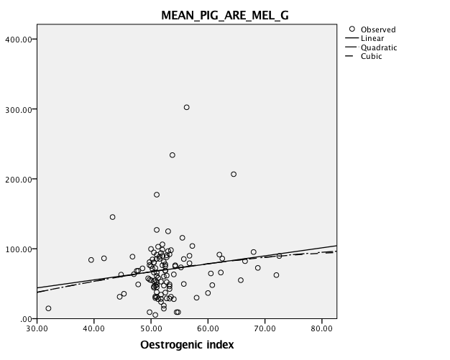
Legend:
X axis = Oestrogenic index = Vaginal Maturation Index
Y axis = MEAN_PIG_ARE_MEL_G = Areolar Pigmentation

Variables
2D:4D ratio & Areolar Pigmentation

Standardized coefficient and significance (linear model)
Right 2D:4D: β= -0.207; 95% CI= -0.403 to -0.049; p=0.040
Left 2D:4D: β= -0.276; 95% CI= -0.469 to 0.083; p=0.006

Graph
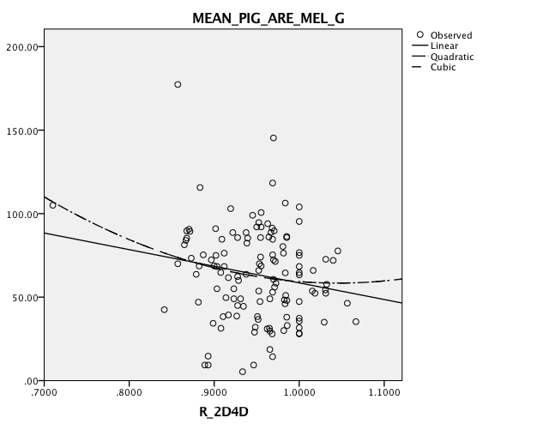

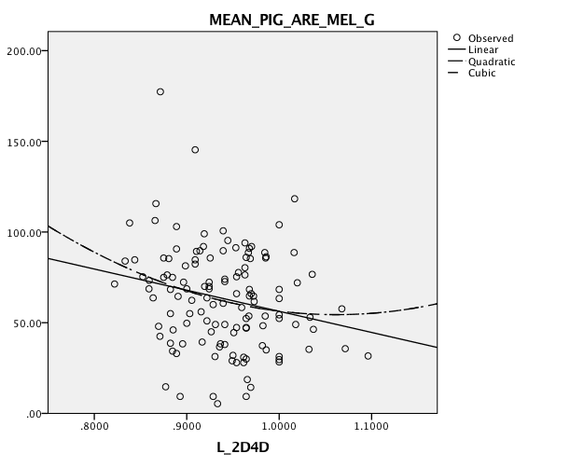
Legend
X axis = R_2D4D/L_2D4D = 2nd to 4th digit ratio (right and left)
Y axis = MEAN_PIG_ARE_MEL_G = Areolar Pigmentation

Variables
AGD-fourchette & Areolar Pigmentation

Standardized coefficient and significance (linear model)
β=0.253; 95% CI=0.018 to 0.488; p=0.036

Graph
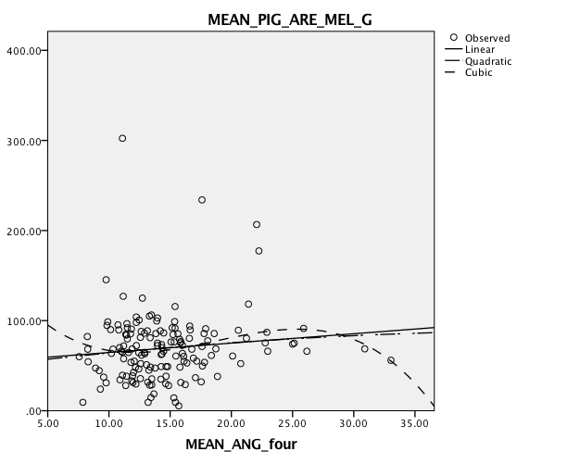
Legend
X axis = MEAN_ANG_four = AGD-fourchette = Anogenital Distance -Anus to Fourchette-
Y axis = MEAN_PIG_ARE_MEL_G = Areolar Pigmentation

Variables
AGD-clitoris & AGD-fourchette

Standardized coefficient and significance (linear model)
β=0.295; 95% CI=0.138 to 0.452; p<0.0001

Graph
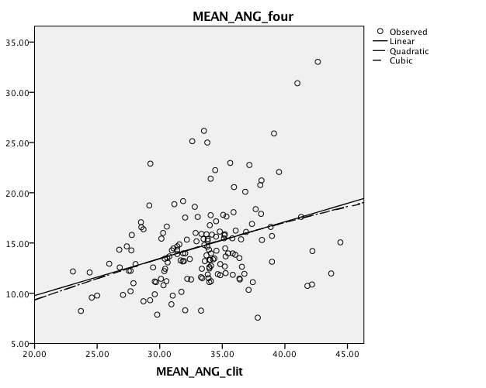
Legend
X axis = MEAN_ANG_clit = AGD-clitoris = Anogenital Distance -Anus to Clitoris-
Y axis = MEAN_ANG_four = AGD-fourchette = Anogenital Distance -Anus to Fourchette-

Variables
Triceps & Sub-Scapular Skinfold Thickness

Standardized coefficient and significance (linear model)
β=0.356, 95% CI=0.207 to 0.505; p<0.0001

Graph
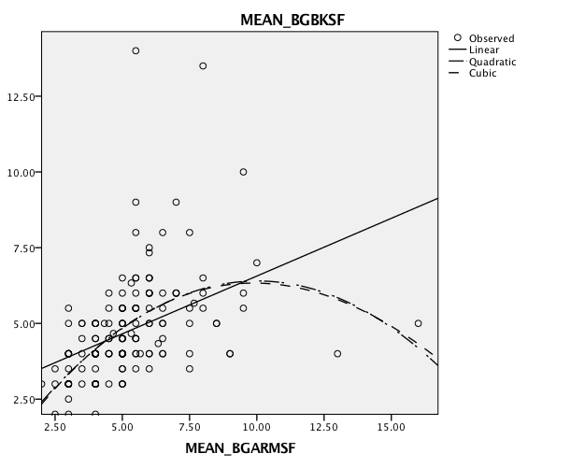
Legend
X axis = MEAN_BGARMSF = Right Arm Skinfold = Triceps Skinfold Thickness
Y axis = MEAN_BGBKSF = Back Skinfold = Sub-Scapular Skinfold Thickness

Variables
Vaginal Maturation Index & Triceps Skinfold Thickness

Standardized coefficient and significance (linear model)
β=0.265; 95% CI=0.085 to 0.445; p=0.005

Graph
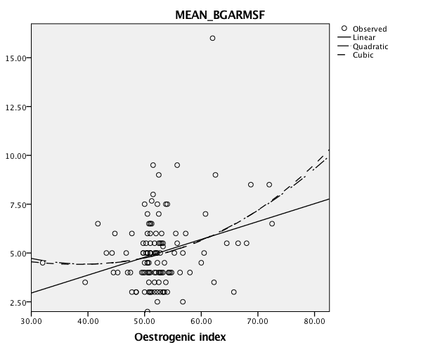
Legend
X axis = Oestrogenic Index = Vaginal Maturation Index
Y axis = MEAN_BGARMSF = Right Arm Skinfold = Triceps Skinfold Thickness

Variables
AGD-clitoris & Right Arm Circumference

Standardized coefficient and significance (linear model)
β=0.176; 95% CI=0.038 to 0.310; p=0.012

Graph
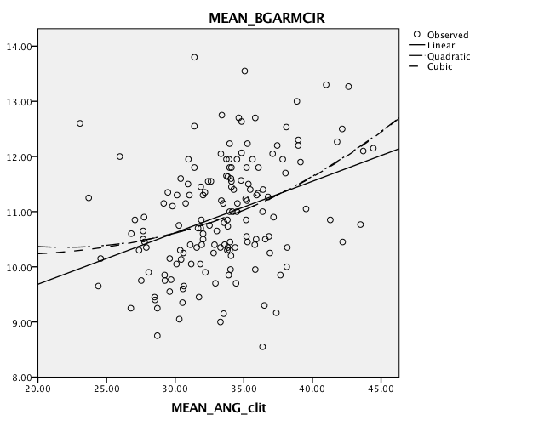
Legend
X axis = MEAN_ANG_clit = AGD-clitoris = Anogenital Distance -Anus to Clitoris-
Y axis = MEAN_BGARMCIR = Right Arm Circumference

BOYS
Variables
AGD-penis & Scrotal Pigmentation

Standardized coefficient and significance (linear model)
β=0.290; 95% CI=0.023 to 0.563; p=0.048

Graph
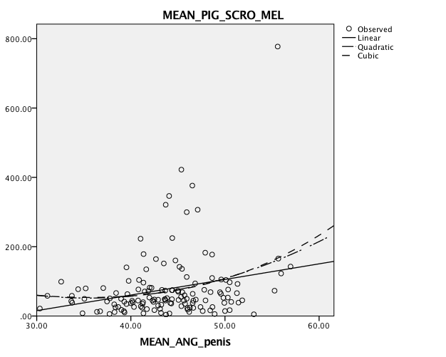

Legend
X axis = MEAN_ANG_penis = AGD-penis = Anogenital Distance -Anus to Penis-
Y axis = MEAN_PIG_SCRO_MEL = Scrotal Pigmentation

Variables
AGD-penis & AGD-scrotum

Standardized coefficient and significance (linear model)
β=0.362; 95% CI=0.212 to 0.512; p<0.0001

Graph
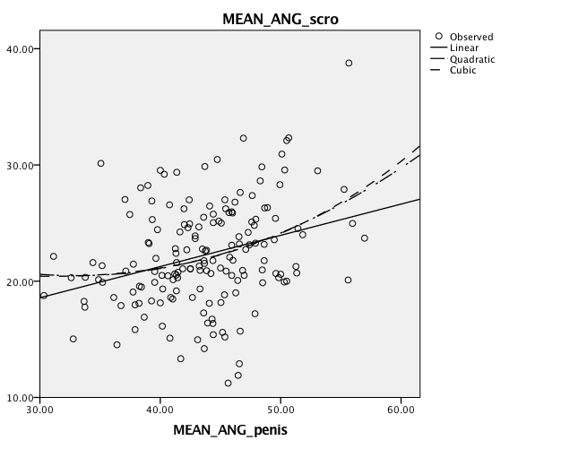
Legend
X axis = MEAN_ANG_penis = AGD-penis = Anogenital Distance -Anus to Penis-
Y axis = MEAN_ANG_scro = AGD-scrotum = Anogenital Distance -Anus to Scrotum-

Variables
Triceps & Sub-Scapular Skinfold Thickness

Standardized coefficient and significance (linear model)
β=0.572; 95% CI=0.435 to 0.709; p<0.0001

Graph
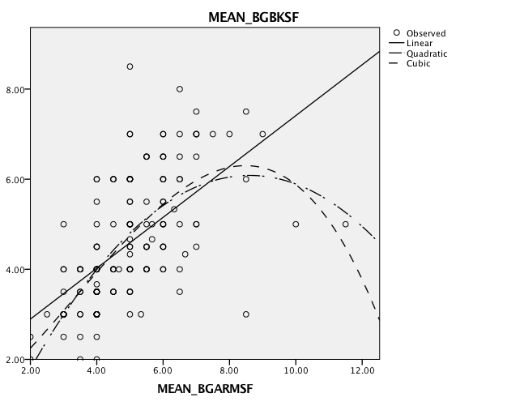
Legend
X axis = MEAN_BGARMSF = Right Arm Skinfold = Triceps Skinfold Thickness
Y axis = MEAN_BGBKSF = Back Skinfold = Sub-Scapular Skinfold Thickness

Variables
AGD-penis & Right Arm Circumference

Standardized coefficient and significance (linear model)
β=0.462; 95% CI=0.257 to 0.667; p<0.0001

Graph
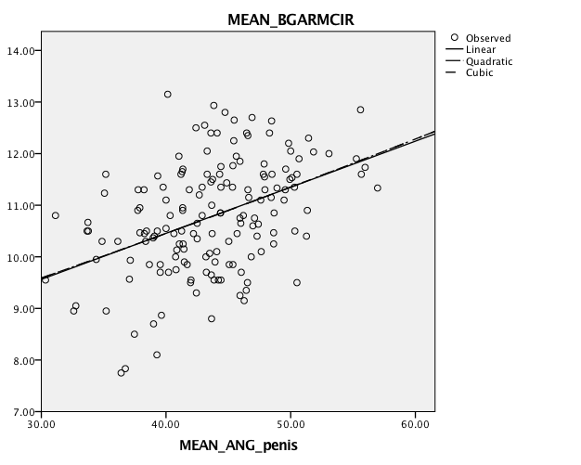
Legend
X axis = MEAN_ANG_penis = AGD-penis = Anogenital Distance -Anus to Penis-
Y axis = MEAN_BGARMCIR = Right Arm Circumference

Table S1: Correlational matrix for girls
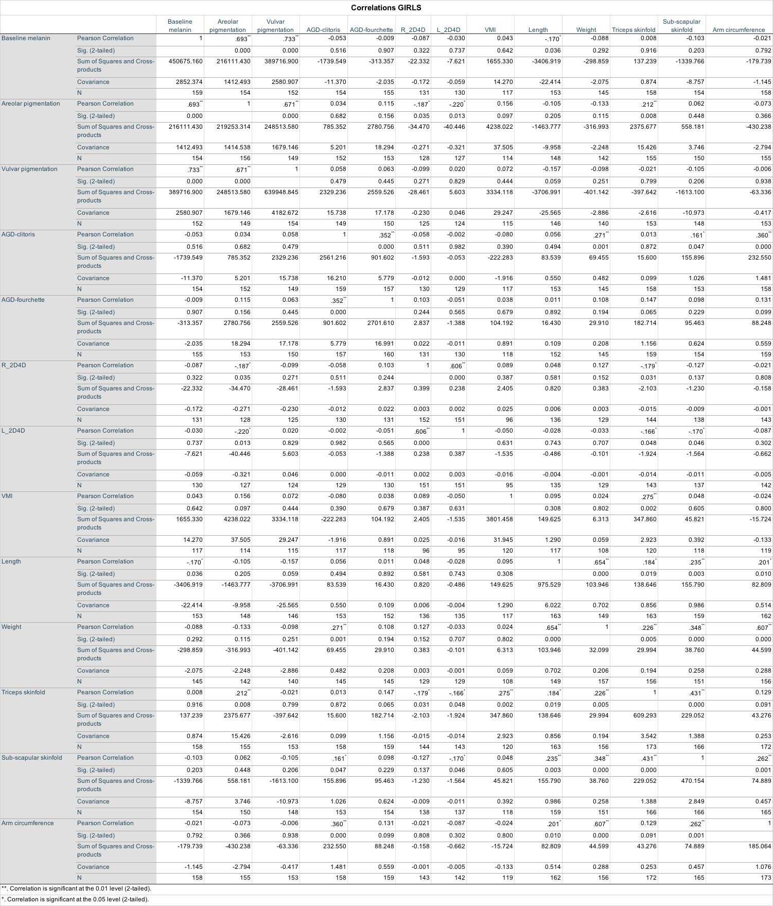
NOTE: This correlation matrix displays raw, unadjusted coefficients that do not account for the effect of any confounding variable.

Table S2: Correlational matrix for boys
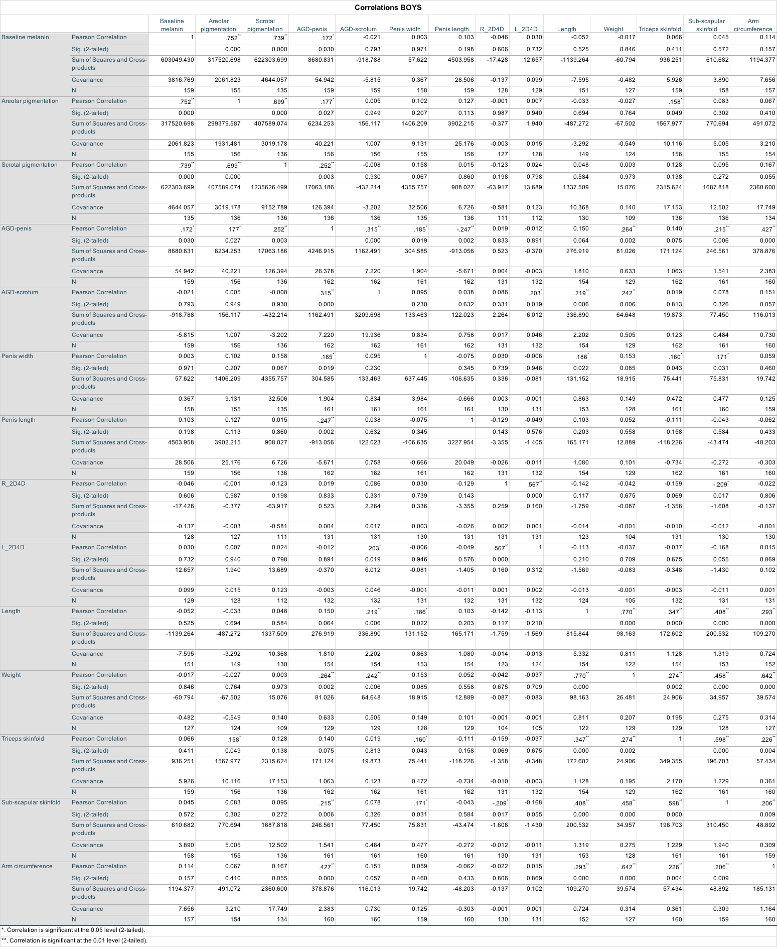
NOTE: This correlation matrix displays raw, unadjusted coefficients that do not account for the effect of any confounding variable.

