Supplemental Materials
Figure 1. Indirect (a) and Direct (b) Effects under 1,000 Simulations of an Unmeasured Moderate Confounder of Standardized Birth Weight and CBCL Aggressive Score
(a)
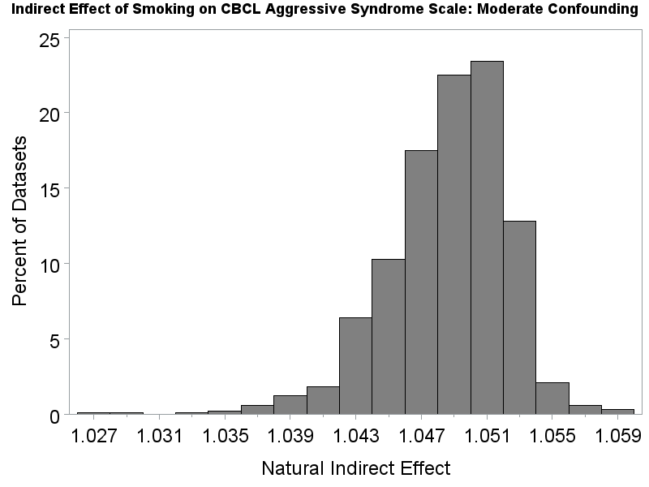

(b)
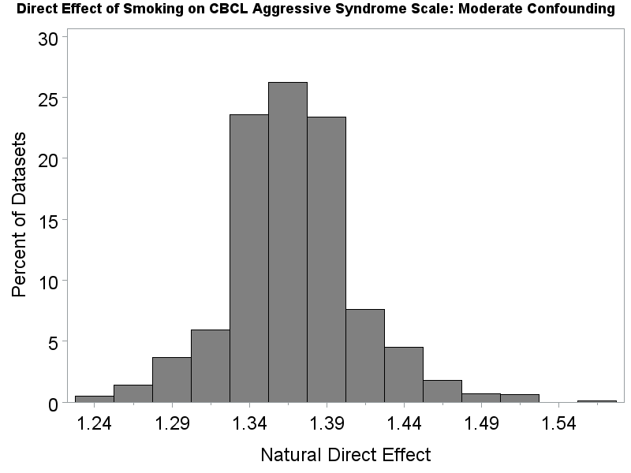

Figure 2. Indirect (a) and Direct (b) Effects under 1,000 Simulations of an Unmeasured Strong Confounder of Standardized Birth Weight and CBCL Aggressive Score
(a)
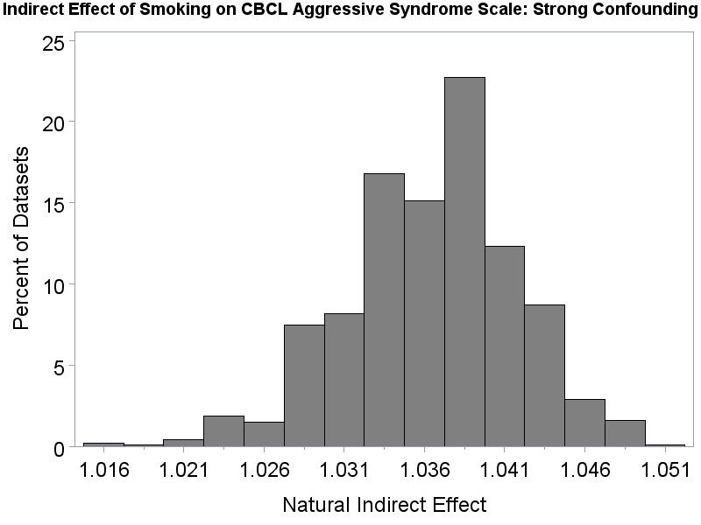
(b)
