Supplementary Material
Supplementary Table S1. Total number of species by site and community subset. Site abbreviations include Burnett Woods Nature Preserve (BWNP), Crawfordsville property (CRAW), and Sargent Road Nature Park (SRNP).
 | All | Native | Introduced | Woody | Native tree
Total | 125 | 92 | 33 | 29 | 10
BWNP | 69 | 52 | 17 | 15 | 8
CRAW | 53 | 34 | 19 | 12 | 13
SRNP | 73 | 52 | 21 | 20 | 20

Supplementary Table S2. Average community index values per plot by community subset for each plot type and location.
Community subset | Community  index | Plot type |  |  |  |  | Location
 |  | L. tulipifera | P. occidentalis |  | P. calleryana | Control |  | BWNP | CRAW | SRNP
Entire understory community | Species richness | 8.43 |  | 7.57 | 7.97 | 8.10 |  | 9.15 | 6.23 | 8.68
 | Total cover | 114.78 |  | 140.68 | 127.80 | 123.63 |  | 118.02 | 118.66 | 143.49
 | Shannon index (H) | 1.62 |  | 1.44 | 1.44 | 1.41 |  | 1.79 | 1.05 | 1.60
 | Simpson’s index (D) | 0.73 |  | 0.68 | 0.66 | 0.64 |  | 0.78 | 0.51 | 0.73
Native community | Species richness | 6.47 |  | 5.57 | 5.63 | 5.80 |  | 7.23 | 3.70 | 6.68
 | Total cover | 92.97 |  | 107.23 | 92.38 | 88.51 |  | 99.06 | 90.53 | 96.22
 | Shannon index (H) | 1.36 |  | 1.18 | 1.17 | 1.18 |  | 1.59 | 0.65 | 1.42
 | Simpson’s index (D) | 0.64 |  | 0.58 | 0.58 | 0.57 |  | 0.74 | 0.34 | 0.70
Introduced community | Species richness | 1.97 |  | 2.00 | 2.33 | 2.30 |  | 1.93 | 2.53 | 2.00
 | Total cover | 21.82 |  | 33.45 | 35.43 | 35.12 |  | 1a8.96 | 28.13 | 47.27
 | Shannon index (H) | 0.44 |  | 0.36 | 0.52 | 0.39 |  | 0.42 | 0.54 | 0.32
 | Simpson’s index (D) | 0.46 |  | 0.38 | 0.46 | 0.23 |  | 0.42 | 0.39 | 0.34
Woody community | Species richness | 1.87 |  | 2.00 | 1.67 | 1.43 |  | 1.70 | 0.90 | 2.63
 | Total cover | 28.98 |  | 35.88 | 22.86 | 14.01 |  | 22.55 | 12.86 | 40.88
 | Shannon index (H) | 0.38 |  | 0.40 | 0.35 | 0.32 |  | 0.37 | 0.08 | 0.64
 | Simpson’s index (D) | 0.49 |  | 0.31 | 0.38 | 0.49 |  | 0.45 | 0.37 | 0.43
Native woody community | Species richness | 1.27 |  | 0.97 | 0.93 | 0.87 |  | 1.13 | 0.23 | 1.68
 | Total cover | 16.97 |  | 14.82 | 11.47 | 7.61 |  | 14.10 | 0.93 | 23.11
 | Shannon index (H) | 0.27 |  | 0.13 | 0.15 | 0.15 |  | 0.19 | 0.02 | 0.32
 | Simpson’s index (D) | 0.60 |  | 0.51 | 0.56 | 0.56 |  | 0.51 | 0.84 | 0.33

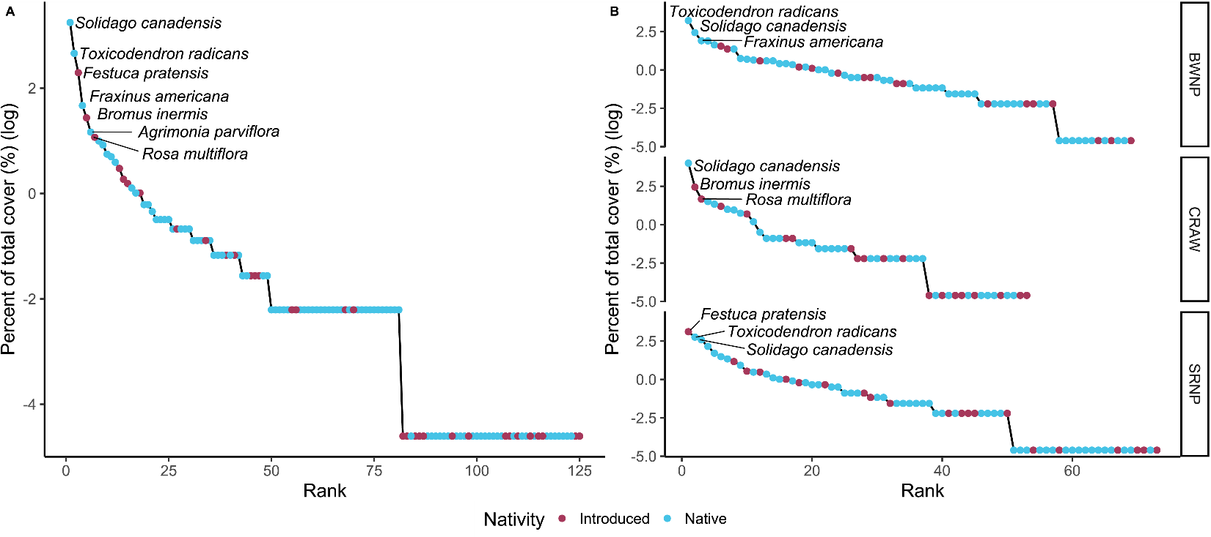
Supplementary Figure S1. Species rank-abundance curves A) across all field sites and B) separated by field site on a log scale. Shown are species by rank and proportion of total cover (%), and species richness (S), Shannon’s index (H), and Simpson’s index (D). Site abbreviations include Burnett Woods Nature Preserve (BWNP), Crawfordsville property (CRAW), and Sargent Road Nature Park (SRNP).
Effect of tree size on community metrics
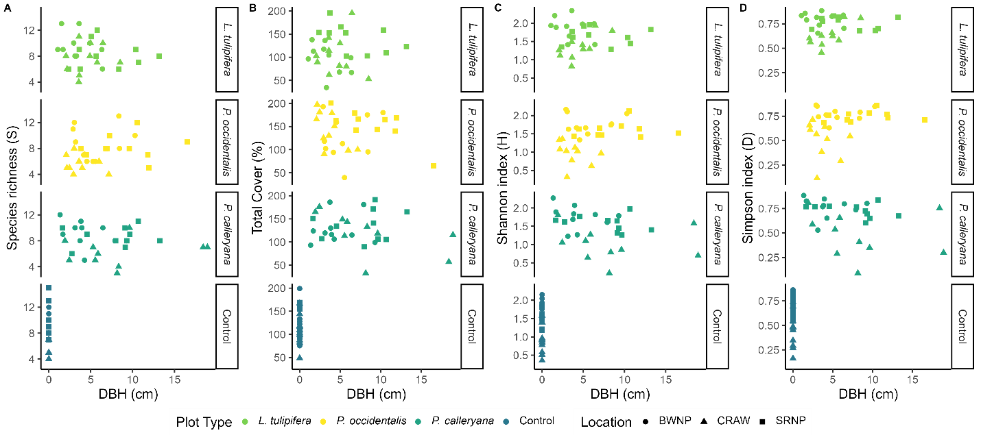
Supplementary Figure S2. Community diversity indices, including A. species richness (S), B. total cover (%), C. Shannon index (H), and Simpson index (D), by diameter at breast height for each focal tree (DBH (cm); n = 120).

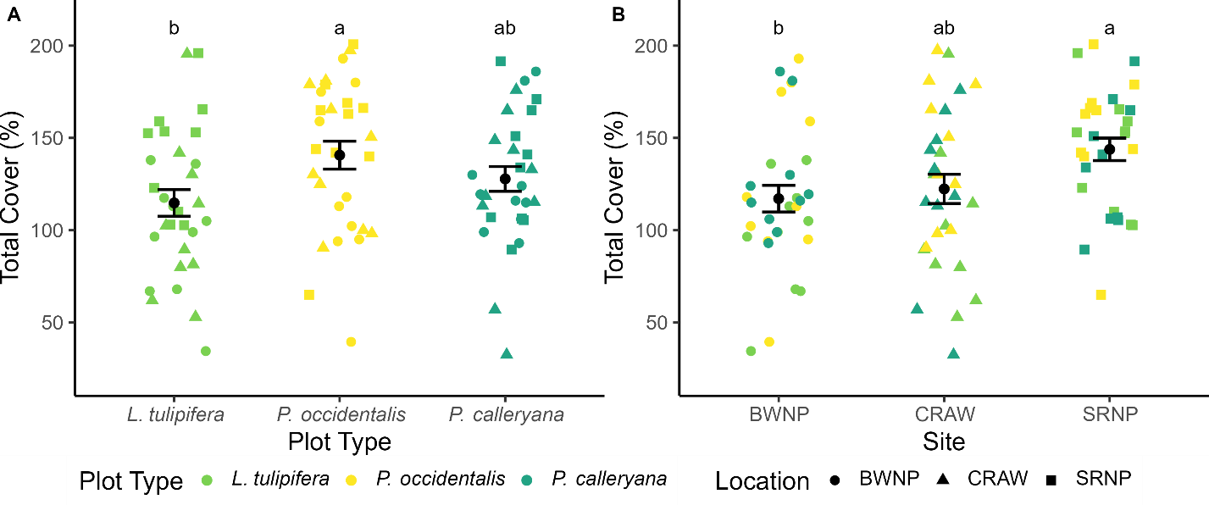
Supplementary Figure S3. Plot-level total cover (%; n = 90) by A) tree species and B) site. Shown are data points and mean ± SE; average values with the same letter code within each panel are not significantly different from each other. Site abbreviations as in Supplementary Figure S1.
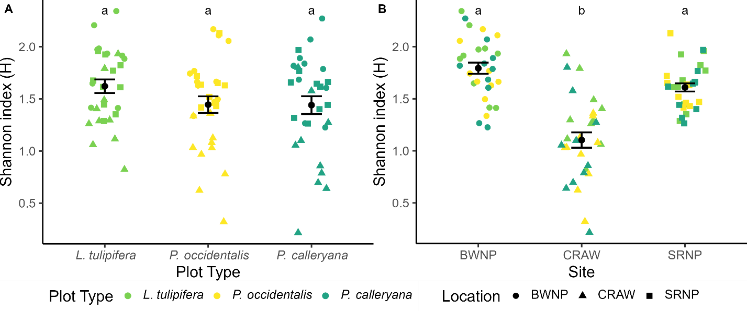
Supplementary Figure S4. Plot-level Shannon’s Index (H; n = 90) by A) tree species and B) site. Shown are data points and mean ± SE; average values with the same letter code within each panel are not significantly different from each other. Site abbreviations as in Fig. S2.
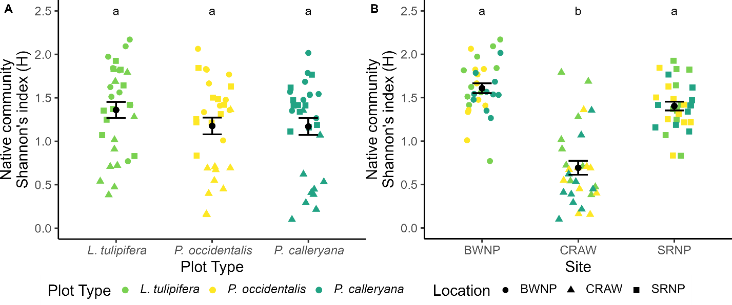
Supplementary Figure S5. Plot-level native community Shannon Index (H; n = 90) by A) tree species and B) site. Shown are data points and mean ± SE; average values with the same letter code within each panel are not significantly different from each other. Site abbreviations as in Fig. S2.

Table S3. Overall linear model results of the community diversity indices by tree species, DBH, location, and their interactions. Significant p-values shown in bold and marginal p-values shown in italics.
Community | Species richness |  |  | Total Cover (%) |  |  | Shannon Index (H) |  |  | Simpson Index (D)
 | F | p | Adjusted R² | F | p | Adjusted R² | F | p | Adjusted R² | F | p | Adjusted R²
Entire understory community | 2.016 | 0.02 | 0.163 | 2.249 | 9.21×10⁻³ | 0.193 | 5.852 | 4.07×10⁻⁸ | 0.481 | 4.988 | 6.21×10⁻⁷ | 0.432
Native community | 4.361 | 4.99×10⁻⁶ | 0.391 | 1.031 | 0.437 | 5.89×10⁻³ | 8.645 | 1.74×10⁻¹¹ | 0.594 | 8.789 | 1.21×10⁻¹¹ | 0.598
Introduced community | 0.696 | 0.80 | -0.062 | 1.561 | 0.10 | 0.097 | 1.14 | 0.36 | 0.026 | 0.624 | 0.86 | -0.077
Woody community | 1.934 | 0.03 | 0.152 | 2.294 | 7.84×10⁻³ | 0.198 | 2.006 | 0.02 | 0.161 | 1.572 | 0.10 | 0.098
Native tree community | 1.907 | 0.03 | 0.148 | 2.213 | 0.01 | 0.188 | 1.12 | 0.35 | 0.022 | 2.764 | 1.43×10⁻³ | 0.252

Table S4. ANOVA results of the linear models of community diversity indices by tree species, DBH, location, and their interactions. Significant p-values shown in bold and marginal p-values shown in italics.
Community | Variable | Species richness |  |  |  |  | Total Cover |  |  |  |  |  |  | Shannon Index (H) |  |  |  |  |  |  |  | Simpson Index (D)
 |  | F | p |  | ω² |  |  | F |  | p |  | ω² |  |  | F |  | p |  | ω² |  | F |  |  | p |  | ω²
Entire understory community | Plot type | 1.296 | 0.28 |  | 0.006 |  |  | 3.835 |  | 0.03 |  | 0.051 |  |  | 3.374 |  | 0.04 |  | 0.028 |  | 2.687 |  |  | 0.07 |  | 0.021
 | DBH | 0.004 | 0.94 |  | -0.009 |  |  | 2.067 |  | 0.15 |  | 0.010 |  |  | 0.227 |  | 0.65 |  | -0.004 |  | 0.502 |  |  | 0.48 |  | -0.003
 | Location | 12.556 | 2.1×10⁻⁵ |  | 0.215 |  |  | 7.491 |  | 1.11×10⁻³ |  | 0.117 |  |  | 40.273 |  | 1.80×10⁻¹² |  | 0.455 |  | 34.126 |  |  | 3.76×10⁻¹¹ |  | 0.420
 | Plot type × DBH | 0.349 | 0.71 |  | -0.012 |  |  | 0.302 |  | 0.74 |  | -0.013 |  |  | 0.659 |  | 0.52 |  | -0.004 |  | 0.556 |  |  | 0.58 |  | -0.006
 | Plot type × Location | 0.523 | 0.72 |  | -0.018 |  |  | 0.833 |  | 0.51 |  | -0.006 |  |  | 0.942 |  | 0.44 |  | -0.001 |  | 0.944 |  |  | 0.44 |  | -0.001
 | DBH × Location | 0.676 | 0.51 |  | 0.006 |  |  | 2.150 |  | 0.12 |  | 0.021 |  |  | 0.471 |  | 0.63 |  | -0.006 |  | 0.072 |  |  | 0.93 |  | -0.012
 | Plot type × DBH × Location | 0.608 | 0.66 |  | -0.013 |  |  | 1.321 |  | 0.27 |  | 0.012 |  |  | 1.481 |  | 0.22 |  | 0.011 |  | 1.410 |  |  | 0.24 |  | 0.010
Native community | Plot type | 2.341 | 0.10 |  | 0.018 |  |  |  |  |  |  |  |  |  | 3.125 |  | 0.05 |  | 0.019 |  | 2.233 |  |  | 0.11 |  | 0.011
 | DBH | 0.081 | 0.77 |  | -0.006 |  |  |  |  |  |  |  |  |  | 0.134 |  | 0.72 |  | -0.004 |  | 0.186 |  |  | 0.67 |  | -0.004
 | Location | 30.652 | 2.34×10⁻¹⁰ |  | 0.403 |  |  |  |  |  |  |  |  |  | 61.879 |  | 2.30×10⁻¹⁶ |  | 0.554 |  | 64.182 |  |  | < 2×10⁻¹⁶ |  | 0.568
 | Plot type × DBH | 0.027 | 0.97 |  | -0.013 |  |  |  |  |  |  |  |  |  | 0.703 |  | 0.50 |  | -0.003 |  | 0.818 |  |  | 0.44 |  | -0.002
 | Plot type × Location | 0.650 | 0.62 |  | -0.010 |  |  |  |  |  |  |  |  |  | 1.260 |  | 0.29 |  | 0.005 |  | 1.590 |  |  | 0.18 |  | 0.011
 | DBH × Location | 1.188 | 0.31 |  | 0.003 |  |  |  |  |  |  |  |  |  | 2.908 |  | 0.06 |  | 0.017 |  | 2.425 |  |  | 0.10 |  | 0.013
 | Plot type × DBH × Location | 0.758 | 0.56 |  | -0.007 |  |  |  |  |  |  |  |  |  | 1.141 |  | 0.34 |  | 0.003 |  | 0.886 |  |  | 0.48 |  | -0.002
Introduced community | Plot type
 | DBH
 | Location
 | Plot type × DBH
 | Plot type × Location
 | DBH × Location
 | Plot type × DBH × Location
Woody community | Plot type | 0.498 | 0.61 |  | -0.009 |  |  | 2.048 |  | 0.14 |  | -0.019 |  |  | 0.162 |  | 0.85 |  | -0.016
 | DBH | 0.372 | 0.37 |  | -0.002 |  |  | 0.013 |  | 0.91 |  | -0.009 |  |  | 0.498 |  | 0.48 |  | -0.005
 | Location | 13.526 | 1.03x10⁻⁵ |  | 0.237 |  |  | 14.611 |  | 4.72×10⁻⁶ |  | 0.243 |  |  | 14.270 |  | 6.02×10⁻⁶ |  | 0.248
 | Plot type × DBH | 0.210 | 0.81 |  | -0.015 |  |  | 0.140 |  | 0.87 |  | -0.015 |  |  | 0.455 |  | 0.64 |  | -0.010
 | Plot type × Location | 0.174 | 0.95 |  | -0.031 |  |  | 1.022 |  | 0.40 |  | -0.001 |  |  | 0.155 |  | 0.96 |  | -0.032
 | DBH × Location | 0.528 | 0.59 |  | -0.009 |  |  | 0.447 |  | 0.64 |  | -0.010 |  |  | 0.659 |  | 0.52 |  | -0.006
 | Plot type × DBH × Location | 0.464 | 0.76 |  | -0.020 |  |  | 0.100 |  | 0.98 |  | -0.032 |  |  | 0.474 |  | 0.75 |  | -0.020
Native tree community | Plot type | 0.820 |  | 0.44 |  | -0.003 |  |  | 0.754 |  | 0.47 |  | -0.004 |  |  |  |  |  |  | 0.450 |  |  | 0.63 |  | -0.014
 | DBH | 0.429 |  | 0.51 |  | -0.005 |  |  | 0.188 |  | 0.67 |  | -0.007 |  |  |  |  |  |  | 1.102 |  |  | 0.29 |  | -0.001
 | Location | 13.997 |  | 7.32×10⁻⁶ |  | 0.247 |  |  | 15.544 |  | 2.45×10⁻⁶ |  | 0.263 |  |  |  |  |  |  | 18.040 |  |  | 4.46×10⁻⁷ |  | 0.318
 | Plot type × DBH | 0.326 | 0.72 |  | -0.013 |  |  | 0.063 |  | 0.94 |  | -0.017 |  |  |  |  |  |  |  |  | 0.275 |  |  | 0.76 |  | -0.003
 | Plot type × Location | 0.323 | 0.86 |  | -0.026 |  |  | 0.318 |  | 0.86 |  | -0.025 |  |  |  |  |  |  |  |  | 1.682 |  |  | 0.16 |  | 0.011
 | DBH × Location | 0.009 | 0.99 |  | -0.019 |  |  | 1.446 |  | 0.24 |  | -0.008 |  |  |  |  |  |  |  |  | 0.421 |  |  | 0.66 |  | -0.010
 | Plot type × DBH × Location | 0.098 | 0.98 |  | -0.034 |  |  | 0.136 |  | 0.97 |  | -0.031 |  |  |  |  |  |  |  |  | 0.196 |  |  | 0.94 |  | 0.006

Per-Site Analysis of Results
To better understand how the impacts of P. calleryana may have varied by location, given the sites’ varied sizes, disturbance histories, and proximity to residential areas, we additionally conducted the analysis on each site individually. These analyses were conducted as described in the methods, except that instead of including field site as a predictor variable in our statistical models, we split the vegetation surveys into entirely separate models and tested only the effect of plot type or the effect of plot type, DBH, and their interaction on total cover, species richness, and Shannon’s and Simpson’s indices of diversity.
These single-location analyses support our conclusion that establishment-phase populations of P. calleryana have a minimal effect on the understory community of early successional meadows. Among the models utilizing only plot type as the predictor variable without accounting for tree size, we found that most community subsets at most locations were not affected by plot type, and for those that were, there was no variation in community attributes between P. calleryana and either the control plots or the plots containing native early-successional tree species (Supplementary Table S5; Supplementary Table S6). Specifically, whole-community species richness and Shannon’s diversity, as well as native community species richness, were higher at L. tulipifera plots than in control plots at the CRAW site, but there was no difference in community attributes between P. calleryana plots and the other plot types at this site (Supplementary Fig. S6a-c). Likewise, while there was an overall effect of plot type on total woody cover at SRNP, there were no significant differences in pairwise comparisons between plot types (Supplementary Fig. S6d). We found no effect of plot type at BWNP on any community indices for any of the community subsets (Supplementary Table S5).
Among the models that accounted for both tree species and size by using plot type, DBH, and their interaction as predictor variables (Supplementary Table S5; Supplementary Table S6), we found that relatively large P. calleryana trees have a more negative effect on Simpson’s index of diversity among woody plant species at CRAW compared to P. occidentalis (Supplementary Fig. S7a). However, this result should be interpreted with caution, as the largest P. calleryana trees at this site (DBH 18.4 and 18.9 cm) were more than twice that of the largest P. occidentalis (DBH 7.2 cm) at the same site. When these large P. calleryana individuals are removed from the analysis, such that the range of P. calleryana trees examined in the model (DBH 1.9–9.6 cm) better approximates the range of the other native tree species (2.1–8.5 cm for L. tulipifera and 2.1–7.2 cm for P. occidentalis), the species-dependent effect of tree size disappears (F_{2,22} = 1.966, p = 0.16, ω² = 0.05) and the Simpson’s diversity of the woody community diminishes with tree size regardless of tree species (Supplementary Fig. S7b; F_{1,22} = 4.333, p = 0.05, ω² = 0.09). Therefore, while the negative trend between P. calleryana size and woody diversity suggests that mature P. calleryana may suppress the woody community at this particular site, it is difficult to determine if this effect varies from that of other tree species without individuals of comparable size to use as a reference. Indeed, our finding that total cover declined at SNRP based on tree size independent of species may support this point, given that the trees measured at this site had more similar ranges of size across species, with L. tulipifera ranging from 2.4–13.2 cm, P. occidentalis ranging from 3.9–16.5 cm and P. calleryana ranging from 1.65–13.3 cm (Supplementary Fig. S8). Otherwise, we found no differences between P. calleryana and the native tree species while controlling for tree size. At CRAW, native species richness was higher at L. tulipifera plots than at P. occidentalis plots, but P. calleryana plots were the same as both (Supplementary Fig. S9a), and while Shannon’s index of the native community varied with tree species overall, pairwise comparisons found no significant differences between specific plot types (Supplementary Fig. S9b).

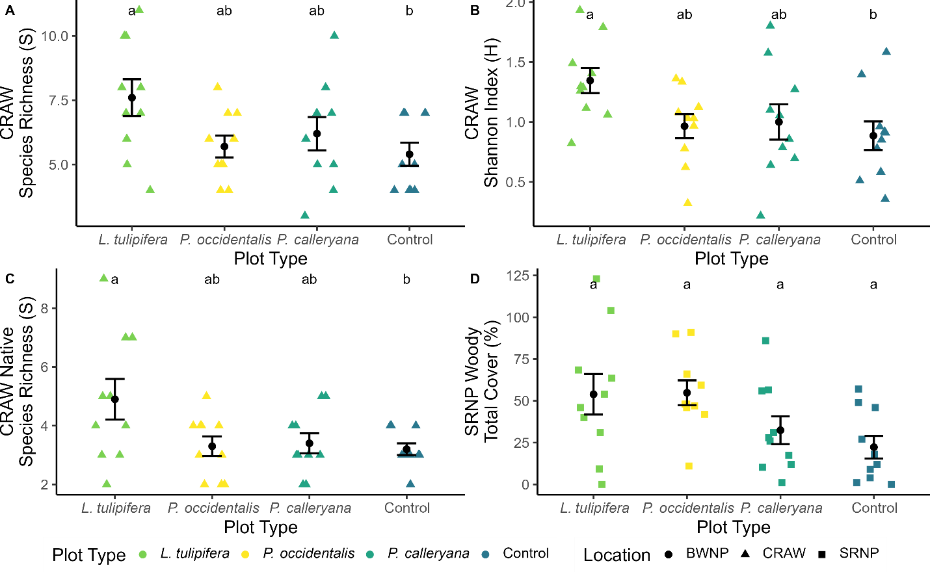
Supplementary Figure S6. Community total cover and diversity indices per community subset by field site (n = 40) for A) entire understory community species richness (S) at CRAW, B) entire understory community Shannon’s index (H) at CRAW, C) native understory community species richness (S) at CRAW, and D) woody understory community total cover (%) at SRNP. Shown are data points and mean ± SE; average values with the same letter code within each panel are not significantly different from each other. Site abbreviations as in Fig. S2.
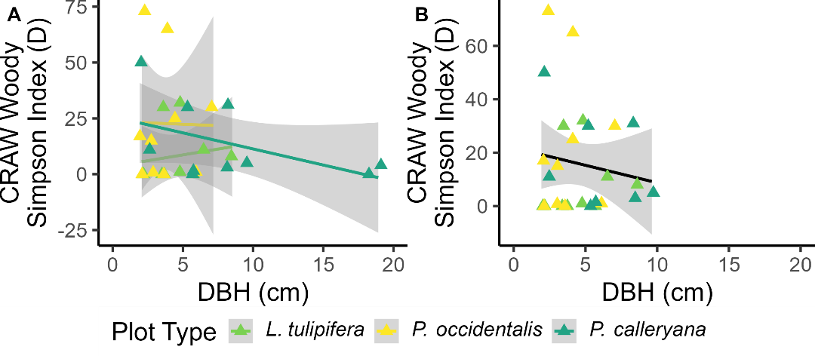
Supplementary Figure S7. Woody understory community Simpson’s diversity by the DBH (cm) of the overlying trees at CRAW (D), A) including all measured trees (n=30) or B) excluding the two largest P. calleryana trees (n=28). Shown are data points and line of best fit ± SE. Site abbreviations as in Fig. S2.
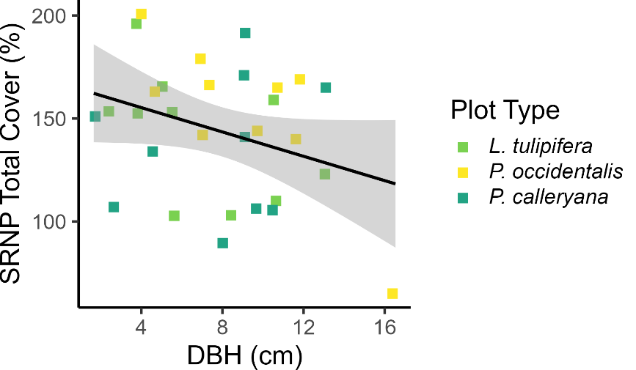
Supplementary Figure S8. Entire understory community total cover by the DBH (cm) of the overlying trees at SRNP (D; n = 30). Shown are data points and line of best fit ± SE. Site abbreviations as in Fig. S2.

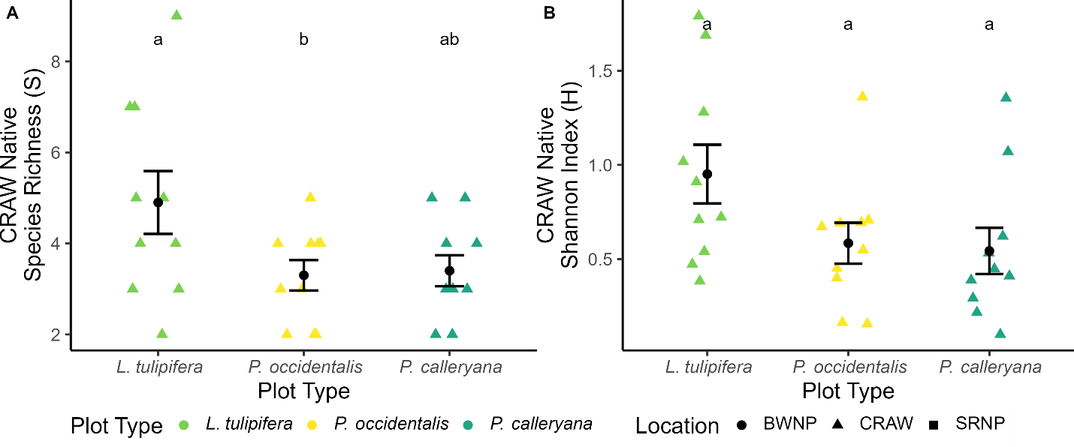
Supplementary Figure S9. Native understory community diversity indices at CRAW (H; n = 30) for A) species richness (S) and B) Shannon’s index of diversity (H). Shown are data points and mean ± SE; average values with the same letter code within each panel are not significantly different from each other. Site abbreviations as in Fig. S2.
SINGLE-SITE ANALYSIS
Table S5. Overall model results of the community indices by community subset, location, and model. Significant p-values shown in bold and marginal p-values shown in italics.
Community | Location | Model | Species richness (S) |  |  | Total cover (%) |  |  | Shannon index (H) |  |  | Simpson index (D)
 |  |  | F | p | Adjusted R² | F | p | Adjusted R² | F | p | Adjusted R² | F | p | Adjusted R²
Entire understory community | BWNP | w/o DBH | 0.189 | 0.90 | -0.07 | 1.336 | 0.28 | 0.03 | 0.393 | 0.76 | -0.05 | 0.288 | 0.83 | -0.06
 |  | w/ DBH | 0.573 | 0.72 | -0.08 | 1.121 | 0.38 | 0.02 | 0.419 | 0.83 | -0.11 | 0.181 | 0.97 | -0.16
 | CRAW | w/o DBH | 2.884 | 0.05 | 0.13 | 1.755 | 0.17 | 0.05 | 2.907 | 0.05 | 0.13 | 1.887 | 0.15 | 0.06
 |  | w/ DBH | 1.170 | 0.35 | 0.03 | 2.374 | 0.07 | 0.19 | 2.232 | 0.08 | 0.18 | 1.357 | 0.28 | 0.06
 | SRNP | w/o DBH | 1.208 | 0.32 | 0.02 | 0.473 | 0.70 | -0.04 | 0.296 | 0.83 | -0.06 | 1.218 | 0.32 | 0.02
 |  | w/ DBH | 0.078 | 1.00 | -0.19 | 2.628 | 0.05 | 0.22 | 0.282 | 0.92 | -0.14 | 0.783 | 0.57 | -0.04
Native community | BWNP | w/o DBH | 0.779 | 0.51 | -0.02 | 0.668 | 0.58 | -0.03 | 0.421 | 0.74 | -0.05 | 0.088 | 0.97 | -0.08
 |  | w/ DBH | 0.415 | 0.83 | -0.11 | 0.494 | 0.78 | -0.10 | 0.336 | 0.89 | -0.13 | 0.169 | 0.97 | -0.17
 | CRAW | w/o DBH | 3.475 | 0.03 | 0.16 | 0.398 | 0.76 | -0.05 | 2.739 | 0.06 | 0.12 | 2.179 | 0.11 | 0.08
 |  | w/ DBH | 3.126 | 0.03 | 0.27 | 1.215 | 0.33 | 0.04 | 3.167 | 0.02 | 0.27 | 1.919 | 0.13 | 0.14
 | SRNP | w/o DBH | 0.843 | 0.48 | -0.01 | 2.367 | 0.09 | 0.10 | 0.344 | 0.79 | -0.05 | 0.175 | 0.91 | -0.07
 |  | w/ DBH | 0.054 | 1.00 | -0.19 | 2.114 | 0.10 | 0.16 | 0.437 | 0.82 | -0.11 | 0.448 | 0.81 | -0.11
Introduced community | BWNP | w/o DBH | 0.888 | 0.46 | -0.01 | 0.268 | 0.85 | -0.06 | 1.360 | 0.27 | 0.03 | 0.762 | 0.52 | -0.02
 |  | w/ DBH | 0.663 | 0.66 | -0.06 | 0.763 | 0.59 | -0.04 | 1.332 | 0.28 | 0.05 | 0.453 | 0.81 | -0.10
 | CRAW | w/o DBH | 0.334 | 0.80 | -0.05 | 1.133 | 0.35 | 0.01 | 1.383 | 0.26 | 0.03 | 2.652 | 0.06 | 0.11
 |  | w/ DBH | 0.358 | 0.87 | -0.12 | 1.890 | 0.13 | 0.13 | 0.751 | 0.59 | -0.04 | 0.667 | 0.65 | -0.06
 | SRNP | w/o DBH | 0.324 | 0.81 | -0.05 | 0.888 | 0.46 | -0.01 | 0.135 | 0.94 | -0.07 | 2.190 | 0.11 | 0.08
 |  | w/ DBH | 0.239 | 0.94 | -0.15 | 0.974 | 0.45 | 0.00 | 0.294 | 0.91 | -0.14 | 0.930 | 0.48 | -0.01
Woody community | BWNP | w/o DBH | 1.030 | 0.39 | 0.00 | 1.213 | 0.32 | 0.02 | 0.383 | 0.77 | -0.05 | 1.304 | 0.29 | 0.02
 |  | w/ DBH | 0.341 | 0.88 | -0.13 | 0.219 | 0.95 | -0.16 | 0.341 | 0.88 | -0.13 | 0.926 | 0.48 | -0.01
 | CRAW | w/o DBH | 0.082 | 0.97 | -0.08 | 1.540 | 0.22 | 0.04 | 0.319 | 0.81 | -0.06 | 1.261 | 0.30 | 0.02
 |  | w/ DBH | 0.103 | 0.99 | -0.18 | 0.855 | 0.52 | -0.03 | 0.552 | 0.74 | -0.08 | 3.126 | 0.03 | 0.27
 | SRNP | w/o DBH | 0.370 | 0.78 | -0.05 | 3.286 | 0.03 | 0.15 | 0.114 | 0.95 | -0.07 | 0.222 | 0.88 | -0.06
 |  | w/ DBH | 0.495 | 0.78 | -0.10 | 1.256 | 0.31 | 0.04 | 0.317 | 0.90 | -0.13 | 0.371 | 0.86 | -0.12
Native tree community | BWNP | w/o DBH | 1.250 | 0.31 | 0.02 | 0.960 | 0.42 | 0.00 | 1.636 | 0.20 | 0.05 | 1.446 | 0.25 | 0.03
 |  | w/ DBH | 0.246 | 0.94 | -0.15 | 0.222 | 0.95 | -0.16 | 0.551 | 0.74 | -0.08 | 0.866 | 0.52 | -0.02
 | CRAW | w/o DBH | 1.539 | 0.22 | 0.04 | 1.880 | 0.15 | 0.06 | 1.000 | 0.40 | 0.00 | 1.497 | 0.23 | 0.04
 |  | w/ DBH | 0.721 | 0.61 | -0.05 | 0.726 | 0.61 | -0.05 | 0.508 | 0.77 | -0.09 | 0.817 | 0.55 | -0.03
 | SRNP | w/o DBH | 0.078 | 0.97 | -0.08 | 0.980 | 0.41 | 0.00 | 0.207 | 0.89 | -0.06 | 0.582 | 0.63 | -0.03
 |  | w/ DBH | 0.169 | 0.97 | -0.17 | 0.650 | 0.66 | -0.06 | 0.158 | 0.98 | -0.17 | 0.440 | 0.82 | -0.11

Table S6. ANOVA results of the linear models of community diversity indices by plot type, DBH, and their interaction, separated by model type, location, community subset, and diversity index. Significant p-values shown in bold and marginal p-values shown in italics.
Model | Location | Community | Index | Variable | F | p | ω²
w/o DBH | CRAW | Entire understory community | Species richness (S) | Plot type | 2.884 | 0.05 | 0.12
w/o DBH | CRAW | Entire understory community | Shannon index (H) | Plot type | 2.907 | 0.05 | 0.13
w/o DBH | CRAW | Native community | Species richness (S) | Plot type | 3.475 | 0.03 | 0.16
w/o DBH | SRNP | Woody community | Total cover (%) | Plot type | 3.287 | 0.03 | 0.15
w/ DBH | SRNP | Woody community | Total cover (%) | Plot type | 0.893 | 0.42 | -0.01
 |  |  |  | DBH | 5.123 | 0.03 | 0.11
 |  |  |  | Plot type * DBH | 3.070 | 0.06 | 0.11
w/ DBH | CRAW | Woody community | Simpson index (D) | Plot type | 2.449 | 0.11 | 0.07
 |  |  |  | DBH | 0.127 | 0.72 | -0.02
 |  |  |  | Plot type * DBH | 5.301 | 0.01 | 0.21
w/ DBH | CRAW | Native community | Species richness (S) | Plot type | 4.006 | 0.03 | 0.15
 |  |  |  | DBH | 3.224 | 0.08 | 0.06
 |  |  |  | Plot type * DBH | 2.196 | 0.13 | 0.06
w/ DBH | CRAW | Native community | Shannon index (H) | Plot type | 3.575 | 0.04 | 0.13
 |  |  |  | DBH | 2.619 | 0.12 | 0.04
 |  |  |  | Plot type * DBH | 3.032 | 0.07 | 0.10

