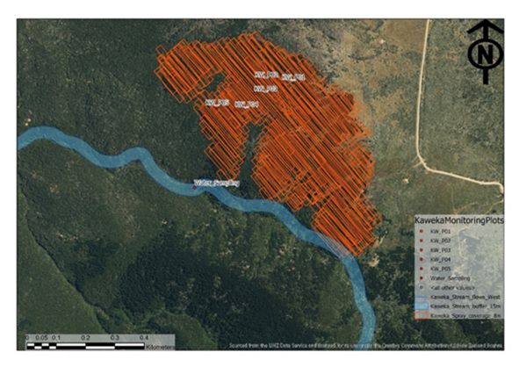

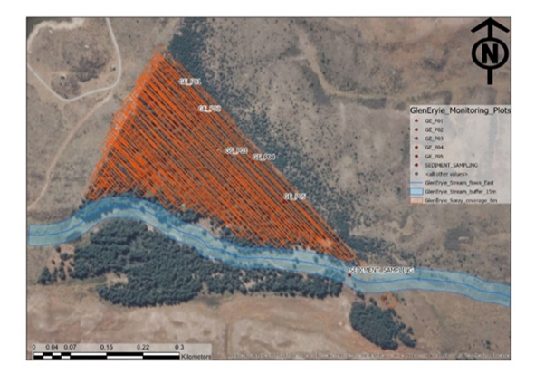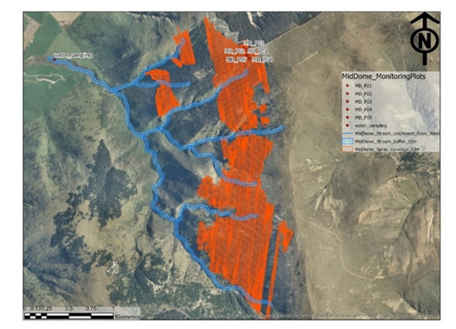

Supplementary Figure S1, a-c. Flight spray lines, position of sampling plots and riparian zone spray buffers at each trial site: Top Panel: Kaweka Forest; Middle Panel: Glen Eyrie Downs and Bottom Panel) Mid Dome.

