Supplementary Table S1. U.S. states and Canadian provinces with legal prohibitions against transport or propagation of Vincetoxicum species
State or province | Species | Status | Notes | References
Connecticut | V. rossicum, V. nigrum | Prohibited | V. rossicum listed as Cynanchum rossicum, V. nigrum as C. louiseae | (Connecticut Invasive Plants Council 2018)
Massachusetts | V. rossicum, V. nigrum | Prohibited | As C. rossicum, C. louiseae | (Massachusetts Department of Agricultural Resources 2017)
Minnesota | V. nigrum | Prohibited Eradicate | As C. louiseae | (Minnesota Department of Agriculture 2022)
New Hampshire | V. rossicum, V. nigrum | Prohibited | As C. rossicum, C. louiseae | (New Hampshire Department of Agriculture, Markets & Food 2017)
New York | V. rossicum, V. nigrum | Prohibited | As C. rossicum, C. louiseae | (New York State Department of Environmental Conservation 2014)
Ohio | V. nigrum | Invasive | A legal status similar to “prohibited” status in other states | (State of Ohio 2018)
Ontario | V. rossicum, V. nigrum | Noxious | V. rossicum as dog-strangling vine, V. nigrum as black dog-strangling vine | (Ontario Ministry of Agriculture, Food and Rural Affairs 2015)
Pennsylvania | V. rossicum, V. nigrum | Class B Noxious Weeds |  | (Pennsylvania Department of Agriculture n.d.)
Vermont | V. rossicum, V. nigrum | Class A Noxious Weed (V. rossicum), Class B Noxious Weed (V. nigrum) | V. rossicum as (erroneously) V. hirundinaria | (Vermont Agency of Agriculture, Food & Markets 2012)
Wisconsin | V. rossicum, V. nigrum | Prohibited (V. rossicum), Prohibited/ Restricted (V. nigrum) | Restricted species (unlike prohibited species) are already established. V. nigrum is established in some parts of Wisconsin. | (State of Wisconsin 2017)

References
Connecticut Invasive Plants Council (2018) Connecticut Invasive Plant List https://cipwg.uconn.edu/wp-content/uploads/sites/244/2018/12/CT-Invasive-Plant-List-2018Scientific-Name.pdf. Accessed March 30, 2022
Massachusetts Department of Agricultural Resources (2017) The Massachusetts Prohibited Plant List. https://www.mass.gov/doc/prohibited-plant-list-sorted-by-scientific-name/download. Accessed March 30, 2022
Minnesota Department of Agriculture (2022) 2022 Noxious Weed List. https://www.mda.state.mn.us/sites/default/files/docs/2022-02/2022NoxiousWeedListFactsheet.pdf. Accessed March 30, 2022
New Hampshire Department of Agriculture, Markets & Food (2017) Fact Sheet: Prohibited Invasive Plant Species Rules, Agr 3800. https://www.agriculture.nh.gov/publications-forms/documents/prohibited-invasive-species.pdf. Accessed March 30, 2022
New York State Department of Environmental Conservation (2014) New York State Prohibited and Regulated Invasive Plants. https://www.dec.ny.gov/docs/lands_forests_pdf/isprohibitedplants2.pdf. Accessed March 30, 2022
Ontario Ministry of Agriculture, Food and Rural Affairs (2015) Noxious Weeds in Ontario. http://www.omafra.gov.on.ca/english/crops/facts/noxious_weeds.htm. Accessed March 30, 2022
Pennsylvania Department of Agriculture (n.d.) Controlled Plant & Noxious Weeds. https://www.agriculture.pa.gov/Plants_Land_Water/PlantIndustry/NIPPP/Pages/Controlled-Plant-Noxious-Weed.aspx. Accessed March 30, 2022
State of Ohio (2018) Rule 901:5-30-01. Invasive Plant Species. https://codes.ohio.gov/ohio-administrative-code/rule-901:5-30-01. Accessed March 30, 2022
State of Wisconsin (2017) Chapter NR40. Invasive Species Identification, Classification and Control. https://docs.legis.wisconsin.gov/code/admin_code/nr/001/40.pdf. Accessed March 30, 2022
Vermont Agency of Agriculture, Food & Markets (2012) Quarantine #3 – Noxious Weeds. https://agriculture.vermont.gov/sites/agriculture/files/documents/PHARM/Plant_Pest/NoxiousWeedsQuarantine.pdf. Accessed March 30, 2022

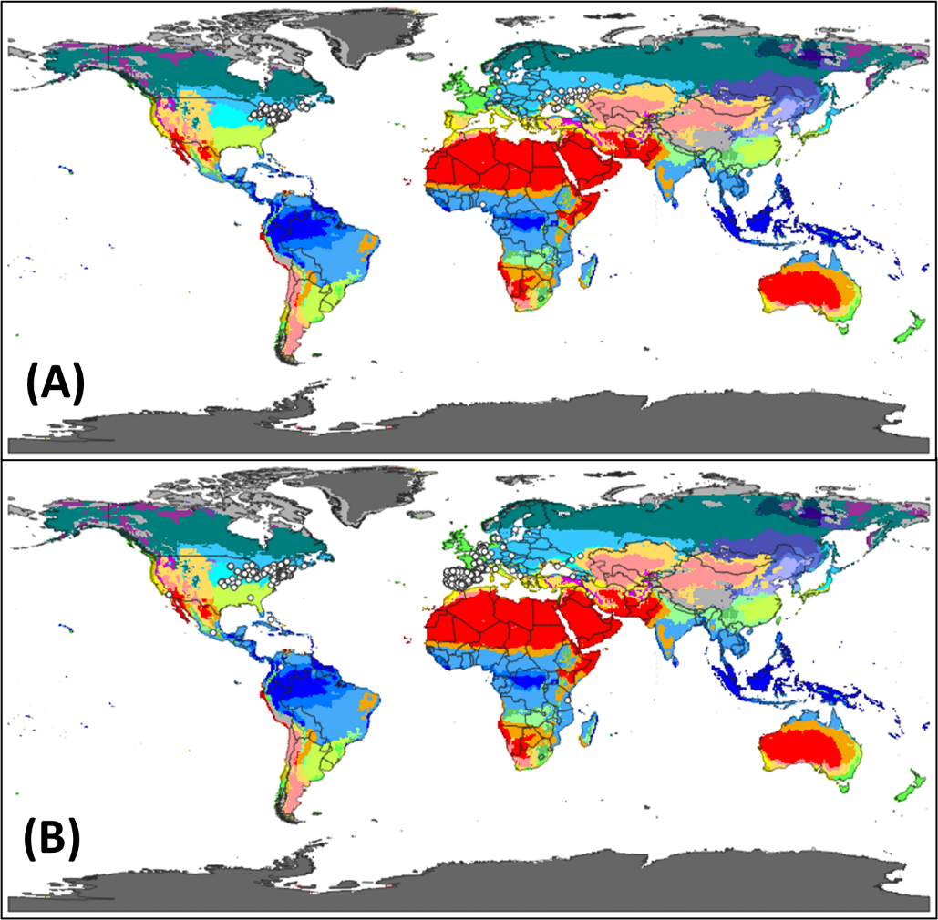
Supplementary Figure S1. (A) Current distribution of Vincetoxicum rossicum (Global Biodiversity Information Facility 2021a) with Köppen-Geiger climate classification (1 km resolution; WGS-84; Beck et al. 2018). Vincetoxicum rossicum inhabits Aw (tropical, savannah; 1 point), BSk (arid, steppe, cold; 6 points), Cfb (temperate, no dry season, warm summer; 8 points), Dfa (cold, no dry season, hot summer; 532 points), Dfb (cold, no dry season, warm summer; 2,159 points) and Dfc (cold, no dry season, cold summer; 20 points) climate types. (B) Current distribution of Vincetoxicum nigrum (Global Biodiversity Information Facility 2021b) with Köppen-Geiger climate classification (1 km resolution; WGS-84; Beck et al. 2018). Vincetoxicum nigrum inhabits Aw (tropical, savannah; 1 point), BWh (arid, desert, hot; 4 points), BSh (arid, steppe, hot; 11 points), BSk (arid, steppe, cold; 980 points), Csa (temperate, dry summer, hot summer; 1,313 points), Csb (temperate, dry summer, warm summer; 279 points), Cwb (temperate, dry winter, warm summer; 1 point), Cfa (temperate, no dry season, hot summer; 165 points), Cfb (temperate, no dry season, warm summer; 657 points), Cfc (temperate, no dry season, cold summer; 2 points), Dsa (cold, dry summer, hot summer; 4 points), Dsb (cold, dry summer, warm summer; 4 points), Dsc (cold, dry summer, cold summer; 3 points), Dfa (cold, no dry season, hot summer; 1,033 points), Dfb (cold, no dry season, warm summer; 308 points), Dfc (cold, no dry season, cold summer; 12 points), and ET (polar tundra; 1 point) climate types.

Supplementary Appendix S1: CLIMEX models for Vincetoxicum rossicum and V. nigrum
Distribution
Both species are native to Europe (Russia and Ukraine for V. rossicum and southwestern Europe for V. nigrum). These species have invaded other areas of Europe and North America (see “Distribution” in main text).

Comments and literature review related to fitting CLIMEX parameters
Distribution records used to estimate CLIMEX parameter values
Distribution data for V. rossicum and V. nigrum were retrieved from the Global Biodiversity Information Facility (2021a, 2021b). CLIMEX software (version 4, Hearne Software, Melbourne, Australia) was used to model potential distributions based on these distribution data and the scientific literature.

Evidence for non-climatic limits to distribution
Physical barriers: Although highly disturbed habitats such as tilled crop fields are unsuitable for Vincetoxicum species, these species inhabit diverse habitats including urban environments (see “Importance”, “Habitat” in main text; Cadotte et al. 2017; Potgieter and Cadotte 2020).

Vectors: Seeds are primarily transported by wind over short distances and by anthropogenic activity over long distances (see “Dispersal and Establishment”, “Invasion Pathways” in main text). Some seeds may be transported by animals such as white-tailed deer (Odocoileus virginianus).

Other species: Several specialist herbivores help control Vincetoxicum species in their native ranges (see “Management Options: Biological” in main text). These specialist herbivores are generally absent from the invaded ranges. Competition from other plant species may reduce the performance of V. rossicum and V. nigrum and lengthen time-to-flowering (see “Life-Form and Life History”, “Dispersal and Establishment” in main text).

Artificial environments: Vincetoxicum species tolerate a variety of moisture and temperature levels, but abiotic limits to their distributions are not fully understood (see “Stress indices” in this document). It is possible that V. rossicum and V. nigrum could be grown in glasshouses or irrigated fields in geographic areas beyond these limits.

Stress indices
Hot: The heat stress temperature threshold (TTHS) represents the average weekly maximum temperature above which heat stress accumulates. For V. rossicum, TTHS was set to 30 C to reflect tolerance of moderately warm temperatures, such as those found in Indiana, USA. For V. nigrum, TTHS was set to 34 C to account for distribution records located farther south (see “Growth: Temperature” in this document).

Cold: The cold stress temperature threshold (TTCS) represents the average weekly minimum temperature below which cold stress accumulates. Although V. rossicum may survive very cold temperatures, including minimum temperatures of –35 C in Ontario (Dickinson et al. 2021; Dickinson and Royer 2014 p. 40), these temperatures impose stress. TTCS was set to –17 C in V. rossicum and –15 C in V. nigrum to account for populations near the northern range limits.

Dry: Dry stress is accumulated when average weekly soil moisture drops below the dry stress threshold (SMDS). Vincetoxicum species occupy a variety of soil moisture environments, but drought may reduce growth and reproduction (DiTommaso et al. 2021; Joline and DiTommaso 2016). Therefore, we set SMDS to 0.1, representing a typical permanent wilting point (Kriticos et al. 2015).

Wet: Wet stress is accumulated when average weekly soil moisture exceeds the wet stress threshold (SMWS). For example, some plant species experience wet stress above field capacity (SM = 1.0). In their invaded North American ranges, V. rossicum and V. nigrum often inhabit wet habitats and can tolerate seasonal (not permanent) flooding (DiTommaso et al. 2005; Kricsfalusy and Miller 2010; Lawlor 2002). To account for this tolerance of wet habitats, SMWS was set to 1.5 for V. rossicum and 1.4 for V. nigrum.

Climatic constraints
Length of growing season: In their invaded North American ranges, Vincetoxicum plants typically begin growing in spring (April or May) and release seeds in late summer or autumn (see “Growth and Development: Phenology” in main text). Phenology depends on environmental factors, including temperature (Sanderson and Antunes 2013). However, detailed data on the relationship between climate and phenology were not available, so we did not explicitly include phenological information in the CLIMEX model.

Growth
Temperature: In CLIMEX, the effect of temperature on growth is defined by Temperature Index parameters: DV0 (the average weekly minimum temperature below which growth ceases), DV1 (the average weekly minimum temperature below which growth is reduced), DV2 (the average weekly maximum temperature above which growth is reduced), and DV3 (the average weekly maximum temperature above which growth ceases).
DV0 was set at 7 C for both species. This value was slightly lower than the maximum April temperature at the northern boundary of their Canadian distributions. DV1 and DV2 were set at 12 C and 24 C, respectively, in both species. These values reflected the minimum and maximum June temperatures in upstate New York, USA, an area with many distribution records for both species. The DV3 value was set to 28 C for V. rossicum and 30 C for V. nigrum, slightly below the heat stress temperature threshold.

Moisture: In CLIMEX, SM0 is the limiting low moisture (weekly average) below which growth ceases, SM1 is the lower limit of the optimal moisture range, SM2 is the upper limit of the optimal moisture range, and SM3 is the limiting high moisture above which growth ceases. SM values in CLIMEX translate to percentages: SM = 0 indicates no soil moisture, SM = 0.5 indicates that moisture is at 50% of field capacity, and SM = 1 indicates completely saturated soil (field capacity). For V. rossicum, SM0 was set to 0.1, a typical value for plants not adapted to arid environments (Kriticos et al. 2015). SM1 was set to 0.4 as an intermediate value, SM2 was set to 0.9 because Vincetoxicum species can tolerate wet conditions, and SM3 was set to 1.2 because Vincetoxicum species do not occupy wetlands (DiTommaso et al. 2005; Lawlor 2002). The same values were used for V. nigrum, except that SM3 was set to 1.4 to account for distribution points in Mexico and Colombia.

Results
Goodness of fit
For V. rossicum, most distribution records are within areas projected to be suitable by the CLIMEX model. There is an exception in Nigeria, where a distribution point lies significantly outside of the projected range. Assuming that this distribution record is valid, it likely represents an anthropogenic introduction (possibly associated with a nearby fresh food market; Google 2022) that may not result in establishment. For V. nigrum, distribution records generally fall within the projected range.

Independent validation:
Because both native and invasive distributions were used to fit the CLIMEX model, independent validation was not possible.

Source risks
Vincetoxicum species are likely to colonize new areas following transport of seeds from areas with large Vincetoxicum populations, such as the northeastern United States. Long-distance seed transport is primarily anthropogenic (see “Invasion Pathways” in main text) and most seeds exhibit some dormancy (see “Reproduction: Seedbanks, Seed Viability, and Germination” in main text). Based on the invasion trajectory observed in North America (see “Invasion History” in main text), it seems likely that V. rossicum and V. nigrum will exhibit long lag phases in newly invaded regions before achieving rapid population growth.

Destination risks
For V. rossicum, approximately half of the United States (including Alaska’s southern coast) and parts of Canada are somewhat suitable. Parts of western and southern South America (especially Peru, Bolivia, Chile, and Argentina) are also suitable. Most areas of Europe are highly suitable. The suitable region extends as far as eastern Russia, the Caucasus region, and Turkey. There are also suitable areas in Central Asia, South Asia, central and eastern China, North Korea, South Korea, the southern coast of Australia, New Zealand, and South Africa.
A larger area of the world is moderately to highly suitable for V. nigrum, relative to V. rossicum. Most of the United States is potentially suitable, especially the eastern United States and the west coast. Parts of Canada, Mexico, and Central America are also suitable. In South America, suitable areas are concentrated on the west coast, in the southern part of the continent (especially eastern Argentina), and in southeastern Brazil. Europe is almost universally highly suitable, excluding northern Scandinavia. Parts of the Middle East, Central Asia, and South Asia are suitable. East Asia, particularly eastern China, and Southeast Asia are potentially suitable, as are southern and eastern Australia and New Zealand. Some areas in northern, central and southern Africa may be vulnerable to invasion as well.

Discussion
The CLIMEX models indicate which areas of the world may be suitable for V. rossicum and V. nigrum persistence under current climate. Model accuracy may be limited a lack of data on soil moisture requirements. Temperature requirements are also not fully characterized, partially because responses to temperature vary among Vincetoxicum populations. Where experimental data were not available or sufficient, we used inferences from current Vincetoxicum distributions to calibrate the CLIMEX models. Consequently, almost all reported occurrences are located in areas that are suitable according to the models.
In North America, existing Vincetoxicum populations mostly occur in the northeastern United States and southeastern Canada. Our findings suggest that both species could expand their North American distributions, although some areas of North America are climatically unsuitable (e.g., too dry or cold) for persistence. In Europe, both species are found mostly in their native ranges (V. rossicum is primarily found in Ukraine and Russia, whereas V. nigrum is primarily found in southwestern Europe). According to the CLIMEX model, both species could colonize most other areas of Europe. However, we reiterate that this model only describes climatic suitability and does not account for biotic influences such as specialist herbivores or competition.
If Vincetoxicum species are transported long distances by humans, they may colonize other areas of the world. These areas may include parts of South America, Asia, Africa (primarily V. nigrum), and Australia. The extensive potential distributions of V. rossicum and V. nigrum underscore the need for preventative measures to limit seed and plant transport, as well as Early Detection and Rapid Response (EDRR) programs to address new invasions. To support accurate risk assessments, additional studies are needed to model potential Vincetoxicum distributions at high spatial resolution, incorporate non-climatic factors, and assess the possible effects of future climate change.

References
Beck HE, Zimmermann NE, McVicar TR, Vergopolan N, Berg A, Wood EF (2018) Present and future Köppen-Geiger climate classification maps at 1-km resolution. Sci Data 5:180214, 10.1038/sdata.2018.214
Cadotte MW, Yasui SLE, Livingstone S, MacIvor JS (2017) Are urban systems beneficial, detrimental, or indifferent for biological invasion? Biol Invasions 19:3489–3503
Dickinson RB, Bourchier RS, Fulthorpe RR, Shen SY, Jones IM, Smith SM (2021) Fungal endophytes increase biomass production in pale swallow-wort (Vincetoxicum rossicum (Kleopow) Barbar.). Botany 99:337–353
Dickinson R, Royer F (2014) Weeds of North America. Chicago: University of Chicago Press. 830 p
DiTommaso A, Averill KM, Qin Z, Ho M, Westbrook AS, Mohler CL (2021) Biomass allocation of Vincetoxicum rossicum and V. nigrum in contrasting competitive environments. Am J Bot 108:1646–1661
DiTommaso A, Lawlor FM, Darbyshire SJ (2005) The biology of invasive alien plants in Canada. 2. Cynanchum rossicum (Kleopow) Borhidi [= Vincetoxicum rossicum (Kleopow) Barbar.] and Cynanchum louiseae (L.) Kartesz & Gandhi [= Vincetoxicum nigrum (L.) Moench]. Can J Plant Sci 85:243–263
Global Biodiversity Information Facility (2021a) Vincetoxicum rossicum (Kleopow) Barbar. https://www.gbif.org/species/5414550. Accessed January 20, 2022
Global Biodiversity Information Facility (2021b) Vincetoxicum nigrum (L.) Moench. https://www.gbif.org/species/5414551. Accessed January 20, 2022
Google (2022) Google Maps. https://www.google.com/maps/. Accessed March 14, 2022
Joline MC, DiTommaso A (2016) Effect of water availability on competitive interactions between two invasive swallowworts (Vincetoxicum spp.) and common milkweed (Abstract). Page 63 in AE Gover, ed. Proceedings of the 1st Annual Meeting of the Northeastern Plant, Pest, and Soils Conference
Kricsfalusy V, Miller G (2010) Community ecology and invasion of natural vegetation by Cynanchum rossicum (Asclepiadaceae) in the Toronto region, Canada. Thaiszia J Bot 20:53–70
Kriticos DJ, Maywald GF, Yonow T, Zurcher EJ, Herrmann NI, Sutherst RW (2015) CLIMEX Version 4: Exploring the Effects of Climate on Plants, Animals and Diseases. Canberra, Australia: CSIRO. 156 p
Lawlor F (2002) Element Stewardship Abstract for Vincetoxicum nigrum (L.) Moench. and Vincetoxicum rossicum (Kleopov) Barbarich: Swallow-wort. Arlington, VA: The Nature Conservancy. 13 p
NOAA NCEI (2022) Global Historical Climatology Network. https://www.ncei.noaa.gov/. Accessed March 3, 2022
Potgieter LJ, Cadotte MW (2020) The application of selected invasion frameworks to urban ecosystems. NeoBiota 62:365–386
Sanderson LA, Antunes PM (2013) The exotic invasive plant Vincetoxicum rossicum is a strong competitor even outside its current realized climatic temperature range. NeoBiota 16:1–15

Supplementary Table S2. CLIMEX parameter values for Vincetoxicum rossicum
Parameter | Description | Value
Moisture
SM0 | Lower soil moisture threshold | 0.1
SM1 | Lower optimum soil moisture | 0.4
SM2 | Upper optimum soil moisture | 0.9
SM3 | Upper soil moisture threshold | 1.2
Temperature
DV0 | Lower temperature threshold | 7 C
DV1 | Lower optimum temperature | 12 C
DV2 | Upper optimum temperature | 24 C
DV3 | Upper temperature threshold | 28 C
Cold Stress
TTCS | Cold stress temperature threshold | –17 C
THCS | Cold stress accumulation rate | –0.01 week^{–1}
DTCS | Cold stress degree-day threshold¹ | 0
DHCS | Cold stress degree-day accumulation rate | 0
Heat Stress
TTHS | Heat stress temperature threshold | 30 C
THHS | Heat stress accumulation rate | 0.01 week^{–1}
Dry Stress
SMDS | Dry stress threshold | 0.1
HDS | Dry stress accumulation rate | –0.01 week^{–1}
Wet Stress
SMWS | Wet stress threshold | 1.5
HWS | Wet stress accumulation rate | 0.001 week^{–1}
¹Stress accumulates if there are fewer than the threshold number of degree-days above DV0

Supplementary Table S3. CLIMEX parameter values for Vincetoxicum nigrum
Parameter | Description | Value
Moisture
SM0 | Lower soil moisture threshold | 0.1
SM1 | Lower optimum soil moisture | 0.4
SM2 | Upper optimum soil moisture | 0.9
SM3 | Upper soil moisture threshold | 1.4
Temperature
DV0 | Lower temperature threshold | 7 C
DV1 | Lower optimum temperature | 12 C
DV2 | Upper optimum temperature | 24 C
DV3 | Upper temperature threshold | 30 C
Cold Stress
TTCS | Cold stress temperature threshold | –15 C
THCS | Cold stress accumulation rate | –0.01 week^{–1}
DTCS | Cold stress degree-day threshold¹ | 0
DHCS | Cold stress degree-day accumulation rate | 0
Heat Stress
TTHS | Heat stress temperature threshold | 34 C
THHS | Heat stress accumulation rate | 0.01 week^{–1}
Dry Stress
SMDS | Dry stress threshold | 0.1
HDS | Dry stress accumulation rate | –0.01 week^{–1}
Wet Stress
SMWS | Wet stress threshold | 1.4
HWS | Wet stress accumulation rate | 0.001 week^{–1}
¹Stress accumulates if there are fewer than the threshold number of degree-days above DV0

