Supplementary Materials

Table S1.
Sample size and the levels of the categorical variables of treatment intensity by park district and treatment type

Sub-dataset | Rincon Mountain District, chemical treatment | Rincon Mountain District, mechanical treatment | Tucson Mountain District, chemical treatment | Tucson Mountain District, mechanical treatment
Sample size | 1508 | 590 | 510 | 554
Levels of total years of treatment | 2, 3, 4, and 5+ years | 2, 3, and 4+ years | 2, 3, 4, and 5+ years | 2, 3, 4, and 5+ years
Levels of average years of treatment gap | 0, 1, 2, 3-4, and 5+ years | 0, 1, 2, 3-4, and 5+ years | 0, 1, and 2+ years | 0, 1, 2, and 3+ years

Table S2.
Pairwise comparisons within the GLS model where initial Pennisetum ciliare cover (log10 transformed) was the response variable and total years of treatment or average years of treatment gaps was the explanatory variable. The differences with p values lower than 0.05 are in bold.

Contrast | Difference in estimated marginal means of (log₁₀ transformed) initial P. ciliare cover | Standard error | Degrees of freedom | t value | p value
Levels of total years of treatment
3 – 2 | 0.246 | 0.044 | 3073 | 5.556 | < 0.0001
4 – 2 | 0.534 | 0.058 | 2953 | 9.193 | < 0.0001
(5+) – 2 | 0.771 | 0.074 | 2937 | 10.373 | < 0.0001
4 – 3 | 0.288 | 0.061 | 2733 | 4.762 | < 0.0001
(5+) – 3 | 0.525 | 0.075 | 2785 | 6.969 | < 0.0001
(5+) – 4 | 0.237 | 0.082 | 2654 | 2.907 | 0.004
Levels of average years of treatment gaps
1 – 0 | -0.103 | 0.049 | 3107 | -2.111 | 0.035
2 – 0 | -0.133 | 0.054 | 3138 | -2.452 | 0.014
(3-4) – 0 | -0.231 | 0.071 | 3124 | -3.278 | 0.001
(5+) – 0 | -0.256 | 0.097 | 3060 | -2.649 | 0.008
2 – 1 | -0.030 | 0.060 | 3101 | -0.494 | 0.621
(3-4) – 1 | -0.129 | 0.076 | 3136 | -1.699 | 0.089
(5+) – 1 | -0.153 | 0.101 | 3072 | -1.514 | 0.130
(3-4) – 2 | -0.099 | 0.075 | 3135 | -1.308 | 0.191
(5+) – 2 | -0.123 | 0.100 | 3100 | -1.235 | 0.217
(5+) – (3-4) | -0.024 | 0.108 | 3100 | -0.225 | 0.822

Table S3.
Pairwise comparisons of treatment effectiveness among park districts (TMD = Tucson Mountain District, RMD = Rincon Mountain District), treatment type, and their interactions within the most parsimonious GLS model. Significant pairwise differences (p < 0.05) are in bold.

Contrast | Difference in estimated marginal means of treatment effectiveness index | Standard error | Degrees of freedom | t value | p value
TMD Chemical - RMD Chemical | 0.031 | 0.110 | 466 | 0.278 | 0.781
RMD Mechanical - RMD Chemical | -0.490 | 0.080 | 1007 | -6.101 | < 0.0001
TMD Mechanical - RMD Chemical | -0.065 | 0.096 | 548 | -0.676 | 0.499
RMD Mechanical - TMD Chemical | -0.521 | 0.111 | 682 | -4.710 | < 0.0001
TMD Mechanical - TMD Chemical | -0.096 | 0.116 | 764 | -0.823 | 0.411
TMD Mechanical - RMD Mechanical | 0.425 | 0.096 | 591 | 4.411 | < 0.0001

Table S4.
Pairwise comparisons of treatment effectiveness among total years of treatment within the most parsimonious GLS models, shown by park district and treatment type. Only results from models where total years of treatment was selected as a significant variable were shown in the table. Significant pairwise differences (p < 0.05) are in bold.

Contrast | Difference in estimated marginal means of treatment effectiveness index | Standard error | Degrees of freedom | t value | p value
Rincon Mountain District, chemical treatment
3 – 2 | -0.044 | 0.061 | 1407 | -0.727 | 0.468
4 – 2 | -0.084 | 0.071 | 1418 | -1.175 | 0.240
(5+) – 2 | -0.273 | 0.094 | 1381 | -2.911 | 0.004
4 – 3 | -0.039 | 0.073 | 1210 | -0.542 | 0.588
(5+) – 3 | -0.229 | 0.094 | 1310 | -2.428 | 0.015
(5+) – 4 | -0.189 | 0.098 | 1291 | -1.940 | 0.053
Tucson Mountain District, mechanical treatment
3 – 2 | 0.237 | 0.108 | 538 | 2.193 | 0.029
4 – 2 | 0.306 | 0.157 | 547 | 1.946 | 0.052
(5+) – 2 | 0.523 | 0.210 | 518 | 2.490 | 0.013
4 – 3 | 0.069 | 0.173 | 535 | 0.401 | 0.689
(5+) – 3 | 0.286 | 0.220 | 490 | 1.300 | 0.194
(5+) – 4 | 0.216 | 0.237 | 476 | 0.912 | 0.362

Table S5.
Pairwise comparisons of treatment effectiveness among average years of treatment gap within the most parsimonious GLS models, shown by park district and treatment type. Only results from models where average years of treatment gaps was selected as a significant variable were shown in the table. Significant pairwise differences (p < 0.05) are in bold.

Contrast | Difference in estimated marginal means of treatment effectiveness index | Standard error | Degrees of freedom | t value | p value
Rincon Mountain District, chemical treatment
1 – 0 | 0.092 | 0.064 | 1385 | 1.450 | 0.147
2 – 0 | -0.032 | 0.072 | 1491 | -0.449 | 0.654
(3-4) – 0 | -0.170 | 0.090 | 1497 | -1.888 | 0.059
(5+) – 0 | -0.615 | 0.116 | 1483 | -5.297 | < 0.0001
2 – 1 | -0.124 | 0.076 | 1456 | -1.644 | 0.100
(3-4) – 1 | -0.262 | 0.095 | 1485 | -2.744 | 0.006
(5+) – 1 | -0.707 | 0.121 | 1494 | -5.821 | < 0.0001
(3-4) – 2 | -0.138 | 0.096 | 1433 | -1.436 | 0.151
(5+) – 2 | -0.583 | 0.122 | 1497 | -4.783 | < 0.0001
(5+) – (3-4) | -0.445 | 0.131 | 1483 | -3.390 | < 0.0001
Rincon Mountain District, mechanical treatment
1 – 0 | -0.098 | 0.173 | 426 | -0.567 | 0.571
2 – 0 | -0.136 | 0.114 | 429 | -1.199 | 0.231
(3-4) – 0 | -0.381 | 0.120 | 548 | -3.166 | 0.002
(5+) – 0 | -0.782 | 0.179 | 463 | -4.359 | < 0.0001
2 – 1 | -0.038 | 0.192 | 386 | -0.200 | 0.842
(3-4) – 1 | -0.283 | 0.200 | 452 | -1.419 | 0.157
(5+) – 1 | -0.684 | 0.240 | 510 | -2.847 | 0.005
(3-4) – 2 | -0.245 | 0.145 | 485 | -1.688 | 0.092
(5+) – 2 | -0.645 | 0.198 | 523 | -3.253 | 0.001
(5+) – (3-4) | -0.401 | 0.203 | 503 | -1.971 | 0.049
Tucson Mountain District, chemical treatment
1 – 0 | -0.145 | 0.094 | 470 | -1.544 | 0.123
(2+) – 0 | 0.167 | 0.123 | 492 | 1.353 | 0.177
(2+) – 1 | 0.312 | 0.136 | 482 | 2.294 | 0.022

Figure S1.
Calculation of total Pennisetum ciliare cover within a 20 m × 20 m grid cell. The green polygons represent polygons in which treatment and P. ciliare percent canopy cover were recorded within a fiscal and water year. Polygon 1 and 2, with an area of a₁ and a₂ fall within the same grid cell. Polygon 3 partially overlaps with grid cell A and the area of the overlapping area is a₃₁. The P. ciliare percent canopy cover (c) shown in each polygon is the midpoint of the percent canopy cover class recorded in each polygon (e.g., 38% is the midpoint of 26-50%). The total P. ciliare cover in the grid cell, shown at the bottom of the figure, is the sum of net P. ciliare cover of all polygon areas that fall within the grid cell.

Figure S2.
The distribution of initial buffelgrass (Pennisetum ciliare) cover in a 400 m² cell did not deviate substantially from a normal distribution on a log scale and had a median of 1.29 m² and a mean of 1.05 m².
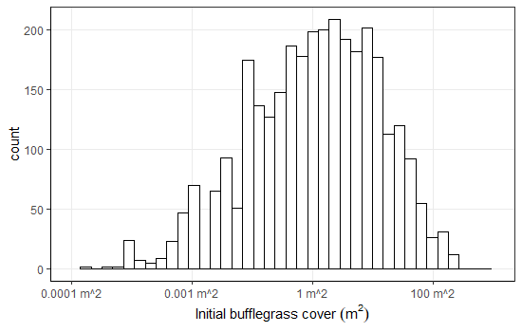

Figure S3.
(A) The distribution of the treatment effectiveness index has a normal distribution compared to (B) a difference of post-treatment and initial buffelgrass (Pennisetum ciliare) cover.
A.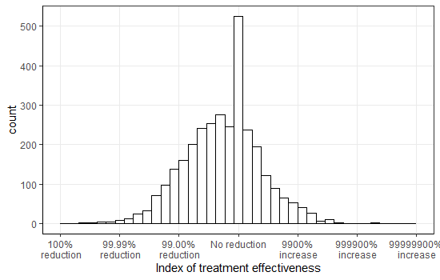
B. 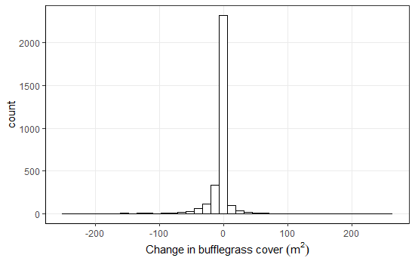

Figure S4.
The relationship between initial Pennisetum ciliare canopy cover and treatment intensity quantified by (A) total years of treatment and (B) average years of treatment gap. Crosses indicate the means and the error bars indicate the 95% confidence intervals. Significant pair-wise differences among treatment intensity levels indicated by different letters and in Table S2

Appendix 1.
Statistical results of all final GLS models in which AIC and log-likelihood of each model are based on restricted maximum likelihood (REML) estimation.
1. The models determining the relationship between treatment effectiveness and treatment intensity

Model: treatment effectiveness index ~ total years of treatment
Data: full dataset
AIC = 8741.093; logLik = -4363.546
Error correlation structure: spherical spatial correlation (range = 249.23 m; nugget= 0.55 m)
Error variance function: none
Residual standard error: 1.076546
Degrees of freedom: 3162 total; 3158 residual
Model: treatment effectiveness index ~ average tears of treatment gap
Data: full dataset
AIC = 8878.353; logLik = -4431.177
Error correlation structure: spherical spatial correlation (range = 232.35 m; nugget = 0.52 m)
Error variance function: none
Residual standard error: 1.105886
Degrees of freedom: 3162 total; 3157 residual

2. The model determining the influence on treatment effectiveness by park district and treatment methods
Model: treatment effectiveness index ~ district × treatment method
Data: full dataset
AIC = 9964.636; logLik = -4974.318
Error correlation structure: spherical spatial correlation (range = 158.11 m; nugget = 0.60 m)
Error variance function:
Structure: Different standard deviations per stratum
Formula: ~1 | treatment method
Parameter estimates: mechanical treatment = 1.000000; chemical treatment = 1.054029
Residual standard error: 1.207057
Degrees of freedom: 3162 total; 3158 residual

3. The models determining the influence on treatment effectiveness by the initial Pennisetum ciliare cover, treatment intensity and physical environmental factors in each district and with each treatment method
Model: treatment effectiveness index ~ log₁₀(initial P. ciliare cover) + total years of treatment + average years of treatment gap + eastness
Data: data subset of Rincon Mountain District and chemical treatment
AIC = 4072.896; logLik = -2024.448
Error correlation Structure: spherical spatial correlation (range = 40.73 m; nugget = 0)
Error variance function: none
Residual standard error: 0.9668044
Degrees of freedom: 1508 total; 1498 residual
Model: treatment effectiveness index ~ log₁₀(initial P. ciliare cover) + average years of treatment gap + slope
Data: data subset of Rincon Mountain District and mechanical treatment
AIC = 1584.113; logLik = -781.0563
Error correlation structure: spherical spatial correlation (range = 38.59; nugget = 0)
Error variance function:
Structure: different standard deviations per stratum
Formula: ~1 | total years of treatment
Parameter estimates: 2 years = 1.000000; 3 years = 1.256386; 4+ years = 1.147869
Residual standard error: 0.871096
Degrees of freedom: 590 total; 583 residual
Model: treatment effectiveness index ~ log₁₀(initial P. ciliare cover) + average years of treatment gap + slope + elevation + northness
Data: data subset of Tucson Mountain District and chemical treatment
AIC = 1337.136; logLik = -659.568
Error correlation structure: spherical spatial correlation (range = 32.15 m; nugget = 0)
Residual standard error: 0.8677845
Degrees of freedom: 510 total; 503 residual
Model: treatment effectiveness index ~ log₁₀(initial P. ciliare cover) + total years of treatment + slope
Data: Data subset of Tucson Mountain District and mechanical treatment
AIC = 1540.016; logLik = -762.008
Error correlation structure: spherical spatial correlation (range = 41.69 m; nugget = 0)
Residual standard error: 0.9858306
Degrees of freedom: 554 total; 548 residual

