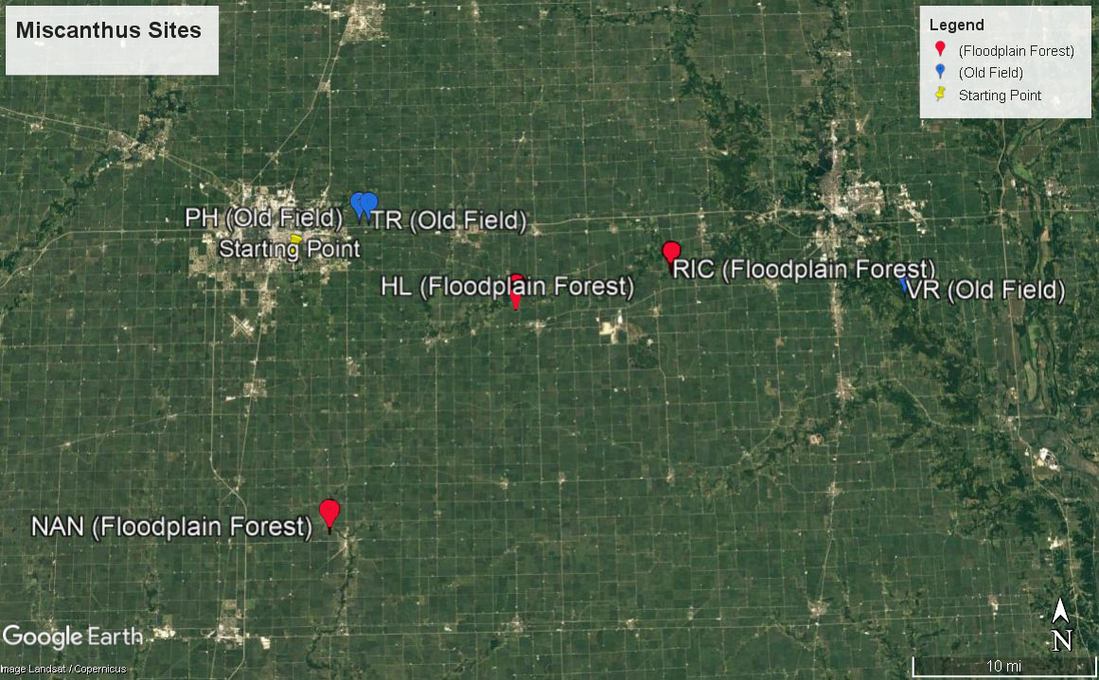

Supplemental Figure 1. Locations of Miscanthus infestation sites in Illinois. Floodplain forest sites (red points) include Homer Lake (HL), Nanney (NAN), and Richter Tracts (RIC). Old field sites (blue points) include Phillips (PH) and Trelease (TR) Prairies, and the Vermillion River Observatory (VRO). The starting point (yellow) marks the location from which travel originated from to reach sites for travel estimates.

Supplemental Table 1. Number of eradication treatments to existing plants per year at each site. Sites included: Homer Lake (HL), Nanney (NAN), Richter Tracts (RIC), Phillips (PH) and Trelease (TR) Prairies, and the Vermillion River Observatory (VRO).

Habitat | Site | 2014 | 2015 | 2016 | 2017 | 2018 | 2019
FF | HL | 1 glyphosate +  clethodim | 0 | 0 | 0 | 0 | 0
FF | NAN | 1 glyphosate +  clethodim | 0 | 0 | 0 | 0 | 0
FF | PH | 2 glyphosate + clethodim | 1 glyphosate | 0 | 0 | 0 | 0
OF | RIC | 0 | 0 | 0 | 0 | 0 | 0
OF | TR | 2 glyphosate +  clethodim | 1 glyphosate | 1 glyphosate | 0 | 1 excavation | 1 glyphosate
OF | VRO | 2 glyphosate + clethodim | 1 glyphosate | 2 glyphosate | 0 | 2 excavation | 1 glyphosate

Supplemental Table 2. Cost parameter estimates by year for herbicides and hourly wages used in eradication efforts.
 | Herbicides |  | Hourly Wages
 | SelectMax | WeatherMax | Minimum | Mean | Maximum
year | $/gallon |  | $/hour*
2014 | 122 | 22 | 34 | 54 | 107
2015 | 116 | 30 | 34 | 54 | 107
2016 | 110 | 38 | 34 | 54 | 107
2017 | 110 | 32 | 34 | 54 | 107
2018 | 110 | 32 | 34 | 54 | 107
2019 | 110 | 33 | 34 | 54 | 107

Supplemental Table 3. Estimated on-site costs (including hourly wage estimates for labor, as well as herbicides and equipment used in eradication efforts) spent monitoring and treating existing Miscanthus plants at each Miscanthus infestation site in either the floodplain forests (FF) or old fields (OF). Sites included: Homer Lake (HL), Nanney (NAN), Richter Tracts (RIC), Phillips (PH) and Trelease (TR) Prairies, and the Vermillion River Observatory (VRO).
 |  | M. sinensis |  |  |  |  |  |  |  |  | M. x giganteus
 |  | Total On-Site |  |  | On-Site Labor |  |  | Total Herbicide | Equipment |  | Total On-Site |  |  | On-Site Labor |  |  | Total Herbicide | Equipment
Habitat | Site | Mean | Max | Min | Mean | Max | Min |  |  |  | Mean | Max | Min | Mean | Max | Min
 |  | Costs Per Site ($/ site) |  |  |  |  |  |  |  |  | Costs Per Site ($/ site)
FF | HL | 344 | 513 | 281 | 171 | 340 | 108 | 3 | 170 |  | 338 | 502 | 277 | 165 | 329 | 104 | 3 | 170
FF | NAN | 307 | 440 | 258 | 135 | 268 | 85 | 3 | 170 |  | 361 | 547 | 292 | 188 | 374 | 119 | 3 | 170
FF | RIC | 135 | 268 | 85 | 135 | 268 | 85 | 0 | 0 |  | 135 | 268 | 85 | 135 | 268 | 85 | 0 | 0
OF | PH | 726 | 1267 | 523 | 549 | 1090 | 346 | 7 | 170 |  | 514 | 846 | 390 | 337 | 670 | 213 | 7 | 170
OF | TR | 975 | 1736 | 691 | 771 | 1532 | 487 | 4 | 200 |  | 1291 | 2364 | 891 | 1087 | 2159 | 686 | 4 | 200
OF | VRO | 1071 | 1926 | 752 | 866 | 1721 | 547 | 5 | 200 |  | 1771 | 3316 | 1193 | 1566 | 3110 | 988 | 5 | 200
 |  | Costs Per Infested Area ($/ m2) |  |  |  |  |  |  |  |  | Costs Per Infested Area ($/ m2)
FF | HL | 1.15 | 1.71 | 0.94 | 0.57 | 1.13 | 0.36 | 0.01 | 0.57 |  | 1.13 | 1.67 | 0.92 | 0.55 | 1.1 | 0.35 | 0.01 | 0.57
FF | NAN | 1.02 | 1.47 | 0.86 | 0.45 | 0.89 | 0.28 | 0.01 | 0.57 |  | 1.2 | 1.82 | 0.97 | 0.63 | 1.25 | 0.4 | 0.01 | 0.57
FF | RIC | 0.45 | 0.89 | 0.28 | 0.45 | 0.89 | 0.28 | 0.0 | 0.0 |  | 0.45 | 0.89 | 0.28 | 0.45 | 0.89 | 0.28 | 0.0 | 0.0
OF | PH | 2.42 | 4.22 | 1.74 | 1.83 | 3.63 | 1.15 | 0.02 | 0.57 |  | 1.71 | 2.82 | 1.3 | 1.12 | 2.23 | 0.71 | 0.02 | 0.57
OF | TR | 3.25 | 5.79 | 2.3 | 2.57 | 5.11 | 1.62 | 0.01 | 0.67 |  | 4.3 | 7.88 | 2.97 | 3.62 | 7.2 | 2.29 | 0.01 | 0.67
OF | VRO | 3.57 | 6.42 | 2.51 | 2.89 | 5.74 | 1.82 | 0.02 | 0.67 |  | 5.9 | 11.05 | 3.98 | 5.22 | 10.37 | 3.29 | 0.02 | 0.67

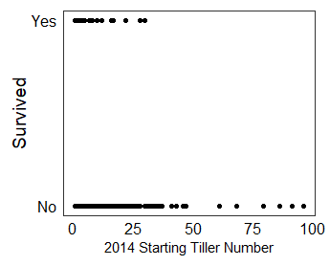
Supplemental Figure 2. Survival of M. sinensis and M. × giganteus plants based on plant tiller number

Travel costs: Labor, and vehicle operation and ownership
To determine the labor costs associated with travel to and from the Miscanthus sites, we first calculated the travel time to each site starting at and returning to the University of Illinois South Farms in Urbana, IL. On days in which travel to multiple sites occurred, we calculated the proportion of travel time and mileage for each site. To do this, we first calculated the total time that would be traveled to visit and return from each site individually. For example, if two sites (sites VR and TR) were visited on the same day, we first calculated time_{VR} as the number of minutes required to travel to and return from site VR, and time_{TR} as the number of minutes required to travel to and return from site TR. We then determined time_{VR,TR} as the number of minutes required to travel to the TR site, then to travel directly from TR to the VR site, and then to return to the starting point. Finally, to calculate the proportion of travel time attributed to each site we used the following equation:
time_{VR/VR,TR}= time_{VR,TR}* (time_{VR}/(time_{VR}+time_{TR}))
For each year, we calculated the sum of all personnel hours spent on travel for each site.
We then multiplied the minimum, maximum, and mean hourly wage estimate (estimated via the survey of invasive species management companies) by all personnel hours devoted to travel for each site to determine the average and potential range of labor costs associated with travel.
Vehicle operation and ownership costs were based on estimates for a four-wheel drive utility vehicle from the American Automobile Association’s (AAA) annual “Your Driving Costs” reports (AAA 2014-2019). Vehicle operation costs include the vehicle fuel and maintenance costs on a per mile basis. To estimate vehicle operation costs, we first calculated the miles traveled to get to and return from each Miscanthus site, with travel starting at and returning to the University of Illinois South Farms in Urbana, IL. On days in which travel to multiple sites occurred, we calculated the proportion of miles attributed to each site (using the same equation for travel time above). The attributed miles per site per visit were multiplied by the annual AAA estimates of operation costs per mile.
Vehicle ownership costs include estimates for vehicle depreciation, insurance, registration, taxes, and finance on a per day basis. To estimate the number of days the vehicle was used to visit each site, we calculated the number of trips required to monitor and treat the existing Miscanthus populations at each site per year and multiplied the annual number of trips per site by the AAA ownership costs per day estimates (AAA 2014-2019).
For vehicle operation and ownership costs, we summed the costs per site per year and calculated the cumulative vehicle operation and ownership costs per site across the five years of the study. Additionally, for vehicle operation and ownership costs, as well as for personnel hours spent on travel to and from each site, we attributed the total cost per site to both Miscanthus species up until the year at which the species was assumed to be eradicated. We then calculated the total travel costs associated with each Miscanthus population by summing the cumulative labor costs spent on travel with the cumulative costs of vehicle ownership and operation. Finally, to relativize the estimated costs by area, for each site we divided the total travel costs by the gross area (m²).
Travel Costs Results
The travel costs associated with eradication of Miscanthus populations included wages of personnel during travel time, as well as the costs associated with owning and operating a vehicle to access Miscanthus infestation sites (Supplemental Table 4). Travel costs were dependent on the distance between the land manager and the eradication site, as well as the number of visits required to monitor and treat existing Miscanthus populations at each site. The floodplain forest sites required fewer visits (total 4 visits per each floodplain forest site) to eradicate Miscanthus populations, therefore estimated total travel costs (using the mean hourly wage for personnel) ranged from $217 to $250 per site and did not vary by Miscanthus species (Supplemental Figure 3).
In contrast to the floodplain forest sites, the old field sites had greater variability in both the distance required to access each site, as well as the number of trips required to monitor and treat existing Miscanthus populations. The most distant site within our study, VRO, was located 65 km from our starting point, requiring 120 minutes roundtrip for each site visit. In contrast, the nearest site, PH, was located only 12 km from our starting point, and therefore required only 30 minutes roundtrip for each site visit. The greater distance to the VRO site, combined with the 17 total trips required for Miscanthus eradication efforts, resulted in a $1,765 mean total travel costs for this site. Only 8 trips were required to the PH site, therefore mean estimated travel costs were estimated to be $354.
As with on-site eradication costs, labor comprised the largest share of costs associated with travel, and was a function of travel time and hourly wage. For example, assuming the minimum hourly wage ($34), costs associated with travel ranged from $85 to $739 for the RIC and VRO sites, respectively. Alternatively, assuming the maximum hourly range ($107), labor costs associated with travel ranged from $269 to $2,326 in the RIC and VRO sites, respectively.
Supplemental Table 4. Cost parameter estimates by year for for owning and operating a vehicle to get to Miscanthus infestation sites.
 | Vehicle
 | Ownership | Operation
 | $/ day | ¢/mile
2014 | 20.48 | 23.8
2015 | 20.22 | 21.6
2016 | 20.65 | 18.12
2017 | 18.42 | 22.21
2018 | 18.46 | 23.18
2019 | 19.65 | 24.44
Other eradication costs associated with travel included vehicle ownership and operation costs. Vehicle ownership costs, which we determined based on the number of days a vehicle was used to access each site, ranged from $19 to $260, and varied based on the number of separate trips to each site that were required to either monitor or treat Miscanthus populations. Vehicle operating costs, based on AAA estimates of costs per mile to operate a vehicle, varied based on the distance and number of trips to each site and ranged from $61 to $334.

Supplemental Table 5. Estimated travel costs by site for personnel hours spent traveling to and from Miscanthus infestation sites, as well as estimated costs associated with owning and operating a vehicle for travel. Sites included: Homer Lake (HL), Nanney (NAN), Richter Tracts (RIC), Phillips (PH) and Trelease (TR) Prairies, and the Vermillion River Observatory (VRO).
 |  | M. sinensis |  |  |  |  |  |  |  |  | M. giganteus
 |  | Total Travel Costs |  |  | Total Travel Labor Costs |  |  | Vehicle Operation Costs | Vehicle Ownership Costs |  | Total Travel Costs |  |  | Total Travel Labor Costs |  |  | Vehicle Operation Costs | Vehicle Ownership Costs
Habitat | Site | Mean | Min | Max | Mean | Min | Max |  |  |  | Mean | Min | Max | Mean | Min | Max
 |  | Costs Per Site ($/ site) |  |  |  |  |  |  |  |  | Costs Per Site ($/ site)
FF | HL | 240 | 189 | 378 | 140 | 88 | 278 | 19 | 82 |  | 240 | 189 | 378 | 140 | 88 | 278 | 19 | 82
FF | NAN | 250 | 197 | 393 | 145 | 92 | 288 | 24 | 82 |  | 250 | 197 | 393 | 145 | 92 | 288 | 24 | 82
FF | RIC | 217 | 167 | 350 | 135 | 85 | 269 | 21 | 61 |  | 217 | 167 | 350 | 135 | 85 | 269 | 21 | 61
OF | PH | 354 | 291 | 523 | 171 | 108 | 339 | 23 | 160 |  | 283 | 231 | 423 | 142 | 90 | 282 | 19 | 122
OF | TR | 507 | 414 | 756 | 253 | 159 | 502 | 33 | 221 |  | 811 | 663 | 1209 | 403 | 254 | 800 | 56 | 353
OF | VRO | 1765 | 1334 | 2920 | 1171 | 739 | 2326 | 260 | 334 |  | 1765 | 1334 | 2920 | 1171 | 739 | 2326 | 260 | 334

Supplemental Figure 3. Cumulative travel costs to monitor and eradicate populations of M. × giganteus (top) and M. sinensis (bottom) plants. Sites include three within floodplain forests: Homer Lake (HL), Nanney (NAN), Richter Tracts (RIC); and three within old fields: Phillips (PH) and Trelease (TR) Prairies, and the Vermillion River Observatory (VRO). Shaded region represents the area between the maximum and minimum cost estimates based on the maximum and minimum hourly wage estimates.

Supplement References
American Automobile Association (AAA). 2014-2019.
Your Driving Costs 2014. http://publicaffairsresources.aaa.biz/wp-content/uploads/2014/05/Your-Driving-Costs-2014.pdf
Your Driving Costs 2015. https://newsroom.aaa.com/2015/04/annual-cost-operate-vehicle-falls-8698-finds-aaa-archive/
Your Driving Costs 2016. http://publicaffairsresources.aaa.biz/wp-content/uploads/2016/03/2016-YDC-Brochure.pdf
Your Driving Costs 2017. https://exchange.aaa.com/wp-content/uploads/2017/08/17-0013_Your-Driving-Costs-Brochure-2017-FNL-CX-1.pdf
Your Driving Costs 2018. https://exchange.aaa.com/wp-content/uploads/2018/09/18-0090_2018-Your-Driving-Costs-Brochure_FNL-Lo-5-2.pdf
Your Driving Costs 2019. https://www.aaa.com/AAA/common/AAR/files/AAA-Your-Driving-Costs.pdf

