Supplementary Table S1. List of species occurring at site 1 and site 2 with their growth habit and nativity status¹.
Scientific Name | Common Name | Site 1 | Site 2 | Growth Habit | Native Status | Desirability
Alyssum simplex | Rudolphi alyssum | X | X | Forb | Nonnative | Desirable
Ambrosia psilostachya | Western ragweed | X | X | Forb | Native | Desirable
Andropogon geradii | Big bluestem | X |  | Grass | Native | Desirable
Antennaria gaertn. | Pussytoes | X | X | Forb | Native | Desirable
Artemisia dracunculus | Tarragon | X | X | Sub-shrub | Native | Desirable
Artemisia frigida | Fringed sagebrush | X | X | Sub-shrub | Native | Desirable
Artemisisa ludoviciana | White sagebrush | X | X | Sub-shrub | Native | Desirable
Astragalus agrestris | Purple milkvetch | X | X | Forb | Native | Desirable
Astragalus flexuosus | Flexile milkvetch | X | X | Forb | Native | Desirable
Astragalus laxmanii | Laxmann's milkvetch |  | X | Forb | Native | Desirable
Astragalus spp. | Milkvetch |  | X | Forb | Native | Desirable
Boechera stricta | Canada rockcress | X | X | Forb | Native | Desirable
Bouteloua dactyolides | Buffalograss | X | X | Grass | Native | Desirable
Bouteloua gracilis | Blue grama | X |  | Grass | Native | Desirable
Bromus tectorum | Downy brome | X | X | Grass | Nonnative | Undesirable
Comandra umbellata | Bastard toadflax |  | X | Forb | Native | Desirable
Cryptantha virgata | Miner's candle |  | X | Forb | Native | Desirable
Elymus elymoides | Bottlebrush squirreltail |  | X | Grass | Native | Desirable
Ericameria nauseosa | Rubber rabbitbrush | X | X | Shrub | Native | Desirable
Erigeron divergens | Spreading fleabane | X |  | Forb | Native | Desirable
Erigeron flagellaris | Trailing fleabane | X | X | Forb | Native | Desirable
Eriogonum umbellatum | Sulfur-flower buckwheat | X | X | Forb | Native | Desirable
Eriogonum jamesii | James' buckwheat |  | X | Forb | Native | Desirable
Erodium cicutarium | Redstem filaree | X |  | Forb | Nonnative | Undesirable
Erysimum capitatum | Western wallflower |  | X | Forb | Native | Desirable
Euphorbia brachycera | Horned spurge |  | X | Forb | Native | Desirable
Gaillardia aristata | Blanketflower | X | X | Forb | Native | Desirable
Geranium caespitosum | Parry’s Geranium |  | X | Sub-shrub | Native | Desirable
Grindelia squarrosa | Curlycup gumweed | X | X | Forb | Native | Desirable
Helianthus pumilus | Little sunflower | X | X | Forb | Native | Desirable
Hesperostipa comata | Needle-and-thread | X | X | Grass | Native | Desirable
Heterotheca villosa | Hairy false goldenaster | X | X | Sub-shrub | Native | Desirable
Hypericum perforatum | Common St. Johnswort | X | X | Forb | Nonnative | Undesirable
Gutierrezia sarothrae | Broom snakeweed |  | X | Shrub | Native | Desirable
Koeleria macrantha | Prairie Junegrass | X | X | Grass | Native | Desirable
Linarius dalmatica | Dalmatian toadflax | X | X | Forb | Nonnative | Undesirable
Liatris punctata | Dotted blazing star | X | X | Forb | Native | Desirable
Lupinus argenteus | Silvery lupine | X |  | Forb | Native | Desirable
Mirabilis hirsuta | Hairy four o'clock |  | X | Forb | Native | Desirable
Opuntia polyacantha | Plains pricklypear | X | X | Shrub | Native | Desirable
Pascopyrum smithii | Western wheatgrass | X | X | Grass | Native | Desirable
Plantago patagonica | Woolly plantain | X |  | Forb | Native | Desirable
Poa compressa | Canada bluegrass | X | X | Grass | Nonnative | Desirable
Poa pratensis | Kentucky bluegrass | X | X | Grass | Nonnative | Desirable
Potentilla hippiana | Woolly cinquefoil |  | X | Forb | Native | Desirable
Psoralidium tenuiflorum | Slimflower scurfpea | X | X | Forb | Native | Desirable
Ratibida columnifera | Upright prairie coneflower | X | X | Forb | Native | Desirable
Rosa woodsii | Woods' rose |  | X | Forb | Native | Desirable
Tragopogon dubius | Yellow salsify | X | X | Forb | Nonnative | Undesirable
Rhus trilobata | Skunkbush sumac | X |  | Shrub | Native | Desirable
Senecio spartisoides | Broom-like ragwort |  | X | Sub-shrub | Nonnative | Desirable
Silene drumondii | Drummond's campion |  | X | Forb | Native | Desirable
Solidago altissima | Tall goldenrod | X |  | Forb | Native | Desirable
Sphaeralcea coccinea | Scarlet globemallow | X |  | Forb | Native | Desirable
Symphyotrichum falcatum | White prairie aster | X | X | Forb | Native | Desirable
Thlaspi arvense | Field pennycress | X |  | Forb | Nonnative | Undesirable
Verbascum blattaria | Moth mullein | X | X | Forb | Nonnative | Undesirable
Yucca glauca | Soapweed | X | X | Shrub | Native | Desirable
¹ Taxonomic information for species were collected from the USDA-NRCS Plants Database.

Supplementary Table S2. Results of linear mixed model ANOVA tests for the effects of treatment, burn type, and year on Bromus tectorum cover. Sites were combined for analysis of variance.
 | B. tectorum
Source | df | Fª | P^{b}
Year | 1 | 2.452 | 0.118
Treatment | 10 | 42.854 | <0.0001
Burn Type | 1 | 49.157 | <0.0001
Year x Treatment | 10 | 0.918 | 0.516
Year x Burn Type | 1 | 0.488 | 0.485
Treatment x Burn Type | 10 | 3.652 | <0.01
Year x Treatment x Burn Type | 10 | 0.609 | 0.806

ªF = F-statistic from Analysis of Variance summary table; df = degrees of freedom
^{b}P = P-value from Analysis of Variance summary table, α = 0.05; values in bold indicate significance at P < 0.05

Supplementary Table S3. Results of linear mixed model ANOVA tests for the effects of treatment and burn type on perennial grass, perennial forbs, and shrub/sub-shrub cover.
 |  | Perennial Grass |  | Perennial Forbs |  | Shrubs/sub-shrubs
Source | df | Fª | P^{b} | Fª | P^{b} | Fª | P^{b}
Site 1
Year | 1 | 14.164 | <0.001 | 36.535 | <0.001 | 0.188 | 0.665
Treatment | 10 | 2.919 | 0.002 | 1.241 | 0.271 | 1.253 | 0.264
Burn Type | 1 | 1.365 | 0.291 | 1.871 | 0.172 | 0.598 | 0.471
Year x Treatment | 10 | 0.214 | 0.995 | 1.095 | 0.371 | 0.076 | 0.999
Year x Burn Type | 1 | 0.109 | 0.742 | 15.68 | <0.01 | 0.001 | 0.979
Treatment x Burn Type | 10 | 0.623 | 0.792 | 2.225 | 0.02 | 2.972 | 0.002
Year x Treatment x Burn Type | 10 | 0.154 | 0.998 | 0.678 | 0.742 | 0.363 | 0.96
Site 2
Year | 1 | 6.687 | 0.011 | 19.054 | <0.001 | 14.658 | <0.001
Treatment | 10 | 1.444 | 0.168 | 2.285 | 0.017 | 2.107 | 0.028
Burn Type | 1 | 0.758 | 0.399 | 2.637 | 0.203 | 1.023 | 0.322
Year x Treatment | 10 | 0.684 | 0.738 | 0.418 | 0.934 | 0.179 | 0.997
Year x Burn Type | 1 | 0.073 | 0.788 | 0.118 | 0.732 | 0.048 | 0.826
Treatment x Burn Type | 10 | 0.83 | 0.6 | 1.649 | 0.1 | 0.217 | 0.994
Year x Treatment x Burn Type | 10 | 0.962 | 0.479 | 0.699 | 0.723 | 0.421 | 0.934
ªF = F-statistic from Analysis of Variance summary table; df = degrees of freedom
^{b}P = P-value from Analysis of Variance summary table, α = 0.05; values in bold indicate significance at P < 0.05.

Supplementary Table S4. Results of linear mixed model ANOVA tests for the effects of treatment, burn type, and year on species richness, Shannon’s diversity index, and Simpson’s diversity index.
 |  | Species Richness |  | Shannon's Diversity Index |  | Simpson's Diversity Index
Source | df | Fª | P^{b} | Fª | P^{b} | Fª | P^{b}
Site 1
Year | 1 | 0.009 | 0.951 | 0.705 | 0.403 | 0.012 | 0.912
Treatment | 10 | 1.183 | 0.902 | 1.593 | 0.116 | 1.359 | 0.207
Burn Type | 1 | 0.0 | 0.996 | 0.027 | 0.879 | 0.002 | 0.965
Year x Treatment | 10 | 0.814 | 0.974 | 0.787 | 0.641 | 0.603 | 0.809
Year x Burn Type | 1 | 0.039 | 0.918 | 0.161 | 0.689 | 0.843 | 0.36
Treatment x Burn Type | 10 | 0.847 | 0.963 | 0.789 | 0.629 | 1.058 | 0.399
Year x Treatment x Burn Type | 10 | 0.598 | 0.987 | 0.391 | 0.949 | 0.683 | 0.739
Site 2
Year | 1 | 0.348 | 0.154 | 0.713 | 0.001 | 0.714 | 0.012
Treatment | 10 | 0.294 | 0.793 | 1.113 | 0.244 | 1.267 | 0.093
Burn Type | 1 | 0.178 | <0.0001 | 0.372 | 0.023 | 0.683 | 0.025
Year x Treatment | 10 | 0.02 | 0.997 | 2.634 | 0.819 | 4.967 | 0.497
Year x Burn Type | 1 | 0.517 | 0.701 | 0.655 | 0.077 | 0.988 | 0.03
Treatment x Burn Type | 10 | 70.354 | 0.739 | 70.107 | <0.001 | 40.898 | <0.001
Year x Treatment x Burn Type | 10 | 3.739 | 0.998 | 13.163 | 0.68 | 8.776 | 0.539
ªF = F-statistic from Analysis of Variance summary table; df = degrees of freedom
^{b}P = P-value from Analysis of Variance summary table, α = 0.05; values in bold indicate significance at P < 0.05.
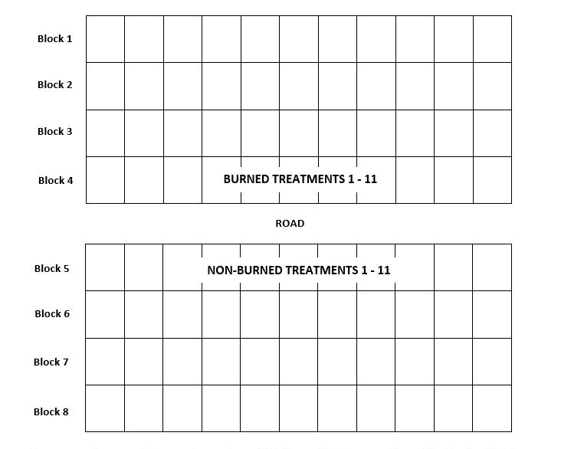
Supplementary Figure S1. Diagram of experimental design. With the exception of block 1, herbicide treatments were randomized within each block. Each row represents a block. The study includes 11 treatments, applied in four replications/blocks within the two burn types, and two sites, resulting in 176 experimental units.

