Supplemental Material

Figure S1. Aboveground biomass of Potentilla recta, native and non-native forbs, and native and non-native grasses pre- and post-treatment at Wycliffe (a) and Tobacco Plains (b), separated by month/year and treatment (C: control, G1: grazing once, G2: grazing twice, H: herbicide, G1H: grazing once + herbicide, G2H: grazing twice + herbicide).

Figure S2. Proportion of Potentilla recta and native and non-native forb and grass cover at Wycliffe (a) and Tobacco Plains (b) in July 2020, separated by treatment (C: control, G1: grazing once, G2: grazing twice, H: herbicide, G1H: grazing once + herbicide, G2H: grazing twice + herbicide).

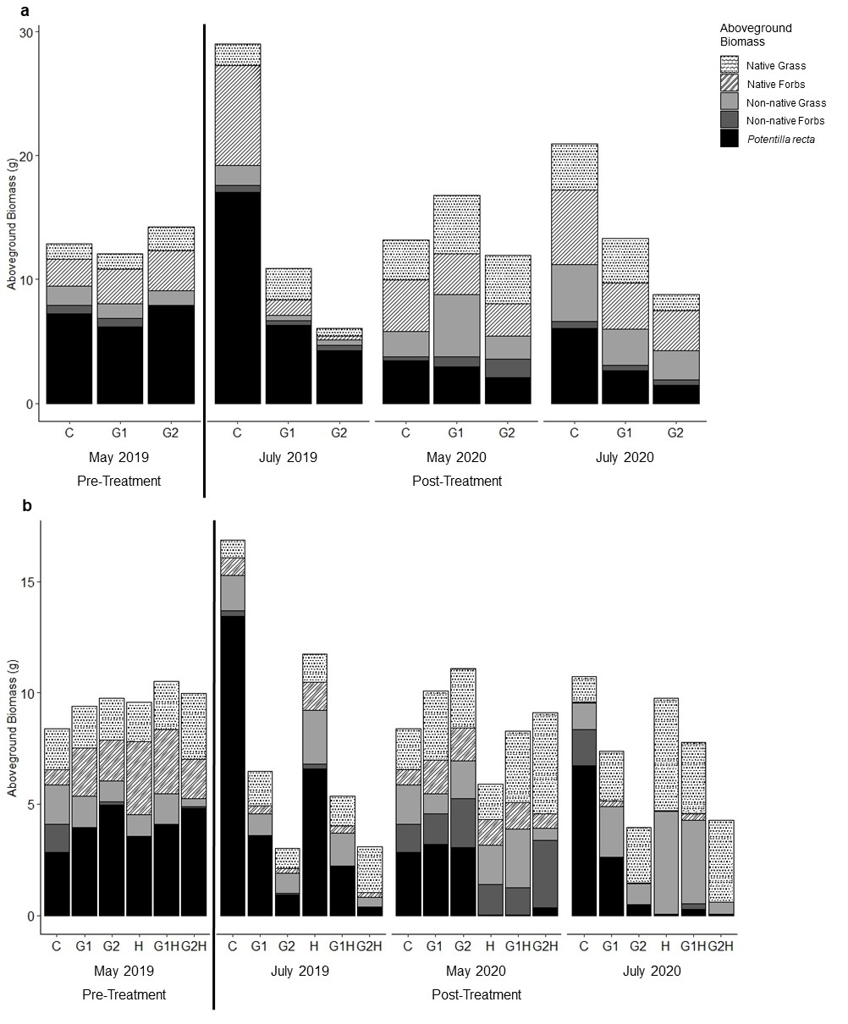
Figure S1

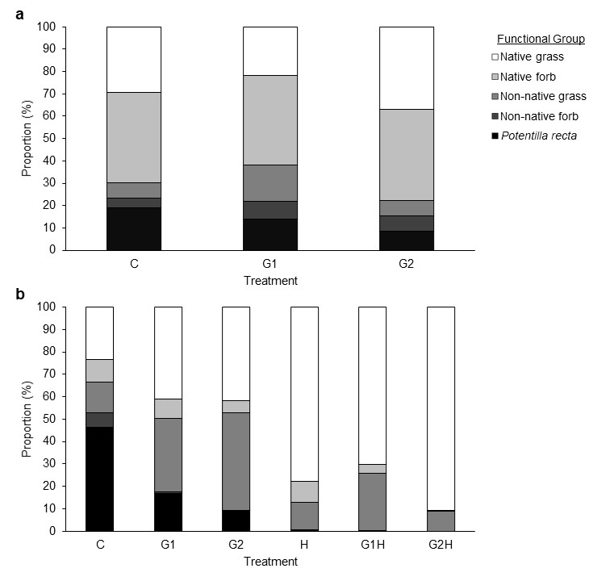
Figure S2

